|  |
| --- |
| MatchAware |
| UI Design and Prototyping Report |
| Patrick Borrelli |

Table of Contents

Introduction 2

User Interface Flow 2

System Login 2

Role Selection 3

Club Administrator Home 3

Field Administrator Home 4

Referee Assignor Home 5

Training Administrator Home 6

Coach Home 6

Referee Home 7

Trainer Home 7

Parent/Player Home 8

Navigation Structure 8

Login Flow 9

Role Selection 10

Club Admin 11

Field Admin 12

Referee Assignor 13

Training Administrator 14

Coach 15

Referee 16

Trainer 17

Parent/Player 18

References 18

# Introduction

MatchAware is a comprehensive and easy to use Field Scheduling solution for youth sports clubs of all sizes. MatchAware provides an easy set of interfaces to provide scheduling of field and facility resources for league games, practice sessions, scrimmages, and training camps for any number of teams, as well as supporting workflow based change requests, rescheduling notifications, and referee and trainer assignments. The initial release of the software is Soccer Club specific, and future releases will add functionality and terminology applicable to other youth sports clubs. All prototyping included in this report is focused on the mobile interface which will by nature be somewhat limited due to available screen size.

# User Interface Flow

System Login – The system is role-based. An authenticated user belongs to one or more roles that define the subset of functionality that the user is authorized to access. A new user can either create an account with MatchAware, or login with their existing Facebook credentials.

During the login process the user may choose to store their credentials by selecting the ‘remember me’ option.

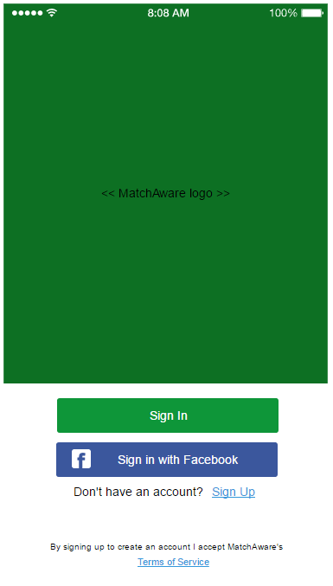

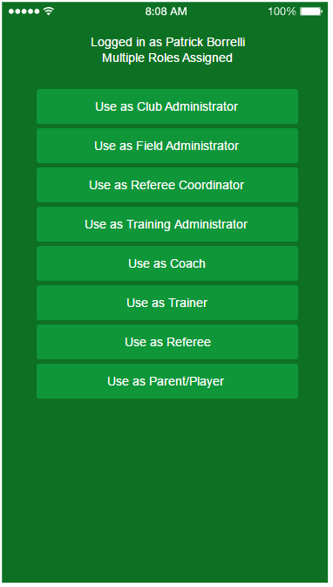Role Selection- Once the user is authenticated, they are routed based on their security role, if one or more are associated with the user’s account.

* User has no security role – users in this class are presented with the option to either create a new club, or to request access to an existing club. The request to join an existing club (selected from a dropdown of all clubs registered in the system) will send a notification to the Club Administrator for the selected club. The user’s account will be in a wait state until approval has been given. Otherwise, the user can create a new club, and they are automatically assigned the role of Club Administrator and will be brought to the Club Administrator home page.
* User has one security role – if a user already has one, and only one security role [Club Administrator, Field Administrator, Referee Coordinator, Training Administrator, Referee, Coach, Trainer, Parent/Player] they will automatically be brought to the home screen for that security group.
* User has multiple security roles – a user that belongs to more than security role is brought to the Role Selection screen, allowing them to select which role to use for this session.

Club Administrator Home – An authenticated club administrator is presented with the Club Admin Home screen. The club admin home screen has a primary tabbed navigation that groups like functionality, and each tab may have a secondary navigation system. The Club Admin home will provide the following functional tabs:

* User Administration – contains all functionality related to user management. Three subtabs are included for processing Access Requests, Assigning and Modifying user security roles, and Inviting Users to the system via either email or mobile.
* Team Administration – provides display of all current teams within the club in a sortable display format, and functionality to add/edit or import teams in a csv formatted file.
* Club Configuration – this tab contains all the essential functionality needed to setup and configure the Club. The following sub tabs group like functionality:
  + Age Groups – provides mechanisms to Add, Edit, Delete and View age group definitions
  + Leagues – provides mechanisms to Add, Edit, Delete and View leagues that this club’s teams participate in.
  + Rule Sets – provides the ability to Add, Edit, Delete and View rules to be applied to specific League and Age Group combinations. Rules include game duration, field sizes, goal dimensions, ball size, number of players on the field, etc.
  + Organizations – provides the club administrator a mechanism to Add, Edit, Delete and View external training organizations that the club utilizes for professional team training.

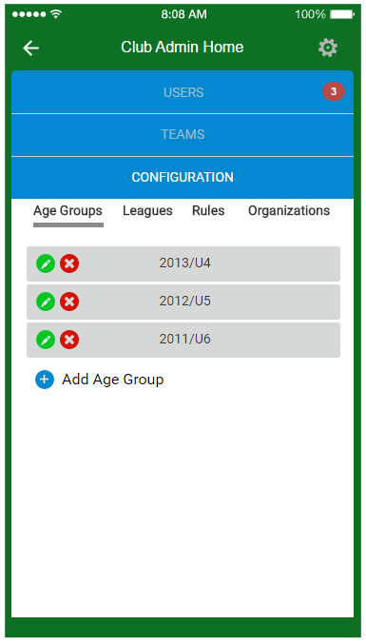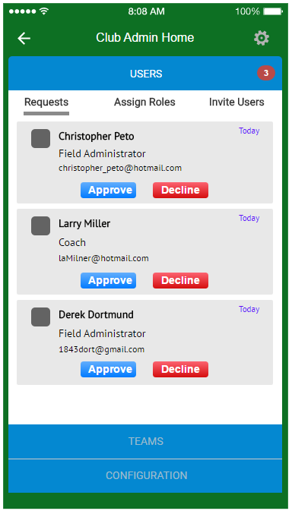

Field Administrator Home – An authenticated field administrator is presented with the Field Admin Home screen. This screen provides a similar tabbed primary navigation system, and presents the user with the following tabs:

* Configuration – allows administrative user to add/edit/delete Facilities and the fields present at those facilities, along with various attributes of those facilities and fields (i.e., indoor/outdoor, field size, lighting, hours of operation, etc). Also provides the user to define specific events types for scheduling (default event types are League Game, Scrimmage, Practice, Training Session, Clinic, Camp, Tryouts)
* Facility Closures – provides functionality for viewing facility status, and setting up, and sending notifications for, both current field closures (starting at time of submission and continuing up to 24 hours) and long term or future closures.
* Scheduling – the heart of the MatchAware software is field scheduling. This subset of the functionality provides sub tabs for the following functionality:
  + Pending Events/Change Request Processing – displays all events that need to be scheduled, and any previously scheduled event sent back to the field administrator with a change request. Provides mechanism for scheduling those events by dragging and dropping onto the schedule grid (web-only) and by auto-finding of available field time slots.
  + Pre-season Practice Slot Bidding – allows the administrator to initialize request submission for weekly practice slots by creating a notification to be sent to coaches of all teams in the system or any subset of teams. When coach responses are sent, they are displayed on the screen and field administrator can respond to them and assign the requested slots.
  + Ad-Hoc scheduling – admin can manually create and schedule an event on the fly.
  + Schedule Import – (web-only) Admin can import an existing schedule from either CSV file or a third party API. An API interface for GotSoccer is planned, but will not be available in the first release.

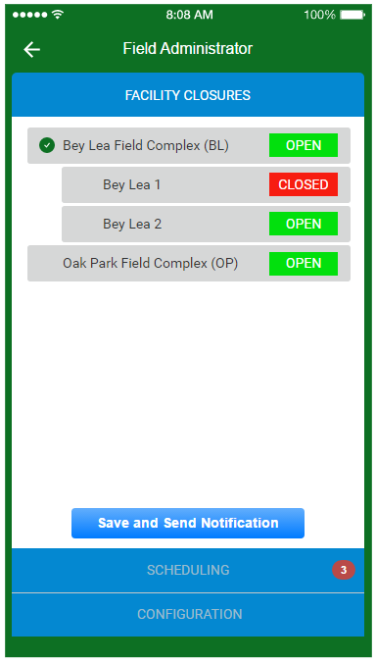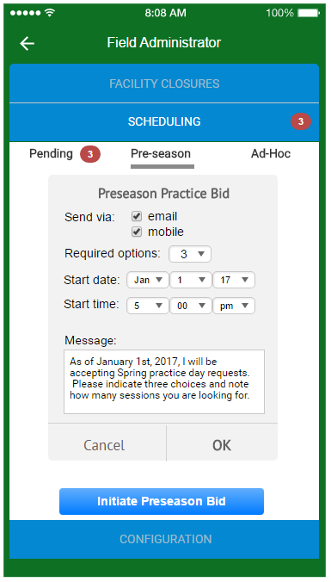

Referee Assignor Home – [deferred to future release] an authenticated referee coordinator is presented with the Ref Coordinator Home screen. This page will have a similar tabbed primary navigation grouping like functionality in the following tabs:

* Referees – provides functionality to process access requests, as well as add, edit, delete and invite referees.
* Scheduling – sub tabs are provided for the following functionality:
  + View schedule – schedule can be viewed in a full grid (web-only) or for individual days, for individual referees, individual teams, etc.
  + Pending Events/Change Request Processing – displays all events that need to be assigned, and any previous assignments sent back to the referee assignor with a change request. Provides mechanism for assigning referees and sending notifications as well as responding to change requests.

Training Administrator Home- an authenticate training administrator is presented with the Training Admin Home screen. The following functional tabs are provided:

* Trainers – provides functionality to process access requests, as well as add, edit, delete and invite trainers.
* Scheduling – sub tabs are provided for the following functionality:
  + View schedule – schedule can be viewed in a full grid (web-only) or for individual days, for individual trainers, individual teams, etc.
  + Pending Events/Change Request Processing – displays all events that need to be assigned a trainer, and any previous assignments sent back with a change request. Provides mechanism for assigning trainers and sending notifications as well as responding to change requests.
  + Field request – provides mechanism to request field or facility access for events.
  + Pre-season Training Slot Bidding – allows the administrator to initialize request submission for weekly training slots by creating a notification to be sent to coaches of all teams in the system or any subset of teams. When coach responses are sent, they are displayed on the screen and training administrator can respond to them and assign the requested slots.

Coach Home – an authenticated coach is presented with the Coach Home screen. The following functional tabs are provided:

* Team – provides all functionality related to team management including processing Access Requests, viewing roster, adding, editing, deleting or inviting players and parents, and messaging team members.
* Scheduling – provides mechanisms to view the team’s schedule, view events pending reschedule (due to field closures, typically), submit change requests for scheduled events, respond to pre-season practice and training bid requests, and request ad-hoc field space assignments (extra sessions, team tryouts, etc).

Referee Home – [deferred to future release] an authenticated referee is presented with the Referee Home screen. The following functional tabs are provided:

* Schedule – view upcoming schedule of games assigned, submit change requests.
* Notifications – view notifications of new assignments, accept or decline game assignments, see notification of changes to assignments, game times, locations.
* Change Request Status – view status of all in progress change requests.

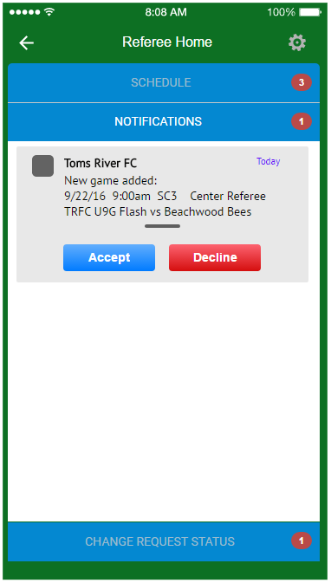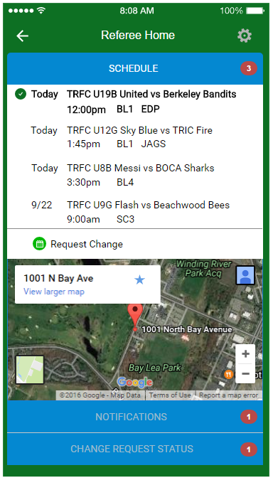

Trainer Home - an authenticated trainer is presented with the Trainer Home screen. The following functional tabs are provided:

* Schedule – view upcoming schedule of sessions assigned, submit change requests.
* Notifications – view notifications of new session assignments, see notification of changes to assignments, session times, locations.
* Change Request Status – view status of all in progress change requests.

Parent/Player Home - an authenticated parent or player is presented with the Parent/Player Home screen. The following functional tabs are provided:

* Schedule – view upcoming schedule of events and messages from coaches/trainers associated with that event.
* Notifications – view notifications of new events, see notification of changes to existing events, times, locations.
* Request access to additional team schedule.

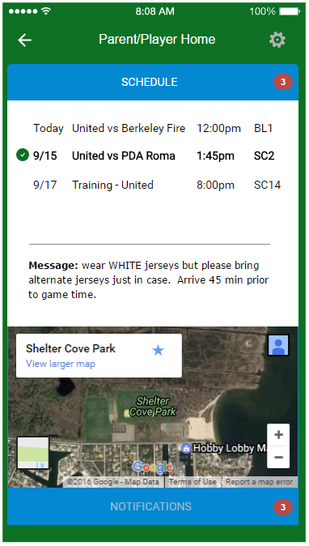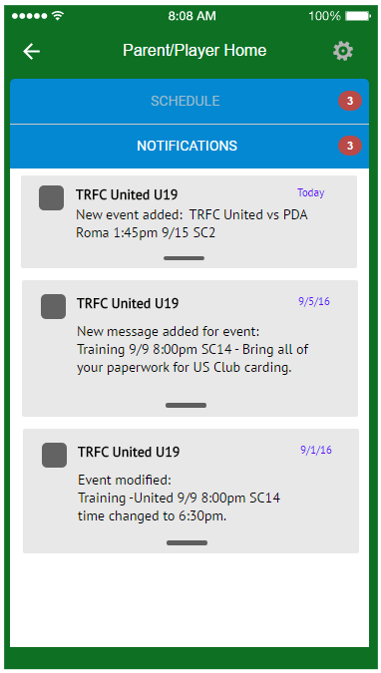

# Navigation Structure

Navigation through the application is represented here as a series of flow diagrams.

Each functional area has its own flow, and links to additional flows using the off-page connector shape shown here:

Login Flow – details all login, authentication and account creation logistics.

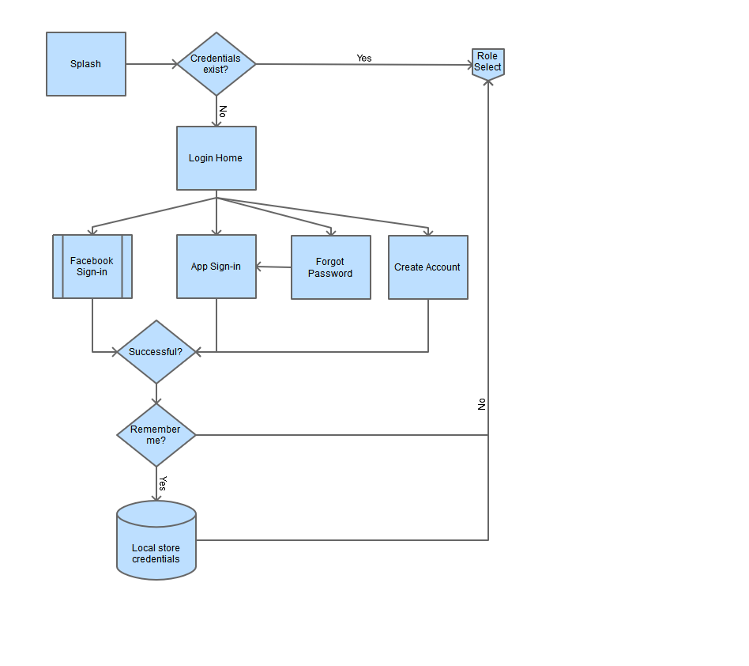

Role Selection **–** the next flow in the process details the determination of which screen to present to the authenticated user.

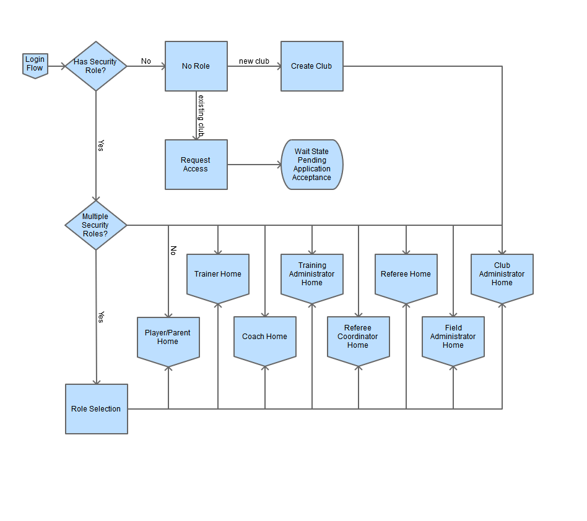

Club Admin – details the flow of all functionality assigned to the club administrator.

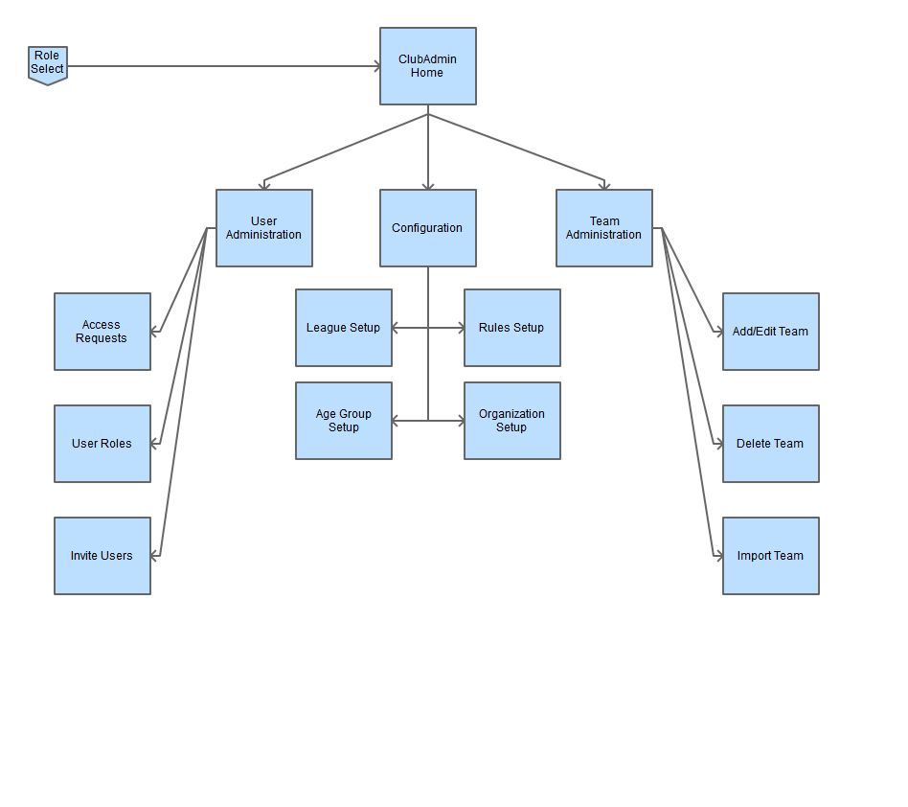

Field Admin – highlights the flow involved in the field administration role.

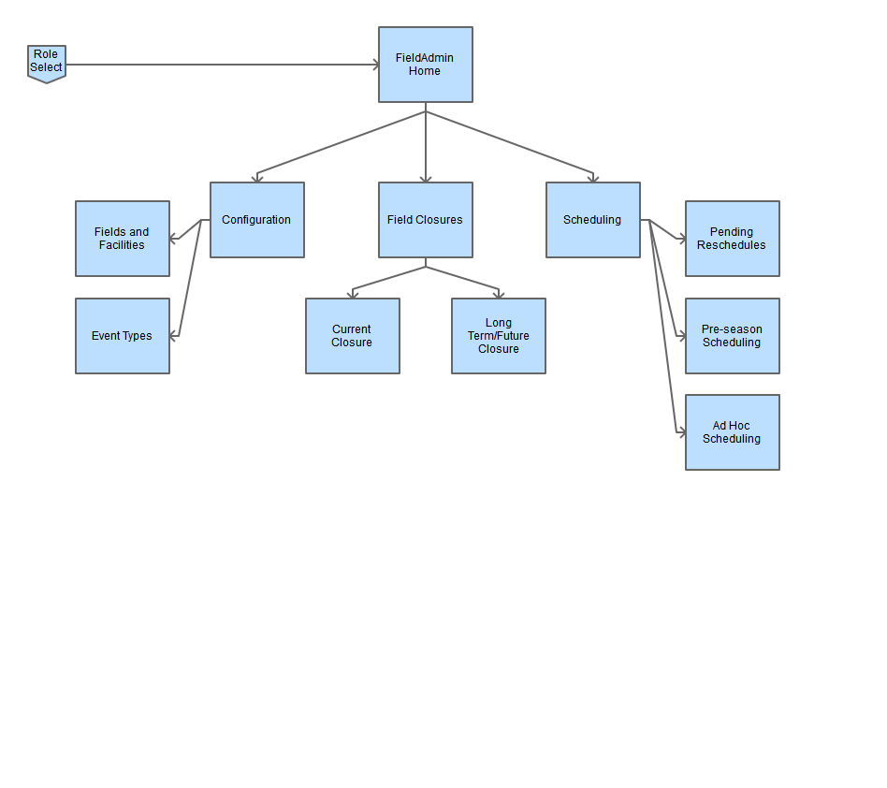

Referee Assignor – details all program flow involved in referee assignor functionality

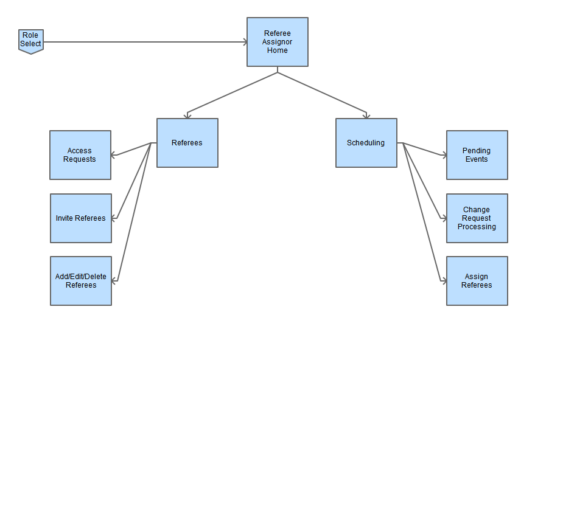

Training Administrator – highlights all program flow related to the role of the training administrator

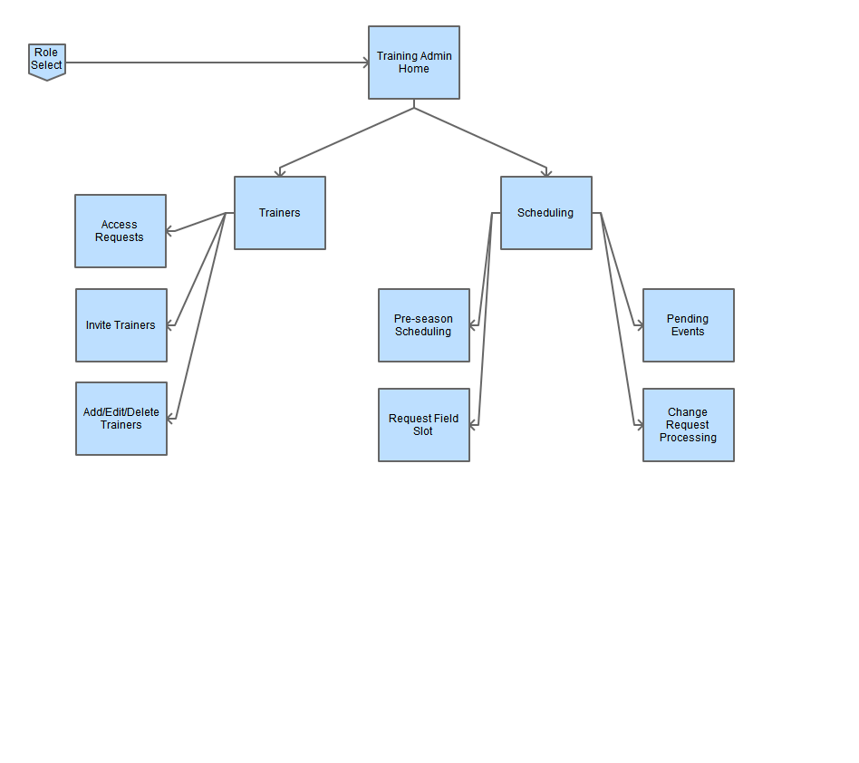

Coach– outlines the program flow relevant to the Coach security role.

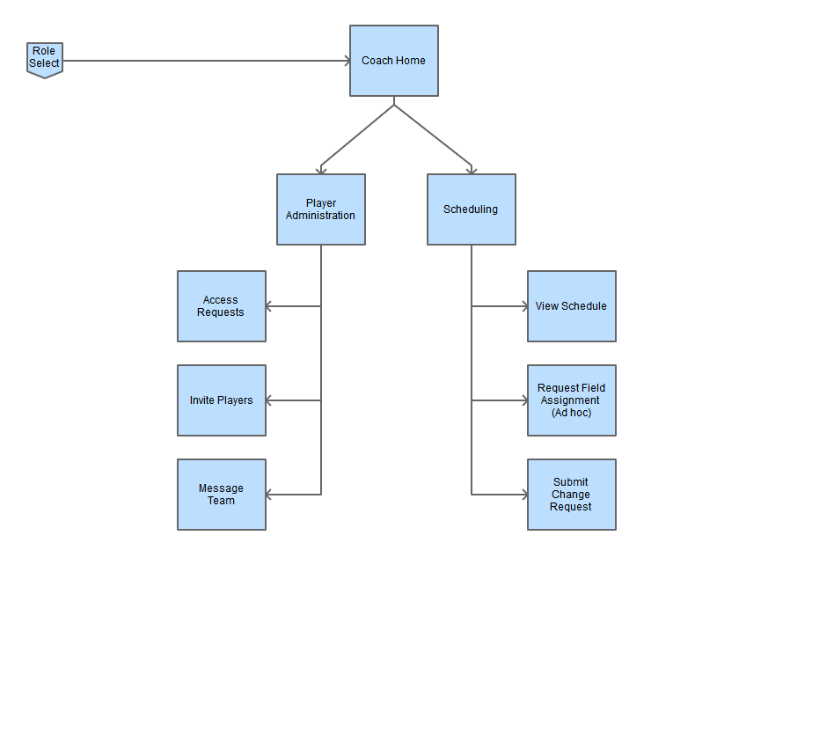

Referee – program flow path for the functionality assigned to a referee.

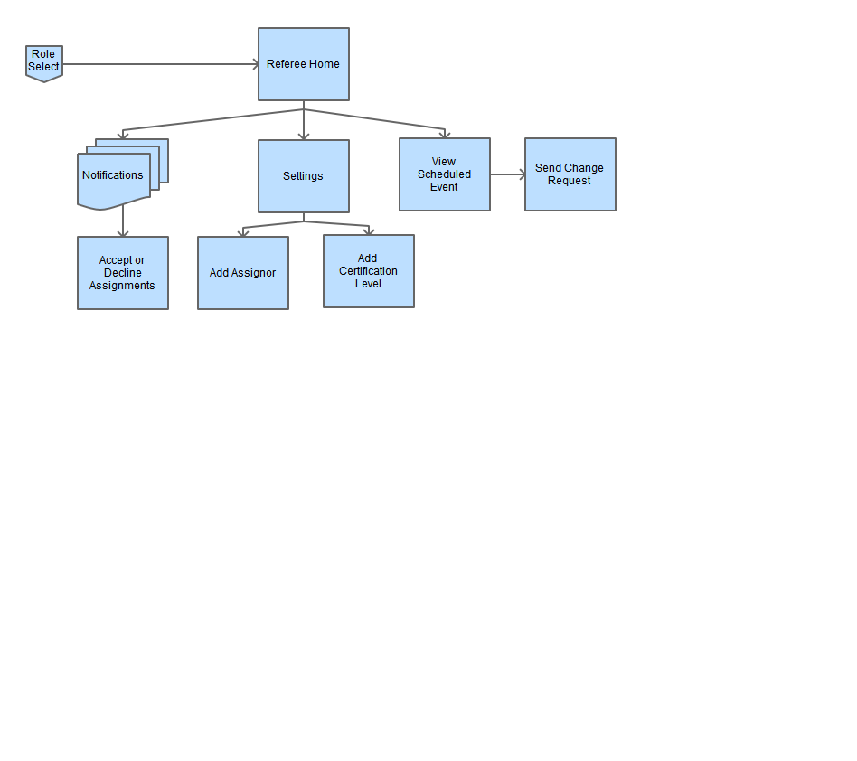

Trainer – details program flow for all trainer functionality.

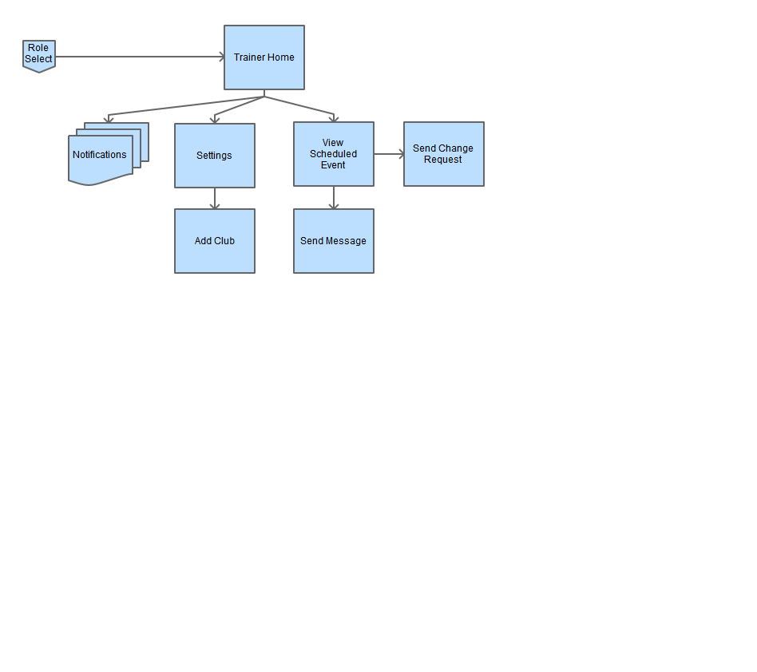

Parent/Player- defined program flow for parent or player user.

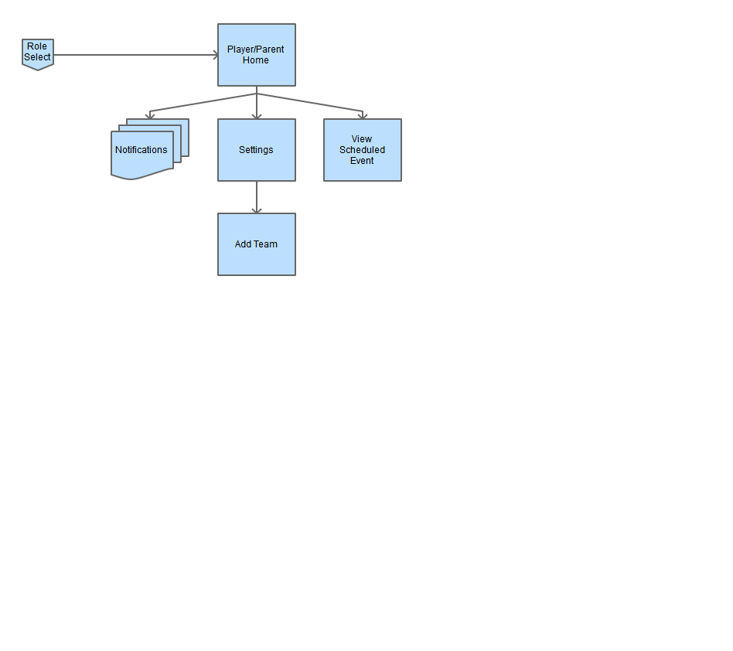

# References

All prototype elements for this report were created with UXPIN (https://www.uxpin.com/)

All flow diagrams were created with Pencil (http://pencil.evolus.vn/)

The Google Maps API was used in creation of prototype images, and will be used in the project. (https://enterprise.google.com/intl/en_uk/maps/products/mapsapi.html)