

Texas Tech University

CS4366 Senior Capstone Project

TTU CS Blog

Design

Authors: Instructor:

Randall Harper Mr. Cong Pu

Jason Weber

James Little

Patrick Braud

Contents

Functional Requirements 3

Use Cases 4

# Functional Requirements

* User Functional Requirements

1. The user will be able to make posts under topics.
2. The user ‘guest’ will not have access to post.
3. The user ‘faculty’ will only have access to post under the topics research and articles.
4. The user ‘administrator’ will have the authority to close and/or move a post.
5. The user ‘registered’ will mark answers on their posted questions as either ‘top answer’, ‘helpful’, or ‘incorrect’.
6. Users 'guest', 'faculty', 'administrator', and 'registered' have the ability to search the blog.

* System Functional Requirements

1. The system shall maintain a total number of topics.
2. The system shall grant users credit for correctly answered questions requested by another user. If marked ‘top answer’, the user who answered the question will receive double credit. If marked ‘helpful’, the user will gain the base credit amount. If marked ‘incorrect’, the user will not gain any credit.
3. The system shall automatically email the user who made a post when another use has attempted to answer.
4. The system shall automatically email the user who answered a post when it has been marked by the user who posted the question.
5. The system shall mark each post as answered or unanswered.
6. The system shall close a post if it remains unanswered after the time out period.

# Use CasesC:\wamp\www\CapstoneProject\Proposal\Design\Administrator User Use Case Diagram.JPG

|  |  |
| --- | --- |
| ***Administrator*** |  |
| Title | **Administrator Close Post** |
| Summary | The administrator user has the authority to close a post. |
| Preconditions | The administrator user is logged in and is located on a thread on the domain. |
| Post-conditions | The administrator user closes a thread. |
|  |  |
| Actor : Administrator User | System |
|  | 0. The system displays any page on the forum domain and an administrator user is logged in. |
| 1. The administrator user selects a thread to be closed. | 2. The system displays "Are you sure?" question on the thread selected by the administrator user. |
| 3. The administrator user selects close thread. | 4. The systems displays page "Thread Closed" with title of thread. |

|  |  |
| --- | --- |
| ***Administrator*** |  |
| Title | **Administrator Move Post** |
| Summary | The administrator user has the authority to move a post to a different topic/category. |
| Preconditions | The administrator user is logged in and is located on a thread on the domain. |
| Post-conditions | The administrator user moves a thread. |
|  |  |
| Actor : Administrator User | System |
|  | 0. The system displays any page on the forum domain and an administrator user is logged in. |
| 1. The administrator user selects a thread to be moved. | 2. The system displays "Are you sure?" questions on the thread selected by the administrator user. |
| 3. The administrator user selects move thread. | 4. The system displays page "Thread Moved" with title of thread to new location. |

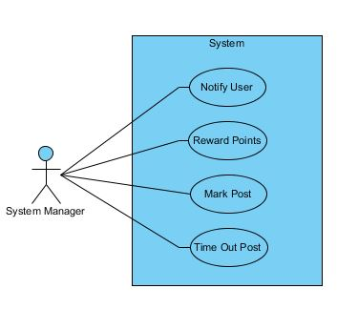

|  |  |
| --- | --- |
| ***Blog Manager*** |  |
| Title | **Reward Points** |
| Summary | The system will reward points based on correct answers to posted questions |
| Preconditions | A user has chosen a correct answer to their post |
| Post-conditions | The user who answered correctly is rewarded points to their account |
|  |  |
| Actor : Blog Manager | System |
|  | 0. The system finds an answer marked as correct |
| 1. The blog manager identifies the user with the correct answer | 2. The system rewards a set number of points to the appropriate account |

## *Reward Points*

|  |  |
| --- | --- |
| ***Registered User*** |  |
| Title | **Post Question** |
| Summary | The registered user can post new questions on the blog |
| Preconditions | The user is registered and logged in |
| Post-conditions | A new question is posted onto the blog |
|  |  |
| Actor : Registered User | System |
| 0. The user clicks the 'Post' button | 1. System displays PostTemplate page |
| 2. The user fills out the template for their question | 3. System creates a new post page for the user's question |

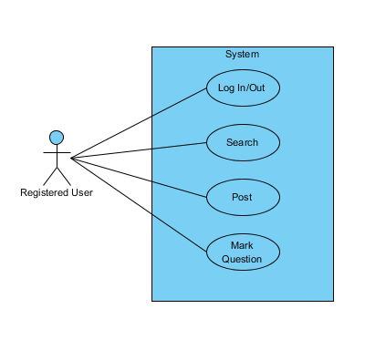

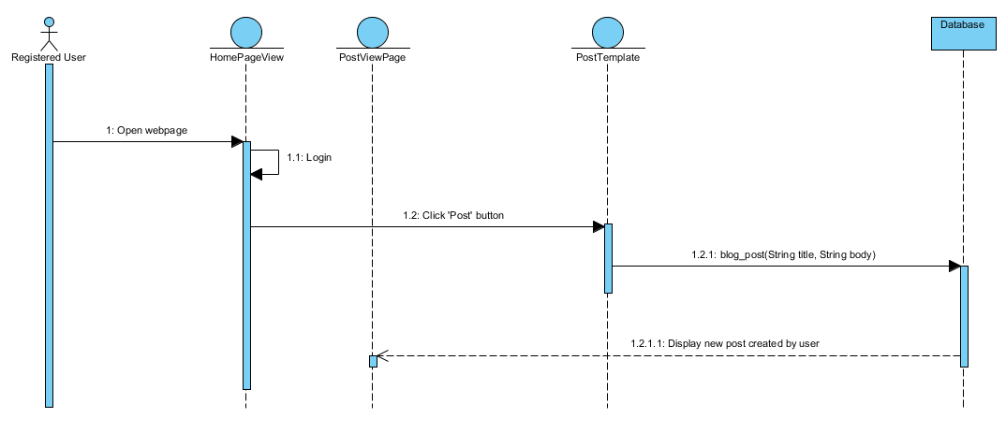 ***Post Question***

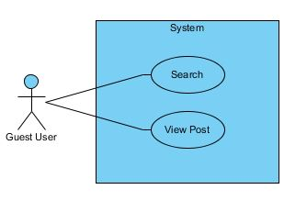

|  |  |
| --- | --- |
| ***Guest*** |  |
| Title | Search |
| Summary | The guest user can search the forums by entering a search criteria in the search bar. |
| Preconditions | The guest user must be on the forum domain. |
| Post-conditions | The guest user will have results on the searched criteria. |
|  |  |
| Actor : Guest | System |
|  | 0. The system displays any page on the forum domain. |
| 1. The guest user enters a search criteria in the search bar. | 2. The system displays any topics from the given search criteria. |
| 3. The guest user may select from the given results. | 3. The system will display the selected thread. |

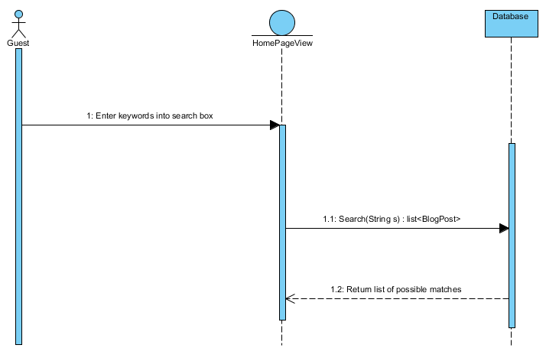***Search***

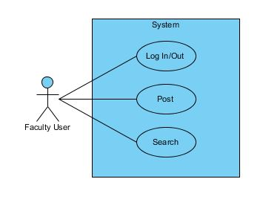

|  |  |
| --- | --- |
| ***Faculty*** |  |
| Title | **Login** |
| Summary | Users with accounts can login |
| Preconditions | The user has account on the blog |
| Post-conditions | The user logs into the blog |
|  |  |
| Actor : Registered User | System |
| 0. The user opens the webpage | 1. System displays the blog homepage |
| 2. The user enters their login credentials and clicks 'Login' | 3. System verifies user's login credentials and logs user in |

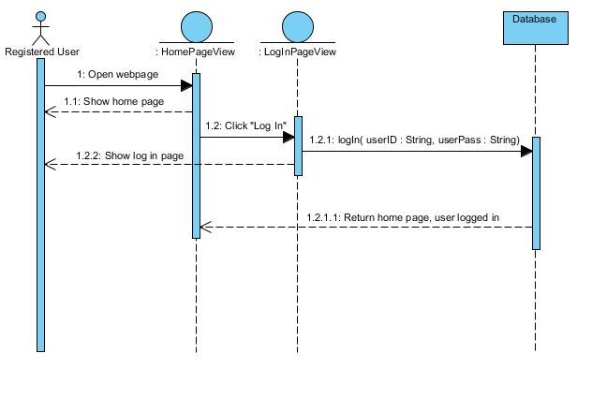***Login***