Clean Agile. Back to Basics

by Robert C. Martin (Book Summary)

Patrick Bucher

Table of Contents

# 1 Introduction to Agile

The *Agile Manifesto* originated from the gathering of 17 software experts in early 2001 as a reaction to heavy-weight processes like *Waterfall*. Since then, Agile was adopted widely and has been extended in various ways—unfortunately, not always in the spirit of the original idea.

## 1.1 History of Agile

The basic idea of Agile—working with small, intermediate goals and measuring the progress—might be as old as civilization. Agile practices might also have been used in the early days of software development. However, the idea of *Scientific Management*, which is based on Taylorism, with its top-down approach and heavy planning, was prevalent in many industries at that time, conflicting with the *Pre-Agile* practice then prevalent in software development.

Scientific Management was suitable for projects with a high cost of change, a well-defined problem definition, and extremely specific goals. Pre-Agile practices, on the other hand, were a good fit for projects with a low cost of change, an only partially defined problem, and goals only being informally specified.

Unfortunately, there was no discussion at that time on which approach was the better fit for software projects. Instead, the Waterfall model—initially used as a straw man to be proven unsuitable by Winston Royce in his 1970 paper *Managing the Development of Large Software Systems*—was widely adopted in the industry. And Waterfall, with its emphasize on analysis, planning, and closely sticking to a plan, was a descendant of Scientific Management, not of Pre-Agile practices.

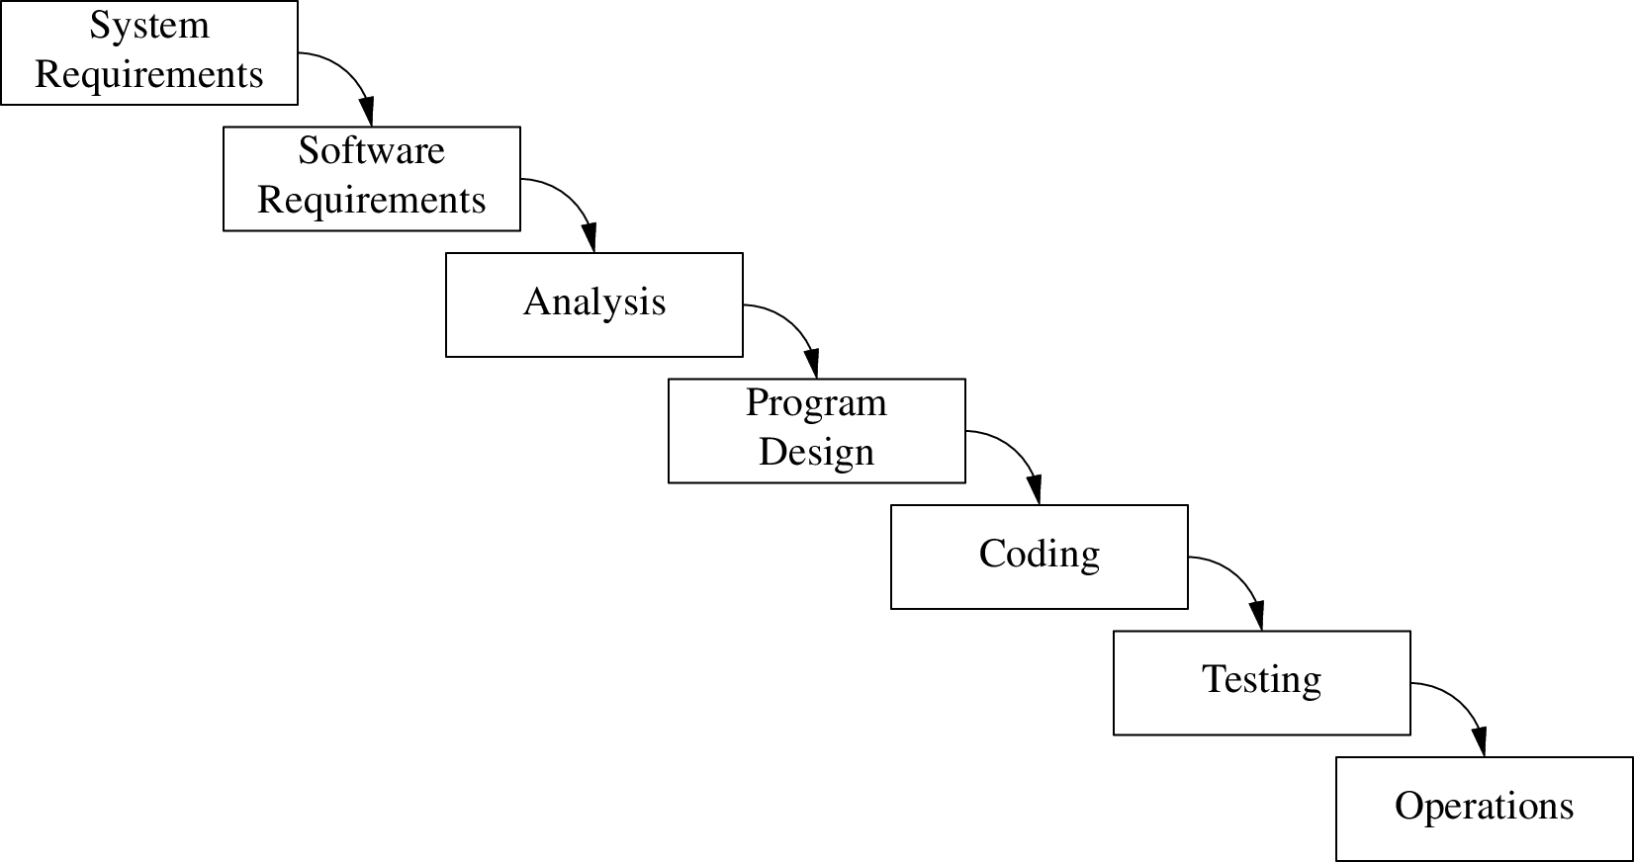

The Waterfall Model

Waterfall dominated the industry since the 1970s for almost 30 years. Its subsequent phases of analysis, design, and implementation looked promising to developers working in endless “code and fix” cycles, lacking even the discipline of Pre-Agile.

What looked good on paper—and produced promising looking results in the analysis and design phases—often terribly failed in the implementation phase. Those problems, however, have been attributed to bad execution, and the Waterfall approach itself wasn’t criticized. Instead, it became so dominant that new developments in the software industry like structured or object-oriented *programming* were soon followed by the disciplines of structured and object-oriented *analysis* and *design*—perfectly fitting the Waterfall mindset.

Some proponents of those ideas, however, started to challenge the Waterfall model in the mid-1990s, for example Grady Booch with his method of object-oriented design (OOD), the *Design Pattern* movement, and the authors of the *Scrum* paper. Kent Beck’s *Extreme Programming* (XP) and *Test-Driven Development* (TDD) approaches of the late 1990s clearly moved away from Waterfall towards an Agile approach. Martin Fowler’s take on *Refactoring*, emphasizing continuous improvement, certainly is a bad fit for Waterfall.

## 1.2 The Agile Manifesto

17 proponents of various agile ideas—Kent Beck, Robert C. Martin, Ward Cunningham (XP), Ken Schwaber, Mike Beedle, Jeff Sutherland (Scrum), Andrew Hunt, David Thomas (“Pragmatic Programmers”), among others—met in Snowbird, Utah in early 2001 to come up with a manifesto capturing the common essence of all those lightweight ideas. After two days, broad consensus was reached:

We are uncovering better ways of developing software by doing it and helping others do it.

* **Individuals and interactions** over processes and tools
* **Working software** over comprehensive documentation
* **Customer collaboration** over contract negotiation
* **Responding to change** over following a plan

That is, while there is value in the items on the right, we value the items on the left more.

This *Agile Manifesto* was published after the gathering on [agilemanifesto.org](https://agilemanifesto.org/), where it still can be signed. The [12 Principles](https://agilemanifesto.org/principles.html) were written as a collaborative effort within the two weeks that followed the conference. This document explains and directs the four values stated in the manifesto; it shows, that those values have actual consequences.

## 1.3 Agile Overview

Many software projects are managed using approaches based on faith and motivational techniques. As a result, such projects are chronically late, despite developers working overtime.

All projects are constrained by a trade-off called the *Iron Cross of Project Management*: good, fast, cheap, done—pick three! Good project managers understand this trade-off and strive for results that are done good enough within an acceptable time frame and budget, which provide the crucial features.

Agile produces data that helps managers taking good decisions. The *velocity* shows the amount of points a development team finishes within an iteration. A *burn-down chart* shows the points remaining until the next milestone. The latter not necessarily shrinks at the rate of the velocity, because requirements and their estimations can change. Still, the burn-down chart’s slope can be used to predict a likely date when the milestone is going to be reached.

Agile is a feedback-driven approach. Even though the Agile Manifesto doesn’t mention velocity or burn-down charts, collecting such data and taking decisions based on it is crucial. Make that data public, transparent, and obvious.

A project’s end date is usually given and not negotiable, often for good business reasons. The requirements, however, often change, because customers only have a rough goal, but don’t know the detailed steps how to reach it.

## 1.4 A Waterfall Project

In the Waterfall days, a project was often split up into three phases of equal length: analysis, design, and implementation. In the analysis phase, requirements are gathered and planning is done. In the design phase, a solution is sketched and the planning is refined. Neither phase has hard and tangible goals; they are done when the end date of the phase is reached.

The implementation phase, however, needs to produce working software—a goal that is hard and tangible, and whose attainment is easy to judge. Schedule slips are only detected in this phase, and stakeholders only become aware of such issues when the project should be almost finished.

Such projects often end in a *Death March*: a hardly working solution is produced after a lot of overtime work, despite deadlines being moved forward repeatedly. The “solution” for the next project usually is to do even more analysis and design—more of what didn’t work in the first place (*Runaway Process Inflation*).

## 1.5 The Agile Way

Like Waterfall, an Agile project starts with analysis—but analysis never ends. The time is divided in iterations or *sprints* of typically one or two weeks. *Iteration Zero* is used to write the initial stories, to estimate them, to set up the development environment, to draft a tentative design, and to come up with a rough plan. Analysis, design, and implementation take place in every iteration.

After the first iteration is completed, usually fewer stories have been finished than originally estimated. This is not a failure, but provides a first measurement that can be used to adjust the original plan. After a couple of iterations, a realistic average velocity and an estimation of the project’s release date can be calcualted. This might be disappointing, but realistic. Hope is replaced by real data early in the process.

Project management dealing with the Iron Cross—good, fast, cheap, done: pick three!—can now do the following adjustments:

* *Schedule*: The end date is usually not negotiable, and if it is, delays usually cost the business significantly.
* *Staff*: *“Adding manpower to a late project makes it later.”* (Brooke’s Law) If more staff is added to a project, productivity first plummets, and only increases over time. Staff can be added in the long run, if one can afford it.
* *Quality*: Lowering the quality might give the impression of going faster in the short run, but slows down the project in the long run, because more defects are introduced. *“The only way to go fast, is to go well.”*
* *Scope*: If there’s no other way, stakeholders can often be convinced to limit their demands to features that are absolutely needed.

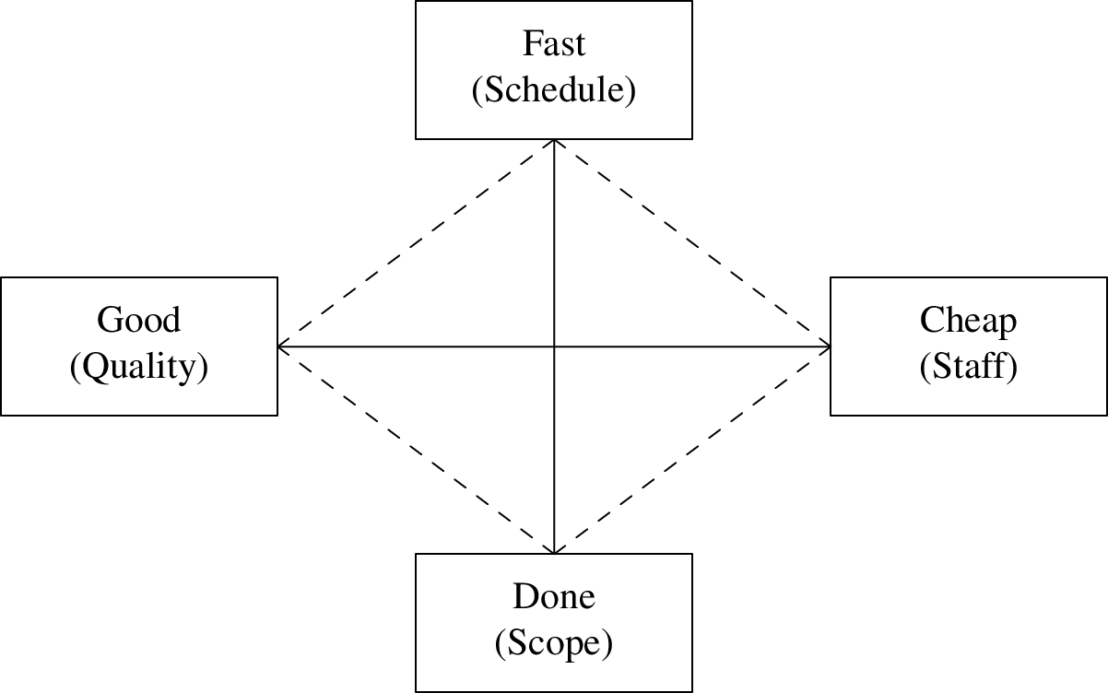

The Iron Cross of Project Management (adjustments in parentheses)

Reducing the scope is often the only sensible choice. Make sure at the beginning of every sprint to only implement features that are really needed by the stakeholders. You might waste precious time on “nice to have” features otherwise.

## 1.6 Circle of Life

Extreme Programming (XP), as described in Kent Beck’s *Extreme Programming Explained*, captures the essence of Agile. The practices of XP are organized in the *Circle of Life*, which consists of three rings.

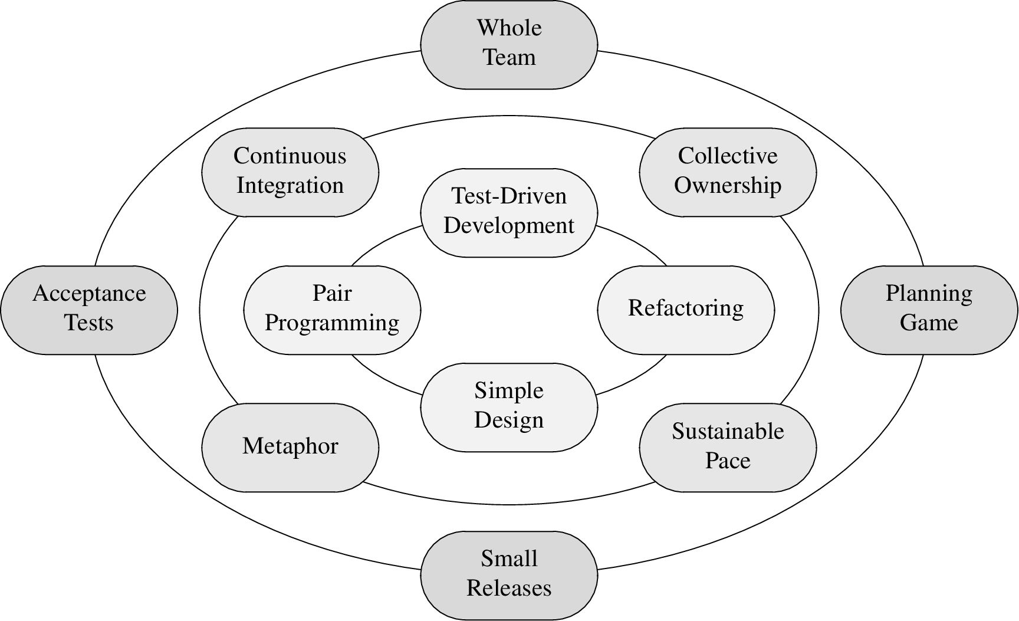

The Circle of Life

The outer ring contains the *business-facing* practices, which are quite similar to the Scrum process:

* **Planning Game**: breaking down a project into features, stories, and tasks
* **Small Releases**: delivering small, but regular increments
* **Acceptance Tests**: providing unambiguous completion criteria (definition of “done”)
* **Whole Team**: working together in different functions (programmers, testers, management)

The middle ring contains the *team-facing* practices:

* **Sustainable Pace**: making progress while preventing burnout of the developing team
* **Collective Ownership**: sharing knowledge on the project to prevent silos
* **Continuous Integration**: closing the feedback loop frequently and keeping the team’s focus
* **Metaphor**: working with a common vocabulary and language

The inner ring contains *technical* practices:

* **Pair Programming**/**Pairing**: sharing knowledge, reviewing, collaborating
* **Simple Design**: preventing wasted efforts
* **Refactoring**: refining and improving all work products continuously
* **Test-Driven Development**: maintaining quality when going quickly

These practices closely match the values of the Agile Manifesto:

* **Individuals and interactions** over processes and tools
  + Whole Team (business-facing)
  + Metaphor (team-facing)
  + Collective Ownership (team-facing)
  + Pairing (technical)
* **Working software** over comprehensive documentation
  + Acceptance Tests (business-facing)
  + Test-Driven Development (technical)
  + Simple Design (technical)
  + Refactoring (technical)
  + Continuous Integration (technical)
* **Customer collaboration** over contract negotiation
  + Planning Game (business-facing)
  + Small Releases (business-facing)
  + Acceptance Tests (business-facing)
  + Metaphor (team-facing)
* **Responding to change** over following a plan
  + Planning Game (business-facing)
  + Small Releases (business-facing)
  + Acceptance Tests (business-facing)
  + Sustainable Pace (team-facing)
  + Refactoring (technical)
  + Test-Driven Development (technical)

To sum up:

Agile is a small discipline that helps small software teams manage small projects. Big projects are made from small projects.

# 2 The Reasons for Agile

Many developers adopting Agile for the promise of speed and quality end up disappointed as these results do not show up immediately. However, the more important reasons for adopting Agile are *professionalism* and *reasonable customer expectations*.

## 2.1 Professionalism

In Agile, high commitment to discipline is more important than ceremony. Disciplined, professional behaviour becomes more important as software itself becomes more important. Computers are almost everywhere nowadays, and so is software. Little gets accomplished without software.

Software is written by programmers—and bad software can kill people. Therefore, programmers will be blamed as people are getting killed due to erroneous software. The disciplines of Agile development are a first step towards professionalism—which might save people’s life in the long run.

## 2.2 Reasonable Customer Expectations

Managers, customers, and users have reasonable expectations of software and its programmers. The goal of Agile development is to meet those expectations, which is not an easy task:

* **Do not ship bad software**: A system should not require from a user to think like a programmer. People spend good money on software—and should get high quality with few defects in return.
* **Continuous technical readiness**: Programmers often fail to ship useful software in time, because they work on too many features at the same time, instead of working only on the most important features first. Agile demands that a system must be technically deployable at the end of every iteration. The code is clean, and the tests all pass. Deploying or not—this is no longer a technical but a business decision.
* **Stable Productivity**: Progress usually is fast at the beginning of a project, but slows down as messy code accumulates. Adding people to a project only helps in the long run—but not at all if those new programmers are trained by those programmers that created the mess in the first place. As this downward spiral continues, progress comes to a halt. Developers demand to start again from scratch. A new code base is built—with the old, messy code base as the sole reliable source for requirements. The old system is maintained and further developed by one half of the team, and the other half lacks behind working on the new system; trying to hit a moving target. Big redesigns often fail, few are ever deployed to customers.
* **Inexpensive Adoptability**: Software (“soft”), as opposed to hardware (“hard”) is supposed to be easy to change. Often seen as a nuisance by some developers, changing requirements are the reason why the discipline of software engineering exists. (If nothing ever changed, hardware could be developed instead.) A good software system is easy to change.
* **Continuous Improvement**: Software should become better as time goes. Design, architecture, code structure, efficiency, and throughput of a system should improve and not detoriate over time.
* **Fearless Competence**: Developers are often afraid of modifying bad code, and therefor, bad code isn’t improved. (“You touch it, you break it. You break it, you own it.”) Test-Driven Development is helpful to overcome this fear by allowing for an automated quality assessment after every change to the code.
* **No QA Findings**: Bugs should not be discovered by QA, but avoided or eliminated by the development team in the first place. If the QA finds bugs, the developers must not only fix those, but also improve their process.
* **Test Automation**: Manual tests are expensive and, thus, will be reduced or skipped if the project’s budget is cut. If development is late, QA has too little time to test. Parts of the system remain untested. Machines are better at performing repetetive tasks like testing than humans (except for exploratory testing). It is a waste of time and money to let humans perform manual tests; it’s also immoral.
* **Cover for each other**: Developers must help each other; they must act as a team. If somebody fails or gets sick, the other team members must help out. Every developer must ensure that others can cover for him or her by documenting the code, sharing knowledge, and helping others reciprocally.
* **Honest Estimates**: Developers must be honest with their estimates based on their level of knowledge. Under uncertainty, ranges (“5 to 15 days”) rather than exact estimates (“10 days”) should be provided. Tasks can’t always be estimated exactly, but in relation to other tasks (“this takes twice as long as that”).
* **Saying “No”**: If no feasible solution for a problem can be found, the developer must say so. This can be inconvenient, but could also save bigger trouble down the road.
* **Continuous Learning**: Developers must keep up with an ever and fast changing industry by learning all the time. It’s great if a company provides training, but the responsibility for learning remains with the developer.
* **Mentoring**: Existing team members must teach new team members. Both sides learn in the process, because teaching is a great way of learning.

## 2.3 The Bill of Rights

Agile is supposed to heal the divide between business and development. Both sides—customers and developers—have complementary rights.

Customers have the right to …

* … an overall plan: what can be accomplished when at what cost?
* … get the most out of every iteration.
* … see progress in terms of passing tests they define.
* … change their minds and priorities.
* … be informed on schedule and estimate changes.
* … cancel at any time and remain with a working system nonetheless.

Developers have the right to …

* … know what is needed, and what the priorities are.
* … produce high-quality work.
* … ask for and receive help.
* … update their estimates.
* … accept responsibilities rather than having them assigned.

Agile is not a process, it is a set of *rights, expectations, and disciplines* that form the basis for an ethical profession.

# 3 Business Practices

Development must follow the business-facing practices of Planning, Small Releases, Acceptance Tests, and Whole Team in order to succeed.

## 3.1 Planning

A project can be planned by breaking it up into its pieces recursively and estimating those pieces. The more those pieces are broken up—down to individual lines of code in the extreme case—the more accurate and precise the estimate becomes, but the more time it takes to come up with this estimation. An estimate should be as accurate as possible, but only as precise as necessary.

By giving a range of time (e.g. 5-15 days) instead of an exact duration (e.g. 10 days), an estimate can be imprecise, but still accurate. A *trivariate estimation* gives a best-case, a nominal-case, and a worst-case for a task to be finished with a probability of 5%, 50%, or 95%, respectively.

For example, a task estimated to take 8 (best-case), 12 (nominal-case), and 16 (worst-case) days has a 5% chance of finishing within 8 days, a 50% chance of finishing within 12 days, and a chance of 95% to finish within 16 days. To put it differently: Given 100 similar tasks, 5 will be completed within the best-case, 50 within the nominal-case, and 95 within the worst-case estimate.

### 3.1.1 User Stories and Story Points

This technique works well for long-term planning, but is too imprecise for day-to-day planning within a project. For this purpose, a technique based on an iteratively calibrating feedback loop is used: *Story Points*.

A *user story* is written from the user’s perspective and describes a feature of the system to be developed, for example: “As a user, I want to be asked if I want to save my document when I close the application without saving.” The details are left out at first and will be clarified as the developers are taking the story up for development.

Despite modern technology, writing those stories on index cards lets you physically *handle* those stories in meetings, which can be highly valuable. Index cards impose a certain discipline of keeping the stories vague, so that the planning process isn’t bogged down by too much detail. The cards also must not become too valuable for being discarded.

The story cards written in Iteration Zero are estimated in an informal meeting, which takes place regularly, usually at the beginning of every sprint. Writing and estimating stories is an ongoing process. Estimation starts by picking a story of average size, to which an average number of story points is assigned, say, 3 story points when working with a range of 1-5 story points.

Other stories are compared in size against this *Golden Story* and assigned story points accordingly. The story points estimated are written on the story’s index card. Those points do *not* map to units of time! Different developers would spend a different amount of time for implementing the same story. Fortunately, those differences even out as a lot of stories are implemented over the course of many sprints thanks to the *Law of Large Numbers*.

### 3.1.2 Iteration Planning

An iteration starts with the *Iteration Planning Meeting* (IPM), which should not take up more time than one twentieth of the total iteration, i.e. at most half a day for a two week iteration. The whole team—stakeholders, programmers, testers, business analysts, project managers—attend the IPM.

The programmers estimate their velocity for the upcoming iteration, i.e. how many story points they think they can complete. This is a rough guess and probably way too high for the first iteration. The stakeholders choose the stories to fit in within the velocity estimated by the programmers. This estimate is *not* a commitment!

The stakeholders play the *Four-Quadrant Game* to pick the right stories, i.e. those with the highest return on invest (ROI). Along the two axes of cost and value, each story can be put in one of four quadrants:

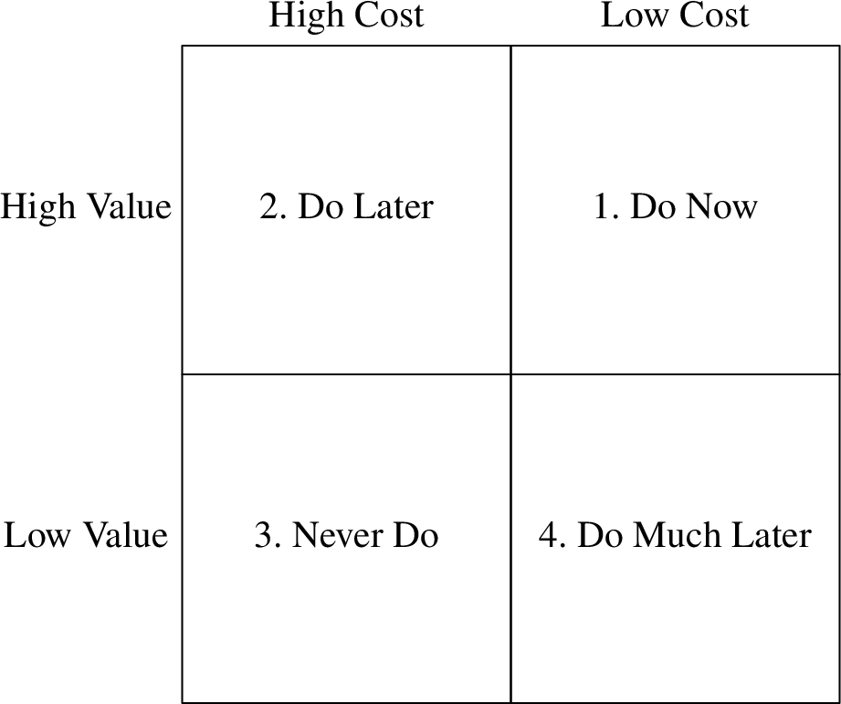

The Four-Quadrant Game

1. Valuable, but cheap: those stories should be done right away.
2. Valuable, but expensive: those stories should be done later on.
3. Not valuable, but expensive: don’t do this stories, discard them.
4. Not valuable, but cheap: consider doing those stories (much) later.

At the midpoint of the iteration, half of the story points should be done. If less are done, which is to expect from the first iteration, the iteration is *not* a failure, because it generates valuable data. The first half of the iteration is a good prediction for its second half in terms of velocity, like today’s weather is the best predictor for tomorrow’s weather. Likewise, the current iteration’s velocity is also a good predictor for next iterations’s velocity.

The project ends if no more stories worth implementing in terms of their ROI can be gathered for another iteration.

### 3.1.3 INVEST Stories

User stories do not describe features in detail, they are rather a reminder of features. The acronym INVEST stands for simple guidelines to be followed when writing stories:

* **I**: *Independent*. User stories don’t have to be implemented in a particular order, because they are independent of each other. Even though dependencies cannot be avoided sometimes, they should be kept at a minimum, so that stories can be implemented in the order of their business value.
* **N**: *Negotiable*. User stories should leave space for negotiations between business and development. Those negotiations can help to keep the cost low by agreeing on simple features and easy implementations.
* **V**: *Valuable*. User stories must create clear and quantifiable value to the business. Soft quantifications like high/medium/low are fine, as long as stories can be compared in terms of their business value. Such stories usually cut through all layers: from frontend over backend to the database and middleware. Architecture, refactoring, and cleanup tasks are not user stories!
* **E**: *Estimable*. User stories must be concrete enough in order to be estimated by the developers. However, stories must still be negotiable, so aim for the sweet spot between specificy and vagueness by being precise about the business value while leaving out implementation details.
* **S**: *Small*. User stories should be small enough so that they can be implemented by one or two developers within a single iteration. A good rule of thumb is to pick roughly the same number of stories for an iteration as there are developers on the team.
* **T**: *Testable*. User stories should be accompanied by tests specified by the business. A story is complete when all of its tests pass. Tests are usually written by QA and automated by the developers. Specifying the tests can happen later than the actual story is written.

### 3.1.4 Story Estimation

There are different ways to estimate user stories. *Flying Fingers* is the simplest: After reading and discussing a story, developers hold up the amount of fingers corresponding to their estimation of story points. They do so behind their backs, and all hands are shown on the count of three.

*Planning Poker* is a similar approch based on numbered cards denoting story points. Some decks use a Fibonacci series (1, 2, 3, 5, 8), sometimes with additional indications: infinity (∞) for stories too big for estimation, a question mark (?) if there’s not enough information available to estimate a story, and zero (0) if the story is too trivial for estimation.

As fingers or cards are revealed, there might be a consensus, in which case the common number is written on the index card. If there is a big deviation, those differences are being discussed, followed by another round of estimation, until a consensus can be reached.

Stories too trivial for estimation (0) can be combined by stapling those index cards together. Here, multiple zeros can indeed add up to something more than zero. Stories too big (∞) can be split up as long they comply to the INVEST guidelines.

Stories too unclear for estimation (?) often require additional research. A meta-story—a so-called *spike*, cutting a very thin slice through the sytem—is created and referred to as a dependency of the original, unclear story.

### 3.1.5 Iteration and Release

An iteration produces data by getting stories done. The focus should be on finishing entire stories rather than tasks within stories: better 80% of stories completely done than 80% of the tasks for each story done. Stories are not assigned to programmers, but picked individually or by negotiating within the developer team. Experienced programmers should guide rookies away from picking up too many or too heavy stories.

QA should start writing the acceptance tests right after the IPM, so that they are finished up to the midpoint of the iteration. Developers can help in the process, but not the same developer should be responsible for implementing a story and writing the acceptance tests for it. However, QA and developers should work closely together on the acceptance tests. A story is done when all of its acceptance tests pass.

At the end of every iteration, a demo is given to the stakeholders. The newly added features and passing acceptance tests—both old and new—should be shown. After the demo, velocity and burn-down charts are updated. Noisy at the beginning, the velocity will average out after a few iterations.

A rising velocity can hint to story point inflation: as pressure is put on the development team to get more done, developers start assigning more points to their stories. Velocity is a measurement and not an objective; don’t put pressure on something you measure!

A falling velocity likely points to bad code quality, dragging further development down. If too few unit tests are written, developers become hesitant refactoring the code. As pressure builds up, developers will be tempted to inflate story points. Keep in mind the Golden Story of the initial iteration to countersteer.

Release as often as possible. The goal of continuous delivery is to release to production after every change. Historically, those cycles were long because of long technical turnover times (testing, checking out code). With modern source code management systems, working with optimistic locks, checkout time approaches zero, and Continuous Delivery becomes possible. Old organizations must adjust their processes accordingly to overcome their inertia, which requires cultural change.

## 3.2 Acceptance Tests

*Acceptance Tests* are based on the idea that requirements should be specified by the business. The word “specify” has different meanings, depending on who’s using it: business wants to keep the specification somewhat vague in natural language, whereas programmers prefer a specification as precise as needed for a machine to execute it.

The solution to this conflict is that business specifies a test in a natural language, but using a formal structure like *Given, When, Then* (as used in *Behaviour-Driven Development*, BDD). Developers then implement those tests using their programming language. Those tests become the “Definition of Done” for the user story.

* A story is not specified until its acceptance tests are written.
* A story is not completed until its acceptance tests pass.

Business people usually define the “happy path”, which shows that the system produces the intended value. QA extends those tests with the “unhappy paths”, because they are good at finding corner cases and ways a user might break the system.

QA no longer is the bottleneck at the end of the iteration, but deeply involved from the beginning. Finding lots of bugs at the end of the iteration is no longer considered proof of QA doing its job properly. Instead, QA supplies test specifications to development, and development makes sure that those tests all pass. This process of running the tests should be automated, of course.

## 3.3 Whole Team

The *Whole Team* practice used to be called *On-Site Customer*. It is based on the idea that reducing physical distance improves communication. “Customer” is meant in a broad sense: it can describe a stakeholder of a project or a Scrum Product Owner.

Having the whole project team sitting in the same room not only makes communication more efficient, it also creates serendipity: People in different roles will get together by mere chance (watercooler, coffee machine). Hopefully, those unplanned interactions create synergy within the team.

The advantages of co-location—better communication, serendipity—fall off in outsourcing settings. As the distance—physical, cultural, in terms of language, and time zone—becomes bigger, communication tends to get worse. Technology has improved, however, and working remotely works quite well nowadays, especially if there’s only a gap in space, but none in terms of culture, language, and time zone. Serendipituous conversation and nonverbal communication, however, are significantly reduced in a remote setting.

# 4 Team Practices

Agile’s Team Practices are all about the relationships of the individual team members to one another and with the product they are building. Those are *Metaphor*, *Sustainable Pace*, *Collective Ownership*, and *Continuous Integration*.

## 4.1 Metaphor

Effective communication within a team requires a common language, including a well-defined vocabulary of terms and concepts. Using metaphors, e.g. comparing a multi-step process with an assembly line, can improve communication both within the team and with the customer. Silly and bad metaphors, on the other side, can be embarassing or even insulting towards the stakeholders.

The term *Ubiquitous Language*, coined by Eric Evans in his book *Domain-Driven Design*, very well defines what a team needs: a model of the problem domain, described by a commonly accepted vocabulary, i.e. by programmers, QA, managers, customers, users—everyone involved with the project.

## 4.2 Sustainable Pace

Working long hours can make programmers feel proud of themselves. They are valuable and needed, after all, and sometimes a project is saved by working overtime. Unfortunately, this well intended dedication can lead to burnout, with long-term negative effects for both programmer and employer.

Judgement is often impeded when working late at night after a full working day; often grave mistakes are made and bad decisions are taken at that point.

A software project is more like a marathon than a sprint or a series of sprints, and therefor must be approached at a sustainable pace. If there’s spare energy just before the finish line, it’s ok to sprint for this last stretch.

Developers must not comply when asked by the management to go faster. Working a lot of overtime is not a demonstration of dedication to the employer, but a consequence of bad planning, and often the result of manipulable developers being coerced into agreeing on unrealistic deadlines.

Programmers should figure out how many hours of sleep they need, and make it a priority to consistently get that amount of sleep.

## 4.3 Collective Ownership

In an Agile project, code is not owned by individuals, but collectively, i.e. by the team as a whole. Even though specialization is allowed and becomes a necessity as the system grows, the ability to work outside of one’s speciality must be maintained.

The need for generalization in a system grows with its code base. But generalization can only be achieved by developers seeing the big picture. With Collective Ownership, knowledge is distributed across the team, which then becomes better at communicating and making decisions.

Teams practicing individual code ownership with strong barriers to modifying or even reading other’s code often become dysfunctional. Finger pointing and miscommunication become rampant in such teams. Code solving the same problem is written multiple times rather than shared.

## 4.4 Continuous Integration

The practice of *Continuous Integration* initially consisted of checking in source code and merging it with the main line every couple of hours. Feature toggles are used to hide changes that were already deployed, but should not be active yet. Later, the introduction of *Continuous Build* tools, which run all the tests automatically as code is check in, shortened this cycle to minutes.

Programmers should run all the tests locally before checkin in code, so that the continuous build never breaks. If the build breaks nonetheless, it’s the highest priority for the entire team to get it running and the tests passing again. Once discipline slips and the build is left in a broken state, the team very unlikely will make the effort to “catch up later”. As a consequence, broken systems will be deployed sooner or later.

## 4.5 Standup Meetings

The *Standup Meeting* or *Daily Scrum* is optional. It can be held less often than daily, at whatever schedule it fits the team best. The meeting should take roughly ten minutes, no matter how big the team is.

The team members stand in a circle and answer the following questions:

1. What did I do since the last meeting?
2. What will I do until the next meeting?
3. What is in my way?

No discussions are held, no explanations are given, no complaints are made. Every developer gets half a minute. If people other than developers take part, they either should only listen or talk according to the same rules as the developers.

*The Chicken and the Pig* is a fable that demonstrates why non-developers—the chickens, making a small sacrifice to provide eggs—and developers—the pigs, sacrificing their life to provide meat—should not have the same weight in making decisions about the (menu) plan.

# 5 Technical Practices

The technical practices of Agile reach deep into the programmer’s behaviour when writing code, by adding a set of rituals considered absurd by many programmers. Those practices at the very core of Agile are: *Test-Driven Development*, *Refactoring*, *Simple Design*, and *Pair Programming*.

## 5.1 Test-Driven Development

Programming is a lot like accounting: a single little mistake can have huge negative consequences. Therefor, accountants developed *double-entry bookkeeping*, which requires every transaction being entered twice into the book: once on the credit side, and once on the debit side. The sums of each account from both sides are collected in the balance sheet. The differences of the credit and debit side must amount to zero, otherwise a mistake has been made. Such mistakes can be detected quickly, if the transactions are entered one at a time, and the difference of both sides is checked to remain zero after every entered transaction.

*Test-Driven Development* (TDD) is the corresponding technique for programming. Every required behaviour of the program is entered twice: once as test code, and once as production code. Behaviours are added one by one: first as a (yet failing) test, second as working production code making that test pass. As in accounting, a result of zero is to be achieved: zero failing tests. Like this, mistakes can be caught as they’d enter the code base—and be avoided in time. Unlike double-entry bookkeeping, TDD is not (yet?) required by law.

TDD can be described with the following three simple rules:

1. Do not write production code until you have test code failing due to the lack of that very production code.
2. Do not write more test code than needed to fail the test—with compiler errors counting as failing.
3. Do not write more production code than needed to make the test pass.

When sticking to those rules, programmers oscillate between test and production code at a rate of just a few seconds. What looks like a distraction at the beginning will ensure that everything works—or at least worked just a minute ago. The code that introduced the error is easy to detect: it must be among the few lines that just have been written.

Some programmers are very good at working with debuggers, because they’ve spent a lot of time debugging. You only need to debug a lot, if you have a lot of bugs. With TDD, less bugs are introduced, so it’s ok for developers sticking to the discipline of TDD to be bad at operating debuggers. (Debugging is still required now and then, but much less often.)

A comprehensive test suite is the best kind of documentation for programmers: working, self-contained, small code examples.

Writing tests after the fact for code that already has been tested manually feels like boring busy work. It’s more fun to test and program according to the three rules of TDD. Code having been written under the rules of TDD is designed for testability. Writing tests for production code not designed for testability is hard—and therefor likely to be left away. This leaves holes in the test suite, and a passing test suite can no longer be trusted. However, a good test suite that passes should be the go ahead for deployment.

Though desirable, a high test coverage of, say, 90% and above, is not a metric for management, but for the development team. It requires a strong understanding of the code base in order to interpret the test coverage metric in a meaningful way. Enforcing high test coverage by the means of builds failing for a coverage deemed too low is counterproductive, because it incentivises programmers to write bogus tests without meaningful assertions.

The ultimate goal of TDD is *courage*, not coverage: Programmers with trust in their test suite fearlessly modify and improve existing code. Developers lacking that kind of trust will shy away from cleaning up messy code; the code begins to rot. If the code becomes unmaintainable, further development becomes harder and, ultimately, comes to a halt. TDD, on the other hand, keeps the code orderly and gives the programmers confidence for further development.

## 5.2 Refactoring

*Refactoring* is the practice of improving the structure of the code without changing its behaviour. This behaviour is defined by the test cases, which must still pass after the code has been refactored.

The practice of Refactoring is strongly coupled to the practice of TDD. A good test suite is required so that the code can be refactored fearlessly. The third rule of TDD states that one must not write more production code than needed in order to pass the test. Improving that very code, however, is allowed—and strongly encouraged.

The process of Refactoring is described in the *Red/Green/Refactor* cycle:

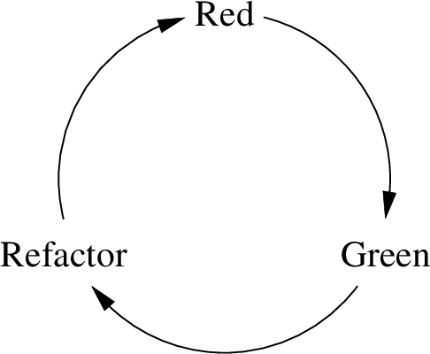

The Red/Green/Refactor Cycle

1. *Red*: Write a failing test.
2. *Green*: Write as much production code as needed to pass the test.
3. *Refactor*: Clean up that code without breaking any tests.

Writing code that works is hard enough, and so is writing code that is clean. Therefore, those two goals—*working* code and *clean* code—are best achieved in two separate steps.

The changes done to the code during the Refactoring step can range from trivial cosmetics to deep restructurings, e.g.:

* changing the names of variables, functions, classes, etc.
* rewriting switch statements in terms of multiple classes with polymorphic dispatch
* splitting up big functions or classes into multiple smaller ones
* moving code around, e.g. into other functions, classes, or components

Martin Fowler describes such techniques and the entire process in his book *Refactoring: Improving the Design of Existing Code* (Second Edition 2018, First Edition 2000) in much more detail.

Refactoring is an ongoing process, and not something to be put on a schedule once the mess made of the code becomes unbearable. With continuous Refactoring, no big mess is ever made.

There are requirements that make it necessary to change the design and structure of the code to a very large extent. In this case, bigger Refactorings must be applied to the code base. Even though such Refactorings stretch over long periods, they still should be approached using the continuous approach, with all tests passing througout the entire process.

## 5.3 Simple Design

The practice of *Simple Design* aims to write only the code required, and its structure being as simple, small, and expressive as possible. Kent Beck has four rules to achieve this goal:

1. *Pass all the tests.* The code must work as intended, of course.
2. *Reveal the intent.* The code must be expressive, i.e. easy to read and self-descriptive. Splitting up code into smaller units and applying cosmetic refactorings helps in this respect.
3. *Remove duplication.* The code should not say the same thing more than once. Grouping common code into new functions and calling them from that code’s original place is a simple way to do this. Other situations require more sophisticated solutions, such as the *Strategy* or the *Decorator* design patterns.
4. *Decrease elements.* The code must be freed from any superfluous structural elements like classes, functions, variables, etc.

Complex design puts the programmer under high cognitive load—the *Design Weight*. A system with a high Design Weight takes more effort to understand and to manipulate. Likewise, requirements with high complexity make it harder to understand and manipulate the system.

However, a more elaborate design can help to handle more complex requirements, so a tradeoff between complexity in requirements and appropriate design must be found in order to achieve the goal of simple design.

## 5.4 Pair Programming

The practice of *Pair Programming* or *Pairing* is the act of two programmers working together on a single programming problem by sharing their keyboard and screen—physically by sitting at the same desk, or virtually using screen sharing software.

Pairing is optional and intermittent: Some of the time you pair, then you program alone again. Whether or not to pair is an individual and team decision—not the manager’s!

The two programmers can take on different roles when pairing: one is the *driver* with keyboard and mouse, following the directions of the *navigator*, giving recommendations and hints. The technique *Ping-Pong* consists of one programmer writing a test, and the other programmer making it pass. Those roles can be switched frequently.

Pairing is neither mandated nor scheduled, but done spontaneously. Pairs are short-lived and dissolve after a session of 30 minutes up to a full working day.

The ultimate goal of pairing is sharing knowledge. This is achieved especially if seniors pair up with juniors. At first glance, pairing looks inefficient and costly: certainly, two programmers behind a single screen and keyboard cannot write as much code as if they’d have their own workstation. However, pairing not only distributes knowledge, it also reduces errors, improves the design, and strengthens collaboration within the team. In general, managers like to see their people collaborating and sharing knowledge, and won’t complain about pairing.

Pairing is not only useful for writing new, but also for reviewing existing code. It’s also not strictly limited to two programmers, but called “mob programming” when done by three or more individuals.

As with testing, refactoring, and designing, *do not ask for permission* to pair. This is the programmer’s domain, and the programmer is the expert.

To sum up: The technical practices introduced in ths chapter are at the very core of Agile. With Agile, it’s possible to make a big mess in a hurry, if you ignore these technical practices.

# 6 Becoming Agile

Even though becoming Agile looks easy—it’s just a couple of disciplines and practices, after all—many organizations fail at it. The reason for this could be that those organizations trying to adopt Agile have misconceptions about what becoming Agile actually means.

## 6.1 Agile Values

Kent Beck named the following four values that are at the very core of Agile:

1. *Courage*: Agile teams don’t sacrifice quality and opportunity in exchange for political safety. It takes courage to maintain high code quality and to stay disciplined. However, deploying code without confidence in its quality and design is reckless, which is not the same as being courageous.
2. *Communication*: Agile teams value communication—not only within their team, but also with stakeholders on the outside. Informal communication is especially useful, for it helps teams to grow together and strengthens the relationship to the stakeholders.
3. *Feedback*: The Agile practices and disciplines have one common benefit: they provide rapid feedback. This helps to detect when things go wrong early on, so that there’s still space for corrections. This feedback also confronts the team with the consequences of decisions made earlier.
4. *Simplicity*: Being simple is being *direct*. Software problems are often solved by introducing additional layers of indirection. Agile values reduce the amount of problems to be solved, so less indirection is needed. Indirection in communication—passive aggression or grudgingly acceding to unreasonable demands instead of openly opposing them—just postpones conflicts to a later date. Reduce indirection in the code to a sustainable level, but eliminate indirection in personal communication completely.

When adopting Agile, don’t spend a lot of time evaluating different frameworks like XP or Scrum. At the end, you’ll tweak the framework in a way best fitting your organization’s needs.

Adopt the Circle of Life, especially the technical practices in the innermost circle. Without those, the code will degrade, and the Agile practices in the two outer rings will make a mess of everything very quickly.

## 6.2 Transformation

The values of large organizations—safety, consistency, command-and-control, plan execution—are diametrically opposed to the values of Agile. Therefore, a transition to Agile is a transition in values.

Such change is usually opposed the most by the middle-management layer, which is trained to avoid risks and direct communication. Middle management is a layer of indirection, after all—exactly what is to be avoided in Agile. Executives, on the other side, are risk takers that constantly seek out new opportunities, and therefore tend to be supportive of Agile transformations.

Employees in special roles, such as tech leads, architects, or project managers, also tend to oppose Agile transformations, for they see their roles diminished in an Agile team. Actually, their skills and experience are especially needed in Agile teams.

It is also possible for a development team to internally make the transition to Agile while still conforming to the process imposed by middle management towards the outside. Instead of arguing against writing analysis and design documents, those artifacts are just created during the first couple of sprints as a by-product of the code that already has been written. Analysis and design are done for every story, after all, especially in early stories.

Even though this “faking it” can be considered dishonest, nobody will complain if it yields good results. The team just acts for the greater good of the company, as opposed to just complying to the demands of middle management.

If the transition to Agile values only happens for a few individuals within a team, those employees tend to leave the team or the organization sooner or later, seeking out new opportunities better in alignment to their freshly acquired mindset.

Large organizations usually don’t adopt Agile as a whole entity, but create new, smaller organizations based on Agile values. Eventually, those new companies become bigger and grow out of the parent company, as the former thrives with Agile and the latter stagnates with its old ways.

## 6.3 Coaching

An *Agile Trainer* conducts the initial training with the team and inculcates Agile values. Agile trainers are usually hired from the outside for a short tenure, i.e. for a couple of weeks.

The role of an *Agile Coach*, on the other hand, should be filled from someone within the team, even though an Agile trainer from the outside could initially take that role during a short transition period.

The coach makes sure that the team sticks to the Agile way, acting as the team’s consience. The role of the coach can be re-assigned to other team-members frequently, as long as it is taken seriously.

The coach is not a manager and also not responsible for planning and budget. Neither do customers nor managers need to know who the coach is, for that role is strictly internal to the team.

In Scrum, such a coach is called a *Scrum Master*. Since many project managers have taken the training and certification to become a Scrum Master, that role is often conflated with the role of the project manager.

Even though the trainings that lead to such certificates are useful, the certificate itself proofs next to nothing, i.e. only that the certification fee has been paid. If formal training is given, not only a single person should receive it, but the entire team.

### 6.3.1 Coaching—An Alternative View (by Damon Poole)

A big part of coaching is to ask questions. Agile training needs to take the learner’s unique circumstances into account. Embracing Agile requires a shift in thinking. To overcome that hurdle, one needs to be shown “what’s in for me”. Coaching is not so much offering expertise, but rather pointing out how Agile can help to overcome challenges and solve problems.

Coaching is not prescribing a solution, but to discover blind spots and to bring the underlying beliefs that stand in the way to the surface.

An Agile transformation should be conducted in an Agile way, and not as a project with a clear goal, executed in a top-down manner.

## 6.4 Agile in the Large

Agile was intended for small teams of 4 to 12 developers, not for big ones. However, it was soon tried to adopt Agile for multiple teams and large organizations. First using a technique called *Scrum of Scrums*, later with frameworks like *SAFe* (Scaled Agile Framework) and *LeSS* (Large Scale Scrum).

The problem of managing big teams is as old as civilization and has been solved already rather well. (If this weren’t the case, no pyramids would have been built.) The problem of organizing small teams that develop software, however, is rather new. Software is unique and requires a special set of disciplines. Agile was brought up to solve that particular problem of software development. It therefore isn’t suitable for managing other endeavours, such as construction or hardware manufacturing.

The problem of managing big software teams is just a matter of organizing them into smaller teams. The former is a standard management technique, i.e. a problem solved, the latter is done using Agile. Software organizations have very diverse teams, such as development, QA, marketing, research, etc. But even the problem of organizing very diverse teams has been solved long ago by many civilizations time and again, just think of organizing a big army.

## 6.5 Agile Tools (by Tim Ottinger and Jeff Langr)

Carpenters first learn to master hand tools—hammer, measure, saw—before they move on to power tools—drill, nail gun, CAD. However, they never abandon their hand tools entirely, but always pick the appropriate tool for every job: simple task, simple tool.

Mastery of every item in the toolbox allows us to focus on the problem at hand, as opposed to the tool that is in our hand: Through mastery, the tool becomes *transparent*. Without mastery, tools can become an impediment and even do harm to our project.

Software developers use a lot of different tools (editors, compilers, version control, etc.), so it is unfeasible to master each and every tool. Therefor, only the tools should be picked that offer the most value for the least learning effort.

Tools for the same purpose (e.g. version control) are replaced by better ones now and then, like CVS was replaced by Git in recent years. If you learn a tool like Git well enough—the 80/20 rule applies (20% of the effort gives you 80% of the benefit), such a tool becomes transparent, so that you can focus on the task instead of the tool.

Better tools can influence and improve the way we’re working. Git, for example, with its support for fast and cheap branching, allows for new workflows, such as test && commit || revert: the tool is *exapted*, i.e. used in a way the creator of the tool hadn’t intended.

Great tools do the following:

* Help people accomplish their objectives
* Can be learned “well enough” quickly
* Become transparent to users
* Allow adaptation and exaptation
* Are affordable

For co-located Agile teams, simple physical tools like sticky notes, tape and a whiteboard often do the job. However, they fail for remote teams and don’t automatically retain a history of the project.

In IT, the tempation to use powerful software tools is always there. Before adopting such powerful tools, make sure that you really can handle the process. The tool you introduce must support your specific process. Shape the tools to your needs, not the other way around.

Complicated tools for Agile Lifecycle Management (ALM) require constant attention and upfront training. They usually can only be changed in the ways their vendors intended—if at all. ALM tools usually are expensive and require maintenance and administration. Such tools never become transparent, and therefore don’t help the developers doing their work. Instead, those tools offer powerful performance charts and statistics, which can be used as a weapon against programmers to shame them into working harder, because the tool suggests so. ALM tools should not replace or even stand in the way of personal, informal interactions. When in doubt, start with a simple tool, and consider switching to a more powerful one later if needed.

# 7 Craftsmanship (by Sandro Mancuso)

Agile was quickly adopted, but its original idea also got distorted as a mere process to deliver software faster. Instead of working autonomously, the developers were micro-managed again, with the transparency provided by Agile used against them.

Managers defined roadmaps and milestones, and the developers were coerced into making their estimates accordingly. One top-priority story after the other had to be done in a hurry, ignoring the technical practices in the process. This was the *Agile Hangover*: The divide between business and development that Agile was supposed to heal came back even stronger.

Agile training only consisted of business- and team-facing practices, as if better communication and collaboration alone would make developers more skilled. It takes a large set of technical skills to release software in short cycles while keeping up the quality of the code base in the process. Experimentation and self-learning are not enough, but must be combined with coaching and training.

## 7.1 The Software Craftsmanship Manifesto

Developers and Agile moved apart over the years, so a new movement attempted to bring them back together in 2008: *Software Craftsmanship*, with its new [manifesto](https://manifesto.softwarecraftsmanship.org/) built on top of the Agile manifesto:

As aspiring Software Craftsmen, we are raising the bar of professional software development by practicing it and helping others learn the craft. Through this work we have to come to value:

* Not only working software, but also **well-crafted software**
* Not only responding to change, but also **steadily adding value**
* Not only individuals and interactions, but also a **community of professionals**
* Not only customer collaboration, but also **productive partnerships**

That is, in pursuit of the items on the left we have found the items on the right to be indispensable.

This is a developers’ movement, and *Craftspeople*, as they call themselves, don’t want it to be hijacked again.

## 7.2 Ideologies and Methodologies

Ideologies are systems of ideas and define ideals to aim at. Methodologies are systems of methods and practices, which can be used to reach those ideals. Agile is an ideology, its goal is to provide business agility and customer satisfaction. Scrum and XP, among others, are methodologies for reaching those goals.

Methodologies are like training wheels: useful to get started, they soon become a hindrance to further advancement. Too much focus on methods and practices distracts teams and organizations from reaching their goals. Still, practices are important, because professionals are defined by the way they work, i.e. by their practices.

Unlike methodologies such as Scrum and XP, Software Craftsmanship does not focus on a fixed set of practices, but rather promotes a perpetual search for better ones. However, since its inception in 2008, the Software Craftsmanship community considers XP to povide the best set of practices. When discussing (better) practices, it’s essential to first agree on the goals to be achieved by them, and only then to look at specific practices as ways to reach them.

The members of the Software Craftsmanship movement don’t see programming just as a job, but as their profession, which isn’t just a way to get a regular paycheck, but a part of their identity: Craftspeople do not just *work as* programmers, they *are* programmers. Therefore, they invest in their careers, which doesn’t mean that they not also maintain a private life beyond their profession.

Agile and Software Craftsmanship share the same goals. Combined, they are the perfect way to reach them.