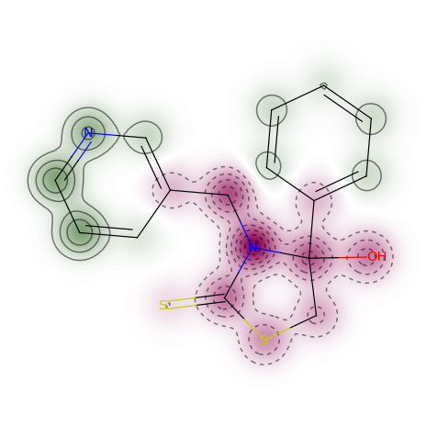

Biomedical Engineering Chemical Toolkit Version 1.0

Installation Requirements:
python
anaconda

https://www.rdkit.org/docs/Install.html

------------------------------------------------------
To run Target prediction: open toxpredict.ipynb in jupyter notebook. Cd into the directory with all the .pkl files and type jupyter notebook into the command line. Then open toxpredict.ipynb. Change the smiles to the molecule you want to test. smile=”your smiles here” You can also supply a SDF file of no more than 100 smiles (must use SDFS of batch size 100). See rdkit Documentation at https://www.rdkit.org/docs/GettingStartedInPython.html

Validation.xlsx contains the sensitivity and specificity for each pickled model.
Independenttest.xlsx contains a list of marketed drugs used to independently validate the models.

The smiles used to train each model are contained in the folder Training.

-----------------------------------------------------------

Interpreting output: For the molecule above, the green represents a positive region for the molecule, the red represents a negative region of the molecule for a tested property, and gray represents no detection. For more on this method please read Similarity maps-- a visualization strategy for molecular fingerprints and machine learning methods.

After running the toxpredict.ipynb check the output folder for .png images of your given compound. There should also be a file called compound1.txt that will contained the ranked probabilities for each of the tests. Only consider probabilities above 50 percent as positive for a given target. The images in this folder will contain the predictions for all models regardless of if they are positive or negative, so be sure to find the positive ones.

Creating Your own models:

If you want to create your own models, run ai.py on some pubchem bioassays (over 1 million available).
https://pubchem.ncbi.nlm.nih.gov/#query=interferon&tab=assay
Also see chembl bioassays
These assays must be saved as .txt files with two columns the first for the smiles and the next column for either 1 or zero (active and inactive respectively). Copy ai.py into the directory with the text files for the assays. The text file names should contain the name of the assay. Then type python ai.py >> statistics.txt for an output of the confusion matrices for each model. Open statistics.txt to see the output for each model. You want a model with both good sensitivity and specificity (as close to one as possible). It’s important to note that a model can appear highly accurate but if sensitivity is zero, then the model does not detect positives. The confusion matrices are set up as follows:

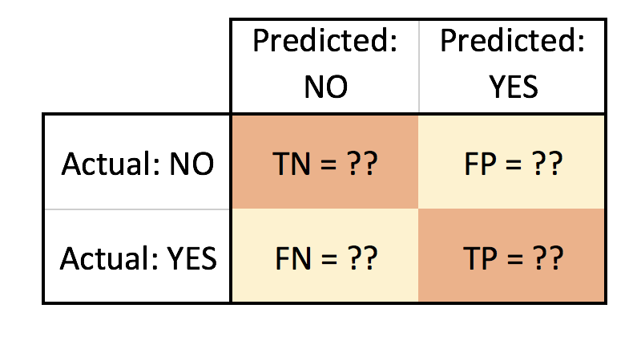

It’s important to note that column 1, row 1 is NOT true positive as you might expect from stats class. Sensitive models will not have 0 in the bottom right corner. If you are not getting good sensitivity and specificity, then you may want to change the penalty C=500000 to some other value. By default the SVC is set up to use a RBF best fit but this can be changed as per the scikit learn documentation. The output files will be saved as .pkl files that can later be loaded for future use.

Pan Assay Interference

See

Seven Year Itch: Pan-Assay Interference Compounds (PAINS) in 2017—Utility and Limitations

New Substructure Filters for Removal of Pan Assay Interference Compounds (PAINS) from Screening Libraries and for Their Exclusion in Bioassays
Pan Assay Interference Compounds commonly result in false positives in biological screening assays. Since they bind everything, they are not selective and therefore do not make good drug targets. We found that the higher the drug score in Data Warrior http://www.openmolecules.org/datawarrior/
the lower the frequency of compounds containing PAINS. Using data warrior’s evolutionary algorithm (be sure to use the wand tool if you want to fix the scaffold), evolve a few runs by taking the compounds with the top drug scores (macro → run macro → calculate properties) by taking the top 5 scoring compounds as starting points for evolution until you get drug scores greater than .9. Select based on skelsphere similarity and the algorithm will generate a large number of compounds that have high drug scores, which are oftentimes painless.

The program NIH.py uses the rdkit NIH filter to find PAINFUL compounds and will tell you what functional groups for each compound were responsible for a positive PAINFUL test result.
To use NIH.py, edit the line

inf=open('s7.smi','r')
to whatever .smi file name you want to test. Then just use the command line python NIH.py. The program also tells you the fraction of SP3 hybridzied carbons. Compounds with scores > .47 are more selective binders. Note that double bonds reduce the fraction of sp3 hybridization, as they make the compound more flat. See Escape from flatland: increasing saturation as an approach to improving clinical success. Then run the program by typing python NIH.py >> myresults.txt. Myresults.txt will contain the output. Make sure that the smiles are in the same directory as the script.
PAINS are defined as follows:
* NIH - annotated compounds with problematic functional groups Reference: Doveston R, et al. A
Unified Lead-oriented Synthesis of over Fifty Molecular Scaffolds.
Org Biomol Chem 13 (2014) 859Ð65. doi:10.1039/C4OB02287D.

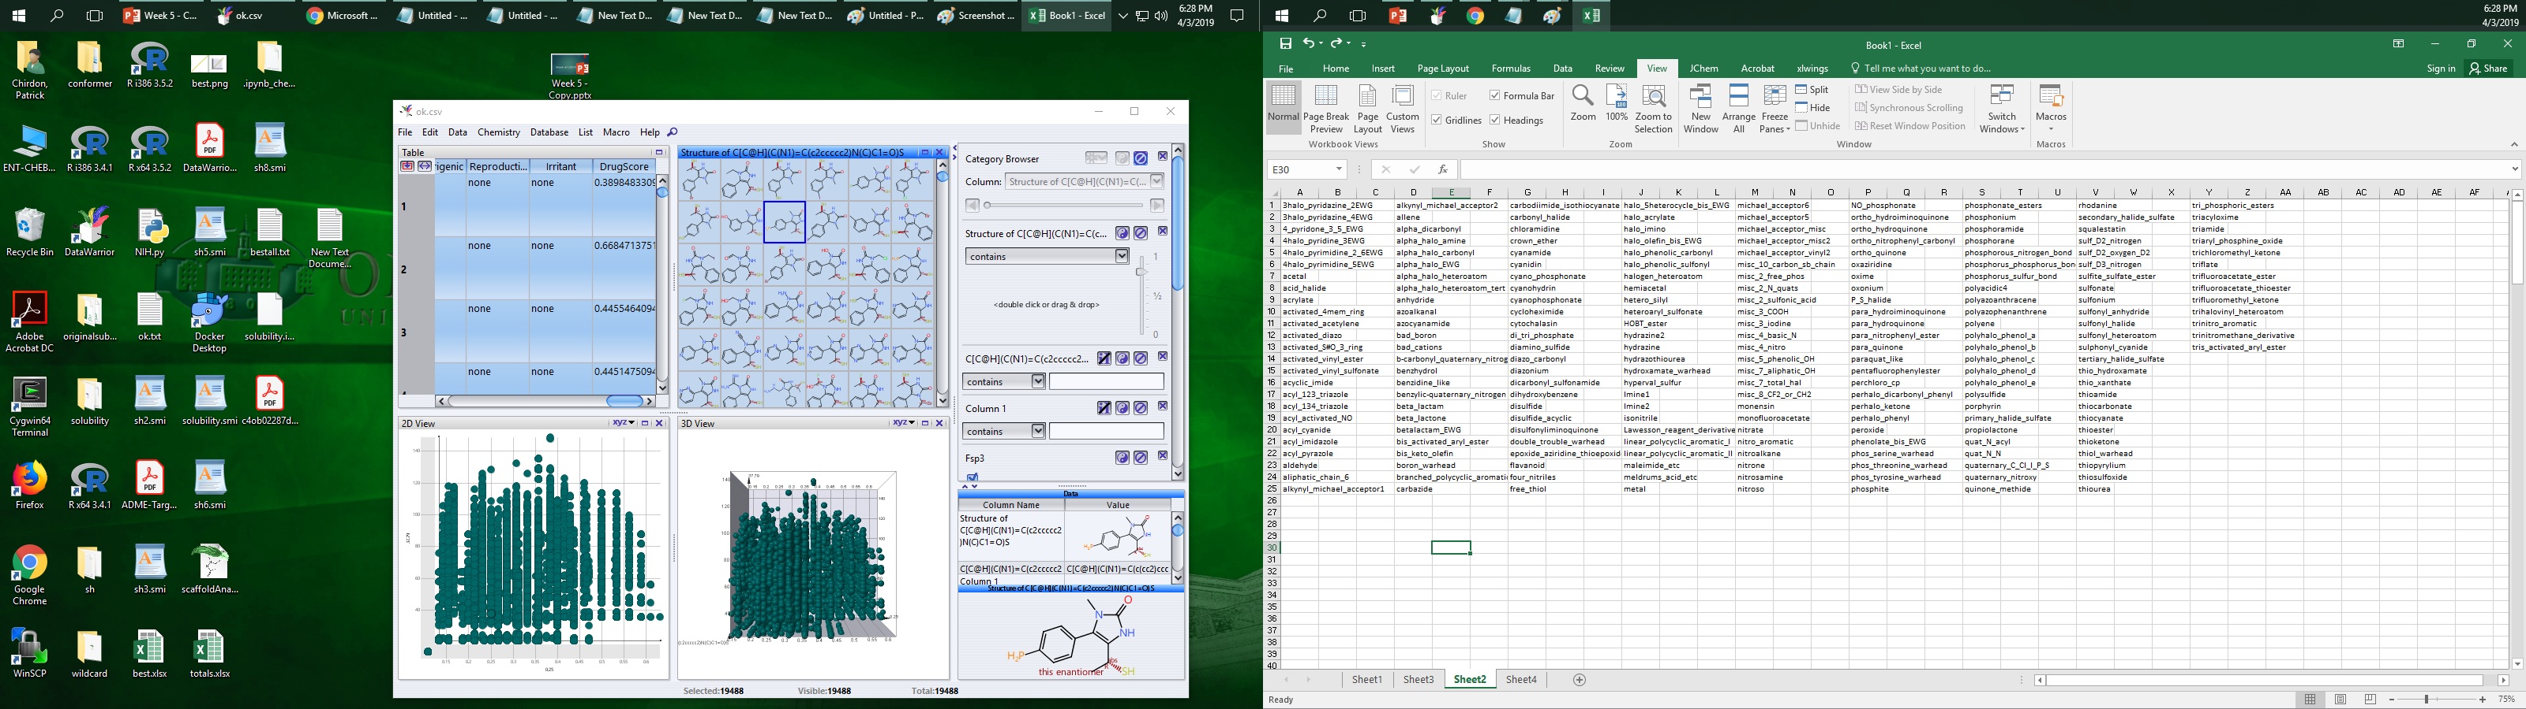

Reference: Jadhav A, et al. Quantitative Analyses of Aggregation, Autofluorescence,
and Reactivity Artifacts in a Screen for Inhibitors of a Thiol Protease.
J Med Chem 53 (2009) 37Ð51. doi:10.1021/jm901070c

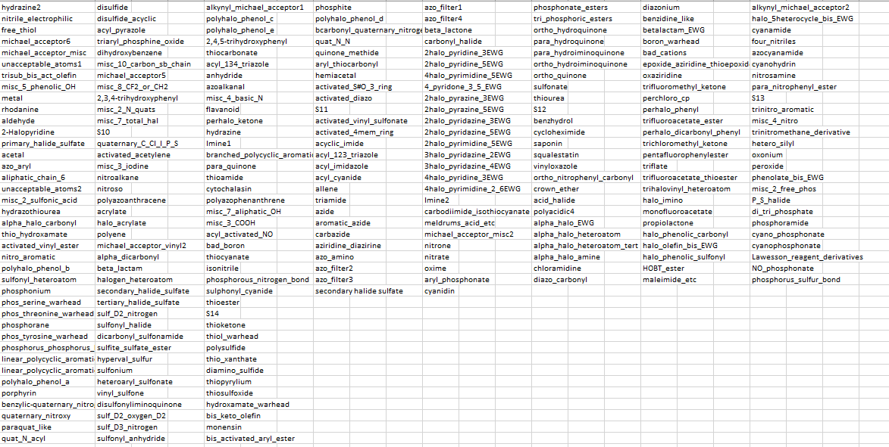

Reference: Jadhav A, et al. Quantitative Analyses of Aggregation, Autofluorescence,
and Reactivity Artifacts in a Screen for Inhibitors of a Thiol Protease.
J Med Chem 53 (2009) 37Ð51. doi:10.1021/jm901070c

Fragmenter.py

Change the line open("top500pocket3.smi") to the name of whatever smiles file you want to screen. After running the compounds through a docking program like Rosetta, place the lowest scoring binders in a .smi file and change the line above. Type python fragmenter.py >> newcompounds.txt
(make sure that the smiles are in the same directory as the script). Newcompounds.txt will contain smiles that can be opened with data warrior and converted into 3d conformers for docking within data warrior. Oftentimes, there will be some compounds that bind with lower energy than the original.

solubilitypredict.py

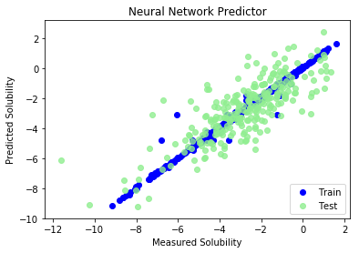

Solubility defined as log S at 25 degrees
C > -4. 74% of FDA approved compounds
Have solubility > -4

