**Patrick Ian E. Cura**

**2154687**

**Programming 3 – Assignment 1 – Task 2 – Threads**

**Description of the chosen scenario**

The chosen scenario is a Pizza Store. There is a Pizza Making Machine that accepts orders either a Mushroom Pizza or an Anchovy Pizza from customers. The Pizza Making Machine also processes requests to replenish the supplies/ingredients to make the pizzas. Each of the ingredients have a storage limit. So once the storage limit for a particular ingredient is met, that ingredient cannot be replenished until the ingredient’s current amount is less than the storage limit.

The ingredients are as follows:

|  |  |
| --- | --- |
| **Ingredient** | **Storage Limit** |
| Garlic | 6 |
| Olives | 8 |
| Mushrooms | 10 |
| Anchovies | 6 |

It should also be noted that a particular pizza has a recipe and requires certain number of ingredients in order to be made. The recipes are as follows:

|  |  |
| --- | --- |
| **Mushroom Pizza** | |
| **Ingredient** | **Number Required** |
| Garlic | 1 |
| Olives | 0 |
| Mushrooms | 4 |
| Anchovies | 0 |

|  |  |
| --- | --- |
| **Anchovy Pizza** | |
| **Ingredient** | **Number Required** |
| Garlic | 2 |
| Olives | 2 |
| Mushrooms | 0 |
| Anchovies | 3 |

If the number of ingredients required to make a pizza is not met, the pizza cannot be made and the creation of other pizzas will have to wait.

**Name of the classes, methods, and objects that exists in the program**

The main program is named Main.java. It has two types of Runnable objects that are run: ReplenishSuppliesRunnable and OrderRunnable.

ReplenishSuppliesRunnable can take ingredient names and it will replenish that ingredient’s supplies in the Pizza Making Machine.

OrderRunnable can take Pizza Order names and will take care of creating the specified pizza.

The main class that does all the logic is the PizzaMakingMachine.

It has a constructor that initializes the current number of ingredients and the pizza recipes.

It also has methods for replenishing the ingredient supplies and a method for creating specified pizza.

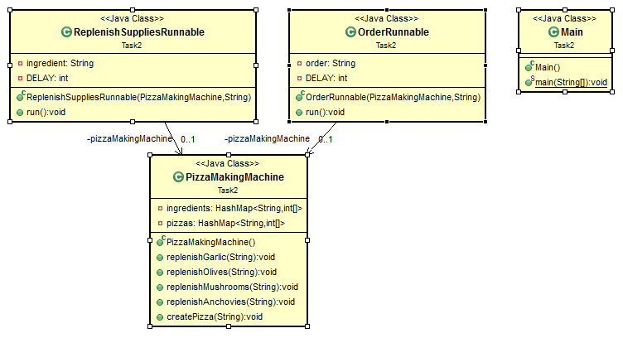

**Explanation as to how multithreading functionality is achieved**

Multithreading is implemented for the replenishing of ingredients and the creation of pizzas. The replenishing of ingredients and creation of pizzas can run concurrently

**Discussion on why you implemented Synchronization to your objects**

In the PizzaMakingMachine, the replenish ingredient methods and create pizza method has

**Screenshot illustrating the execution of the program**