

Website Scripting Foundation Journal

By:

Patrick Ian E. Cura

March – June 2016

Contents
1. Week 1: HTML
2.1 Exercise 1………………………………………………………………...6
2.2 Exercise 2…...……………………………………………………………
2. Week 2: CSS
2.1 Exercise 1…………………………………………………………………29
2.2 Exercise 2………………………………………………………………………30
3. Week 3: CSS 2
3.1 Exercise 1………………………………………………………………...6
3.2 Exercise 2…...……………………………………………………………
4. Week 4: JavaScript 1
4.1 Exercise 1…………………………………………………………………29
4.2 Exercise 2………………………………………………………………………30
5. Week 5: JavaScript 2
2.1 Exercise 1………………………………………………………………...6
2.2 Exercise 2…...……………………………………………………………
6. Week 6: Form Validation
2.1 Exercise 1…………………………………………………………………29
2.2 Exercise 2………………………………………………………………………30
7. Week 7: PHP Basic
3.1 Exercise 1………………………………………………………………...6
3.2 Exercise 2…...……………………………………………………………
8. Week 8: PHP & MYSQL
2.1 Exercise 1………………………………………………………………...6
2.2 Exercise 2…...……………………………………………………………
9. Week 9: PHP SESSIONS
2.1 Exercise 1…………………………………………………………………29
2.2 Exercise 2………………………………………………………………………30
10. Week 10: PHP COOKIES
3.1 Exercise 1………………………………………………………………...6
3.2 Exercise 2…...……………………………………………………………

Week 1

Basic HTML

1.1 Exercise 1
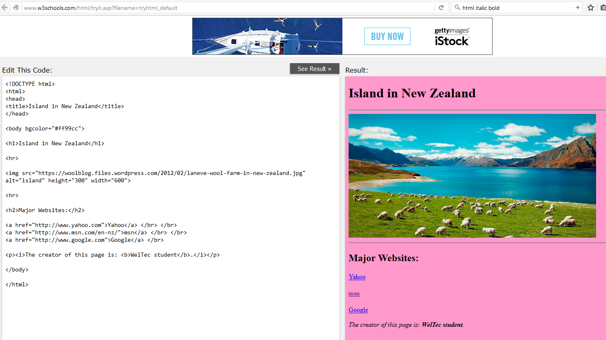
<!DOCTYPE html>
<html>
<head>
<title>Island in New Zealand</title>
</head>

<body bgcolor="#ff99cc">

<h1>Island in New Zealand</h1>

<hr>

<img src="https://woolblog.files.wordpress.com/2012/02/laneve-wool-farm-in-new-zealand.jpg" alt="island" height="300" width="600">

<hr>

<h2>Major Websites:</h2>

<a href="http://www.yahoo.com">Yahoo</a> </br> </br>
<a href="http://www.msn.com/en-nz/">msn</a> </br> </br>
<a href="http://www.google.com">Google</a> </br>

<p><i>The creator of this page is: <b>WelTec student</b>.</i></p>

</body>

</html>

1.2 Exercise 2
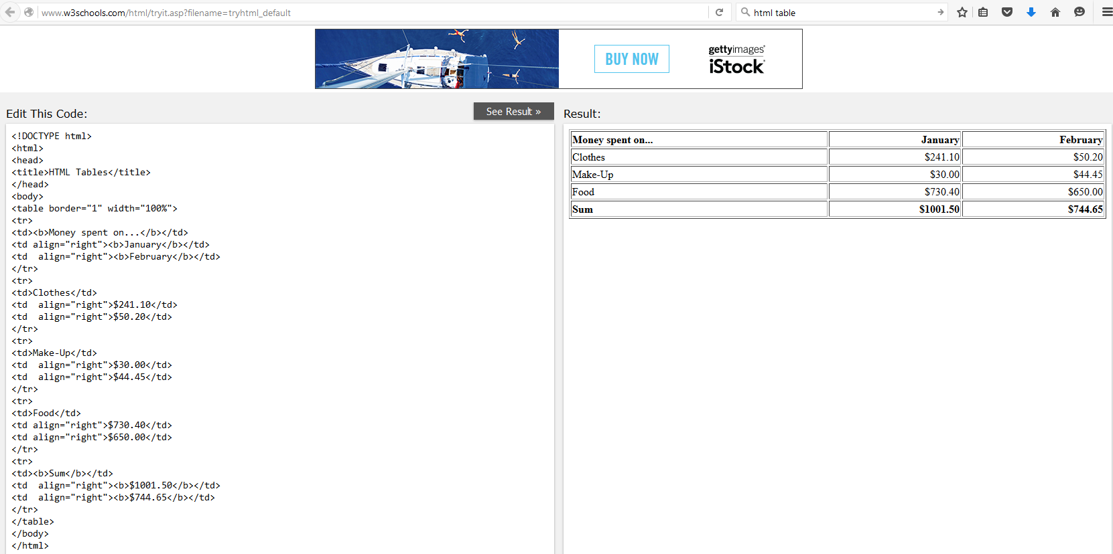
<!DOCTYPE html>
<html>
<head>
<title>HTML Tables</title>
</head>
<body>
<table border="1" width="100%">
<tr>
<td><b>Money spent on...</b></td>
<td align="right"><b>January</b></td>
<td align="right"><b>February</b></td>
</tr>
<tr>
<td>Clothes</td>
<td align="right">$241.10</td>
<td align="right">$50.20</td>
</tr>
<tr>
<td>Make-Up</td>
<td align="right">$30.00</td>
<td align="right">$44.45</td>
</tr>
<tr>
<td>Food</td>
<td align="right">$730.40</td>
<td align="right">$650.00</td>
</tr>
<tr>
<td><b>Sum</b></td>
<td align="right"><b>$1001.50</b></td>
<td align="right"><b>$744.65</b></td>
</tr>
</table>
</body>
</html>

1.3 Exercise 3
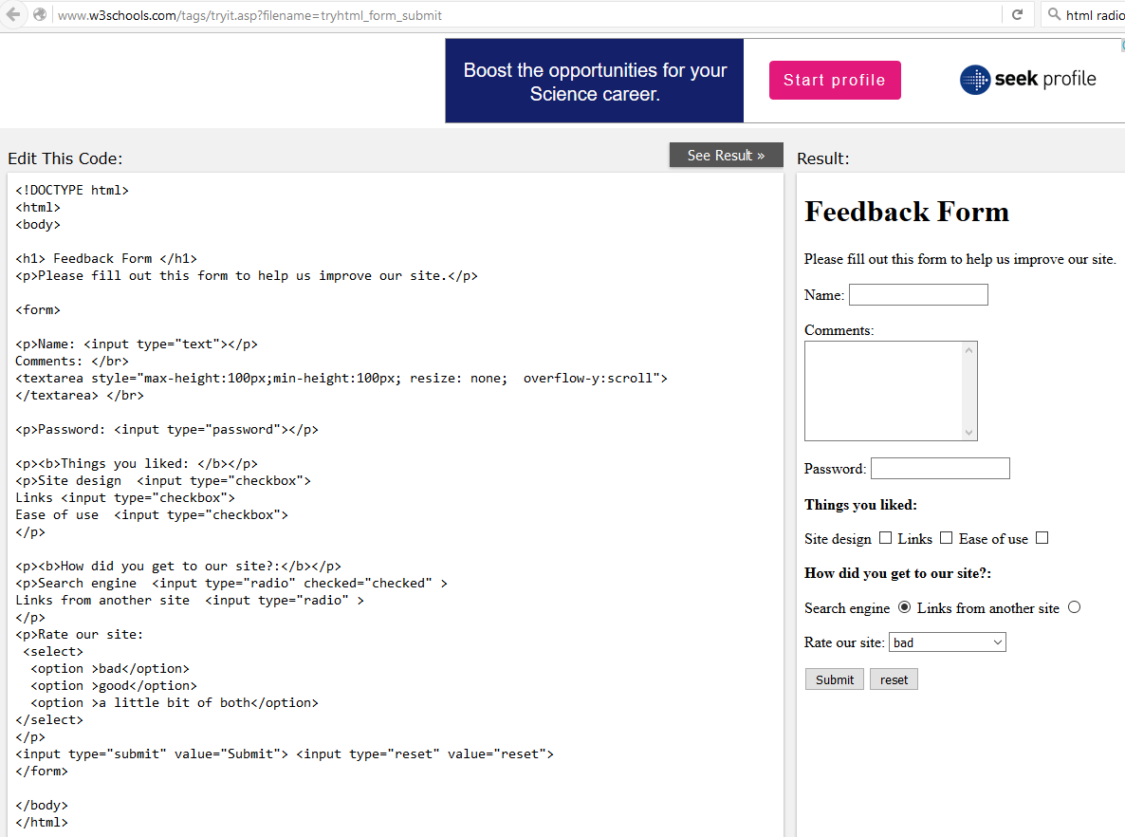
<!DOCTYPE html>
<html>
<body>

<h1> Feedback Form </h1>
<p>Please fill out this form to help us improve our site.</p>

<form>

<p>Name: <input type="text"></p>
Comments: </br>
<textarea style="max-height:100px;min-height:100px; resize: none; overflow-y:scroll">
</textarea> </br>

<p>Password: <input type="password"></p>

<p><b>Things you liked: </b></p>
<p>Site design <input type="checkbox">
Links <input type="checkbox">
Ease of use <input type="checkbox">
</p>

<p><b>How did you get to our site?:</b></p>
<p>Search engine <input type="radio" checked="checked" >
Links from another site <input type="radio" >
</p>
<p>Rate our site:
<select>
<option >bad</option>
<option >good</option>
<option >a little bit of both</option>
</select>
</p>
<input type="submit" value="Submit"> <input type="reset" value="reset">
</form>

</body>
</html>

WEEK 2

Basic CSS

2.1 Exercise 1
(2.2) What is difference between an embedded stylesheet and an external stylesheet? Provide some examples.
An example use of an embedded stylesheet is the following:
<head>

<STYLE TYPE="text/css" >
<!--
BODY { background: url(foo.gif) red; color: black }
P EM { background: yellow; color: black }
.note { margin-left: 5em; margin-right: 5em }
-->
</STYLE>
</head>

An example use of an external stylesheet is the following:
<head>
<link rel="stylesheet" type="text/css" href="theme.css">
</head>

The external stylesheet would be quite neater as it would not occupy space in the html file because it is in a separate css file.

(2.3) What is difference between <div> and <span> elements? Provide examples.
As per http://stackoverflow.com/questions/183532/what-is-the-difference-between-html-tags-div-and-span
div is a block element, span is inline.

2.2 Exercise 2

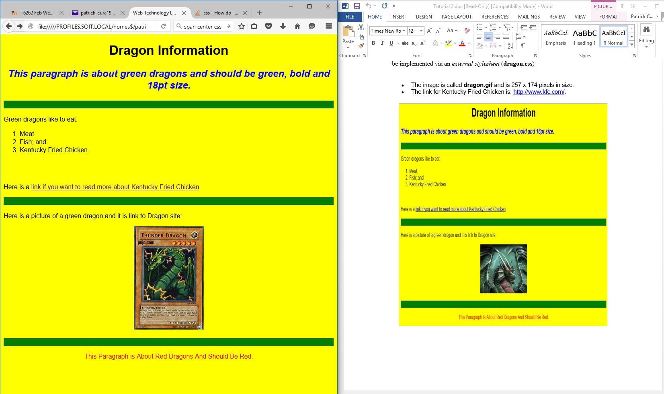
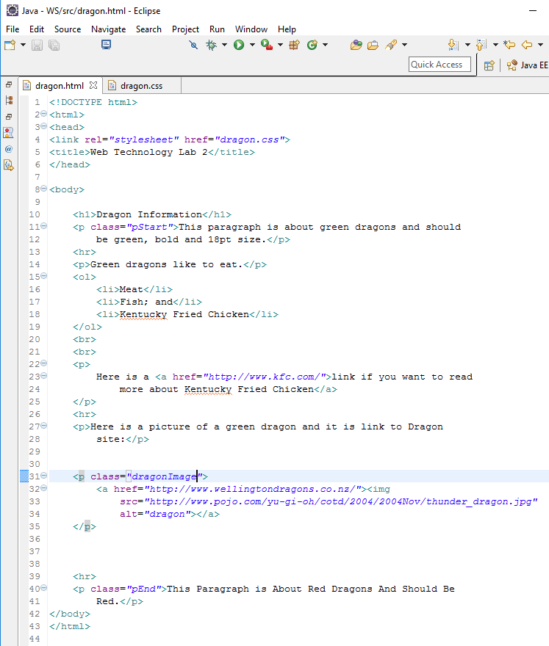
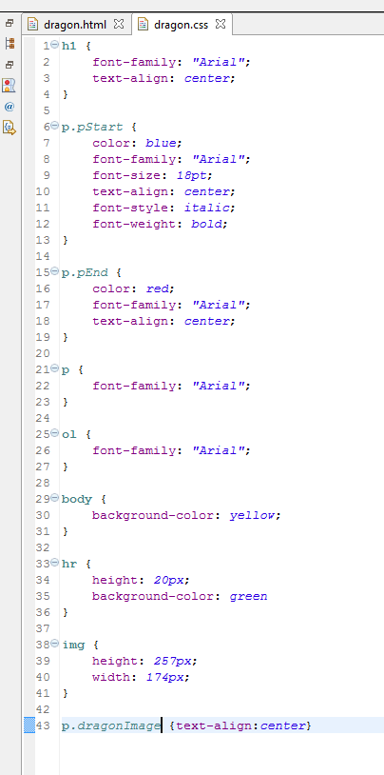
<!DOCTYPE html>
<html>
<head>
<link rel="stylesheet" href="dragon.css">
<title>Web Technology Lab 2</title>
</head>

<body>

<h1>Dragon Information</h1>
<p class="pStart">This paragraph is about green dragons and should
be green, bold and 18pt size.</p>
<hr>
<p>Green dragons like to eat.</p>
<ol>
<li>Meat</li>
<li>Fish; and</li>
<li>Kentucky Fried Chicken</li>
</ol>
<br>
<br>
<p>
Here is a <a href="http://www.kfc.com/">link if you want to read
more about Kentucky Fried Chicken</a>
</p>
<hr>
<p>Here is a picture of a green dragon and it is link to Dragon
site:</p>

<p class="dragonImage">
<a href="http://www.wellingtondragons.co.nz/"><img
src="http://www.pojo.com/yu-gi-oh/cotd/2004/2004Nov/thunder_dragon.jpg"
alt="dragon"></a>
</p>

<hr>
<p class="pEnd">This Paragraph is About Red Dragons And Should Be
Red.</p>
</body>
</html>

h1 {
font-family: "Arial";
text-align: center;
}

p.pStart {
color: blue;
font-family: "Arial";
font-size: 18pt;
text-align: center;
font-style: italic;
font-weight: bold;
}

p.pEnd {
color: red;
font-family: "Arial";
text-align: center;
}

p {
font-family: "Arial";
}

ol {
font-family: "Arial";
}

body {
background-color: yellow;
}

hr {
height: 20px;
background-color: green
}

img {
height: 257px;
width: 174px;
}

p.dragonImage {text-align:center}

WEEK 3

CSS 2

<!DOCTYPE html>
<html>
<head>
<link rel="stylesheet" href="exercise3.css">
<title>Web Technology Lab 3</title>
</head>

<body>

<h1>Dragon Information</h1>
<p class="pStart">This Paragraph is About Green Dragons And Should
Be Green.</p>
<hr class="start">
<p>Green dragons like to eat.</p>
<ul>
<li>Maidens;</li>
<li>Toast; and</li>
<li>Kentucky Fried Chicken</li>
</ul>
<br>
<br>
<p>
Here is a <a href="http://www.kfc.com/">link if you want to read
more about Kentucky Fried Chicken</a>
</p>
<hr class="others">

<br>
<br>

<p>Here is a picture of a kid:</p>

<div class="kidImage">
<a href="http://www.wellingtondragons.co.nz/"> <img
src='https://49.media.tumblr.com/853eeed88ba575c84805bf501b070614/tumblr_nogw446JTf1tkan41o1_500.gif'>
</a> my picture
</div>

<hr class="others">
<p class="pEnd">This paragraph is about red dragons and should be
red.</p>

<hr class="others">

<table border="1">
<tr>
<th>Age(years)</th>
<th>Length(years)</th>
</tr>
<tr>
<td>1 year</td>
<td>10 meters</td>
</tr>
<tr>
<td>2 years</td>
<td rowspan="2">20 meters</td>
</tr>
<tr>
<td>3 years</td>
</tr>
</table>

</body>
</html>

h1 {
text-align: center;
text-decoration: underline;
color: blue;
}

p.pStart {
color: green;
font-size: 18pt;
text-align: center;
font-weight: bold;
background-color: red;
margin-left: 2cm;
margin-right: 2cm;
}

li {
font-style: italic;
margin-left: 80px;
}

p.pEnd {
color: red;
}

body {
background-color: yellow;
font-family: "Arial";
}

hr.start {
border: none;
border-top: 10px dashed #000000;
}

hr.others {
color: DeepPink;
height: 1px;
}

img {
height: 257px;
width: 174px;
}

div.kidImage {
height: 289px;
width: 174px;
border: 15px outset red;
text-align: center;
margin-top: 100px;
margin-bottom: 100px;
margin-right: 150px;
margin-left: 80px;
color: green;;
}

table {
border: 15px outset green;
margin: 100px 150px 100px 80px;
}

a:hover {
background-color: pink;
color: green;
}
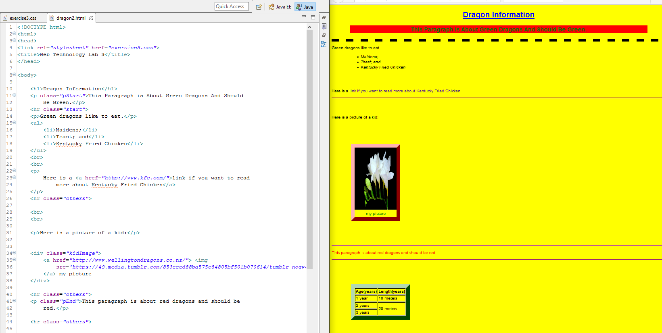

WEEK 4

JavaScript

<html dir="ltr"><head>
<script src="week4.js">
</script>
</head>
<body contenteditable="true">

<form>
<h1> enter number 1:</h1>
<input id="num1" type="text" value="30" size="4">
<h1> enter number 2:</h1>
<input id="num2" type="text" value="10" size="4">
<br><br>
<input type="button" value="*" onclick="multiply()">
<input type="button" value="/" onclick="divide()">
</form>
</body></html>

/*
* To change this license header, choose License Headers in Project Properties.
* To change this template file, choose Tools | Templates
* and open the template in the editor.
*/

function multiply()
{
//document.write(document.getElementById("num1").value);
document.write(document.getElementById("num1").value * document.getElementById("num2").value);
}

function divide()
{
document.write(document.getElementById("num1").value / document.getElementById("num2").value);
}

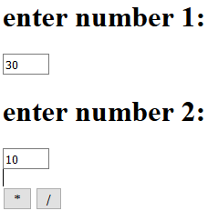

WEEK 5

JavaScript

<html>
<head>
<title> JavaScript example </title>
</head>
<body>
<p> No particular content here </p>
<script type="text/javascript">
name = window.prompt("What is your username?", "Type it here");
sID = window.prompt("What is your student id?", "Type it here");

if ((name == "" || name == null) || (sID == "" || sID == null)) {
alert("Please input your username or student ID");
location.reload();
} else {
x = confirm("Your name is: " + name + "." + "\nYour id is: " + sID);
alright = false;
if (x)
{
alert("Thanks for your input");
window.close();
}
else {
location.reload();
}
}

</script>
</body>
</html>
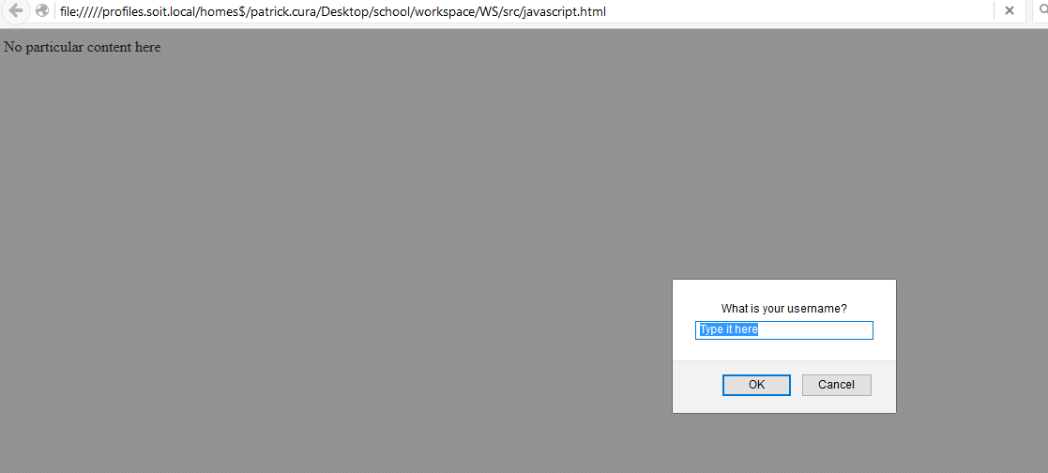
No particular content here

<html>
<head>
<title> JavaScript example </title>
<script type="text/javascript">
function hid()
{
document.getElementById("body").style.background = "yellow";
document.getElementById("hide").style.background = "red";
document.getElementById("image").style.visibility = "hidden";
}
function disp()
{
document.getElementById("body").style.background = "white";
document.getElementById("display").style.background = "pink";
document.getElementById("image").style.visibility = "visible";
}
</script>
</head>
<body id="body">

<img id="image" src="http://bestplacestotravel.info/countries/new-zealand/lower-hutt/lower-hutt-06.jpg"> &nbsp; &nbsp;
<form>
<input value="Hide" type="button" id="hide" onclick="hid()">
<input value="Display" type="button" id="display" onclick="disp()">
</form>

</body>
</html>

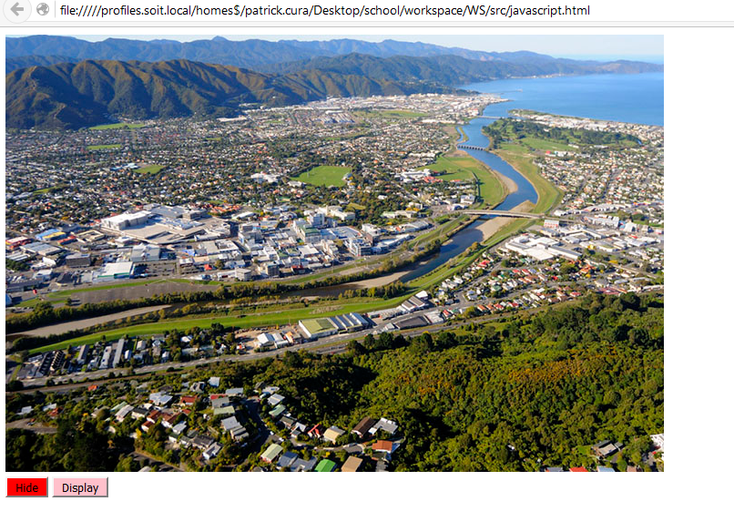

WEEK 6

Form Validation

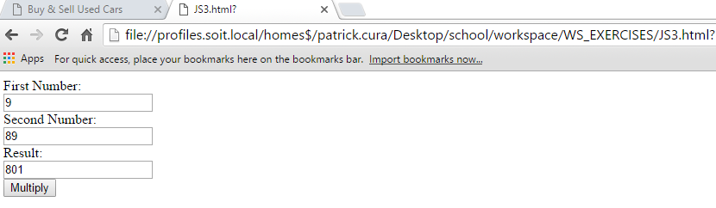
<html>
<head>
<script src="JS3.js"></script>
</head>
<body>

<form onsubmit="return validateFields()">
First Number:<br>
<input type="text" id="firstnumber">
<br>
Second Number:<br>
<input type="text" id="secondnumber">
<br>
Result:<br>
<input type="text" id="result">
<br>
<input type="submit" value="Multiply">
</form>

</body>
</html>

/*
* To change this license header, choose License Headers in Project Properties.
* To change this template file, choose Tools | Templates
* and open the template in the editor.
*/

/**
* http://stackoverflow.com/questions/11961474/how-to-sum-two-numbers-from-input-tag
*/

function validateFields()
{
var firstnumber = document.getElementById('firstnumber');
var secondnumber = document.getElementById('secondnumber');

var result = parseFloat(firstnumber.value) * parseFloat(secondnumber.value);

//alert(result);

document.getElementById('result').value = result;

return false;
}\

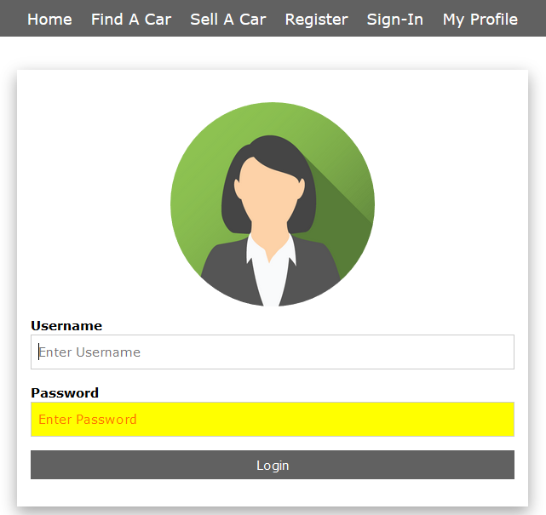

<form onsubmit="return validateLoginFields()" action="myProfile.html">
<label><b>Username</b></label>
<input class="w3-input w3-border w3-margin-bottom" placeholder="Enter Username" type="text" onblur="setStyle1()" onfocus="setStyleFocus('username')" id="username" name="Username">

<label><b>Password</b></label>
<input class="w3-input w3-border" placeholder="Enter Password" type="password" onblur="setStyle2()" onfocus="setStyleFocus('password')" id="password" name="Password">
<input value="Login" type="submit" class="w3-btn w3-btn-block w3-dark-grey w3-section">
</form>

function validateLoginFields()
{
var username = document.getElementById('username');
var password = document.getElementById('password');

if (!validateRequired(username))
{
return false;
}
if (!validateRequired(password))
{
return false;
}

if(username.value == "patrick" && password.value == "cura")
{
window.location.assign("myProfile.html");
}
else
{
alert("Username Password combination not in the database")
username.value = "";
password.value = "";
username.style.backgroundColor = "";
username.style.color = "";
password.style.backgroundColor = "";
password.style.color = "";
username.focus();
return false;
}

return true;
}

function setStyle1()
{
var username = document.getElementById("username");
if (username.value == "")
{
username.style.backgroundColor = "yellow";
username.style.color = "red";
}
else
{
username.style.backgroundColor = "";
username.style.color = "";
}
}

function setStyle2()
{
var password = document.getElementById("password");
if (password.value == "")
{
password.style.backgroundColor = "yellow";
password.style.color = "red";
}
else
{
password.style.backgroundColor = "";
password.style.color = "";
}
}

function setStyleFocus(id)
{
var field = document.getElementById(id);
field.style.backgroundColor = "";
field.style.color = "";
}

function validateRequired(field)
{
if (field.value == "")
{
alert(field.getAttribute("name") + " is required");
return false;
}
else
{
return true;
}
}

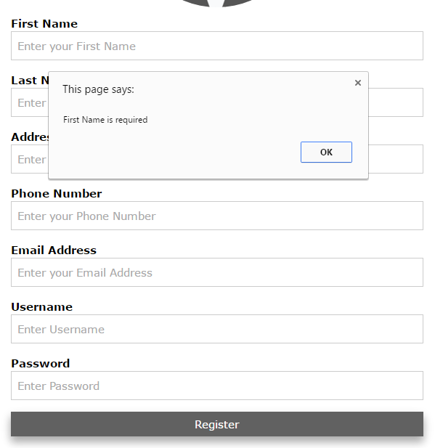

/*
* To change this license header, choose License Headers in Project Properties.
* To change this template file, choose Tools | Templates
* and open the template in the editor.
*/

/**
* http://stackoverflow.com/questions/3502354/how-to-check-if-a-textbox-is-empty-using-javascript
* http://www.tutorialspoint.com/javascript/javascript_form_validations.htm
* http://stackoverflow.com/questions/21822324/javascript-form-validation-without-alert
* http://www.w3schools.com/jsref/jsref_regexp_wordchar.asp
* http://www.w3schools.com/jsref/jsref_regexp_g.asp
* http://www.w3resource.com/javascript/form/phone-no-validation.php
* http://www.regexpal.com/
* http://stackoverflow.com/questions/46155/validate-email-address-in-javascript
* http://www.formget.com/form-validation-using-javascript/
* http://www.w3schools.com/jsref/jsref_obj_regexp.asp
* http://stackoverflow.com/questions/11352870/regular-expression-to-match-specific-string
* http://stackoverflow.com/questions/4745112/javascript-regex-for-alphanumeric-string-with-length-of-3-5-chars
*/

function validateRegisterFields(form)
{
if (!validateRequired(form.firstName))
{
return false;
}
if (!validateRequired(form.lastName))
{
return false;
}
if (!validateRequired(form.address))
{
return false;
}
if (!validateRequired(form.phoneNumber))
{
return false;
}
if (!validateRequired(form.emailAddress))
{
return false;
}
if (!validateRequired(form.username))
{
return false;
}
if (!validateRequired(form.password))
{
return false;
}

if (!validatePhoneNumber(form.phoneNumber))
{
return false;
}
if (!validateEmail(form.emailAddress))
{
return false;
}

if (!validateUsernamePassword(form.username))
{
return false;
}
if (!validateUsernamePassword(form.password))
{
return false;
}

return true;
}

function validateRequired(field)
{
if (field.value == "")
{
alert(field.getAttribute("name") + " is required");
return false;
}
else
{
return true;
}
}

function validatePhoneNumber(field)
{
var pattern = /^02?([0-9]{8})$/; // 02dddddddd (mobile)
var pattern2 = /^0?([0-9]{8})$/; // 0dddddddd

if ((field.value.match(pattern)))
{
return true;
}
else
{
if ((field.value.match(pattern2)))
{
return true;
}
else
{
alert("Phone Number format should be: 0dddddddd or 02dddddddd (mobile)");
return false;
}
}
}

function validateLoginFields()
{
var username = document.getElementById('username');
var password = document.getElementById('password');

if (!validateRequired(username))
{
return false;
}
if (!validateRequired(password))
{
return false;
}

if(username.value == "patrick" && password.value == "cura")
{
window.location.assign("myProfile.html");
}
else
{
alert("Username Password combination not in the database")
username.value = "";
password.value = "";
username.style.backgroundColor = "";
username.style.color = "";
password.style.backgroundColor = "";
password.style.color = "";
username.focus();
return false;
}

return true;
}

function setStyle1()
{
var username = document.getElementById("username");
if (username.value == "")
{
username.style.backgroundColor = "yellow";
username.style.color = "red";
}
else
{
username.style.backgroundColor = "";
username.style.color = "";
}
}

function setStyle2()
{
var password = document.getElementById("password");
if (password.value == "")
{
password.style.backgroundColor = "yellow";
password.style.color = "red";
}
else
{
password.style.backgroundColor = "";
password.style.color = "";
}
}

function setStyleFocus(id)
{
var field = document.getElementById(id);
field.style.backgroundColor = "";
field.style.color = "";
}

function validateEmail(emailAddress)
{
var filter = /\S+@\S+\.(com|net|my)+/;

if (!filter.test(emailAddress.value))
{
alert('Please provide a valid email address');
emailAddress.focus;
return false;
}
else
{
return true;
}
}

function validateUsernamePassword(field)
{
var filter = /^([a-zA-Z0-9_-]){6,}$/;

if (!filter.test(field.value))
{
alert('Please provide a valid: ' + field.getAttribute("name"));
field.focus;
return false;
}
else
{
return true;
}
}

<form onsubmit="return validateRegisterFields(this)" action="myProfile.html">
<label><b>First Name</b></label>
<input class="w3-input w3-border w3-margin-bottom" id="firstName" name="First Name" placeholder="Enter your First Name" type="text">

<label><b>Last Name</b></label>
<input class="w3-input w3-border w3-margin-bottom" id="lastName" name="Last Name" placeholder="Enter your Last Name" type="text">

<label><b>Address</b></label>
<input class="w3-input w3-border w3-margin-bottom" id="address" name="Address" placeholder="Enter your Address" type="text">

<label><b>Phone Number</b></label>
<input class="w3-input w3-border w3-margin-bottom" id="phoneNumber" name="Phone Number" placeholder="Enter your Phone Number" type="text">

<label><b>Email Address</b></label>
<input class="w3-input w3-border w3-margin-bottom" id="emailAddress" name="Email Address" placeholder="Enter your Email Address" type="text">

<label><b>Username</b></label>
<input class="w3-input w3-border w3-margin-bottom" id="username" name="User Name" placeholder="Enter Username" type="text">

<label><b>Password</b></label>
<input class="w3-input w3-border" placeholder="Enter Password" id="password" name="Password" type="password">
<input class="w3-btn w3-btn-block w3-dark-grey w3-section" value="Register" type="submit" >
</form>

WEEK 7

PHP Basics

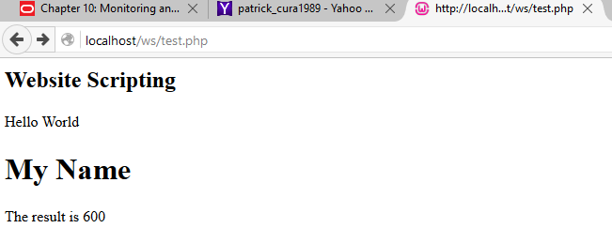

<html>
<body>
<h2> Website Scripting </h2>

<?php

echo "Hello World";

echo "<h1> My Name </h1>";

$x = 20;
$z = 30;

$result = $x * $z;
echo "The result is " . $result;

?>

</body>
</html>

<html>
<head>
<meta http-equiv="content-type"
content="text/html; charset=windows-1252">
<title>Buy &amp; Sell Used Cars</title>
<meta name="viewport" content="width=device-width, initial-scale=1">
<link rel="stylesheet" href="project.css">
<script src="project.js"></script>
</head>
<body>

<div class="w3-light-grey w3-container w3-padding-64 w3-center">
<img
src="http://secure.logomaker.com/logo-images/5760ae8855f56df5.gif">
</div>

<div class="w3-topnav w3-large w3-center w3-dark-grey">
<a href="home.html">Home</a> <a href="findACar.html">Find A Car</a> <a
href="sellACar.html">Sell A Car</a> <a href="register.html">Register</a>
<a href="login.html">Sign-In</a> <a href="myProfile.html">My Profile</a>
</div>

<br>

<div class="w3-content">

<div class="w3-row-padding">
<div class="w3-row w3-margin">

<div class="w3-modal-content w3-card-8 w3-animate-zoom"
style="max-width: 600px">

<div class="w3-center">
<br> <img src="http://www.w3schools.com/w3css/img_avatar4.png"
alt="Avatar" style="width: 40%" class="w3-circle w3-margin-top">
</div>

<div class="w3-container">
<div class="w3-section">
<form onsubmit="return validateRegisterFields(this)" action="test.php" method="GET" >
<label><b>First Name</b></label>
<input class="w3-input w3-border w3-margin-bottom" id="firstName" name="First Name" placeholder="Enter your First Name" type="text">

<label><b>Last Name</b></label>
<input class="w3-input w3-border w3-margin-bottom" id="lastName" name="Last Name" placeholder="Enter your Last Name" type="text">

<label><b>Address</b></label>
<input class="w3-input w3-border w3-margin-bottom" id="address" name="Address" placeholder="Enter your Address" type="text">

<label><b>Phone Number</b></label>
<input class="w3-input w3-border w3-margin-bottom" id="phoneNumber" name="Phone Number" placeholder="Enter your Phone Number" type="text">

<label><b>Email Address</b></label>
<input class="w3-input w3-border w3-margin-bottom" id="emailAddress" name="Email Address" placeholder="Enter your Email Address" type="text">

<label><b>Username</b></label>
<input class="w3-input w3-border w3-margin-bottom" id="username" name="User Name" placeholder="Enter Username" type="text">

<label><b>Password</b></label>
<input class="w3-input w3-border" placeholder="Enter Password" id="password" name="Password" type="password">
<input class="w3-btn w3-btn-block w3-dark-grey w3-section" value="Register" type="submit" >
</form>
</div>
</div>

</div>
</div>
</div>

</div>

<footer class="w3-container w3-center w3-dark-grey">
<p>© 2016 All Rights Reserved Wellington Institute of Technology
(WelTec)</p>
</footer>

</body>
</html>

<?php

// http://stackoverflow.com/questions/8207488/get-all-variables-sent-with-post

echo var_dump($_GET);

$x = $_GET["First_Name"];
$y = $_GET['Email_Address'];
$z = $_GET['Phone_Number'];

echo "Your name is: " . $x . "<br>" ;

echo "Your email is: " . $y . "<br>" ;

echo "Your phone number is: " . $z . "<br>" ;

?>

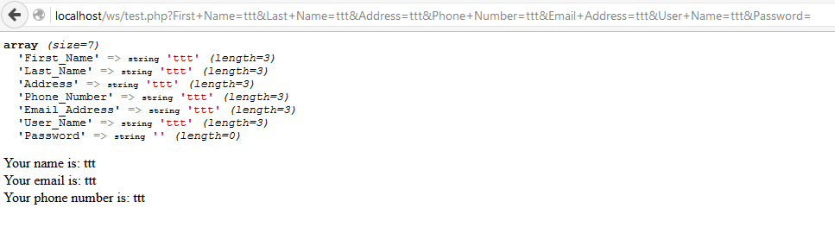

WEEK 8

PHP & MySQL

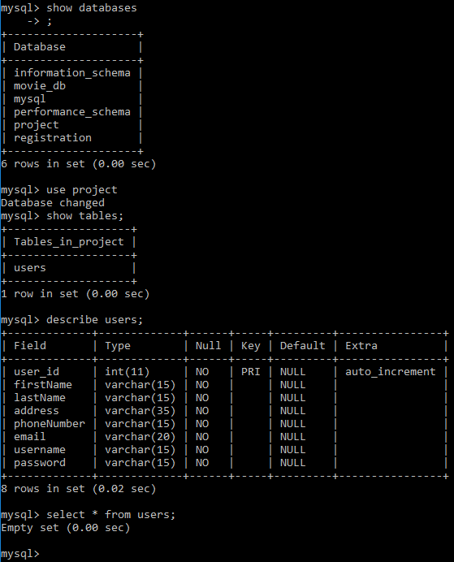
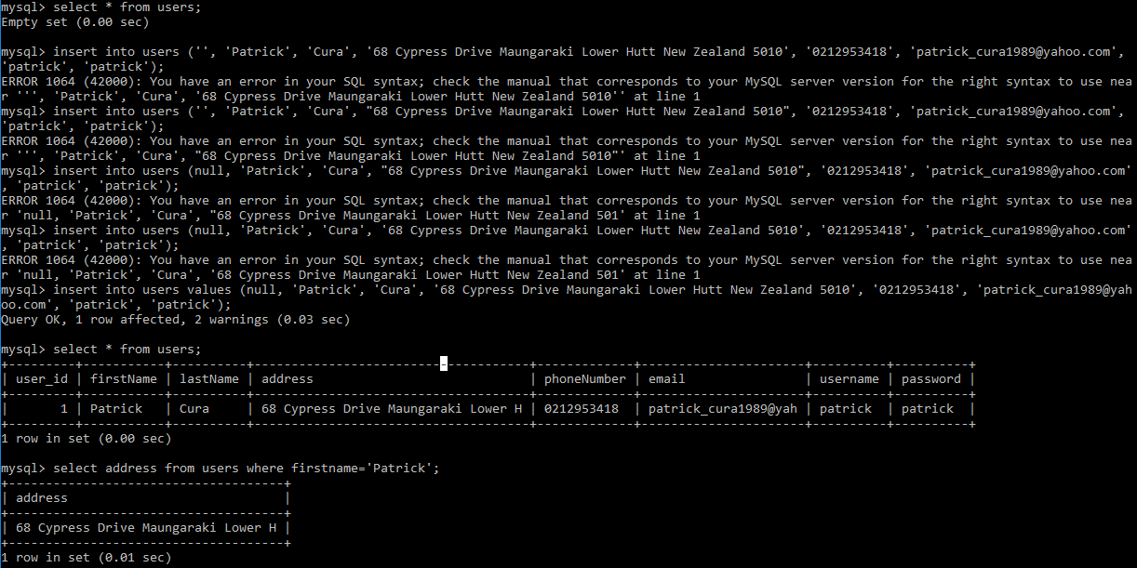
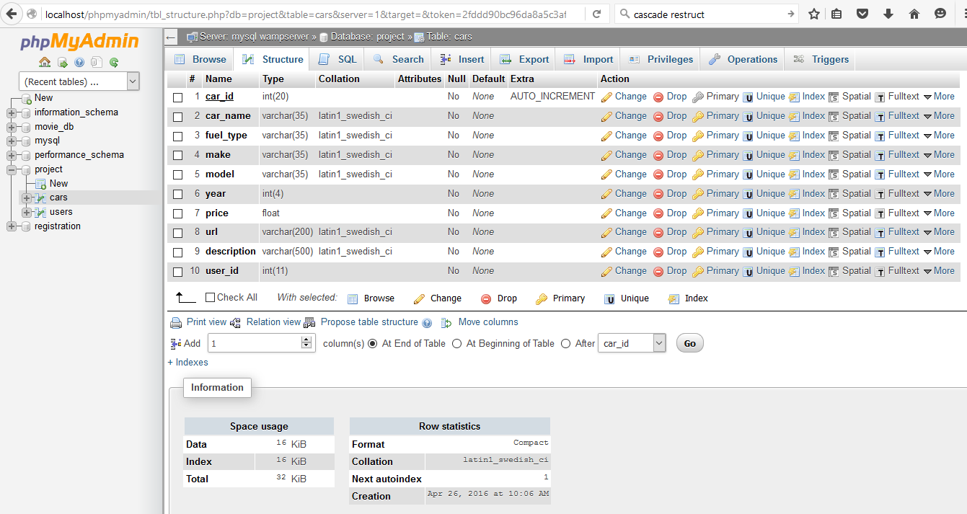

register.php

<form onsubmit="return validateRegisterFields(this)" action="myProfile.php" method="GET">
<label><b>First Name</b></label>
<input class="w3-input w3-border w3-margin-bottom" id="firstName" name="First Name" placeholder="Enter your First Name" type="text">

<label><b>Last Name</b></label>
<input class="w3-input w3-border w3-margin-bottom" id="lastName" name="Last Name" placeholder="Enter your Last Name" type="text">

<label><b>Address</b></label>
<input class="w3-input w3-border w3-margin-bottom" id="address" name="Address" placeholder="Enter your Address" type="text">

<label><b>Phone Number</b></label>
<input class="w3-input w3-border w3-margin-bottom" id="phoneNumber" name="Phone Number" placeholder="Enter your Phone Number" type="text">

<label><b>Email Address</b></label>
<input class="w3-input w3-border w3-margin-bottom" id="emailAddress" name="Email Address" placeholder="Enter your Email Address" type="text">

<label><b>Username</b></label>
<input class="w3-input w3-border w3-margin-bottom" id="username" name="User Name" placeholder="Enter Username" type="text">

<label><b>Password</b></label>
<input class="w3-input w3-border" placeholder="Enter Password" id="password" name="Password" type="password">
<input class="w3-btn w3-btn-block w3-dark-grey w3-section" value="Register" type="submit" >
</form>

myProfile.php

<?php
// http://www.w3schools.com/php/php_mysql_insert.asp
// http://www.tutorialrepublic.com/php-tutorial/php-mysql-insert-query.php

/* Attempt MySQL server connection. Assuming you are running MySQL
server with default setting (user 'root' with no password) */

$link = mysqli_connect("localhost", "root", "", "project");

// Check connection
if ($link === false)
{
die("ERROR: Could not connect. " . mysqli_connect_error());
}

// Escape user inputs for security
$first_name = mysqli_real_escape_string($link, $_GET['First_Name']);
$last_name = mysqli_real_escape_string($link, $_GET['Last_Name']);
$address = mysqli_real_escape_string($link, $_GET['Address']);
$phone_number = mysqli_real_escape_string($link, $_GET['Phone_Number']);
$email_address = mysqli_real_escape_string($link, $_GET['Email_Address']);
$user_name = mysqli_real_escape_string($link, $_GET['User_Name']);
$password = mysqli_real_escape_string($link, $_GET['Password']);

// attempt insert query execution
$sql = "INSERT INTO users VALUES ('','$first_name', '$last_name', '$address', '$phone_number', '$email_address', '$user_name', '$password' )";

if (mysqli_query($link, $sql))
{
echo "Records added successfully.";
}
else
{
echo "ERROR: Could not able to execute $sql. " . mysqli_error($link);
}

// close connection
mysqli_close($link);

?>

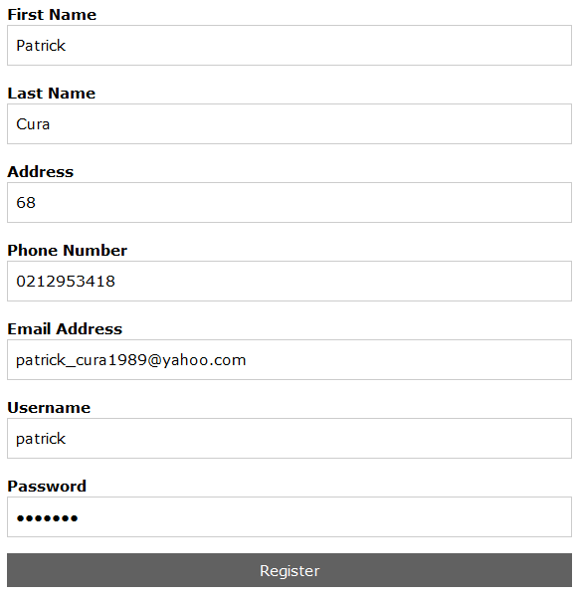

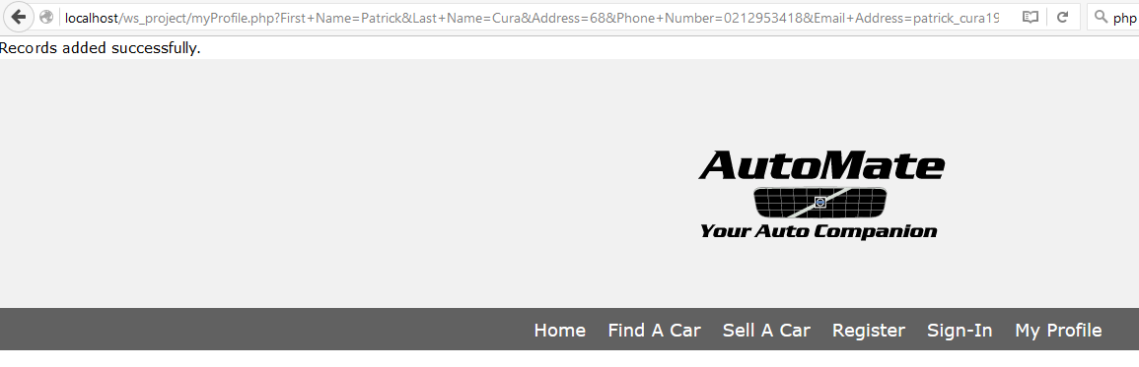

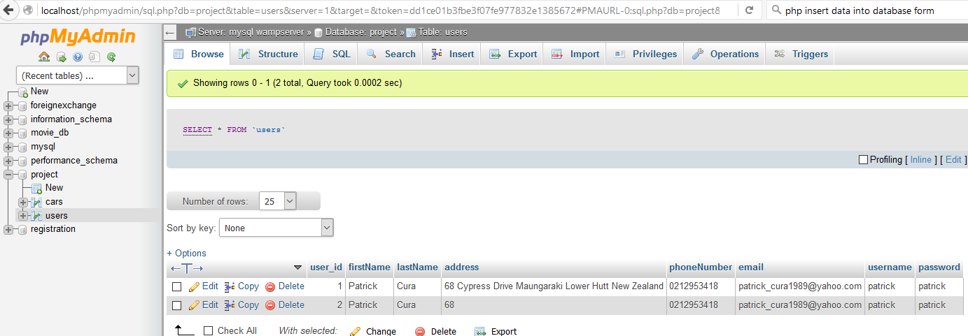

SEARCH A CAR:

<?php
$sql = "SELECT * FROM Cars";

$result = $db_connection->query($sql);

if ($result->num_rows > 0)
{
// output data of each row
while ($row = $result->fetch_assoc())
{
/*
$Car_Name = mysqli_real_escape_string($db_connection, $_POST['Car_Name']);
$Fuel_Type = mysqli_real_escape_string($db_connection, $_POST['Fuel_Type']);
$Make = mysqli_real_escape_string($db_connection, $_POST['Make']);
$Body = mysqli_real_escape_string($db_connection, $_POST['Body']);
$Year = mysqli_real_escape_string($db_connection, $_POST['Year']);
$Price = mysqli_real_escape_string($db_connection, $_POST['Price']);
$Image_URL = mysqli_real_escape_string($db_connection, $_POST['Image_URL']);
$Car_Description = mysqli_real_escape_string($db_connection, $_POST['Car_Description']);
*/

$descriptionList = explode(PHP_EOL, $row["description"]);

echo '<div class="w3-row w3-margin">
<div class="w3-third">
<a href="findACar_2.html">
<img
src="' . $row["url"] . '"
style="width: 100%; min-height: 200px">
</a>
</div>
<div class="w3-twothird w3-container">
<h2>' . $row["car_name"] . '</h2>
<h4>$' . $row["price"] . '</h4>
<div class="w3-left-align">
<ul>';
foreach ($descriptionList as &$value)
{
echo '<li>'.$value.'</li>' ;
}
echo '</ul>
</div>
</div>
</div>';
}
}
else
{
echo "0 results";
}
$db_connection->close();
?>

