Laboratory Sheet 7

Today we will discuss the following topic:

Introduction to PHP (PHP- Part I)

Exercise 1 Web Architecture Diagram
What do you understand by the term server-side scripting? How is this different from client-side scripting?

Exercise 2 PHP syntax
(2.1) Which of the following are valid variable name in PHP?
- $123greetings
- $var_value
- $$var
- $index[10]
- $num12

(2.2) $a = 6.0;
$b = 6;

What is the result of each the following? What do they mean? Why are they different?
$a = $b
$a == $b
$a === $b

(2.3) What will be the output of the following program?

<?php
for($i=0;$i<100;$i++) {
if($i == 10)
break;
echo "i: "." " .$i;
echo "<br>";
}
echo "Loop Complete......";
?>

Exercise 3 Functions
What are the outputs of following scripts?

(3.1)
<?php
function test1($a,$b)
{
$a=$a+$b;
echo "$a<br>";
echo $b=($b+1) ."<br>";
}
$a=5;
$b=10;
echo "first function<br>";
echo "<br/>$a<br>";
test($a,$b);
echo "$b<br>";
?>
(3.2)
<?php
function test2(&$c,$d)
{
$c=$c+$d;
echo "$c<br>";
echo "$d<br>";
}
$a=5;
$b=10;
echo "next function<br>";
echo "$a<br>";
test2($a,$b);
echo "$a<br>";
?>

Exercise 4 PHP and HTML Form

Consider a snapshot of the following HTML Form:

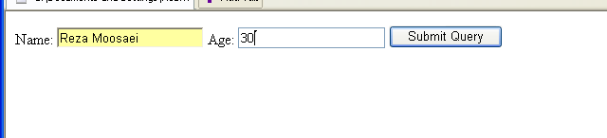

Create the above HTML form and write a PHP script to print Birth year of user.

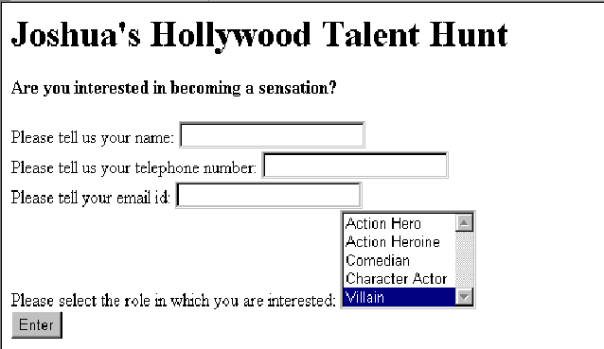
Exercise 5 PHP and HTML Form

Create the above HTML form and write a PHP script that collects the values from all the form elements and displays them in the following format in the next page as:

Hi ___________________(This should contain the name of the applicant),
Your telephone number is _______________ and e-mail address is ____________________.

And you are interested in doing a role of ________________________(This should contain the role selected by user).

We will soon call you for a screen test if selected.

