Laboratory Sheet 8
MYSQL

Today we will discuss the following topic:

- Introduction to MYSQL: This lab guide is designed to provide examples and exercises in the fundamentals of SQL within the MySQL environment.

The learning objectives of this lab are to
• Learn how to start MySQL
• Learn how to use the MySQL command line client window

Exercise 1 Starting MySQL

How you connect to the MySQL database depends on how the MySQL software was installed on your server. This section will describe how to start MySQL from a Windows 7 installation of Wamp server and MySQL. In Wampserver there are two options for connection to MYSQL:
  - MYSQL console : provides command line interface
  - phpMyAdmin: provides graphical user interface
The following describes MYSQL console.

To start MySQL you would:
- Run Wampserver
- Select MySQL console

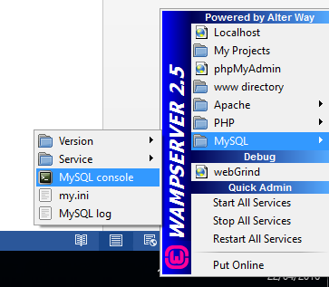

3. Click on the MySQL Command line

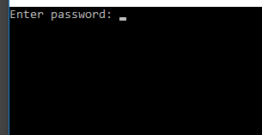
4. No any password is set for your MYSQL. Press enter. Once you have successfully logged on you will see the opening screen as shown in following figure.

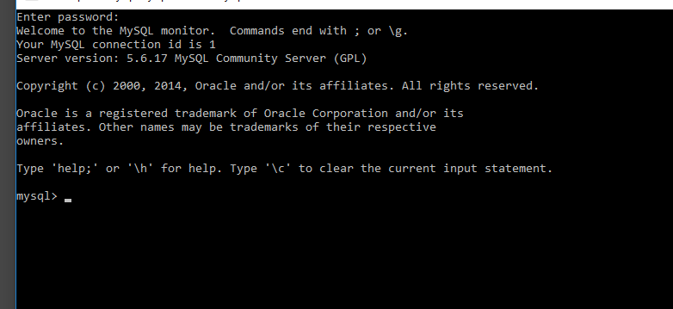

Exercise 2 Creating Database in MySQL

  - Create a database called “registration”.
Notice: To check to see if your database has been created you need to use the SHOW DATABASES command which lists the databases on the MySQL server host.
To work with any specific database you first have to select it. When you first login to MySQL, the default database is always selected, so you need to execute the USE command followed by the name of the database that you want to use.
  - Create a table called “client”. Table contains four fields:
FirstName varchar(25), LastName varchar(25), Email varchar(35), Phone varchar(15), Address varchar(50)
  - Display your created table’s structure. The command DESCRIBE is used to display the structure of an individual table.
  - List all existing tables. Use the SHOW TABLES command.
  - Use of the INSERT command to enter three data records into client table. The INSERT command’s basic syntax looks like this:
INSERT INTO tablename VALUES (value1, value2, ... , valuen).

Exercise 3 Retrieving data from a table

  - Use SELECT command to return following data:
- All table rows
- First and last name of clients
- Email and address of second client
Notice: The SELECT command has many optional clauses but in its simplest can be
written as:
SELECT columnlist
FROM tablelist
[WHERE conditionlist ];

