
Breaking Head is an open source card game about the Drupal.org issue queue based on the game Saboteur designed by Frederic Moyersoen.

This game makes the assumption that there are bad people in the issue queue on drupal.org - this is not the case! Luckily the Drupal community consists of very friendly contributors always willing to help each other. But sometimes working in the queue can be depressing and this game covers situations when people have the feeling that progress is willingly blocked for no good reason.

Basics
The game is about an Drupal.org issue which all players will 'work' on during the game and players are assigned to a team. The Contributors have to get their issue “Fixed & Committed” while the team of Blockers need to prevent this until the game has ended. The teams win and loose as a whole. As every player only knows ones own role for sure, the interesting part of this game is about finding out the other players assignment while trying to keep your own secret.

Players: 3 - 10, Minimum age: 8 (you should have heard about Drupal and know what an issue is)

Contents
66 Playable cards (Blue back)
11 Player cards (Green back)
4 Special cards (Orange back)

Preparation
First make sure playable, player and special cards are apart from each other.

Based upon the total count of players use the following player cards:
3 Players: 3 Contributors, 1 Blocker
4 Players: 4 Contributors, 1 Blocker
5 Players: 4 Contributors, 2 Blockers
6 Players: 5 Contributors, 2 Blockers
7 Players: 5 Contributors, 3 Blockers
8 Players: 6 Contributors, 3 Blockers
9 Players: 7 Contributors, 3 Blockers
10 Players: Use all player cards
Mix them and randomly distribute them covered to all players. Each player can now take a look at the role he was assigned for this round but should not tell it anyone until the end of the game.

Now lay the Issue summary special card uncovered at one end of the table. Mix the remaining 3 end-cards and put them covered at the other end of the table, resulting in the following:

Issue
sum
mary
1
2
3
4
5
6
7
Space for 7 cards between issue summary card
and end-cards

Every player also gets a few playable cards at the beginning:
3 – 5 Players: 6 cards per player
6 – 7 Players: 5 cards per player
8 – 10 Players: 4 cards per player
The rest of these cards are placed covered and easily reachable, somewhere on the table.
Used cards are not reused during a round and should be collected on an extra pile.

Rounds
Beginning from a randomly chosen player, everyone gets to ones turn clockwise.
Each turn a player must first play a card, either by putting one on the table (comment on the issue), by playing an action card or by passing (throwing a card onto the used-cards-pile).
Then a player must draw a card from the pile of unused cards as long as there are cards left.

End
The game ends either when the issue has been successfully fixed & committed (contributors win) or when there are no more cards left to play in the hands of any player (blockers win).
Now all the players uncover their true assignment and the winning team can mock the loosers.

Playing a card

Comment cards are played by laying them on the table with the ultimate target to connect the issue summary with the committed & fixed end-card. As soon as there is a continuous path from the start card to one of the end cards – the connected end-card will be uncovered.

All comment cards must be played in the same
orientation (text is allowed to be upside down) and if there's a connection (a white gap) at the border of a card, the neighbor card on that side must have a connection as well.
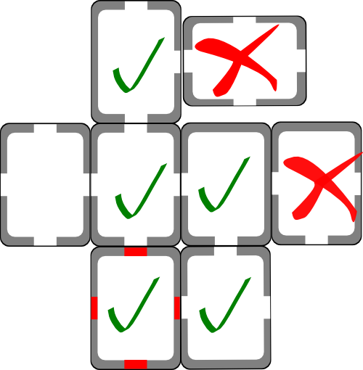
There are a few special comment cards called dead-ends.

These cards can be identified by their red gap and they have the same rules as the normal comment cards but their connection does not count. This means that if there are
several connected comment cards building a path to an
end-card but there is one dead-end card within this continuous path, the path is invalid and the end-card may
not be uncovered until it is bypassed or replaced.

Action cards are playable cards that have their functionality captioned.
- WTF Dries?: Allows a player to choose one of the end-cards and to take a loot at it (privately).
- Spam!: Allows a player to remove a single but any comment card from the table.
- Blocked!: Blocks a player with a specific problem. When a player is blocked one is not allowed to comment on the issue. Each player can be blocked with multiple problems but each must be of a different kind. (Problems are: Broken Wi-Fi, Drupal-Flu, Broken Head)
- Unblocked!: Unblocks a blocked player by resolving a specific problem (LAN fixes broken Wi-fi, Vitamins cure Drupal-Flu and a fixed head fixes a broken head). One unblocking card removes one blocking card with the appropriate symbol. There are unblocking cards with multiple symbols that are able to resolve one of multiple problems.

Passing
If you are not able to play a card or you just don't want to, you still have to put one of your cards on the used-cards-pile and draw a new one.

Source
https://github.com/patrickd-/BreakingHead

