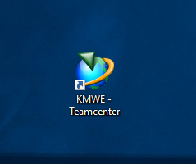

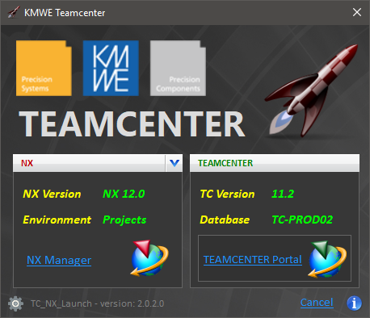

Table of Contents

Function 2

Objective 2

Program execution 2

Interface 4

Administration 5

Installation 5

Server layout 5

Settings 6

Resources (Batch files) 7

Set up NX Custom Environment 8

1st level Environment Variables 8

2nd level Environment Variables 8

3rd & 4th level NX Variables 9

Variables set by _KMWE_PLM_profilevars.bat 9

## Function

Program to launch Siemens TEAMCENTER portal or NX Manager with the appropriate settings for KMWE.

## Objective

Give the user 1 single application/shortcut to start every possible TEAMCENTER/NX configuration and prevent the use of multiple shortcuts.

Be aware: In Teamcenter only one NX version is currently used for compatibility reasons.

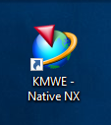This will hopefully change in the future, but for now it’s limited.

Other NX versions can be run natively. See Desktop > KMWE Native NX

## Program execution

When software is started, several settings are read from a XML settings file.

The software checks for each NX version specified in the settings, if this version was installed on the system. If the version is installed, it’s added to the version selection list.

Teamcenter can be used with and without an NX integration, so it makes quite a difference on how things look when started.

* No NX software installed
  + There is no need to present the window to the user, so a splash screen is displayed for 2 seconds and Teamcenter is launched.
  + 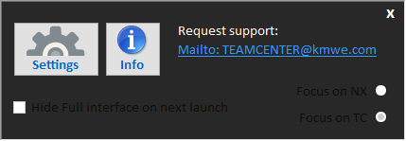If the user clicks the splash screen, the settings panel pops up.
  + When the settings are  
      
    closed teamcenter will be launched.
* NX software installed
  + Run for the 1st time:
    - The NX version and group settings have to be selected under the flag-down button , before the Launch NX Manager function will become available.
    - User can launch the desired application
  + Run next time:
    - Last selected NX version and group are restored and selected.
    - User can launch Teamcenter by hitting <enter> or <space bar> or click a launch button
  + User can select other NX version / environment if desired.
  + User can specify under Settings, witch function/button should receive the focus when launched.  
    in other words, Witch application to start when hitting <enter> or <space bar>
  + 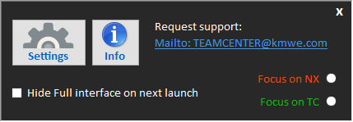User can choose to hide the interface completely -if always the same version, env. and application is used-.   
    With this option checked the next time the user will only see a splash screen for a few seconds and the focused application will be launched.  
    To get back to the settings the user has to click in the splash screen to switch to the full interface again.
* If Teamcenter was already running when the user launches it again, a message is displayed that a session is already running and the software closes without action.
* Users are encouraged to report any issues on Teamcenter to the Teamcenter mailbox (Key-users have access)

## Interface

If no NX software is installed only a Splash screen is displayed



(No NX) click

(With NX and Hide full...) click

Full version

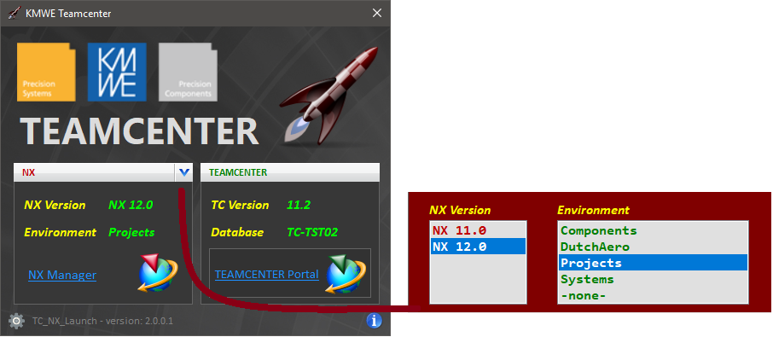



If an environment is not found for the selected version, the launch buttons disappear

This documentation

## Administration

Written in: Microsoft Visual Studio 2017

Language: C# (C sharp)

Framework: .NET Framework 4.5 or higher

Author: [Patrick.delisse@dutchaero.nl](mailto:Patrick.delisse@dutchaero.nl)

### Installation

Software doesn’t need to be installed on clients. It can be run directly from the server.

In the Bin folder there is a script _KMWE_SetShortcut_Launch.vbs that creates shortcuts 1 level above.

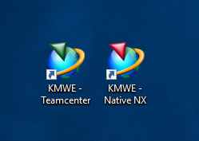A shortcut to this software will be placed on users’ desktop by IT

When software runs and an NX installation is found on the client, a shortcut to launch native NX is placed on the user desktop

### Server layout

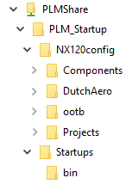

NX configuration for each version

Custom environment for department Components

If no group was selected, take the -out of the box- environment

Shortcut to this software and default Cards PLM shortcuts

Location of this software and the batch files

### Settings

The program needs some ‘company-wide’ settings that can be set in a text (XML) file  and a few ‘user-settings’ that will be stored in the user-profile (registry) and on the server

Company settings:

* Teamcenter version: <TC_ver>11.2</TC_ver>
* Teamcenter server: <TC_server>XXXXXXX</TC_server>
* Batch file to start: <TC_bat>PLMShare\PLM_Startup\Startups\bin\_KMWE_PLM_start.bat</TC_bat>
* Batch argument TC: <TC_portal>4TPortal</TC_portal>
* Batch argument NX: <TC_NXman>4TManager</TC_NXman>
* Fixed NX version in TC: <TC_FixedNX>yes</TC_FixedNX>
* Fixed NX version: <TC_FixedNXver>11</TC_FixedNXver>
* NX version: <NX_AppName>NX 11.0</NX_AppName>  
   <NX_AppName>NX 12.0</NX_AppName>  
   Etc..
* NX custom env. <GroupName>Components</GroupName>  
   <GroupName>DutchAero</GroupName>  
   <GroupName>Projects</GroupName>  
   <GroupName>-none-</GroupName> Use *out of the box* settings from the default NX installation

UserSettings

When user selects an NX installation and customer environment -to launch NX or Teamcenter-, this selection is stored in the user registry:

Key: HKEY_CURRENT_USER\Software\KMWE\NX_Select\Defaults\CustomGroup

Key: HKEY_CURRENT_USER\Software\KMWE\NX_Select\Defaults\NXversion

Other user settings in registry are:

Key: HKEY_CURRENT_USER\Software\KMWE\NX_Select\Defaults\FocusApp

Key: HKEY_CURRENT_USER\Software\KMWE\NX_Select\Defaults\HiddenInterface

The next time the program is started the stored selection is activated and user does not need to reselect.

To store user specific NX settings, a folder is used on location: TeamcenterServer\UserPrefs$\NXversion\userinitials

This will be set by batch file: _KMWE_PLM_profilevars.bat. Folder will be created if it doesn’t exist and if client has NX installed. Folder UserPrefs$ is hidden and writable for everyone within KMWE.

### Resources (Batch files)

Program makes use of several BAT files, some supplied by Cards PLM as part of the standard PLM installation, some specific to KMWE:

* _KMWE_PLM_start.bat  
  This file is a copy of the regular PLM_start.bat file supplied by Cards PLM with one change:  
  call %SCR_PATH%\PLM_profilevars.bat %VERSION_Nx%   
  will be   
  call %SCR_PATH%\_KMWE_PLM_profilevars.bat %VERSION_Nx%
* _KMWE_PLM_profilevars.bat  
  This file is has major differences from the one supplied by Cards PLM. See Details.

## Set up NX Custom Environment

The NX environment to be used is controlled by environment variables that are set in 4 levels.

1. level is to set company-wide variables and specification of a specific group environment.
2. level is to set the group specific variables.
3. level is to set group specific, -only-NX variables
4. level is to set required NX variables that was not set in one of the above levels, to the default -out of the box- value

### 1st level Environment Variables

_KMWE_PLM_profilevars.bat  
In here several Teamcenter and NX variables are set. See complete list

This file is has major differences from the original PLM_profilevars.bat, supplied by Cards PLM.

(Teamcenter variables used are equal to the original PLM_profilevars.bat)

* Reading the chosen NX version from the registry. If no registry entry is found than use a default version specified here
* Reading the chosen Group from the registry  
  If no registry entry is found than use the default -out of the box- NX settings
* Setting of the NX license server;   
  DutchAero uses a different license server than the rest of KMWE  
  Some machines have a node-locked license that are set here
* Finding the NX installation on local machine
* Setting and checking folder locations
* Sets the location for the groups specific NX<group>env.dat file (3rd + 4th level)
* Setting several general variables
* Call 2nd level if it exists

### 2nd level Environment Variables

Startup_TC_NX<nx version>_<group>.bat  
Can be used to set group specific -non NX- variables. An example is to specify Vericut environment variables that are used by the NX-Vericut plug-in.

File is not mandatory.

### 3rd & 4th level NX Variables

NX<group>env.dat  
This file contains any NX variable that is set to a different value than the -out of the box- default and needs to contain at least the following lines to set 4th level variables:

#if FILE ${UGII_BASE_DIR}\ugii\ugii_env_ug.dat

#include ${UGII_BASE_DIR}\ugii\ugii_env_ug.dat

#endif

### Variables set by _KMWE_PLM_profilevars.bat

|  |
| --- |
| ENV_bin = %PLM_ENV%\startups\bin |
| ENV_NX = %PLM_ENV%\NX%NX_Version%config\%NX_Group% |
| ENV_TC = %PLM_ENV%\TC%TC_Version%config |
| ENV_tools = %PLM_ENV%\startups\tools |
| ENV_UserPrefs = \\%PLM_SERVER%\UserPrefs$ |
| FMS_HOME = %TC_ROOT%\tccs |
| JAVA_HOME = %TC_JRE_HOME% |
| JRE_HOME = %TC_JRE_HOME% |
| LOCAL_USER_DATA = c:\Local_data |
| NX_CUSTOM_DIR = %ENV_NX% |
| NX_CUSTOMER = %NX_Group% |
| NX_CUSTOMER_DEFAULTS_DIR = %ENV_NX%\CustomerDefaults |
| NX_Group = read from registry |
| NX_GROUP_SETTINGS = %ENV_NX%\StartUp_TC_NX%NX_Version%_%NX_Group%.bat |
| NX_USER_DEFAULTS_DIR = %USER_PREF_DIR%\UserDefaults |
| NX_Version = %%M |
| NX_VERSION_STR = nx version + release packs etc. |
| PLM_ENV = %PLMShare%\PLM_Startup |
| PLM_ENV_TYPE = |
| PLM_SERVER = TC-xxx02 |
| PLMShare = \\%PLM_SERVER%\plmshare |
| SET NX_Version = 120 |
| SET TC_Version = 112 |
| SPLM_LICENSE_SERVER = 28000@server name |
| TC_DATA = %PLMShare%\TcData%TC_Version% |
| TC_KEEP_SYSTEM_LOG = Y |
| TC_LOG = %TEMP_TC% |
| TC_ROOT = %INSTALL_DIR%\Tc%TC_Version%%TIER%%PLM_ENV_TYPE% |
| TC_TMP_DIR = %TEMP_TC% |
| TCP_NODELAY = 1 |
| TCWEB_PORT = 8080 |
| TCWEB_SERVER = TC-xxx01 |
| TEMP = c:\temp |
| TEMP_NX = %TEMP%\NX%NX_Version% |
| TEMP_TC = %TEMP%\TC%TC_Version% |
| TIER = |
| TPR = %TC_ROOT%\portal |
| UG_VERSION = V.... |
| UGII_BACKGROUND_URL = %ENV_NX%\nx_background.jpg |
| UGII_BASE_DIR = %str1:\ugii\ = % |
| UGII_ENV_FILE = %ENV_NX%\NX%NX_Version%env.dat |
| UGII_LOAD_OPTIONS = %USER_PREF_DIR%\load_options.def |
| UGII_ROOT_DIR = %UGII_BASE_DIR%\NXBIN |
| UGII_ROUTE_UGMANAGER_MODE = FALSE |
| UGII_ROUTING_KIT_UNITS = metric |
| UGII_TMP_DIR = %TEMP_NX% |
| UGII_UGDOC_BASE = http://%TCWEB_SERVER%:8181 |
| UGII_USER_PROFILE_DIR = %USER_PREF_DIR% |
| UGS_LICENSE_BUNDLE = NX..... |
| UGS_LICENSE_SERVER = %SPLM_LICENSE_SERVER% |
| USER_PREF_DIR = %ENV_UserPrefs%\NX%NX_Version%\%USERNAME% |