Supplementary figure 1. An example of artifact detection using the Hilbert transform method
(Top) A 4s stretch of broadband data signal centered around a sharp-wave transition. (bottom) False detection of significantly increased 50-250Hz power by the method used in the study (see Fig. 3). Notice the characteristic pattern of wide-band power increase associated with the sharp transient in the signal, contrasted by HFO detections of specific frequency, lower amplitude and discrete duration (see Fig. 3). Note: every single trial used in the study was inspected for the presence of such sharp-wave patterns and the associated pathological HFOs (Worrell and Gotman, 2011, Matsumoto et al., 2013a). Data signals with more than 30% trials with such activity and/or 60Hz line noise were excluded from the study (see Materials and Methods).

Supplementary figure 2. Induced HFO responses range up to approximately 600Hz
(Left) Spectrogram shows normalized trial-averaged power changes (as in Fig. 2) recorded from a prefrontal cortical electrode in patient 7 during recall stage of the task. Note: multi-taper spectral analysis was adjusted to the extended frequency scale by increasing the taper parameter bandwidth from 4 to 20Hz and the total number of tapers to 10 (arrowhead on the power scale points to Jackknifed upper error estimate at p < 0.01 significance level; white arrow points to the highest frequency reaching the Jackknifed error limit). (right) Cumulative scatterplot of the detected HFOs (see Fig. 2) across a 50-800Hz range (aligned to the spectrogram's frequency axis) is summarized by the top plot of mean trial counts binned across the trial time-course. Notice that bins with significant increase in HFO detections, assessed by comparison to baseline (see Fig. 2; Wilcoxon signed-rank test, * p < 0.01, 140 trials), span the time-course of image presentation and were recorded beyond the viewing period at the time of rating of the presented image (the time of prompt recall question is indicated by the black arrow).

Supplementary figure 3. Induced HFOs during memory recall.
This figure is plotted analogous to Fig. 4 but for the memory recall stage (see Fig. 4 for details of the figure legend). Notice high degree of overlap with the results obtained for the encoding stage, confirming consistency and reproducibility of the reported HFO properties. The latencies of the HFOs induced in the temporal and frontal cortex are significantly longer during memory recall than during encoding in Fig. 4 (see also Fig. 5).

Supplementary figure 4. Induced HFOs reveal discriminative responses to affective images.
This figure is plotted analogous to Fig. 7 to provide example of significantly different responses to trials with affectively images (one amygdala electrode from patient 8). Notice that in this example both the ripple and fast ripple band HFOs are significantly induced in response to affectively charged but not neutral images, in contrast to gamma HFOs which do not discriminate the pictures' affective valence.

Supplementary figure 5. Patient contribution of the electrodes used in the study.
(A) Number of electrodes included in the analysis (outside of seizure onset zone and showing no interictal epileptiform discharges; see Materials and Methods) are broken down into the six structures studied (OC, PH, HP, AM, TC, FC; color-coded). Notice that although no patient had electrodes implanted in all six structures (brain targets were determined solely by clinical requirements), half of the patients contributed data from at least three structures. (B) Bar plot shows how many of the electrodes used in any one patient (as summarized in ‘A’) noted significant induction of HFOs in the task (y-axis same as in ‘A’ for comparison). The percentage on top of each patient’s count signifies the proportion of the aggregate count of electrodes that showed significant HFO induction across all patients (summarized in the pie chart above). Notice that significantly induced HFOs were observed in at least two electrodes in all patients, except for patient 1, and their proportion varied from 1-28% of all the electrodes with HFO responses. Note: both plots present total counts from the encoding and recall stages of the task.

Supplementary table 1. Number of electrodes used in the analysis of encoding and recall stages of the task

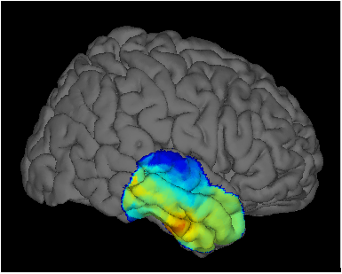
Supplementary video 1. Gamma HFO (50-125Hz) power changes recorded on temporal cortical surface electrodes during memory encoding
See Fig. 1 for more details.

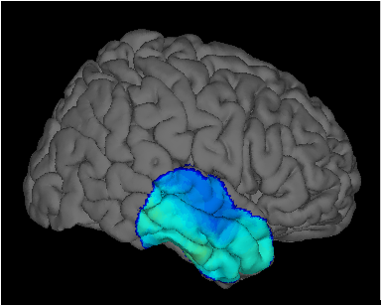
Supplementary video 2. Ripple HFO (125-250Hz) power changes recorded on temporal cortical surface electrodes during memory encoding
See Fig.1 for more details.

Supplementary video 3. Fast-ripple HFO (250-500Hz) power changes recorded on temporal cortical surface electrodes during memory encoding
See Fig. 1 for more details.

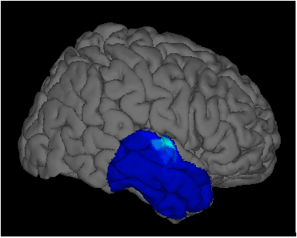
Supplementary video 4. Low frequency (4-15Hz) power changes recorded on temporal cortical surface electrodes during memory encoding
See Fig. 1 for more details.

