Database Tutorial Exercise

1. Return all actors whose last names are ALLEN from the actor table

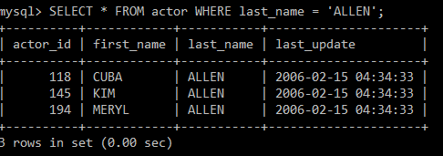

2. Return all the actors who’s last_name column has a value DAVIS, and the row’s first_name has a value SUSAN.

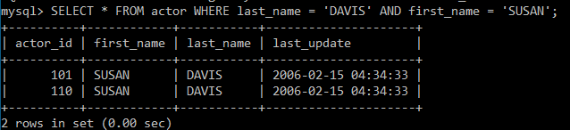

3. Return all actors where last_name column has a value ALLEN or DAVIS.

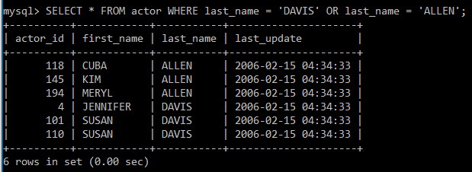

4. Return the number of categories which have a name that does not start with the letter A.

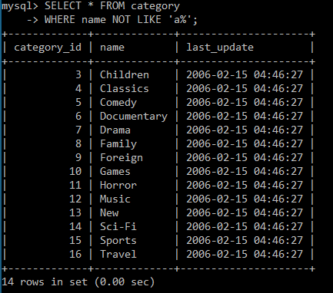

5. Return all actor names and the name of each film title they were in.

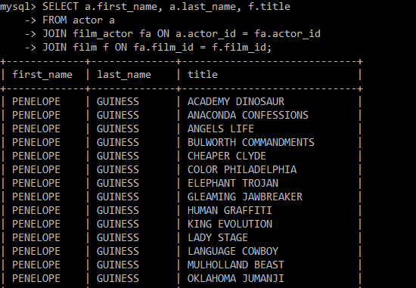

6. Return the title, release year, and category of all movies.

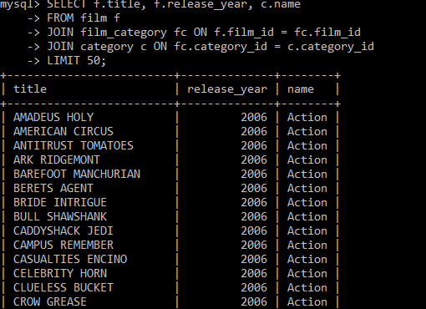

7. Return how much JOHNNY TURPIN has spent on movie rentals.

8. Return the name of the customer that has spent the most of movie rentals, include the amount they have spent.

9. Return all movie title, release year, actor name and category where the actor first_name is ‘Sean’

10.1 Return top 10 customers that have spent the most money on rentals. Include the customer name, rental id and the total spent.

I had to use MAX for the rental_id because it wouldn’t let me otherwise. Because of the ‘only_full_group_by’.

10.2 Return the top 10 most popular rental films. Include the titles and the number of times they’ve been rented.

10.3 Return the rental history of Jamie Waugh. Include the rental date, return date, film title, rental duration, and the customer’s full name.

10.4 Return the total number of rentals made in each month of the year 2005.

10.5 Return the average rental duration for each category of films.

10.6 Return the top 10 actors who have starred in the most rental films, including their names and the number of films they have starred in.

10.7 Return the rental history for a specific film, including the rental date, return date, customer name, and rental duration in days.

10.8 Return the customers that have rented a film from store 1 in May 2005. The film needs to be PG-13. Order results by rental date in descending order.

