Integrating Vision and Multimodal Language Models for Collaborative Building Footprint Quality Assessment
Extracting building footprints has been an important topic in remote sensing for many years. Most methods are based on deep learning and convolutional neural networks (CNNs), which are trained on large datasets for specific use cases (Luo et al., 2021; O’Shea & Nash, 2015). These models have been used in many fields, such as disaster management, urban planning, and infrastructure monitoring (Awrangjeb et al., 2012). However, CNNs are limited because they need large labeled data and do not generalize well to new areas.
In recent years, with the rise of artificial intelligence, researchers have started to use foundation models instead of classical CNNs. The Dense Prediction Transformer (DPT) by Ranftl, Bochkovskiy, and Koltun (2021) was one of the first to show how transformer-based models can replace CNNs. These new models can look at the whole image at once and make more coherent predictions.
Today, research is moving toward combining visual foundation models with multimodal large language models (MLLMs) (Wu & Gan, 2023). These models can understand both text and images and are being studied for how well they can process spatial data (Ji & Gao, 2023) and interact with vision models (Wang et al., 2024). In remote sensing, first studies have started to combine these two types of models (Chen et al., 2024), usually so that the language model helps describe or guide what the visual model should segment.
My project takes a different approach. Instead of using the language model to control the vision model, I want to generate rough building polygons with a visual foundation model and then use a multimodal language model to check and evaluate them. The language model will identify possible errors and suggest how to improve the polygons. This is my research gap combining these two model types in a new way. Although the focus is on building footprints, the same idea could also be used for other remote sensing quality checks.
- RQ1: How accurately can MLLMs detect and describe typical geometric errors in building polygons?
- RQ2: How can the feedback from an MLLM be converted into spatial prompts to refine segmentation results?
- RQ3: How does the combined pipeline perform compared to conventional CNN-based approaches?
I tested this approach using two foundation models. As the multimodal large language model (MLLM), I used the OpenAI API with GPT-5, and as the visual model, I used SAM. Both models are pretrained on a large amount of data (see On the Opportunities and Risks of Foundation Models, Bommasani et al., 2021) and therefore do not necessarily require additional fine-tuning.
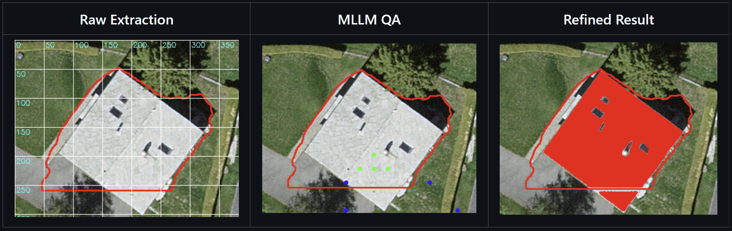
For the final master’s thesis, it still needs to be decided whether foundation models such as SAM, GPT, LLaVA 1.6 / 1.7 (Vicuna-13B), or InternVL 2 (20B) will be used, or if instead specific models will be trained for this task (e.g., LaMa v or similar architectures).
As a reference and benchmark, the TLM model from swisstopo will be used together with swisstopo aerial imagery ( .....). The dataset is subject to licensing agreements that restrict its use with commercial services such as the OpenAI API ( link to agreement licencing). Therefore, the goal is to use an open-source multimodal model that can be run locally in a Docker container or on a Swiss-based server to ensure compliance with data protection and licensing requirements.
Regarding the motivation and purpose of this work:
The task of building footprint extraction originates from the geospatial industry, for example at swisstopo, where according to a short informal interview with an operator there is still no fully operational automated system capable of reliably generating building footprints for new or changed buildings.
The overall goal of this study is to explore whether combining visual and multimodal foundation models can improve the last missing 10 % of correctness that often remains in existing deep-learning-based extraction workflows (see … ). By adding an additional quality-assurance layer before the final building footprint generation, the system could provide a more accurate and reliable footprint suggestion, reducing manual post-editing and improving production efficiency.
Period | Phase | Key Tasks & Milestones
Nov – Dec 2025 | Literature Review & Concept Development | - Read and summarize core papers (CNNs → DPT → SAM → MLLM).  - Define research questions, objectives, and hypothesis.  - Write Introduction draft and Theoretical framework.  - Set up environment (Docker, GPU access, Swisstopo data).  Milestone 1: Approved proposal & first theory draft.
Jan – Feb 2026 | Visual Model Implementation (SAM / DPT) | - Implement footprint extraction workflow.  - Evaluate baseline results (IoU, precision, recall).  - Continue writing Methodology – Part 1 (Visual Model).  Milestone 2: Working baseline & documented visual workflow.
Mar 2026 | MLLM QA Integration | - Implement and test MLLM evaluation stage (GPT-4V, LLaVA, etc.).  - Define JSON schema for issues & suggestions.  - Draft Methodology – Part 2 (MLLM QA).  Milestone 3: Functional QA pipeline with description in text.
Apr – May 2026 | Model Coupling & Framework Development | - Integrate MLLM + Visual Model into single pipeline.  - Automate improvement suggestions and feedback loop.  - Update Methodology with diagrams and flowcharts.  Milestone 4: Prototype framework complete & method fully written.
Jun 2026 | Evaluation & Analysis | - Run large-scale experiments on Swisstopo dataset.  - Compare performance vs. baseline and between models.  - Begin Results chapter (quantitative tables, figures).  Milestone 5: Evaluation dataset processed & first results written.
Jul – Aug 2026 | Discussion, Conclusion & Finalization | - Write Discussion, Conclusion, and Abstract.  - Final proofreading, formatting, and supervisor feedback.  - Prepare presentation (if required).  Milestone 6: Final thesis submission (mid-August).

Literature:
Awrangjeb, M., Zhang, C., & Fraser, C. S. (2012). Automatic extraction of building footprints and roof structures from airborne LIDAR data. IEEE Transactions on Geoscience and Remote Sensing, 50(7), 2258–2278.
https://doi.org/10.1109/TGRS.2011.2171975
Bommasani, R., Hudson, D. A., Adeli, E., Altman, R., Arora, S., von Arx, S., ... & Liang, P. (2021). On the opportunities and risks of foundation models. Stanford Institute for Human-Centered Artificial Intelligence.
https://arxiv.org/abs/2108.07258
Chen, Y.-C., Li, W.-H., Sun, C., Wang, Y.-C. F., & Chen, C.-S. (2024). M3RS: Multi-modal multi-resolution remote sensing model for segmentation and understanding. arXiv preprint arXiv:2406.09385.
Ji, Y., & Gao, S. (2023). Spatially grounded multimodal foundation models for geographic artificial intelligence. Computers, Environment and Urban Systems, 103, 102036.
https://doi.org/10.1016/j.compenvurbsys.2023.102036
Luo, L., Xu, Y., & Li, X. (2021). Automatic building footprint extraction from very high-resolution imagery using deep learning techniques. ISPRS Journal of Photogrammetry and Remote Sensing, 178, 1–15.
https://doi.org/10.1016/j.isprsjprs.2021.06.011
O’Shea, K., & Nash, R. (2015). An introduction to convolutional neural networks. arXiv preprint arXiv:1511.08458.
Ranftl, R., Bochkovskiy, A., & Koltun, V. (2021). Vision transformers for dense prediction. Proceedings of the IEEE/CVF International Conference on Computer Vision (ICCV), 12179–12188.
https://arxiv.org/abs/2103.13413
Wang, J., Zhou, J., Xu, Y., & Zhang, T. (2024). A survey on multimodal large language models: From pre-training to applications. arXiv preprint arXiv:2404.08767.
Wu, J., & Gan, W. (2023). A survey on multimodal large language models: Vision, language, and beyond. arXiv preprint arXiv:2310.01845.
swisstopo (2025). Topographic Landscape Model (TLM) and Orthophotos – Licensing Information.
https://www.swisstopo.admin.ch/en/geodata/landscape-model.html

Additional Sources:
Chen, X., & Koltun, V. (2021). DPT: Dense Prediction Transformer – Supplementary Material.
https://github.com/intel-isl/DPT
Ji, Y., Li, D., Gao, S., & Goodchild, M. F. (2024). Multimodal geographic foundation models. arXiv preprint arXiv:2412.07899.
Wang, Y., Zhou, J., Xu, Y., & Zhang, T. (2024). Integrating vision and language foundation models for geospatial intelligence. arXiv preprint arXiv:2402.04788.
Luo, L., Wang, M., Zhang, Z., & Li, X. (2023). Automatic detection of residential buildings using convolutional neural networks. Remote Sensing Letters, 14(3), 210–219.

