Integrating Vision and Multimodal Language Models for Collaborative Building Footprint Quality Assessment
Extracting building footprints has long been an essential task in aerial imagery interpretation and GIScience, supporting applications such as disaster management, urban planning, and infrastructure monitoring (Awrangjeb et al., 2010). Accurate and up-to-date building footprints are not only required by national mapping agencies for maintaining topographic databases but also play a critical role in crisis situations (Zheng et al., 2021) for example, after hurricanes in Jamaica, earthquakes in Afghanistan, or the war in Ukraine (Aimati, 2023). While global AI-generated datasets such as Google Open Buildings (Google Research, 2023) greatly expand spatial coverage, they still contain substantial geometric errors including oversimplified outlines, missing building parts, and false positives (Figure 1, Sirko et al. 2021). These limitations mean that even with recent advances in deep learning and remote sensing automation building footprint datasets still require extensive manual verification.
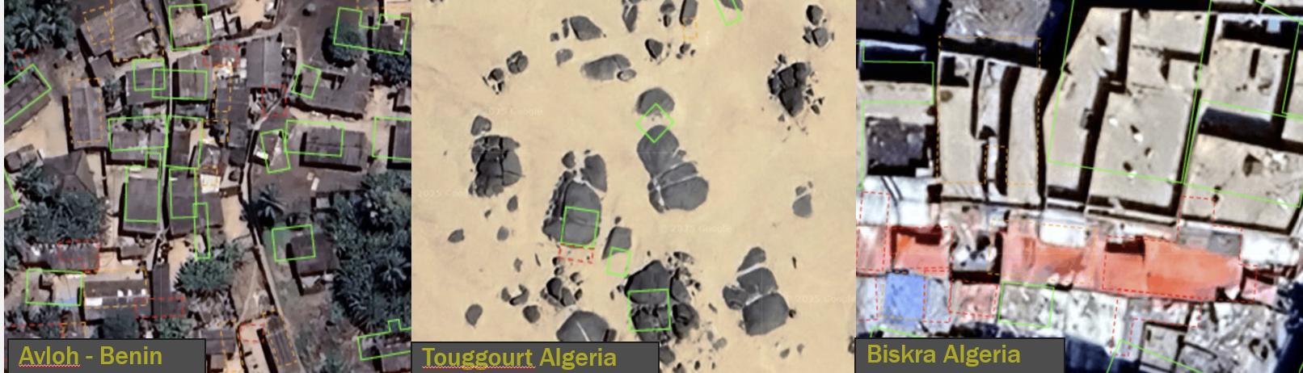
Figure 1 Examples from the Google Open Buildings Explorer (accessed on 26 Nov 2025)
The proposed workflow will therefore focus on evaluating and improving existing building polygons, rather than generating new ones. For the development of the method, Google Open Buildings provides an ideal starting point, as it is globally available and exhibits a wide variety of real-world errors across different countries. High-quality data from Switzerland, such as authoritative building footprints and aerial imagery, can serve as a benchmark for controlled development and evaluation of the workflow. Once the approach is established and performs well, specific locations will be selected where it’s tried to improve the Google open building Dataset. This will allow the method to be tested in more challenging real-world GIS situations and to demonstrate its performance across diverse geographic and imaging conditions.
In recent years, with the rise of artificial intelligence, researchers have increasingly explored the use of foundation models instead of traditional deep learning architectures. Most deep learning models (including CNNs) rely on large, labeled datasets and often generalize poorly to new domains. The Vision Transformer (ViT) (Dosovitskiy et al., 2020) was one of the first transformer-based models for vision tasks, demonstrating that attention mechanisms can effectively replace convolutional operations. Building on this idea, the Dense Prediction Transformer (DPT) (Ranftl et al., 2021) further showed that transformers can produce coherent, global predictions for dense visual tasks. Recently, research has moved toward integrating visual foundation models with multimodal large language models (MLLMs) (Wu & Gan, 2023). These models can process visual and textual information, offering new ways to interpret and reason about spatial data (Ji et al., 2025). In GIScience, such approaches could be crucial for enhancing spatial reasoning and enabling automated analysis of geospatial features beyond pixel-level classification. Early studies have begun to explore these combinations (Zhou et al., 2024), typically by allowing the language model to guide the visual model’s segmentation process.
My project takes a different approach. Instead of using a language model to directly control what a vision model should segment, I propose a two-step framework in which the MLLM evaluates the segmentation output rather than guiding the segmentation process itself. This clearly separates assessment and correction. In the first stage, imperfect building polygons either from Google Open Buildings or from a deliberately degraded Swiss dataset are used as the starting point. These polygons are then evaluated by a multimodal large language model (MLLM), which identifies geometric inconsistencies, describes them semantically, and suggests how they should be improved. In the second stage, a visual foundation model uses this feedback to apply targeted geometric refinements to the polygon, for example by adjusting edges, adding missing parts, or removing false positives. This two-step design is valuable because it addresses key limitations of current one-step or end-to-end approaches, which typically require large labeled datasets and are difficult to adapt across regions or data domains. By decoupling generation, evaluation and correction the proposed workflow allows for clearer feedback loops and greater flexibility in integrating automated quality assurance into geospatial production processes. The research gap lies in the limited transfer of such multimodal, feedback driven AI approaches to GIScience, particularly in the automated quality assessment of vector based building footprints.
Rough Research questions:
- RQ1: How accurately can multimodal large language models (MLLMs) detect and describe typical geometric errors in building polygons?
- RQ2: How effective is the conversion of MLLM generated feedback into spatial refinements for improving the geometric quality of building polygons?
- RQ3: How well does the workflow improve and validate building footprints in a real global dataset like Google Open Buildings across different regions?
I tested this approach using two foundation models. As the multimodal large language model (MLLM), I used InternVL-8B (https://huggingface.co/OpenGVLab/InternVL2-8B), and as the visual model, I used the Segment Anything Model (SAM) developed by Meta AI (Kirillov et al., 2023 ; https://github.com/facebookresearch/sam2 ). Both models are foundation models and are therefore pretrained on a large amount of data (Bommasani et al., 2021) and do not necessarily require additional fine tuning.
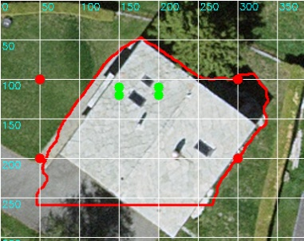
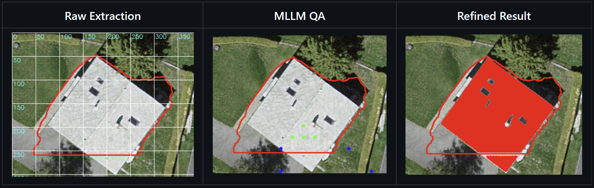
Figure 2 Overview of the tested workflow. Raw Extraction shows the initially generated building polygon with an overlaid grid used for MLLM processing. MLLM QA illustrates the quality assessment step, where the multimodal language model identifies and suggests geometric improvements. Refined Result displays the final building footprint after applying the suggested refinements (in solid red).
For the final master’s thesis, it still needs to be decided which foundation models such as SAM3, Qwen VL (30B), or InternVL 2 (8B), SenseNova-SI-InternVL3-8B will be used.
As a reference and benchmark, the workflow will first be developed using artificially degraded building footprints, together with SwissImage aerial imagery and the high-quality swisstopo TLM dataset (swisstopo, 2025). This controlled setting allows the method’s behaviour to be evaluated systematically and enables the development of automated benchmark metrics based on authoritative ground-truth data. After the approach has been validated in this Swiss setting, it will be applied to selected real-world regions from the Google Open Buildings dataset, where geometric inconsistencies are more frequent and spatial conditions more diverse. For these international test areas, additional validation can be performed using complementary datasets such as xView2 (xView2 Team, 2019) or comparable publicly available sources. If automated validation is not possible or insufficient, a small set of randomly selected polygons will be inspected manually to ensure the reliability of the evaluation. Because the swisstopo dataset is subject to licensing (Terms of Use) constraints that prohibit the use of commercial APIs such as the OpenAI models, the workflow will rely on an open-source, locally/cloud deployable multimodal model running in Docker or on a Swiss-based server to comply with data protection and licensing requirements.

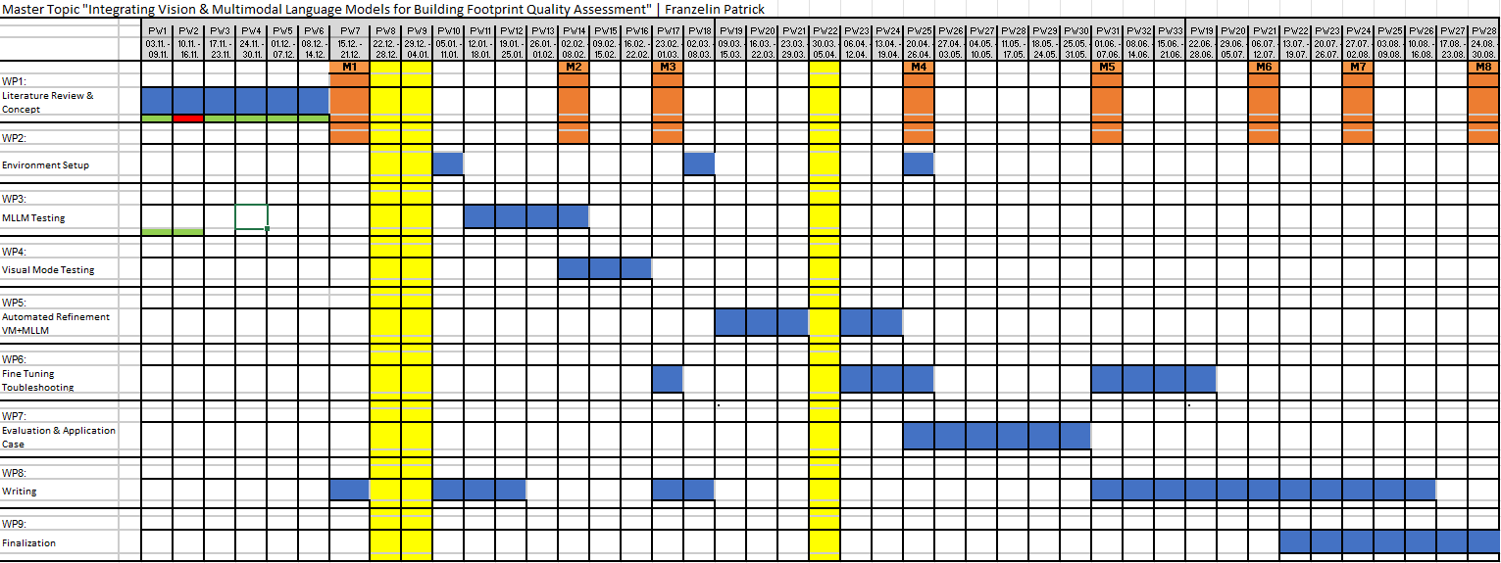
Figure 3 Master thesis timeline showing work packages (WP1–WP9), weekly planning, and key milestones (M1–M8).
M1: Concept & literature overview done
M2: MLLM error detection ready
M3: Visual model refinement ready
M4: Integrated pipeline running
M5: Use-case results ready
M6: Writing until Discussion done
M7: Full writing finished
M8: Submission

AI Statement: ChatGPT 5.1 was used to help generate and structure the timeline table, and to refine the wording. It also supported me in improving sentence structure, understanding, spelling, and grammar. In addition, it assisted with citation formatting.
I confirm that I have checked the accuracy of the AI-generated content to the best of my knowledge and beliefs and I declare that I personally take the full responsibility for this human-machine collaboration outcome.
Literature:
Aimaiti, Y., Sanon, C., Koch, M., Baise, L. G., & Moaveni, B. (2022). War related building damage assessment in Kyiv, Ukraine, using Sentinel-1 radar and Sentinel-2 optical images. Remote Sensing, 14(24), 6239.
Awrangjeb, Mohammad & Zhang, Chunsun & Fraser, Clive. (2013). Automatic Extraction of Building Roofs Using LIDAR Data and Multispectral Imagery. International Journal of Photogrammetry and Remote Sensing. 83. 1-18. 10.1016/j.isprsjprs.2013.05.006.
Adimoolam, Y. K., Poullis, C., & Averkiou, M. (2024). Pix2Poly: A sequence prediction method for end-to-end polygonal building footprint extraction from remote sensing imagery. Proceedings of the IEEE/CVF Winter Conference on Applications of Computer Vision (WACV 2025). IEEE. https://arxiv.org/abs/2412.07899
Bommasani, R., Hudson, D. A., Adeli, E., Altman, R., Arora, S., von Arx, S., ... & Liang, P. (2021). On the opportunities and risks of foundation models. Stanford Institute for Human-Centered Artificial Intelligence.
https://arxiv.org/abs/2108.07258
Ji, Y., Gao, S., Nie, Y., Majić, I., & Janowicz, K. (2025). Foundation models for geospatial reasoning: Assessing the capabilities of large language models in understanding geometries and topological spatial relations. International Journal of Geographical Information Science. (Preprint version compiled June 12, 2025).
Kirillov, A., Mintun, E., Ravi, N., Mao, H., Rolland, C., Gustafson, L., ... & Girshick, R. (2023). Segment anything. In Proceedings of the IEEE/CVF international conference on computer vision (pp. 4015-4026).
O’Shea, K., & Nash, R. (2015). An introduction to convolutional neural networks. arXiv preprint arXiv:1511.08458.
Ranftl, R., Bochkovskiy, A., & Koltun, V. (2021). Vision transformers for dense prediction. Proceedings of the IEEE/CVF International Conference on Computer Vision (ICCV), 12179–12188. https://arxiv.org/abs/2103.13413
Rastogi, A., Singh, A. K., & Sharma, A. (2022). Automatic building footprint extraction from very high-resolution imagery using deep learning techniques. ISPRS Journal of Photogrammetry and Remote Sensing, 183, 176–188. https://doi.org/10.1016/j.isprsjprs.2022.05.006
Wu, J., & Gan, W. (2023). Multimodal Large Language Models: A Survey (arXiv:2311.13165).
Zheng, Z., Zhong, Y., Wang, J., Ma, A., & Zhang, L. (2021). Building damage assessment for rapid disaster response with a deep object-based semantic change detection framework: From natural disasters to man-made disasters. Remote Sensing of Environment, 265, 112636.
Zhou, Y., Feng, L., Ke, Y., Jiang, X., Yan, J., Yang, X., & Zhang, W. (2024). Towards Vision-Language Geo-Foundation Model: A Survey (arXiv:2406.09385).
Datasets and regarding paper:
swisstopo (2025). Topographic Landscape Model (TLM) and Orthophotos. Federal Office of Topography swisstopo. https://www.swisstopo.admin.ch/en/information-topographic-landscape-model
Sirko, W., Kashubin, S., Ritter, M., Annkah, A., Bouchareb, Y. S. E., Dauphin, Y., ... & Quinn, J. (2021). Continental-scale building detection from high resolution satellite imagery. arXiv preprint arXiv:2107.12283.
Google Research. (2023). Google Open Buildings V3 Polygons. Available from Google Earth Engine: GOOGLE/Research/open-buildings/v3/polygons Google for Developers+1
Gupta, R., Hosfelt, R., Sajeev, S., Patel, N., Goodman, S., Raskar, R., & Heim, E. (2019). xBD: A Dataset for Assessing Building Damage from Satellite Imagery. Proceedings of the IEEE Conference on Computer Vision and Pattern Recognition (CVPR) Workshops.
xView2 Team. (2019). xView2: Building Damage Assessment Challenge Dataset. Carnegie Mellon University, Defense Innovation Unit (DIU). https://xview2.org/

