SDC250 – Performance Assessment 1.8
WHERE and ORDER BY Clause
Name: Patrick Gonzalez

Question 1
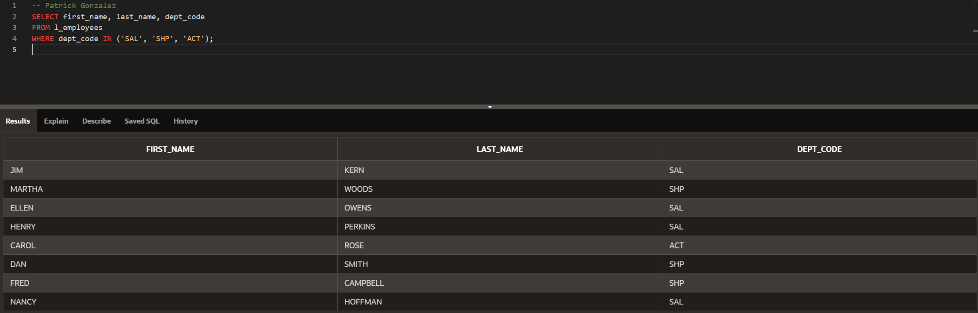

Question 2
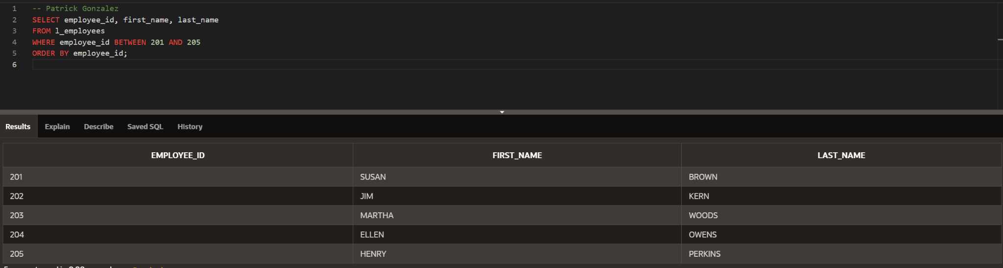

Question 3
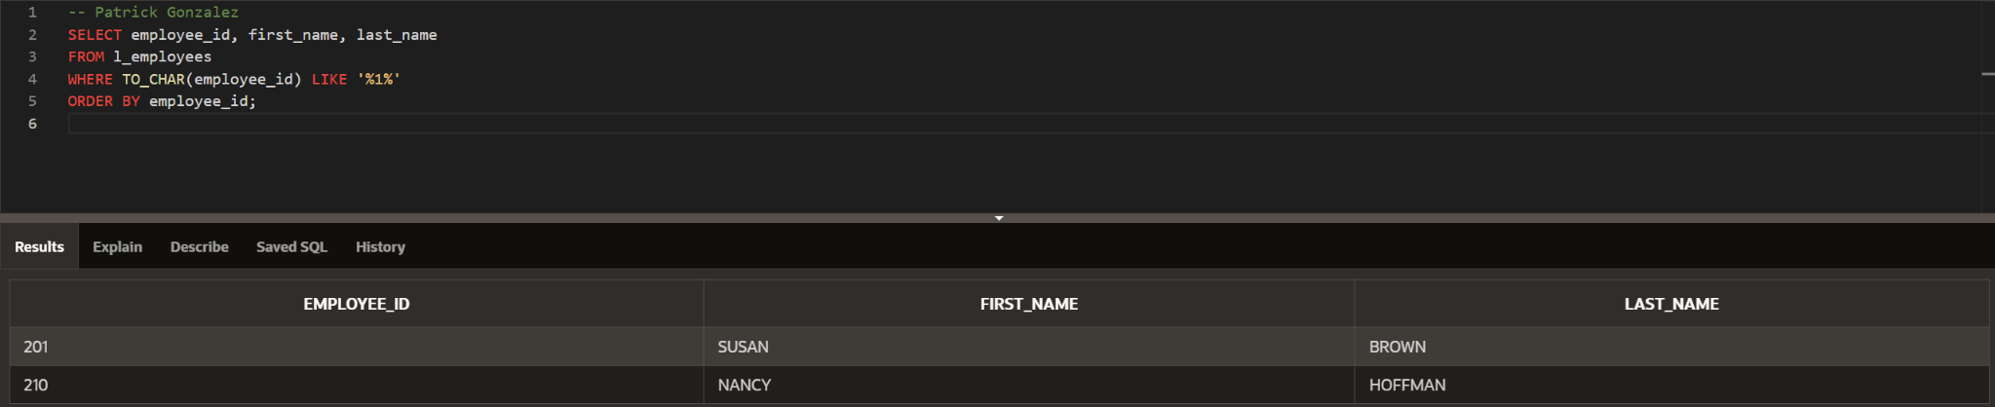

Question 4
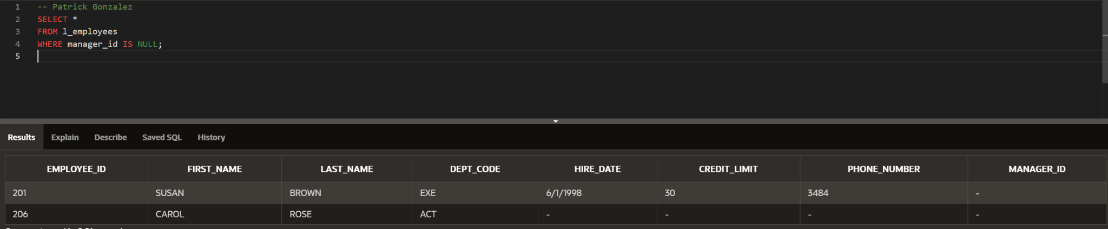

Question 5 – ORDER BY Alias
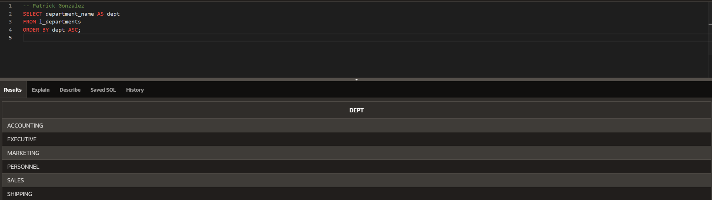

Question 5 – ORDER BY Position
