
QE Cart
Version 4.2

User Instruction Manual
Contents

WELCOME TO QE CART 5
Logging Into the Administration Area: 5
USER OPTIONS 6
Creating a New User: 8
Editing User Accounts: 8
Working With User Groups: 8
Creating a New User Group and Setting Permissions: 10
Settings 11
Shop 12
Local 13
Options 13
Extra Images 14
Mail 15
Server 15
SHIPPING / PACKAGING CONFIGURATION 17
Shipping / Packaging Configuration: Company Modules 17
Shipping / Packaging Configuration: Other Modules 18
PRODUCTS MENU 19
Quick Primer: Categories & Products 19
Managing Categories: 20
Managing Products: 22
Extra Product Images: 26
Product Options (Product Attributes): 27
Specials: 29
Manufacturers / Brand Names: 30
Product Reviews: 31
Downloads: 32
CUSTOMERS MANAGEMENT 33
Managing Customer Records: 34
Order Totals: 35
Customer Points: 35
Discount Members: 35
ORDERS SYSTEM 36
PAYMENT GATEWAYS 38
MODULES 39
CONTENT MANAGER 41
The Page Editor: 42
BANNER MANAGER 44
HEADER IMAGE MANAGER 45
BULK IMAGE MANAGER 47
LINK MANAGER 48
MENU MANAGER 49
BACKUP AND RESTORE 50
REPORTS 51
NEWSLETTERS 52
Creating a Newsletter 52
Managing the Mailing List 53

WELCOME TO QE CART
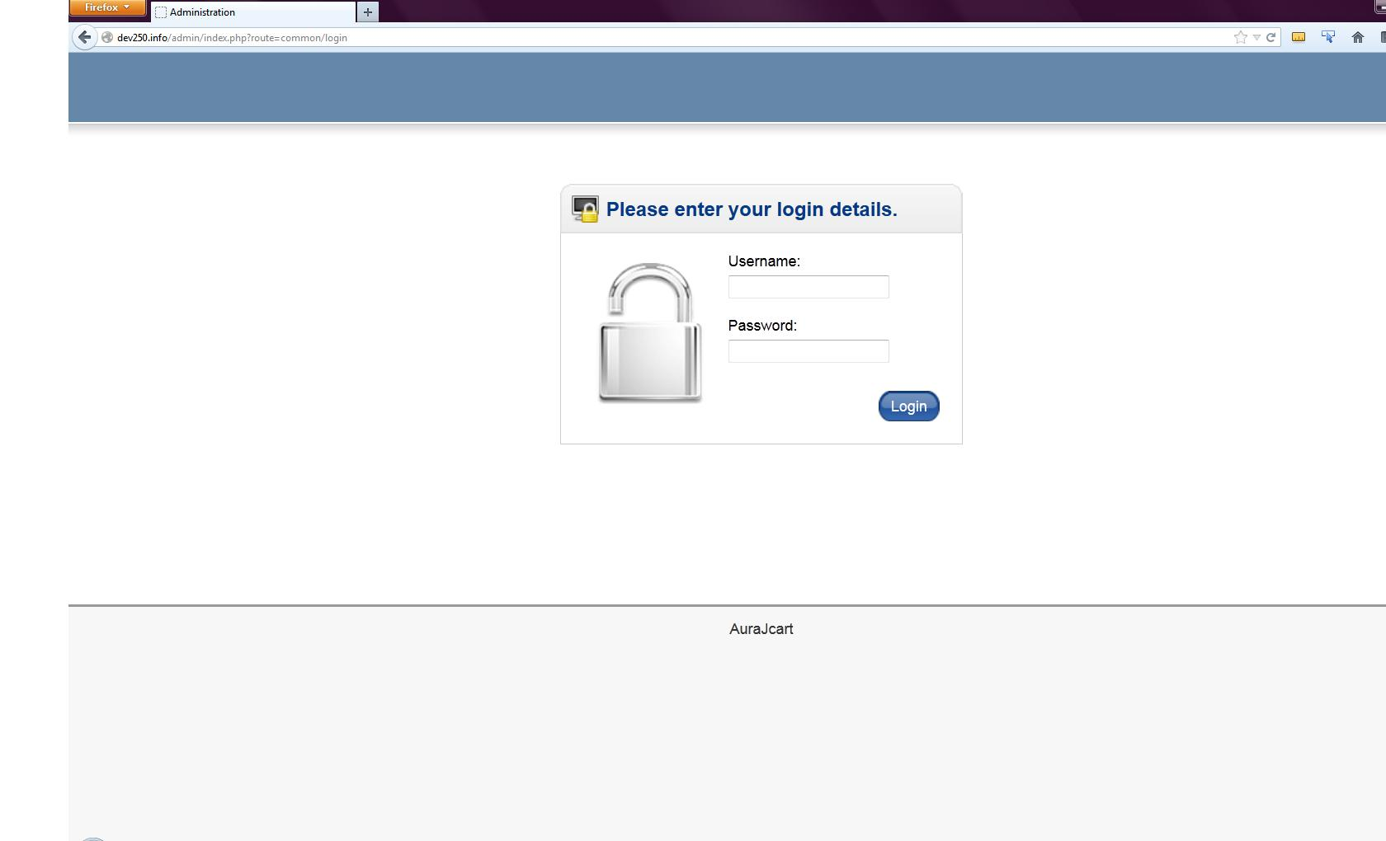

Welcome to your new website! QE Cart is the industry’s most versatile, easy to use and advanced web site ecommerce solution!
Administrator login page

Logging Into the Administration Area:
To begin using the back end administrative functions of QE Cart, you must first log into the back end of your website. Type into your address bar: www.yourdomain.com/admin/login.php. For example, if your web site was www.bobsstore.com then you would type in www.bobsstore.com/admin/ to get to the administrator log in page.
Once at the login page, you enter your administrator username and password, and click the “Login” button to log into your back end. Use the username and password provided to you. You will be taken immediately to the Dashboard for your site.
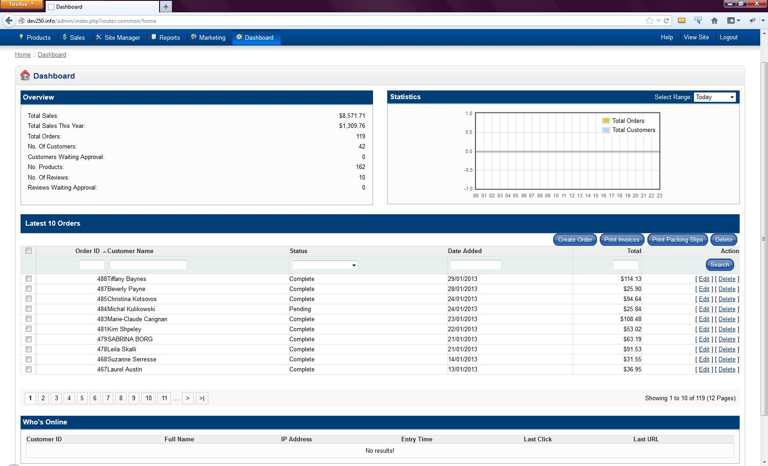
From the dashboard, you will be able to access all of the functions provided by QE Cart. The navigation bar on the top has drop-down menus leading to all the different administation features. The dashboard also provides a summary of sales information, and a list of the most recent 10 sales made on your website.

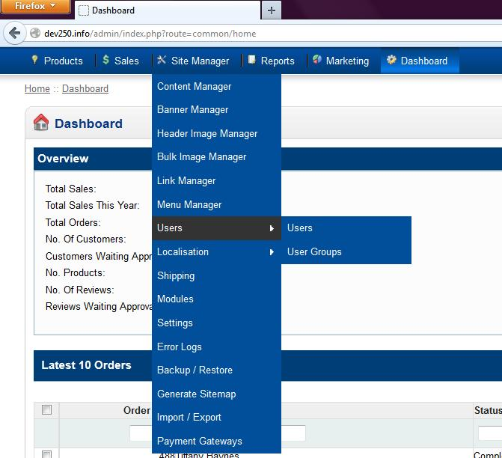
USER OPTIONS

The user options can be accessed from the Site Manager drop-down.

The Users Menu
The user page allows you to add/edit/remove user accounts for your website. The user groups page gives you the ability to create/edit/remove group access levels. Group access levels are a way to control what administrative options are available to administrators.

Creating a New User:
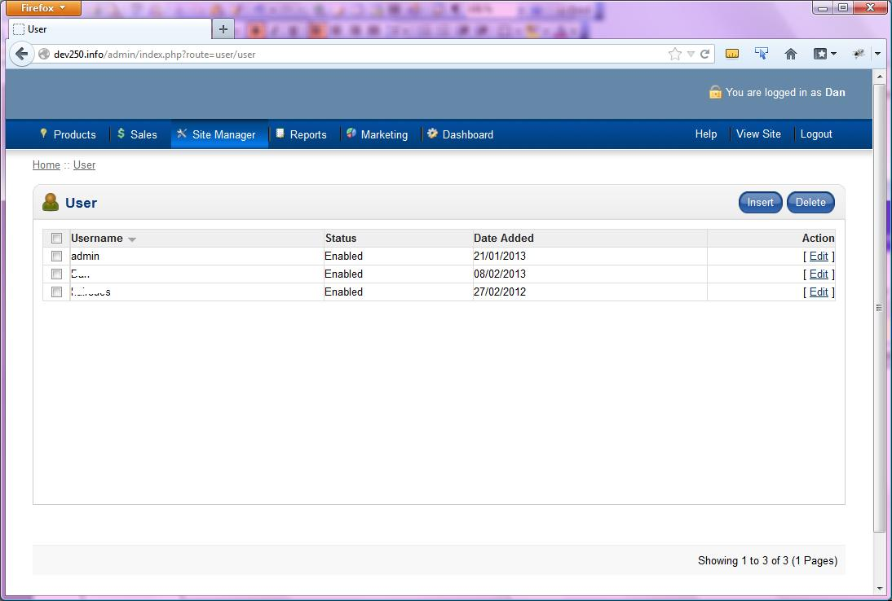
Add a new admin member
To create a new user account, click the “Insert” button. You will be taken to a new page, where you can fill in the information, and select the group level to assign to this account. Make sure, if you want the account to work immediately, to select “Enabled” in the “Status” field. Hit “Save” to create the new account.

Editing User Accounts:
To edit an existing user account, click the “Edit” button that lines up with the username, on the right side. This will take you to the edit page; when you are finished making changes, click “Save”.

Working With User Groups:
User Groups (in the user menu, as shown on the previous page) allow you to control what features of the QE Cart back end your website administrators have access to. By default, QE Cart has 2 groups created for you: Top Administrator and Marketing. The Top Administrator group has full access to all admin functions, and the Marketing group only has access to the orders and sales functions.

Creating a New User Group and Setting Permissions:
Click on “Insert” and enter in the name you wish to give the new group. Now you must assign permissions for what functions will be available for your new group.
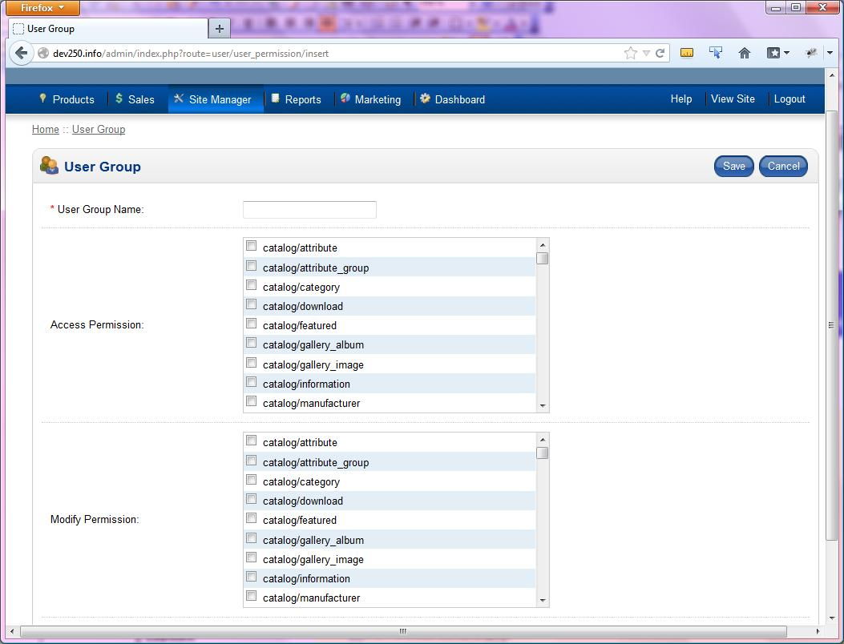
Setting group permissions
Simply click on the box beside any feature to enable access to that function. When this is completed, click the “Save” button to save your selections. You can change these at any time by simply coming back into the Users section of the Administrator menu, clicking the “Groups” button, clicking once on the name of the group you wish to edit, and then hitting the “New Permissions” button.

Settings
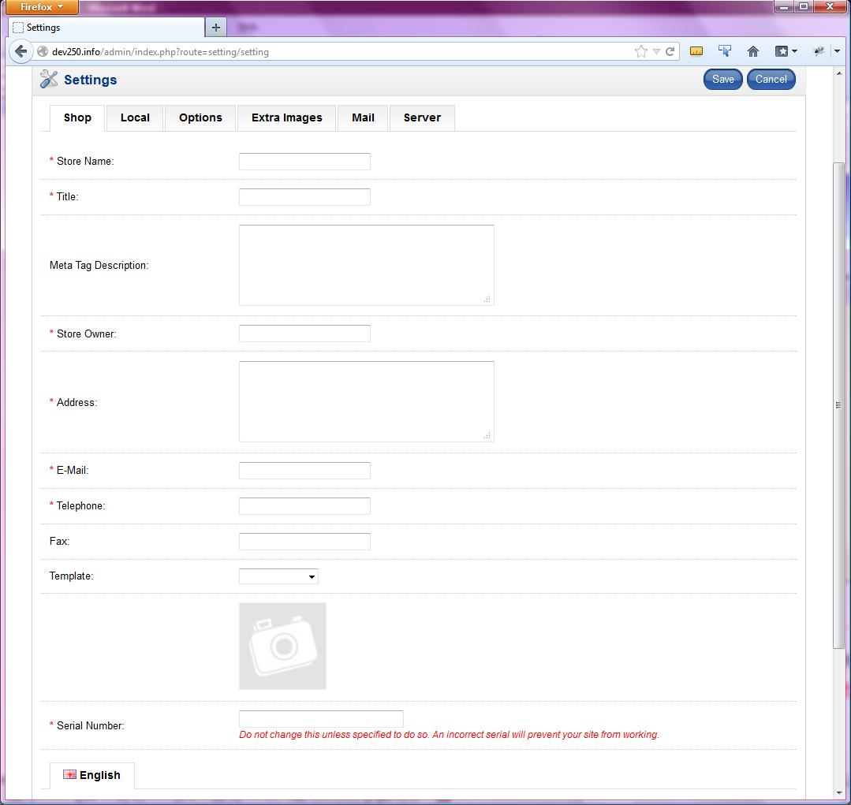
Settings
The “Settings” menu section, found in the “Site Manager” drop-down menu, is a set of pages that allows you to configure general options for your QE Cart shop. Performing edits works just like before: make your changes, and click “Save”. The Settings page has several tabs across the top, labeled Shop, Local, Options, Extra Images, Mail, and Server.

Shop
Store Name: | Enter the name of your site
Title: | Title of the web site (will appear at top of browser window)
Meta Tag Description: | Description of your site, which will appear as the summary of your page in search engine results
Store Owner: | Your name
Address: | Physical address of your business
E-Mail Address: | E-mail address for the site
Telephone: | Telephone number of your business
Fax: | Fax number of your business
Template: | The website template seen by visitors to your site
Serial Number: | <unknown, ask about this>
Order E-mail Message: | The email message you would like automatically sent to your customers when they make a purchase

Local
Country: | Country your business is in
Region/State: | State or Province your business is in
Language: | Language your website should appear in
Administration Language: | Language you would like your administration pages in
Currency: | Currency your items are priced in
Auto Update Currency: | Set website to automatically update relative values based on international trading
Display Prices With Tax: | Choose to include tax in the prices listed on each item
Measurement Class: | Unit of length to use
Weight Class | Unit of weight to use

Options
Alert Mail: | Send email to store owner when an order is created
Customer Group: | Default customer group
Login Display Prices: | Allow a customer to see item prices only if they are logged in
Approve New Customers: | Customer accounts must be approved by administrator
Guest Checkout: | Let customers check out without an account
Account Terms: | Customer must agree to terms before they may create an account
Checkout Terms: | Customer must agree to terms before they may check out
Display Stock: | Show quantity of item in stock on product page
Show Out Of Stock: | Indicate an item is out of stock if relevant
Stock Checkout: | Allow customers to buy an item whether or not it is in stock
Stock Subtract: | Reduce stock when an order goes through
Order Status: | Default order status when an order is processed
Stock Status: | Default stock status
Allow Downloads: | Allow downloads to be associated with purchases
Download Order Status: | Order status required before a customer may access their downloadable products
Display Featured Products: | Show featured products
Display New Products: | Show new products
Display Products on Special: | Show products which are currently on special

Extra Images
Logo For Emails: | Logo to appear in automated emails
Administration Logo: | Logo in the admin area
Icon: | Favicon that appears next to the page title on the web browser
Product Image Thumb Size: | Product thumbnail picture size
Product Image Popup Size: | Size of popup when product thumbnail is clicked
Category List Size: | Size of product thumbnail in category list
Product List Size: | Size of product thumbnail in product list
Additional Product Image Size: | Thumbnail size for additional images
Related Product Image Size: | Thumbnail size for related products
Cart Image Size: | Size of product thumbnail when product is in shopping cart

Mail
Mail Protocol: | Defines if this server uses a local connection to send mail or uses an SMTP connection via TCP/IP.
SMTP Host: | SMTP server address (often mail.yourdomain.com)
SMTP Username: | Username to access SMTP server
SMTP Password: | Password associated with the username
SMTP Port: | SMTP port, default is 25
SMTP Timeout: | Time before an attempt to connect to the server fails

Server
Use SSL: | Only use if you have an SSL certificate installed
Encryption Key: | Private key for encrypting private order information
Use SEO URLs: | Use search engine friendly URLs—to use, apache module ‘mod-rewrite’ must be installed and you need to rename the htaccess.txt to .htaccess
Output Compression Level: | Use GZIP to make transfers more efficient.
Display Errors: | Display error messages directly on the web page
Log Errors: | Log errors in a text document
Error Log Filename: | Filename of document that errors are logged to

SHIPPING / PACKAGING CONFIGURATION
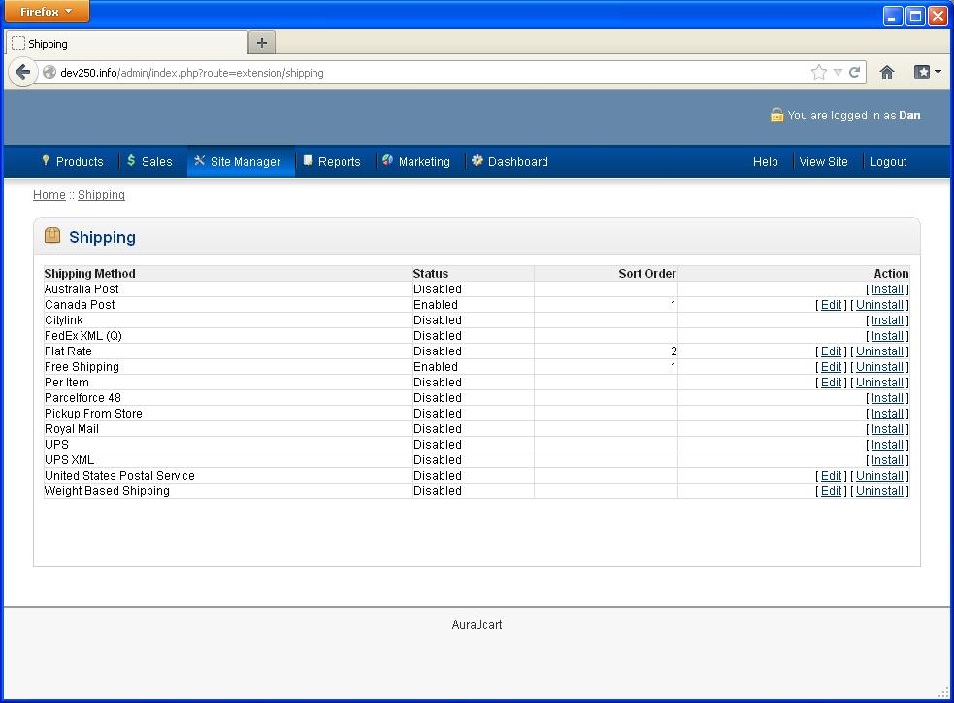
Shipping / Packaging
This section allows for configuration of shipping and packaging modules on your site. You can install additional modules for your website here, on the right hand side. When you click on the Shipping link in the Site Manager menu to enter this section, you will be shown the main page which lists all company and additional modules.

Shipping / Packaging Configuration: Company Modules
This page will show any major shipping company modules that have been installed. Click once on the name of the module you wish to edit, and then click “Edit” to edit the settings for the selected module. Each of these will require some kind of authentication for your business. You will have to sign up with Canada Post, or FedEx, or whomever you choose, in order to use their service, and thus, their module.

Shipping / Packaging Configuration: Other Modules
This page displays any additional special use shipping modules, such as flat-rate, pick up from store, free shipping or other such modules. Click once on the name of the module you wish to edit, and then click “Edit” to edit the settings for the selected module.

PRODUCTS MENU
This section allows you to create and modify products, add images and set product options for the catalog of products that you will be selling on your website. 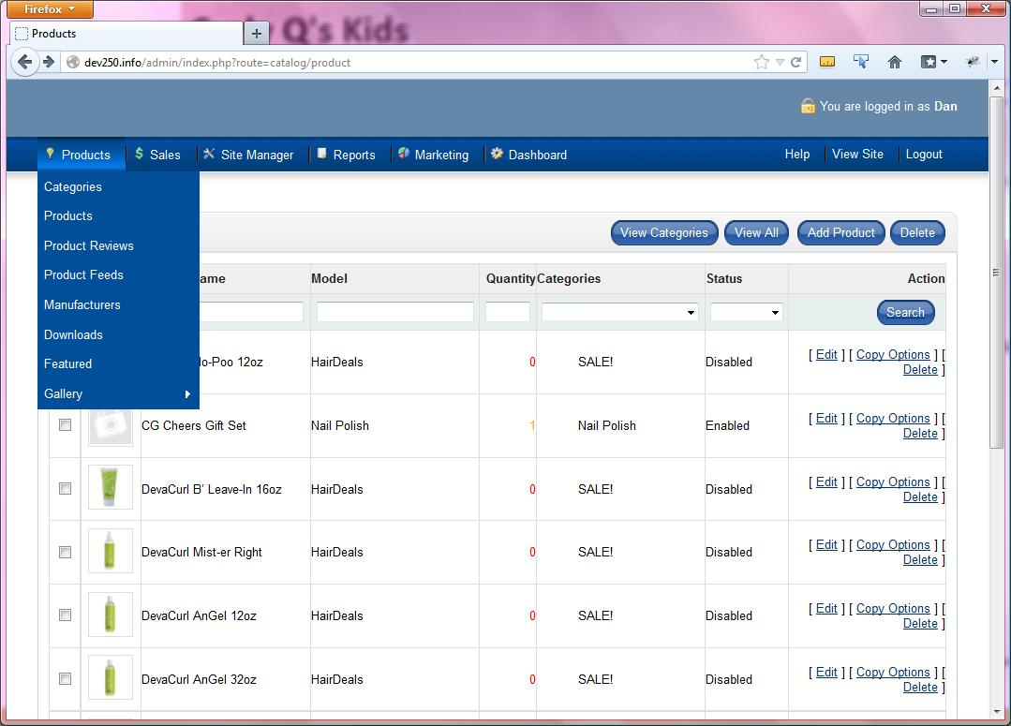
Listing of Categories and Products

Quick Primer: Categories & Products
Let’s go into a little detail of how categories and products work in QE CART. A category is a “container" which will hold related products inside of it. A category can contain both products or additional categories (call a sub-category). By having this ability you have an easy way to organize your products.
Let’s say for example, you sell kitchen appliances. By using categories and sub-categories you can break down how your products are displayed so visitors to the site can easily navigate and find exactly what they wish to find. You can create, for example, a main category called “Stoves”. Inside stoves you can create 2 more categories called “Gas Stoves” and “Electric Stoves”, and each of those categories contains the appropriate products.
This is a great way to organize your products on the site. A category is shown on the Categories page, accessed from the products drop-down menu. From here you can add or edit categories, in a very similar manner as you added/edited users. Products are created within the products page (in the products drop-down) and the interface should once again be relatively familiar. Continue on for a more in depth tutorial.

Managing Categories:
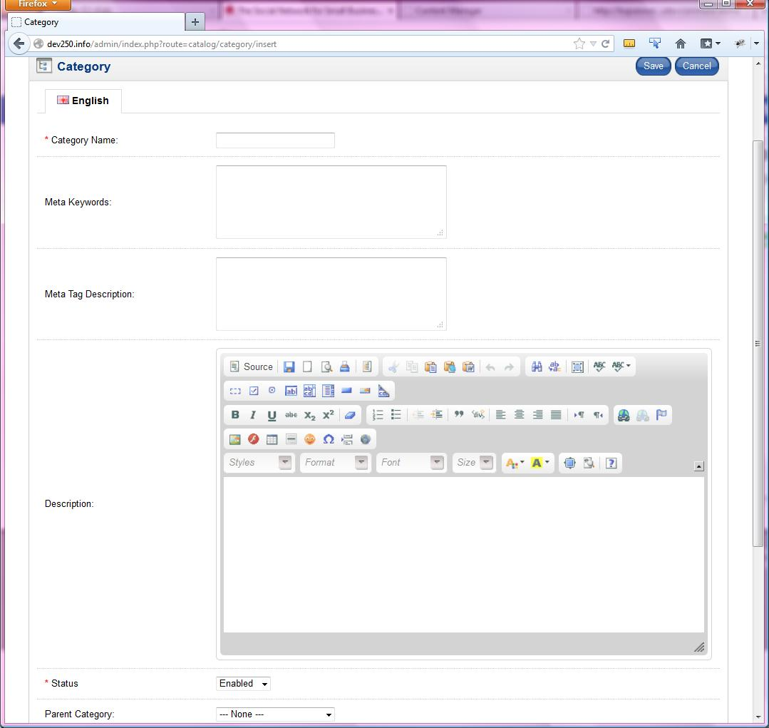
Creating a New Category
To create a new category, click on the “New Category” button. A new page will be displayed where you can input the new information for your category. Note the meta fields, as these are important to improve search engine attention towards your site; make the fields relevant, so the search engines get an accurate picture of what is in the category. A descriptive URL Alias is also important, both for useful search engine results, and for keeping your page URLs from overlapping. Ensure that the status is set to “Enabled” if you want the category to appear. Click on “Save” to save the new category when you have entered the needed information.
To edit an existing category, click on the edit link to the right of the category. You will be taken to the same page as the ‘Create a Category’ page, but with all of the preexisting information filled in.
Note on subcategories: To create a subcategory, all you must do is select a parent when on the category creation/editing page. Pages with no parent will automatically be a top-level category, while pages with parents will become subcategories, and only appear within their parent category.
To delete an existing category (and all its contents), click on the checkbox next to the category name to highlight the category you wish to delete. Then click on the “Delete” button to delete the category.
**Warning** if you delete a category, categories contained inside the category will also be deleted! Please make sure you wish to delete the category, as there is no way to recover a deleted category or its contents once deleted!

Managing Products:
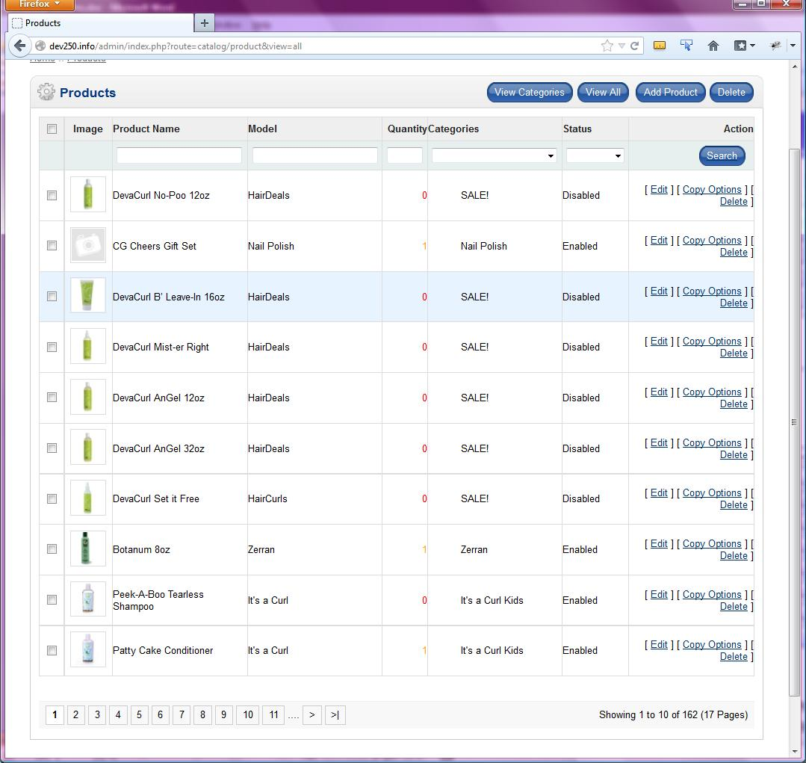
Create a New Product
To create a new product, simply click on “Add Product”. Once again, the new page that loads should look fairly familiar, but it will include many more fields than, for example, the category creation page.

Product Name: | Enter the name of the product
Meta Title Tag: | Title to appear at the very top of the web browser
Meta Keywords: | Keywords relating to the product; used by search engines
Meta Tag Description: | Small blurb about the product; may appear in search engine
Product’s Description: | Enter your product’s description
Image: | Picture you want associated with the product, on the product page
Model: | Enter a product model ID or number if you have one
Gift Certificate: | Whether a gift certificate applies to this item
SKU: | Stock Keeping Unit number
Sort Order: | Order in which items should appear (i.e. 1 for first, 2 for second)
URL Alias: | URL for your product (will appear as: www.yourwebsite.com/URL Alias)
Youtube ID: | If the product has an associated video, place the link in this field
Manufacturer: | Choose the brand/manufacturer of the product (see Brand Names)
Requires Shipping: | Select whether shipping costs should be added during checkout
Date Available: | Set the date that a product will become visible on the website
Quantity: | Enter the amount of stock of the product
Out Of Stock Status: | Select whether the product is in stock or not
Status: | Set if a product will be shown to visitors or not on the site
Tax Class: | Sets the tax class that will be used to calculate tax on the product’s price  (see Locations / Taxes)
Price | The price that is displayed to customers
Companion Products | Use the drop down to choose products that will be recommended to purchase with this product
Dimensions (L x W x H): | 3 fields, enter length, width, and height in order
Measurement Class: | Length unit the dimensions are measured in (cm, in., etc.)
Weight: | Weight of the product. This is needed for most shipping modules to calculate the shipping costs of purchases. Please note the units used for this depends on the shipping module used (for example, if using the Canada Post module, units for this field would be in Kilograms [kg], so if your product weighs 20kg, enter in “20”)
Weight Class: | Unit the product’s weight is measured in (kg, lbs., etc.)
Categories: | The category or categories you would like the product to appear inside
Downloads: | If you are selling a downloadable product, select it here (see Downloads)
Related Products: | Select any products related to the product you are creating. For example, other products in the same category.

Once you have entered the required information, click on the “Save” button to add your product to the list, or hit “Cancel” to abort creating the new product.
To edit an existing product, click the “Edit” button to the right of the product you would like to make changes to.
To copy a product, simply navigate to the category the product resides in, select the product by clicking once on its name, and then click the “Copy To” product. You will see a new box on the right side with some options. Use the drop down box to select what category to copy the product to. The copy method will allow you to choose to either make a copy of the product, or make a “duplicate” symbolic link to the original product (so that you can edit the original product, and the copy will be updated as well). If you are duplicating a product, you can select if you wish to copy any product attributes assigned to the product as well. Click the “Copy” button to complete the copy of the desired product.
To delete a product, navigate to the category that contains the product you wish to delete, and then select the product by clicking once on its name, and then pressing the “Delete” button. You will be asked to confirm if you wish to delete the product.
**warning** once you delete a product it cannot be recovered, so be certain you want to delete the product
To move an existing product from one category to a different one, first click the edit button. Scroll down to the bottom of the page, where you will see the categories field. Deselect any categories you want to remove the product from, and then select any you want it added to. Click “Save” at the bottom.
To copy a product’s options to another product, find the product with the attributes you wish to copy, and click on “Copy Options”. You will now be shown the copy form. First, you need to select the product you wish to copy the attributes to by finding it in the dropdown menu.
Select “Delete Current Options” if you wish to delete any existing options attached to the target product before you copy these ones to the product. Otherwise, the copied options will be added to the existing options on the item you are copying to.
Click the “Save” button to complete copying the selected products attributes to the target product.

Extra Product Images:
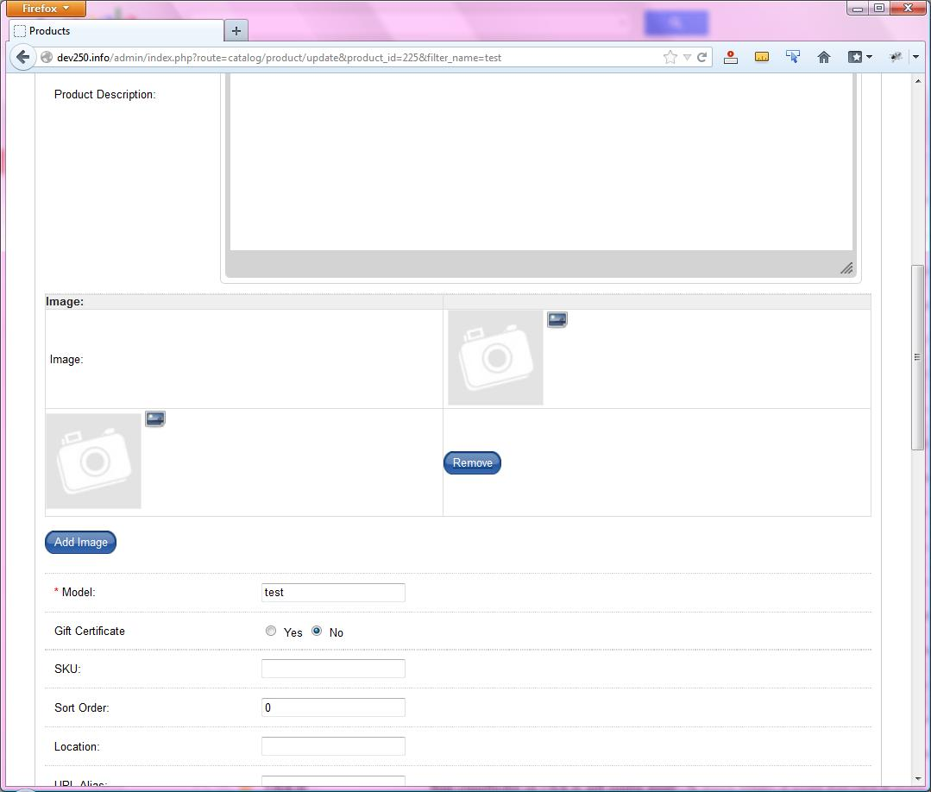
Extra Product Images
Product images allow you to upload images to be displayed for a product on its product detail page. In the “Image” field, click the “Add Image” button. Then, click the small button that looks like a photograph to bring up the image selection. From here, you may either select any of the images already on the server, or click on “Upload” if you would like to add one from your computer. Once your image is uploaded to the server, just double click on it. If at any point you decide you do not want the additional image(s), simply click the “Remove” button next to them.
As in most cases, finalize your work by clicking “Save” at the top or bottom of the page.

Product Options (Product Attributes):
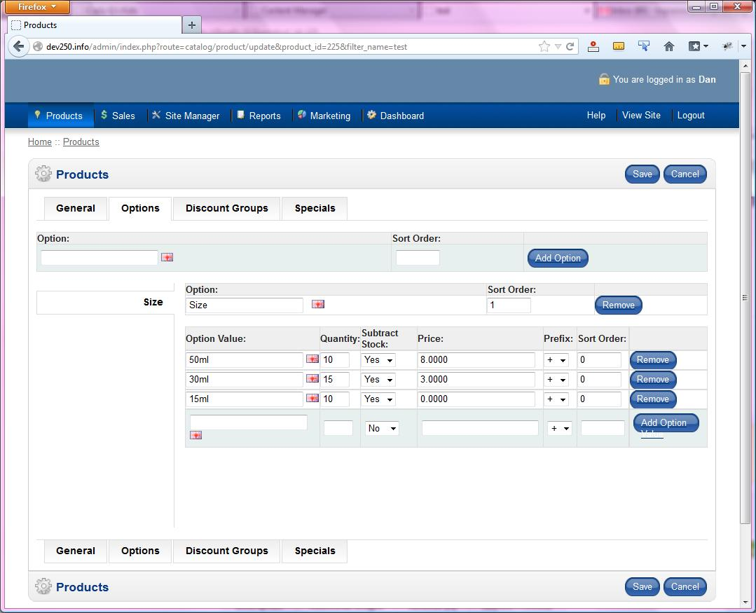
Product Options
Product Options are a way to add options to a product that may or may not affect product prices. For example, if you sold t-shirts, product options could be used to provide the shopper with a drop down box that would allow them to choose which size of a t-shirt they wish to order. Each size could also affect the price of the product (for example, an extra-small shirt could cost $2 less, or an extra-large could cost $5 more).
Let’s use the t-shirts as an example to explain the process. Let’s say you are going to sell a product that is a t-shirt that comes in small, medium, large, and extra large sizes. First, we need to create the Product Option. In the Product Options table are two fields and the “Add Option” button. Type in “Size” in the first field, and additionally type in a number to use for sorting (ie. 1 if you want it to appear first) should you be creating more than one Product Option. Now, click on “Insert”. We have now created a product option called “Size”, which will appear in the tabs on the left hand side, and include an Option Value table.
Now we need to create the option values for the size product option. In the second table, you will see another set of fields. The Option Value field is the name of the value, in this case “Small”. Quantity allows you to input the number of items you have in stock that conform to that value (i.e. small t-shirts), and subtract stock gives the option to subtract stock as those are sold. The next field is Price, which can be used to make a price difference for each different size. Let’s say you made your initial t-shirt product with a base price of $10.00 and the small t-shirt will cost only $8.00.
To do this, you would enter 2.00 in the Price field, because $2.00 is the difference in price. Then you need to change the Prefix field, which is used to select whether the change in price should be positive ($12) or negative ($8). In this case, we are discounting the small, so choose negative (-). You have now instituted a price difference based on an option value.
Enter in a number for the sort order, if you wish to force this option to be in a specific order (otherwise the vales will be listed alphabetically). Click “Add Option Value” lock in your option value. You will notice this also adds another row to the table, so you can input another option value.
Now, you will want to repeat the process for the other t-shirt sizes. Just repeat these steps for “Medium, Large, etc.).
Now we have a Product Option, with the sizes for the t-shirts created. Make sure you click “Save” to save your work, and your changes will be made visible on the front-end.

Specials:
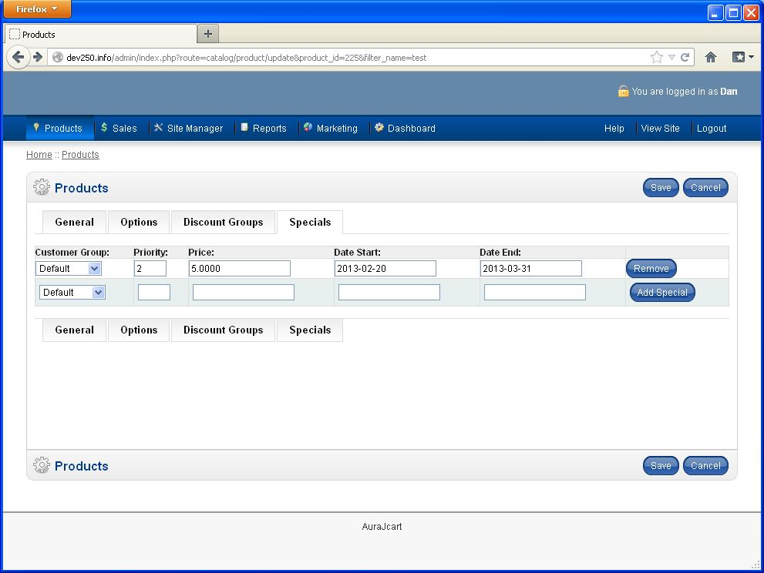
Product Specials
The specials area allows you to place desired products on special for a lower price.
To add a new special, you need to select the customer group the special will apply to, then choose the price and priority (if there are two specials that apply, which takes precedence). Finally, select the dates that the special begins and ends, and then click “Add Special”
To edit an existing special, just change the fields you want to change, and click “Save” at the top of the page.
To remove an existing special, click on “Remove” at the end of the row for the special you want to end

Manufacturers / Brand Names:
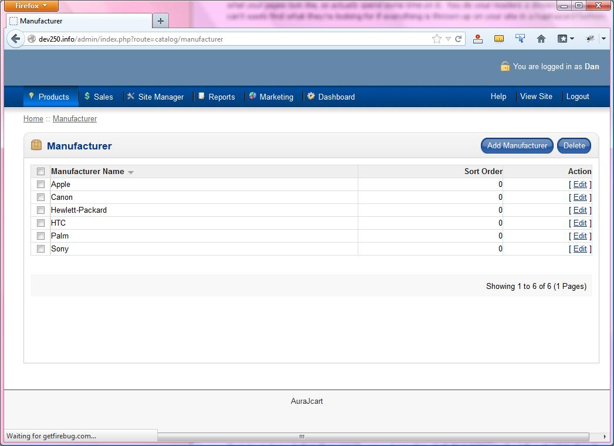
Manufacturer’s page
The manufacturers / brand names allow you to create the list of product manufacturers and brand names that can be assigned to your products when you create or edit them.
To create a new brand name, click on the “Add Manufacturer” button. You will see a new page with the input fields for you to create a new brand name/manufacturer. Type the name of the brand or manufacturer in the first field, use the “Browse” button to upload a picture for the brand or manufacturer (i.e. a logo image), and enter any URL you wish in the bottom fields, and then click “Save” to create the new manufacturer or brand.
To edit an existing brand/manufacturer, select the one you wish to edit by clicking on “Edit” in its row. You can also select its checkbox and click “Delete” to remove a manufacturer or brand name if you wish.

Product Reviews:
This page allows you to view and administer any product reviews left by customers. You can set them to be visible or not on the front end of the site, edit them or delete them.

Downloads:
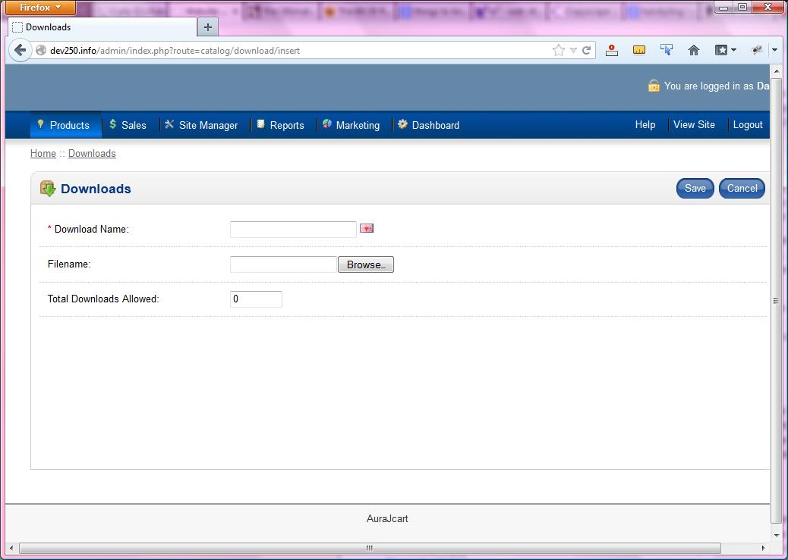
Downloads
The downloads section gives you the ability to create downloads to link to a product, as mentioned above in the “Products” section. To create a new download, just click the “Add Download” button to be taken to the relevant page. Here, you need to create a name for the download, and then find the file that you would like to make available, using the browse button. Finally, set the total number of allowed downloads for the file, and click save. Now, you can attach this download to whatever product you would like in the products page.

CUSTOMERS MANAGEMENT
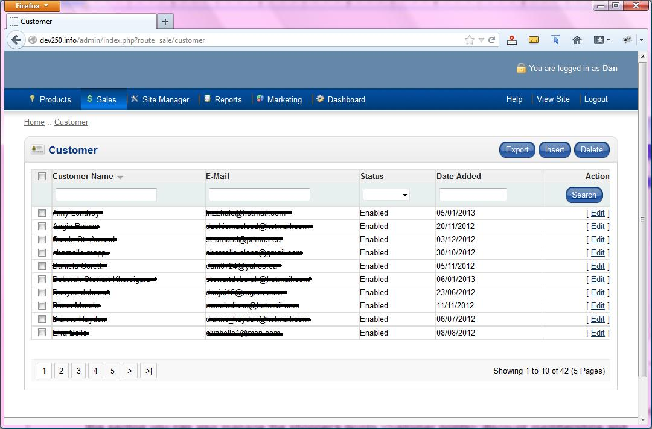
Customers Area
The Customer Manager, under the Sales menu, allows you to view, add, edit, and delete customers and their account information. In this section you can also manage the discount memberships and other various customer-related settings on the site.

Managing Customer Records:
In the Customer Manager area, you can view, add, modify, and delete customer accounts.
To view or edit an existing customer record, navigate through the customer list either by using the forward and back arrows at the bottom of the list, or by entering in a search term in the search box to find a customer. Once you have found the customer click on the “Edit” button on the right box to edit the selected customer record.
You will then be shown the customer record page, where you can edit or view the information on the customer as needed. Click the “Update” button to save changes, or “Cancel” to return without making any changes to the customer record.
To delete an existing customer, find the record you wish to remove and then click once on the customer’s checkbox to highlight it. Then click the “Delete” button to delete the account. Please remember that once you delete the account, the record cannot be recovered.
To view the orders a customer has made, find the record you wish to remove and then click once on the customer name to highlight it. Then click the “Orders” button, and you will be taken to a listing of orders the customer has made (see the sales section for more information).
To send an e-mail to a customer, find the record to which you wish to send and e-mail and then click once on the customer name to highlight it. Then click the “E-mail” button. You will be presented with a page that will allow you to send the customer an e-mail message.
To create a new customer account, click the “New Member” button. You will then be shown a form where you can create a new customer account.

Order Totals:
The “Order Totals” page, in the Sales menu, provides a number of modules that will apply various price adjustments at checkout. For example, enabling the “Taxes” module will result in the checkout page adding the local tax into the total, as well as including it in the breakdown between the subtotal and the total. Some of these modules are less intuitive though, and there are more detailed explanations of those below.

Customer Points:
This section allows you to see the customer (shoppers) points that a customer has on his/her account. These points (if enabled) give a reward for customers who purchase items from your QE CART store in the form of points that can be used towards a future purchase. By default, the points system awards 1 point for every dollar a customer sends, and 1 point = $0.02 in cash.
To add points to a customer’s account, first find the customer’s account by either typing in their name or using the “Next” and “Previous” navigation links, and then select the customer’s record by clicking once on their name. Then click on “Add Points” to add the desired amount of points to their account.
To delete points from a customer’s account, first find the customer’s account by either typing in their name or using the “Next” and “Previous” navigation links, and then select the customer’s record by clicking once on their name. Then click on “Delete Points” to remove the desired amount of points from their account.
To adjust points in customer’s account, first find the customer’s account by either typing in their name or using the “Next” and “Previous” navigation links, and then select the customer’s record by clicking once on their name. Then click on “Adjust” to change their total amount of points on their account.
You can also view a customer’s orders, or send them an e-mail by selecting the desired user record, and then clicking on the appropriate button.

Discount Members:
This section allows you to create special groups for users who will qualify for a discount on the list price of products on your QE CART store.
To create a new group, click on the “Insert” button to create a new discount group. Enter in a name for the group and then select “+” or “–“ from the dropdown box to specify if the group will have an increase or discount in price, and then enter in the % of the increase or discount.
To edit an existing group, select it by clicking on its name, and then hit the “Edit” button.
To delete an existing group, select it by clicking on its name, and then hit the “Edit” button.

ORDERS SYSTEM
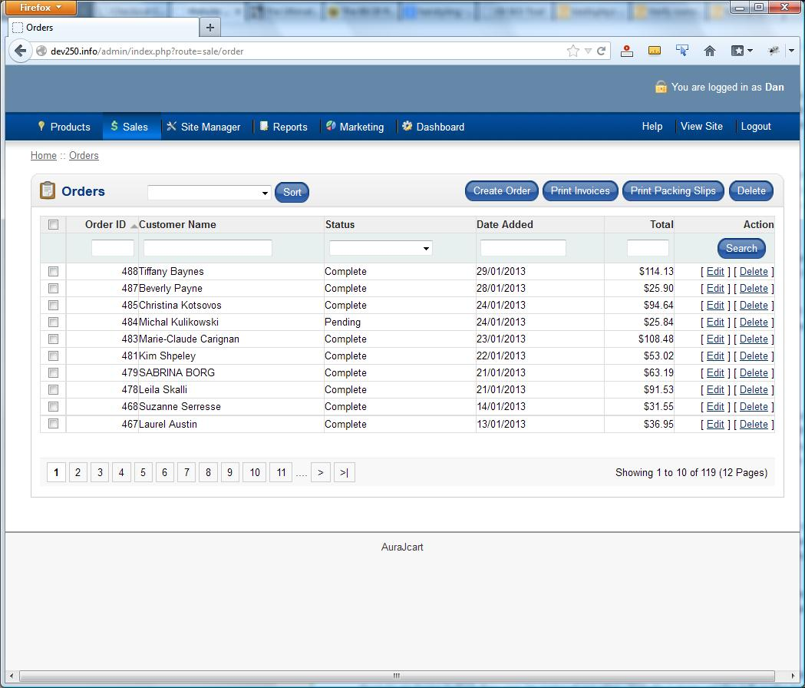
Orders Display
The Orders section allows you to preview and edit orders by customers on the site.
Navigating / selecting an order: To find a particular order you have several ways to search/navigate to it. You can manually search for it by using the page numbers at the bottom (or the < and > links) to go through pages until you find the specified order. You can also use the “Search” button, if you know anything in particular about the order, such as the order ID—you can type it in the “Order ID” box. You can also sort the display orders based on their status (such as all orders, pending orders, etc…), or the date they were made.
To delete an order, find the specific order, and then click on its checkbox to select it. Then click on “Delete” to delete the order. Please note once you delete an order, it cannot be recovered.
To edit an order, find the specific order, and then click on its edit link
To view / print an invoice, find the specific order, and then click on its checkbox. Click on “Print Invoices” to open a copy of the order invoice in a new window. You can then print this as needed via your browser’s “Print” button.
To view / print a packing slip, do the same things as you would to print an invoice, but instead click on “Print Packing Slips”.

PAYMENT GATEWAYS
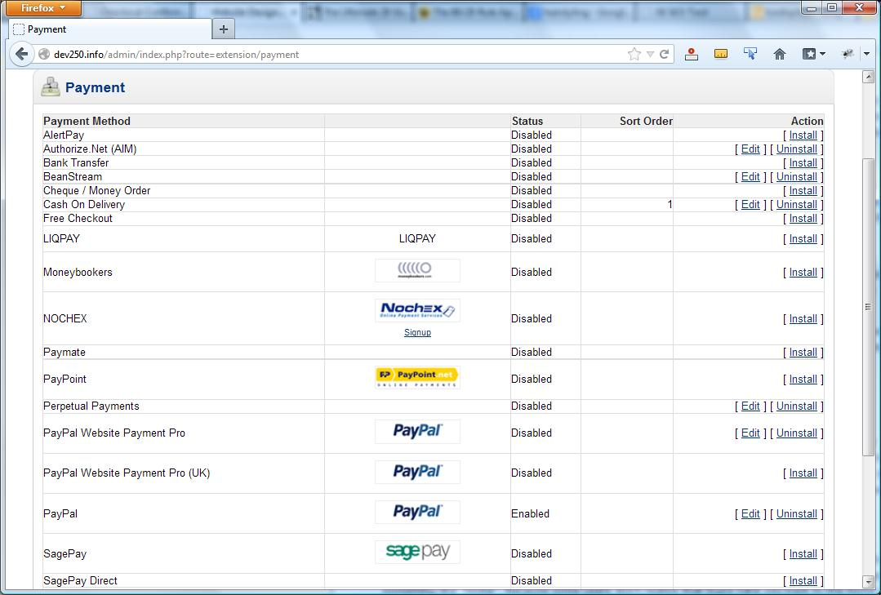
Payment Gateways Configuration
The payment gateway system allows you to enable and configure the various payment modules available in QE CART. Each module has a configuration page (click “Edit”) on which you enter all of the necessary account information. If you have not signed up with one of these services, you should do some research and figure out which one is best for you, and then subscribe. Once you enter all of your account information, you are ready to charge money.

MODULES
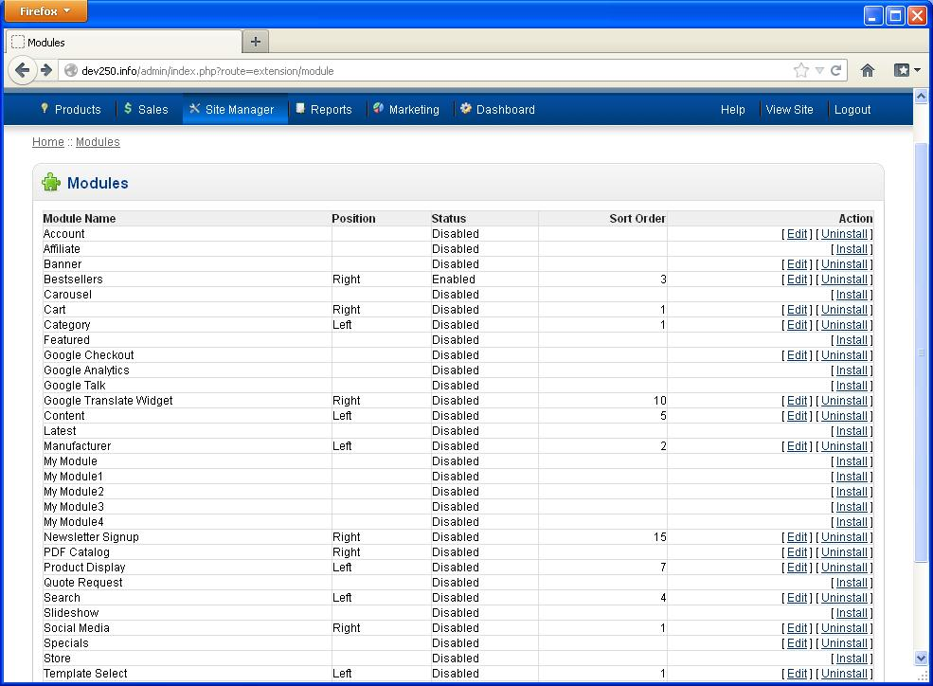
Modules Page
The QE Cart includes many optional modules which you can install at your own discretion. Most of these unlock additional functionality, but they may also require a bit of extra work in order to make them work properly. If you would like to learn about one of these, they are listed below.
Affiliate | Enable affiliate linking
Bestsellers | Enable a sidebar listing the store’s bestsellers
Cart | Enable a view of the cart on a sidebar
Category | Enable a list of categories in a sidebar
Featured | Enable Featured Items
Google Checkout | Enable Google Checkout sidebar
Google Analytics | Enable Google Analytics
Google Talk | Enable Google Talk “chatback” on your sidebar
Google Translate | Enable Google Translation button for your site
Content | Enable
Latest | Enable a sidebar with the most recently added products
Manufacturer | Enable a sidebar with a list of manufacturers
My Module | Custom module—you will need to know web development to use this
Newsletter Signup | Enable a newsletter signup spot on the sidebar
PDF Catalog | Enable sidebar with the option to download a PDF of your products
Product Display | Enable sidebar with products, either Featured or on Special
Quote Request | Enable a form to request a quote on the sidebar
Search | Enable search by price in the sidebar
Social Media | Enable social media links in the sidebar
Template Select | Enable sidebar dropdown that allows people to choose website style/layout

CONTENT MANAGER
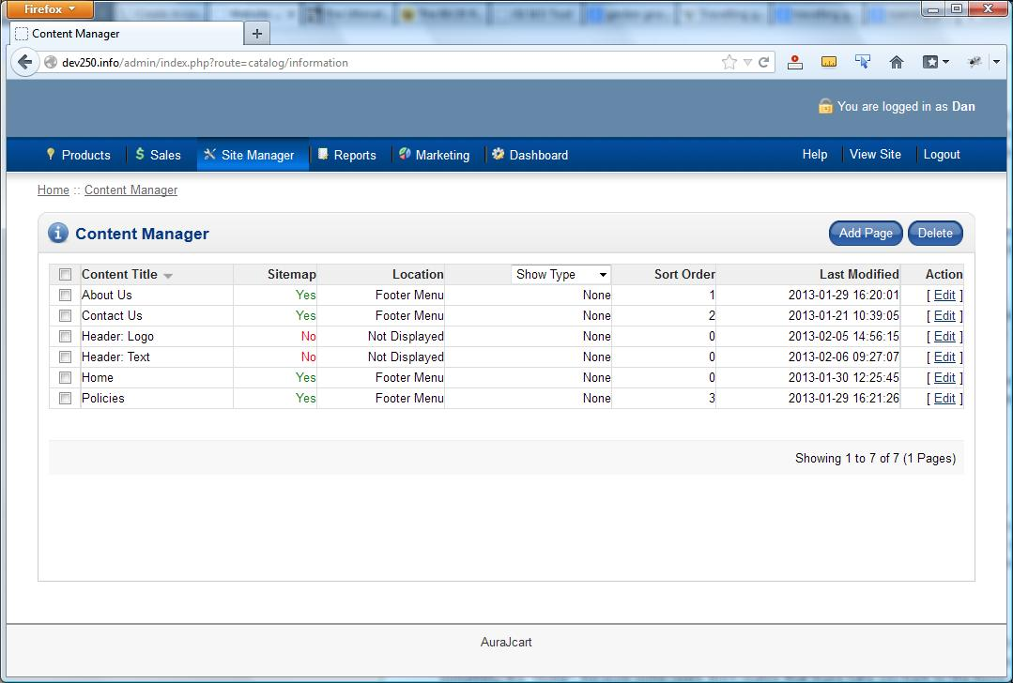
Content Manager
QE CART features a robust and dynamic content manager that allows you to create additional pages as needed on your website. You can add pages or links to other files or even links to other places on the internet.
To add a new page, click the “Add Page” link at the top. Similarly, if you need to edit an existing page, click the edit link to the right of the title of the page you would like to change.

The Page Editor:
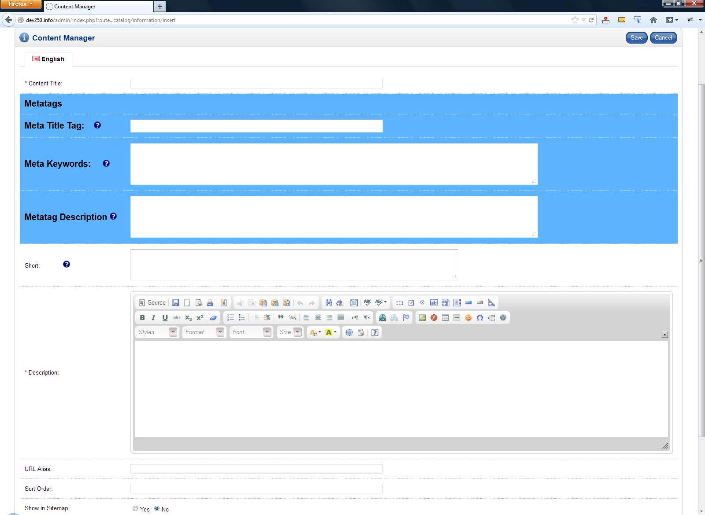
Page Editor
When you choose to add or edit a page, you will be taken to the content editor screen, where you can create/edit the content on the page.
The “Content Title” is the name that appears in the menu as well as the title of the page when displayed. For example, you could put “FAQ” if you were creating a frequently asked questions page.
The Meta information (all of the fields in the blue-background area) is for creating Meta tags in the output HTML code from the server, fill in the necessary information. This is helpful for search engines when they index your page.
The short area is only important if you are writing articles. The short is a small bit of text which appears on the articles page below the title, to inform visitors of what is in the article.
The “Description” area is where you type in whatever text you wish to be displayed on the page. The text editor works much like Microsoft word, and in addition to rich text (e.g. bolded, italicized text), you can also put in images, hyperlinks to other websites, or even tables to lay out data. If you know how to write HTML, you can also click the “Source” button inside the editor to see the HTML, and add your own.
URL Alias allows you to input the URL extension you would prefer (i.e. yourdomain.com/your-preferred-url-alias). If you have a certain keyword associated with a page, you should consider incorporating it in the URL you enter in this field.
The Sort Order property gives you the ability to decide what priority is placed on the page you are creating. If you are looking to make the page you are creating the first link in the footer menu, you would put a “1” in Sort Order.
Show in Sitemap allows you to select whether or not this particular page appears in the site-wide sitemap. Having a page in the sitemap makes it easier for search engines to find and index the page; that is, the page is more likely to appear in search results. If you do not include it in the sitemap, search engines may still find it, but it will take much longer.
Display in Menu allows you to choose where your new page will be linked from. “Left Menu” and “Footer Menu” will put a hyperlink to this page in the respective menu, where it is fairly easily accessible. “Articles Page” will place a link on the articles page, if you have one, which tends to be a bit more off the beaten path. Finally, “Not Displayed” will result in the CMS not providing a link to your new page anywhere. It will still be accessible, but only if you set up a link from somewhere else yourself, or if it pops up in search engine results.
The Type options allow you to alter a few general functions of the page.
Click on the “Save” button to save the page.

BANNER MANAGER
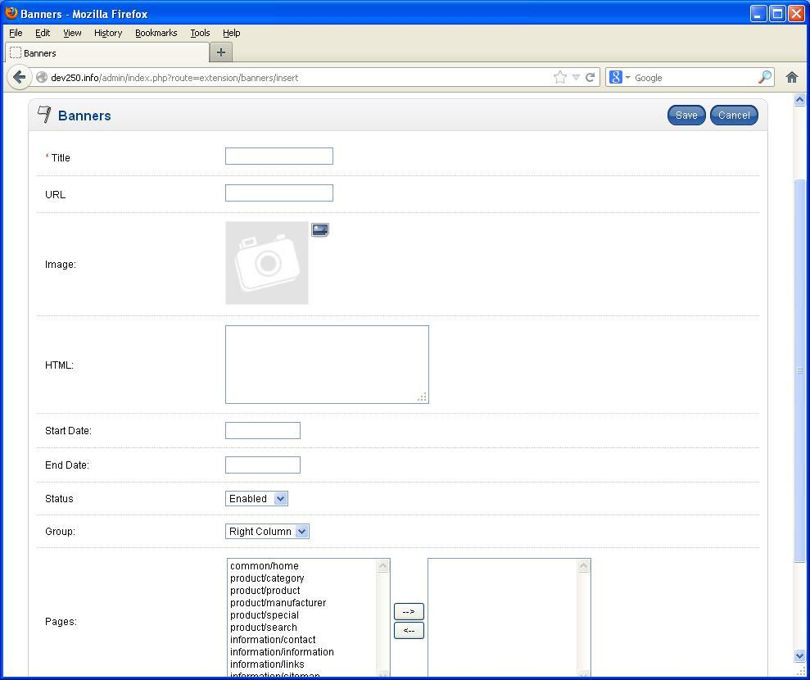
Banner Manager
The Banner Manager in the Site Manager menu gives you the ability to put banner advertisements for other parts of your website on the right or left side of your website, in the area normally reserved for whitespace. If you want to show off a specific product, or a certain category or manufacturer, you might consider using the Banner Manager. However, be aware that it may require some web development knowledge to use to its fullest extent.

HEADER IMAGE MANAGER
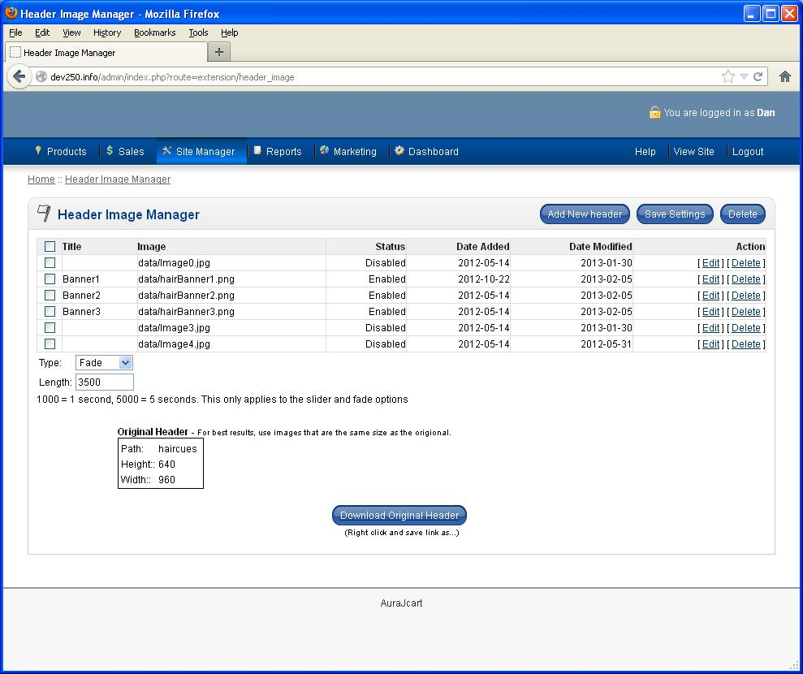
Header Image Manager
The Header Image Manager in the Site Manager menu gives you the ability to change the photos which appear in the header image carousel, if you have enabled it. You can select the amount of time the images remain on screen before switching to the next one. This is recorded in the “Length” field, which is measured in milliseconds. You can also select the type of transition between photos, whether they fade into one another, or slide, or something else. When you are done editing these settings, you must click “Save Settings”.
You can add another image to the rotation by clicking “Add New Header”. From here, you can select a new image, and—if you wish—give it a title, a URL to link to when clicked, and dates on which to begin appearing and on which to stop. When you’re done, just click “Save”.

BULK IMAGE MANAGER
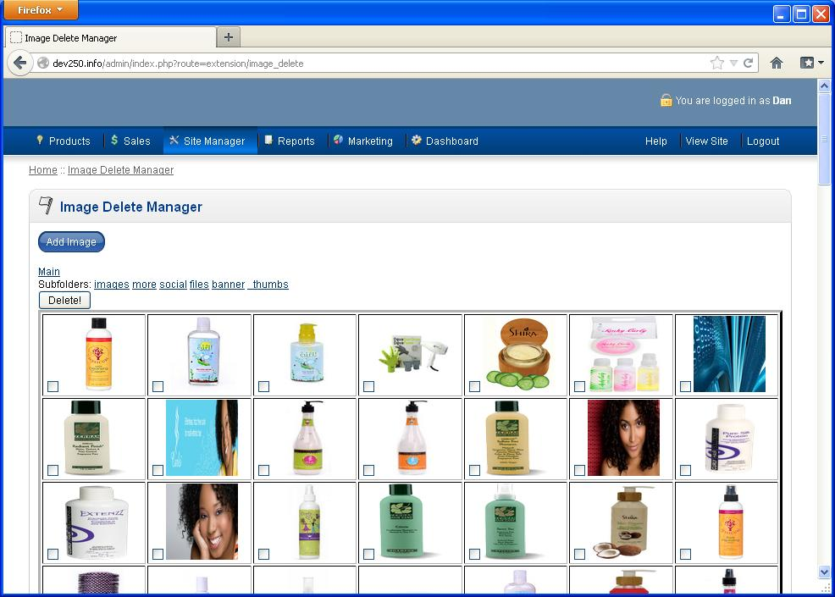
Bulk Image Manager
The Bulk Image Manager, inside the Site Manager menu, gives you the ability to easily and quickly manage all of the pictures on the server from one convenient location. From here, you can upload images by clicking the “Add Image” button—you can upload many at once if you click it multiple times—browse for the image you want to add, and click the “Upload” button. Similarly, you can easily delete one or many pictures by clicking on their respective checkboxes, and clicking the “Delete” button.

LINK MANAGER
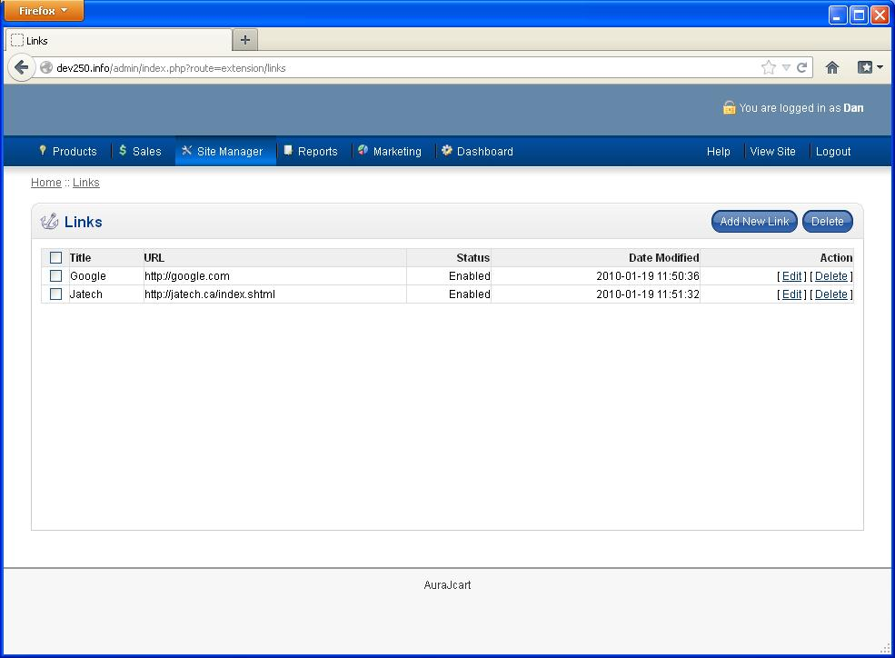
Link Manager
The Link Manager is used to automatically generate a links page. Basically, you can add links to sites which you like, or which are somehow related to your own, or for any other reason you like. In order to do so, you just need to click “Add New Link”. You will be asked for the URL (what you type in the address bar of your web browser), the title of the page—for example, if you’re linking to google.com, the title you would choose is probably “Google”—and to enable the link.
You may also choose to add a description to the link, such as why you decided to promote a particular page with your site, but it is not required. When you are done, just click “Save”, and you will have created a new link.

MENU MANAGER
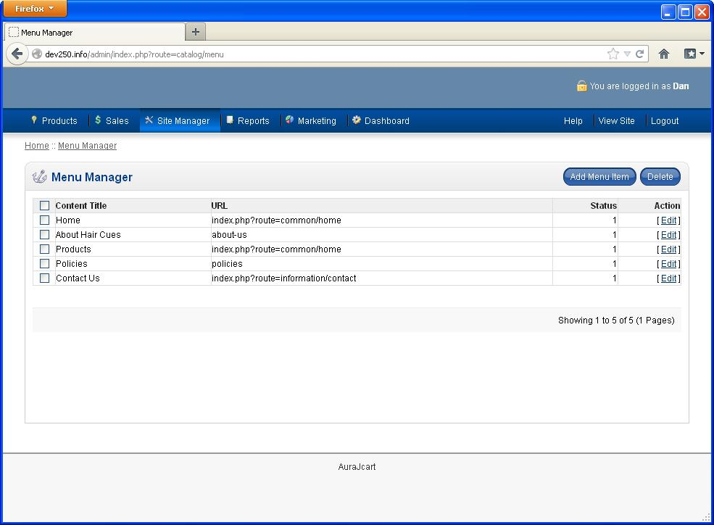
Menu Manager
The Menu Manager is used to put links in the main navigation bar that runs along the top of your site. The way this is used should be considered very carefully, because this is the menu that is going to receive the most use, and therefore the most scrutiny from users. Make sure that the pages you link to from this navigational menu are high priority pages; pages that users should definitely be aware of.
The usual candidates for this menu include links to the homepage, to an “About Us” page, and to a “Contact” page. These pages are all things which customers will find very useful. It is not a great idea to promote specific products in this menu, unless you are only selling one specific thing from the site.

BACKUP AND RESTORE
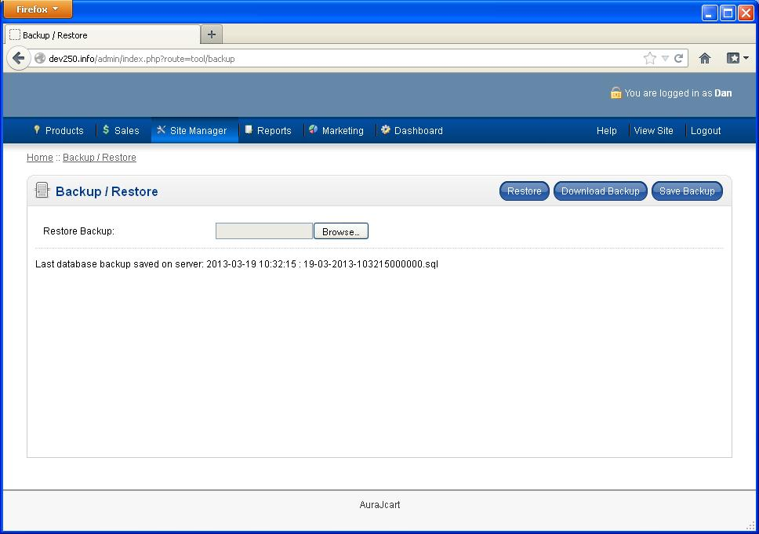
Backup / Restore Page
The “Backup / Restore” page, found in the Site Manager menu allows you the ability to back up all of the SQL database information associated with your site, and save it elsewhere in case the server goes down or something else unforeseen and unfortunate happens. It is then possible to upload one of those backups to put the backed-up information back on the site.

REPORTS
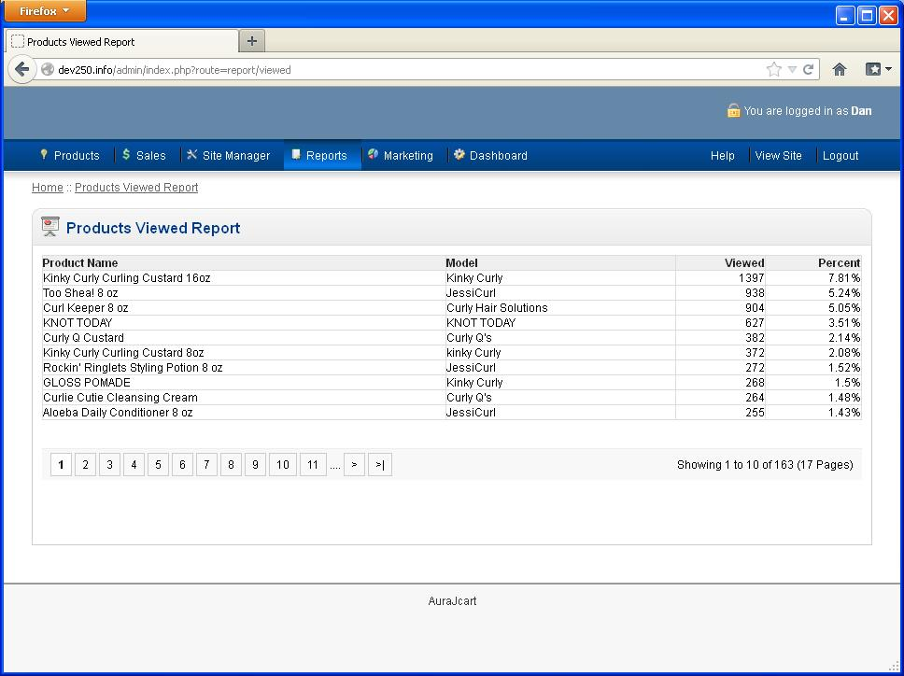
Report on Products Viewed by Customers
The reports section allows you to see various reports on sales and visitor activity on the site. You can see reports on products most viewed referral sources, products most purchased and other reports useful for marketing information.
Products Viewed: List the most viewed products on the site by visitors, ranked from most viewed to least.
Products Purchased: The top ordered products from the store inventory
Sales: The number of orders and the total sales, based on a specified date range, and using a selected unit of time (days, weeks, months, or years).

NEWSLETTERS

Creating a Newsletter
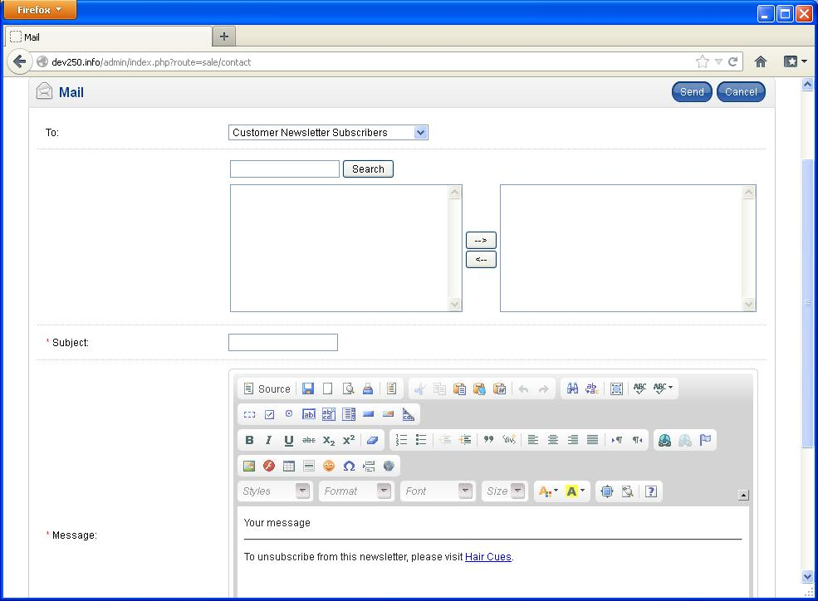
Newsletter Creation
QE CART has a built in newsletter system so you can send newsletters to people.
By clicking “Newsletters” under the Marketing menu, you can access the interface to send out a newsletter. You can select groups to send it to, or specific customers if you would prefer. The rest works more or less like any web email client, with a subject line and a message area.
The message area should be recognizable from other parts of the QE CART backend that you have read about and used. It is a simple HTML editor that works quite a bit like Microsoft Word. Insert what you would like to include in your newsletter—it can include some HTML to set up the layout how you’d like—and then you are done.
Send the newsletter with the “Send” button at the top.

Managing the Mailing List
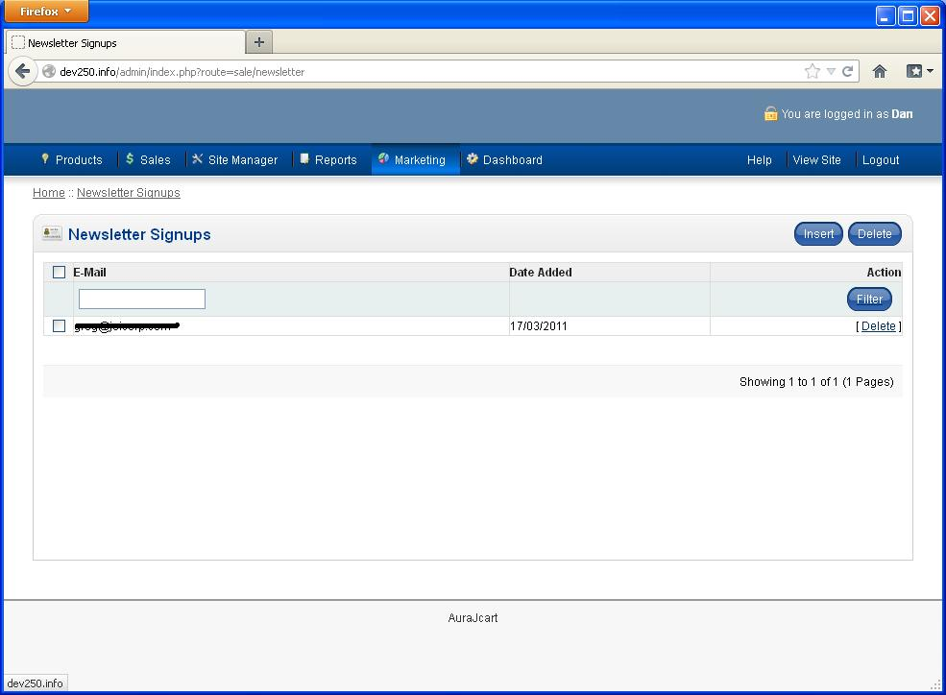
Newsletter Signups

In the “Newsletter Signups” page in the Marketing menu, you can manage who is on the mailing list for your newsletter. If you would like to delete people from the mailing list, you can do so by clicking “Delete” next to their email address. Similarly, you can add people to the mailing list simply by clicking “Insert” and then entering their email address.

