29 Gervais Dr., Suite 301
Don Mills, ON., M3C 1Y9
Phone: 416-848-4325
Fax: 866-640-3115
www.jatech.ca



SEO

Search engines and directories are the number one source for traffic. In fact up to 90% of the total traffic to your website could come from the major search engines and directories. If you would like to have a good ranking in search engines, it would take more than just adding some content, keywords, tags and submitting to hundreds of search engines. The fact that your site is listed in the search engine doesn’t mean you would get traffic. Only expert search engine optimization and positioning strategies tailored specifically to your website (with consideration of your competitors ranking) will result in more traffic. An in-depth study of the content, keywords, meta-tags, site structure, submission, link exchange, search engine and directory submission is required to successfully optimize and position your website for high ranking and targeted visitors.

Having a website is only half the work. Getting traffic to your site is the other half. The life blood of any web site is traffic. It is a necessity – without traffic, websites will surely fail. We specialize in all areas of search engine optimization and we will help you meet your search engine ranking needs.

The object of optimizing your web sites is to generate traffic from search engines to increase sales. The result of this increase in traffic will also mean more potential customers are being informed about your products and or services. Growing interest from potential customers will encourage more clients to purchase your line of products and or services.

The goal of optimization is not to rank #1 on every single keyword across major search engines, because it is unrealistic and not practical. In fact, research has shown that spots 3, 4, and 5 get more clicks than spots number 1 and 2. Why? No one knows, but the popular answer that people assume that the ones on the top are charging more money.

Successful Search Engine Optimization is achieved by doing everything that needs to be done and doing everything the right way. This called "White Hat" tactics. Trying to take short cuts to try to trick the Search Engines will only get your site black listed. We only use and will only advise you to use "White Hat" methods with will result in your site being successful.

Beware of individuals or sites that say they will get you to the top quickly. This is too good to be true. This is simply not possible.

Here we will teach you what needs to be done and how to do it.

Search Engine Optimization is a Game or War that must be played continuously. You can’t expect to play once and win.

FTP: To do SEO on a site you will need to modify files on your web site. You will need the FTP username and password for your site. Your hosting provider will be able to give you this.

Please read the section on FTP

Website Analysis and Keyword Research

A full page by page analysis of your website must be completed to determine how search engine friendly it currently is.

Here is what we are looking for:

1. Is there a sitemap? If not one has to be created. Search Engines use the sitemap to crawl the site. To create a site map you will need to know the basics of html or other language. There are sitemap generators out there but when we create a site map we do it manually to make sure nothing is missed and what we want the Search Engines to index is listed properly.

Image 1 will show you the code for a site map for a typical site:

; rem html site map code

<p><a href="http://www.stringworks.com/" alt="Violin, Violins">Stringworks - Home</a><br /><br />
<a href="http://www.stringworks.com/rental.htm" alt="Violin Rental">Stringworks - Rental Program</a><br /><br />
<a href="http://www.stringworks.com/comments.htm" alt="Violin Comments">Stringworks - Comments</a><br /><br />
<a href="http://www.stringworks.com/ourinst.htm" alt="Violin Instruments">Stringworks - Our Musical Instruments</a><br /><br />
<a href="http://www.stringworks.com/about.htm" alt="Violins - About">Stringworks - About Us</a><br /><br />
<a href="http://www.stringworks.com/cgi-bin/discussion/discus.cgi" alt="Violin Forum">Stringworks - Discussion Board</a><br /><br />
<a href="http://www.stringworks.com/outlet.htm" alt="Violins outlet">Stringworks - Outlet Index</a><br /><br />
<a href="http://www.stringworks.com/mall/violinoutlet.asp" alt="Violins outlet">Stringworks - Violin Outlet</a><br /><br />
<a href="http://www.stringworks.com/mall/violaoutlet.asp" alt="Viola outlet">Stringworks - Viola Outlet</a><br /><br />
<a href="http://www.stringworks.com/mall/cellooutlet.asp" alt="Cello outlet">Stringworks - Cello Outlet</a><br /><br />
<a href="http://www.stringworks.com/mall/bowoutlet.asp" alt="Bow outlet">Stringworks - Bow Outlet</a><br /><br />
<a href="http://www.stringworks.com/faq.htm" alt="Violins faq">Stringworks - F.A.Q.</a><br /><br />
<a href="http://www.stringworks.com/sheetmusic.htm" alt="Violins sheet music">Stringworks - Sheet Music</a><br /><br />
<a href="http://www.stringworks.com/comingsoon.htm" alt="Violins mailing list">Stringworks - Mailing List</a><br /><br />
<a href="http://www.stringworks.com/contact.htm" alt="Violins contact us">Stringworks - Contact Us</a><br /><br />
<a href="http://www.stringworks.com/links.htm" alt="Violins links">Stringworks - Links</a><br /><br />
<a href="http://www.stringworks.com/add_link.php" alt="Violins add links">Stringworks - Add Link</a><br /><br /></p>

Image 2 Below will display what a client or Search Engine see when viewing the site map page

Stringworks - Sitemap
Stringworks - Home
Stringworks - Rental Program
Stringworks - Comments
Stringworks - Our Musical Instruments
Stringworks - About Us
Stringworks - Discussion Board
Stringworks - Outlet Index
Stringworks - Violin Outlet
Stringworks - Viola Outlet
Stringworks - Cello Outlet
Stringworks - Bow Outlet
Stringworks - F.A.Q.
Stringworks - Sheet Music
Stringworks - Mailing List
Stringworks - Contact Us
Stringworks - Links
Stringworks - Add Link

2. Does your site use SEO friendly urls?

Example: NOT Friendly - before mod-rewrites

www.yoursite.com/ t5-dip-led-tube-c-6.html?zenid=0085455019d4c919a039336b1b1b908d

Example: Friendly - using mod-re-writes

www.yoursite.com/t5-led tubes

The correct url address for the page is the 1st example but using a feature called "Mod re-write" the url is so much easier to read by the Search Engines and the Public.

Some shopping carts such as QE Cart, OSCommerce etc. come with this built in or a module for "mod re-write". If your software does not have this built in then you would need a programmer to do this for you. It should not take a long time though. It is usually a matter of modifying the htaccess file when using Apache. To install and setup the module in OSCommerce it would take a programmer about 1 hour to do. In QE Cart it is setup automatically.

3. Keywords: It is very important to pick the correct keywords or keyword phrases that when they are searched for - your site will show up. You should make a list of keywords you think are the best for your site.

Then go to competitor sites on in the browser click on View then Source:

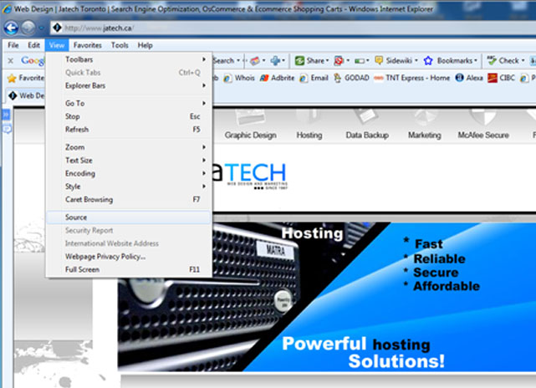

When you click on source, Notepad will open up and display code like this:
(This is only the first few lines of what will show up but this is all we are interested in)

<!DOCTYPE html PUBLIC "-//W3C//DTD XHTML 1.0 Transitional//EN" "http://www.w3.org/TR/xhtml1/DTD/xhtml1-transitional.dtd">
<html xmlns="http://www.w3.org/1999/xhtml" xmlns:v="urn:schemas-microsoft-com:vml" >
<head>
<title>Web Design | Jatech Toronto | Search Engine Optimization, OsCommerce &amp; Ecommerce Shopping Carts</title>
<meta name="keywords" content="web design, toronto web design, toronto web design company, toronto web design firm, custom website design canada, ecommerce toronto, web site designs, shopping carts, online shopping carts, search engine optimization, seo, fax advertising, fax blasting, internet marketing, fax marketing, dvd rental site, brochure web design, website development, web development, web designer, web graphic design" />
<meta name="description" content="Jatech Web Design, Professional web design sites that you can rent or buy, web development, Internet marketing and SEO. Free Quotes" />
<meta name="robots" content="index, follow" />

Notice the tags:

<meta name="keywords" content=" These are the keywords used for this site

<title>Web Design | Jatech Toronto | This is the title that will display at the top of the browser

<meta name="description This description will show when your site appears in a Search Engine

<meta name="robots" This tells the Search Engines to index your site and follow the internal links

So here you can see what this site is using for keywords. So you use this method to see the keywords your competitors are using.

To edit the meta tags in most sites, you will need to use a FTP program, download the index file and edit it in note pad adding the meta tags as you want them to be. Some of the better ecommerce website software, such as QE Cart allow you to edit the meta tags in the content manager which makes this a lot easier.

After you have compiled a list of possible keywords, you then need to find out how many people are searching for each of those keywords. If you know which of your keywords are searched for the most - you can then select which keywords you want to use.

For Google.com: (Copy and Paste into Address bar of browser if link does not work)

https://adwords.google.com/o/Targeting/Explorer?__u=1000000000&__c=1000000000&ideaRequestType=KEYWORD_IDEAS#search.none

For google.ca: (Copy and Paste into Address bar of browser if link does not work)

https://adwords.google.ca/o/Targeting/Explorer?__u=1000000000&__c=1000000000&ideaRequestType=KEYWORD_IDEAS#search.none

Enter your list of possible keywords here and search.

A list of keywords that you entered and more suggested keywords and how many people searched for them in the last month- both locally and globally will be displayed in the results page.

Choose about 10 keywords or keyword phrases to optimize your site for. If you choose more than that, then not only will there be a lot more work but also your site will less relevance for a particular keyword.

Keyword Meta Tag Now the first thing your should do is add these keywords to your meta tags. For most sites you will need to use a FTP (File Transfer Protocol) program and Notepad. If your are using QE Cart you will not need a FTP program to work on the keywords - you will be able to do this with the Content Manager.

FTP - What is it and how does it work?

FTP stands for File Transfer Protocol and FTP programs allow to log into the root directory of your web site and upload or download files. Whoever built your web site probably used FTP to upload the files.
With the FTP program you will be able to download a file you want to work on and then upload it again when you are finished.

Filezilla is an excellent FTP program - it is easy to use and it is free. There are other FTP programs you can use - most of them work just as well.

To use the FTP Program you will need the FTP username and Password. This you can get from your hosting company. The FTP host will be your web site. So in Filezilla, enter the HostName, username and password. Figure 3 Below is what you will see:

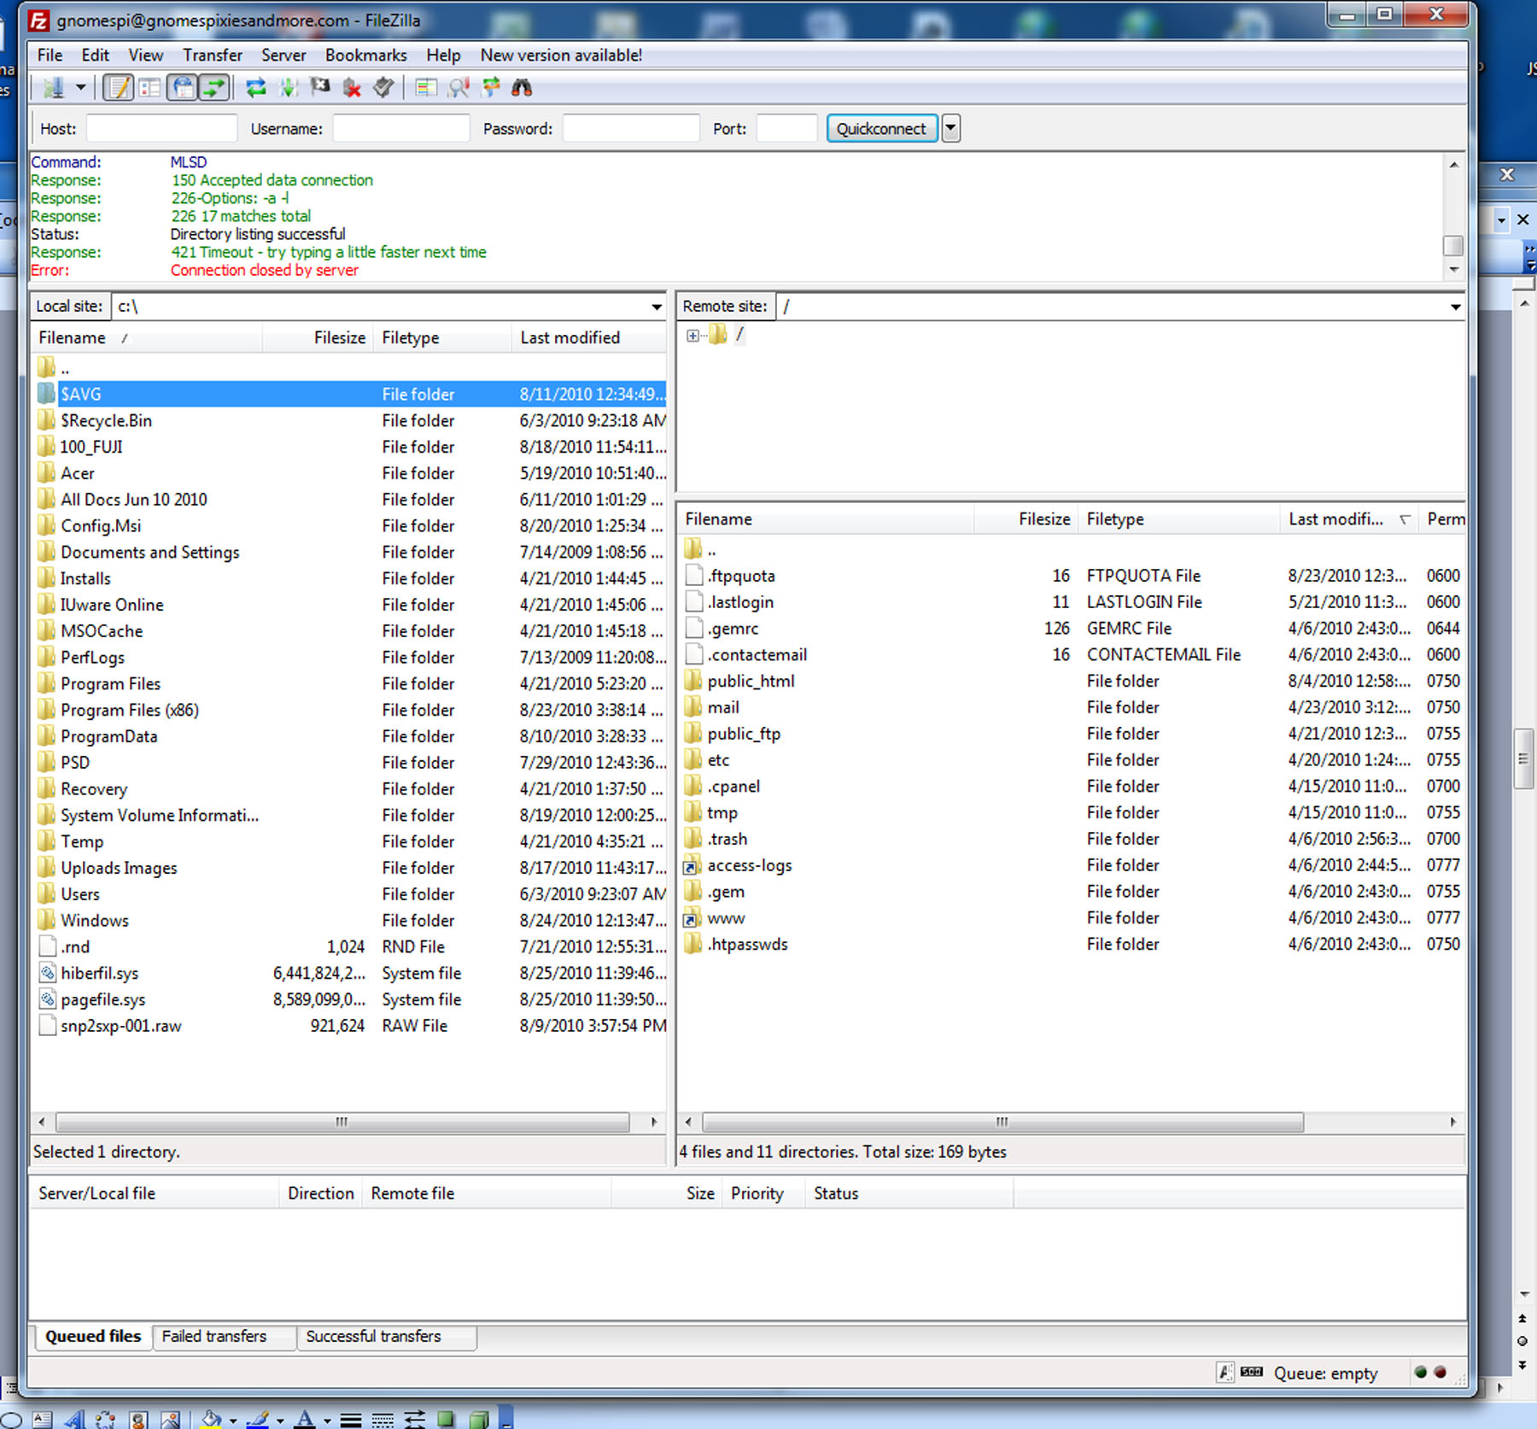

In the lower right panel you will see a folder named public_html. Double click on the folder and it will open this view:

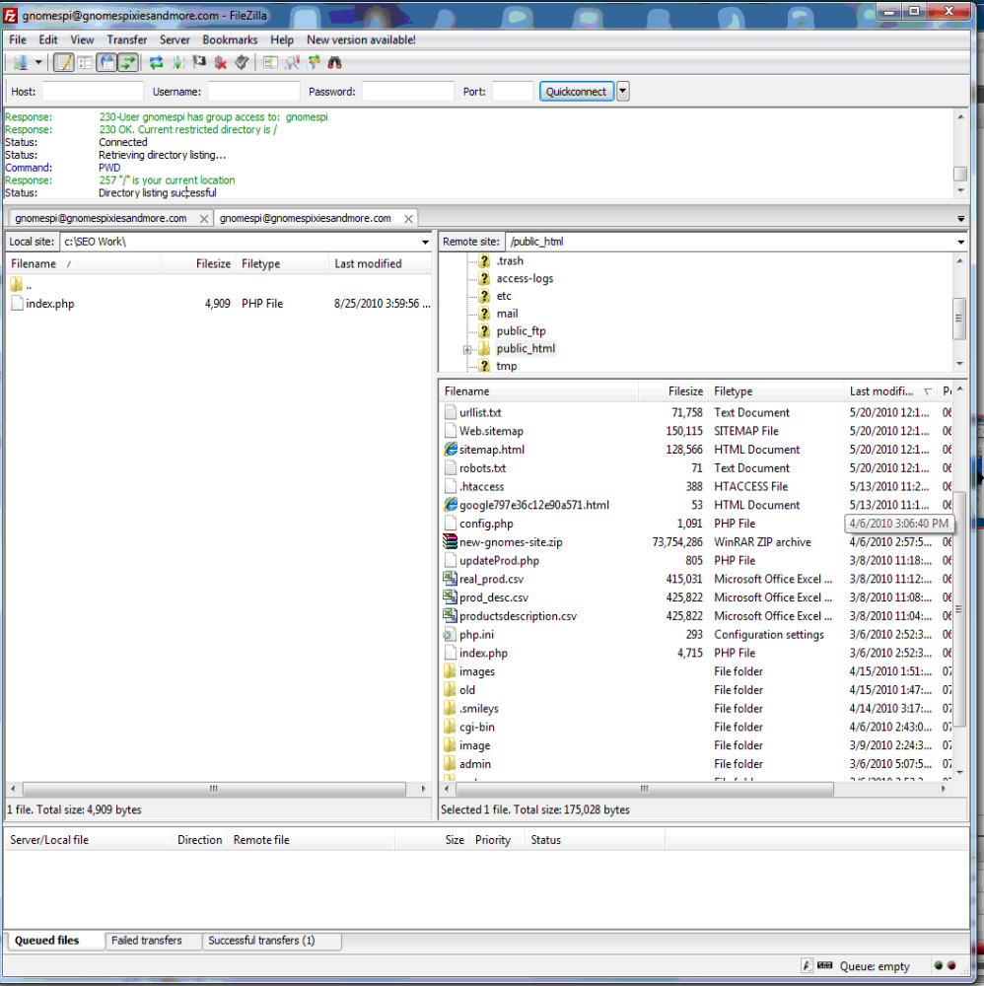

In this view you will see that my index file is called "index.php" Your index file may have a .shtml, .html, or .htm extension. For our purpose it does not matter. However do not change the extension as this may make your site inoperable.

Now click on the index file ( whatever the extension is) file and drag and drop it over to the lower left panel in the directory you want it in. I created a directory on my hard drive - c:\seo work so I can keep the files I am working on in this directory so I know where the
files are.

Now open Notepad and load your index file. Please make sure these tags are in the top part of your index file.

<meta name="keywords" content="keyword1,keyword2,keyword3"/>

<title>Your site name and short description"</title>

<meta name="description" content="your site description” />

<meta name="robots" content="index, follow"/>

Of course please modify these meta tags so they reflect your site.

Then save the file. Please do not change anything else unless you really know what you are doing.

Once the file is saved in the same directory you can go back to Filezilla and copy the changed file back to the web site.

You can and should edit all the pages on your web site and add in the proper meta tags.

Some ecommerce website software programs have a Content Manager and you can edit all the meta tags through the Content Manager.

4. Content IS KING:

The Search Engines strive to deliver the newest and most relevant content to the people who are searching.

The content pages must be well written using the correct keyword density which is approximately 4%. So if the content page has 600 words then the keyword must be mentioned 24 times. A single keyword and a keyword phrase is counted as one keyword.
It is best to only use one keyword or keyword phrase per page, and having that keyword appear 4% of the time. Using more than one keyword on a single page will reduce the keyword density and your results will not be as good.

Articles:

In addition to Content Pages, you can post articles on your keywords on your site. This will be very valuable as the Search Engines are looking to provide searchers with the best and most relevant information.

Articles should be between 400 and 600 words long with about 4% keyword density.

Another important consideration is age - an old article is not as valuable as a more recent one. You should avoid duplicate content. Duplicate content will have a discounted value.

DO NOT PLAGERIZE - this can actually get your site banned!

You can do research on the Internet and read articles - gather the information and then create a new article using your own words. Just do not copy the information.

.
eZines

There are many eZines on the Internet - these are often referred to as "online magazines" and supply many mega thousands of web sites with the articles published to their sites.

Submitting articles to these eZines will be very helpful to your web sites. Again here, you must avoid duplicate content. The articles should also be about 600 words long. You can find a list of eZine sites on www.seolinkcheck.com. The more articles you submit the better for your site. Also, use catchy titles for your articles - this will increase readership and the more popular your articles are the more traffic to your site.

Links - IMPORTANT!

There are three different type of links:

Inbound - this is where another site is linking to your site but you are not linking back. This is the most valuable type of link.

Reciprocal - Reciprocal links are where you exchange links with another site - you have a link on your site to their site and they have a link on their site to your site. There are a number of things you have to watch out for with reciprocal links:

1. They should be a RELEVANT SITE - this is a site that has something in common with your site.

The reason for this is that the Search Engines are looking for the best content to give to the person searching. They are thinking that if the info they want is not on your site then perhaps they will find a link to what they are looking for.

If there is a link on your site that is not considered relevant that it will have little or no value.

This is not a well defined area - I would suggest that if you can not find any common area between the two sites then don't exchange links.

2. Are the links still there? Unfortunately, there are a lot of people out there that will do what they can to get an edge. Here's one of the things what they may do - they agree to exchange links with your site and they put a link your link on their site. Once you have placed a link on your site to their site and a couple of weeks have passed, they remove the link to your site. They now have an inbound link and they have a good inbound link. This is very bad for your site.

If you have a hundred sites that you have exchanged links with and you wanted to go check to make sure they are still there then it would take a well versed person approximately 5 minutes to check each site. That would be at least 500 minutes or over 8 hours. This is really time consuming. But it really needs to be done.

I have talked to a lot of other companies and they have told me that they do not check to see if the links are still there- it takes too long.

We have created a web site - www.seolinkcheck.com - which you have a free membership in that will check this for you.

This site will execute a script that will go to the sites where your links are supposed to be and verify that they are there - and all is well. In addition, this script will check to see if there has been any code entered with the link - such as a "No Follow" tag with has the same effect as deleting the link but is harder to discover.

Seolinkcheck.com will give you a report and you will see what links are still there - properly - and which links there is a problem with. This saves a tremendous amount of time. Your membership in seolinkcheck.com is free. The best reciprocal link you can get is to have one with your best competitor. Some people will say " I don't want to send my clients to my competitor" - and that is understandable.
However, your competitor is likely to have good content and is definitely relevant so a link from them would be worth more. Another good point would be how often have you gone to a web site and looked to see what links hey have? If you were not doing SEO work to promote your site, you would not do it either.

Outbound Links:

Outbound links are definitely a bad thing. This is where you site links to another site and that site does not link back to you. The thinking here is that if you are linking to another site for information, why send the searcher to your site? Why not just send them to the site with the info? This is somewhat simplified but it does get the point across. AVOID outbound links.

Page Rank Tool

Go to google.com and click on the more link in the top left (see the arrow in the image below).
Another drop down menu will appear and the last link will say even more. Click on even more and then in the left column you will see Google Tool Bar listing (see image below) click on this to install the Google Tool Bar. Once this is installed you will have to go to the tool bar options and enable the Page Rank tool.
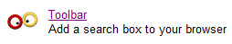

You will then see a small square wit a partial green line in your browser header. You can mouse over this and it will give you a value out of 10. This is what Google says is the value of your web site in your industry to people searching for your products and services.

More on Back Links
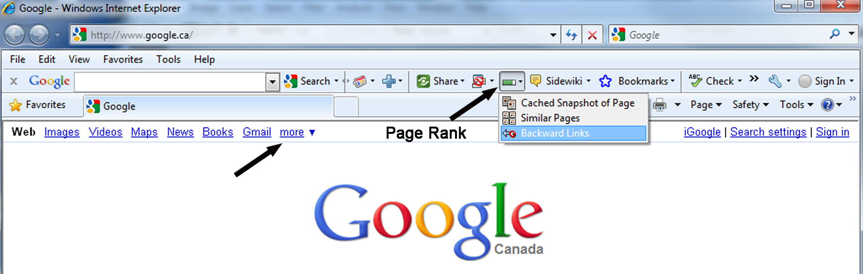

In addition, if you click on the small down arrow as in the image above, a drop down menu will appear which will display the Google recognized back links to your site. This is not considered to be an accurate account of the back links however.

When you create an account for your site on Google webmaster tools, you will see that the back links that Google reports here is different.

To complicate matters further go to www.google.com and enter the following search term:

link www.yoursite.com wow what a difference. The try the same search term in Bing and Yahoo.

The results here are phenomenal. What is important is which links Google values the most. To me, the best indicator or true value links are the one in the Google Web Master Tools.

How many back links does your site have?

Web Master Tools

Each of the major Search Engines have webmaster tools that you can use to help you with your site. These are invaluable to those who are doing Search Engine Marketing on their site.

Google Webmaster Tools Go to Google and search for Google Webmaster Tools. Click on the link and register. Then you can set up your site here.

When you sign up for Google Web Master Tools, here are some of the features that will help you with marketing of your web site.

Google Web master Tools

Link: http://www.google.com/webmasters/


Find out how Google sees your site
Verified site owners can see information about how Google crawls, indexes and ranks your site

Analyze search data
See how many people found your site in search results, and how many people clicked on it

Receive alerts in your inbox
We'll tell you if we detect that your site has malware or generates errors

Check who links to you
We track links from all over the web, and we'll show you who added a link to your site

Tell Google about your site
Submit Sitemaps and see how many pages we added to the index

Yahoo SiteExplorer Tools is the equivalent of Google Web Master Tools but for Yahoo.

Link: https://siteexplorer.search.yahoo.com/

Bing WebMaster Central is Bing's version of Web Master tools for Bing.

Link: http://www.bing.com/toolbox/webmasters/

Blogs:

Blogs are “hot” with Search Engines – if done properly – as they are content rich pages that the Search Engines love. You will need Blog software under a sub-domain of your site. You will have to either write articles on the products or the services you are selling, or find articles on the web and copy them to your Blog. While copying these articles to your blog seems to be ok I don't think it is preferable Fresh content will help keep your site at the top of the Search Engines. WordPress is a popular, easy to use blog software package.

Social Networking - The following sites can draw a lot of traffic to your website. In addition to the traffic they will also add links which will also help with the Search Engines. Go to these sites and create a profile page and then ask friends and business associates to add you to their network.

Facebook

Twitter

Myspace

Linkedin

Digg

Videos: Make some informative product videos and place them on YouTube, Google Videos etc. This will be a great help both for traffic and links.

Site Maps Jatech will create a comprehensive site map that will allow visitors and Search Engine Spiders to navigate the site with ease.

Google Specific Site Map a site map that we will have individually approved by Google. This site map will be used by only Google to index your site.

Google Local: If you have a brick and mortar store we will list you on Google Local. This means when someone searches for your keyword, your site will be listed at the top of the results for your general physical location.

Google Analytics
In your webmaster tools account with Google you can sign up for Google Analytics - this will give you important statistics - such as which keywords are bringing the most traffic to your site. This is a valuable tool.

SEOLinkcheck.com - Reciprocal Links are definitely important for Search Engine Ranking, as mentioned previously.
Classified Ads: We have also added over 600 free classified ad site and the ability to manage these. Again this is great for traffic and also links to your website.

Directories: You can not have your web site listed in too many directories. In SEOLINK check we have a list of Directories that you can list your site in - and the tools to track these entries.

Search Engine Optimization Work Sheet

Site Optimization
Submission to Major Search Engines
Keyword Research
Keywords optimized/pages
Pages Updated Monthly
Hours Worked Adding Links
Site Map Created
Google Site Map
Blog installation & Setup
Articles added to Blog
Articles added to EZines
Add to paid Directories
Add to specialized High traffic Directories
Monthly Ranking Reports (SERP) and SEO traffic report
Social Marketing
Video Marketing - Creation of Videos for
YouTube, Veoh, Google Videos ,etc
Viral Marketing
Facebook
Twitter
MySpace
YouTube

When a site is first optimized and submitted to the Search Engines there is a three month period during which the Search Engines look at your site to determine if there is continued improvement.
This is called the “Sandbox” effect.

Once they see continued improvement over this period they start giving your site credibility.

