GROUP 16

1. Keystone Topic
- Clearly stated topic - Family Activities in Salt Lake City
- Why did you choose it? We chose this topic because we felt that there was plenty of content on the site that related to the topic; however, there was no organization around the topic.
2. Primary Keyword
- Keyword + search volume - family activities Salt Lake City - (4.4k searches)
3. Supporting Keywords
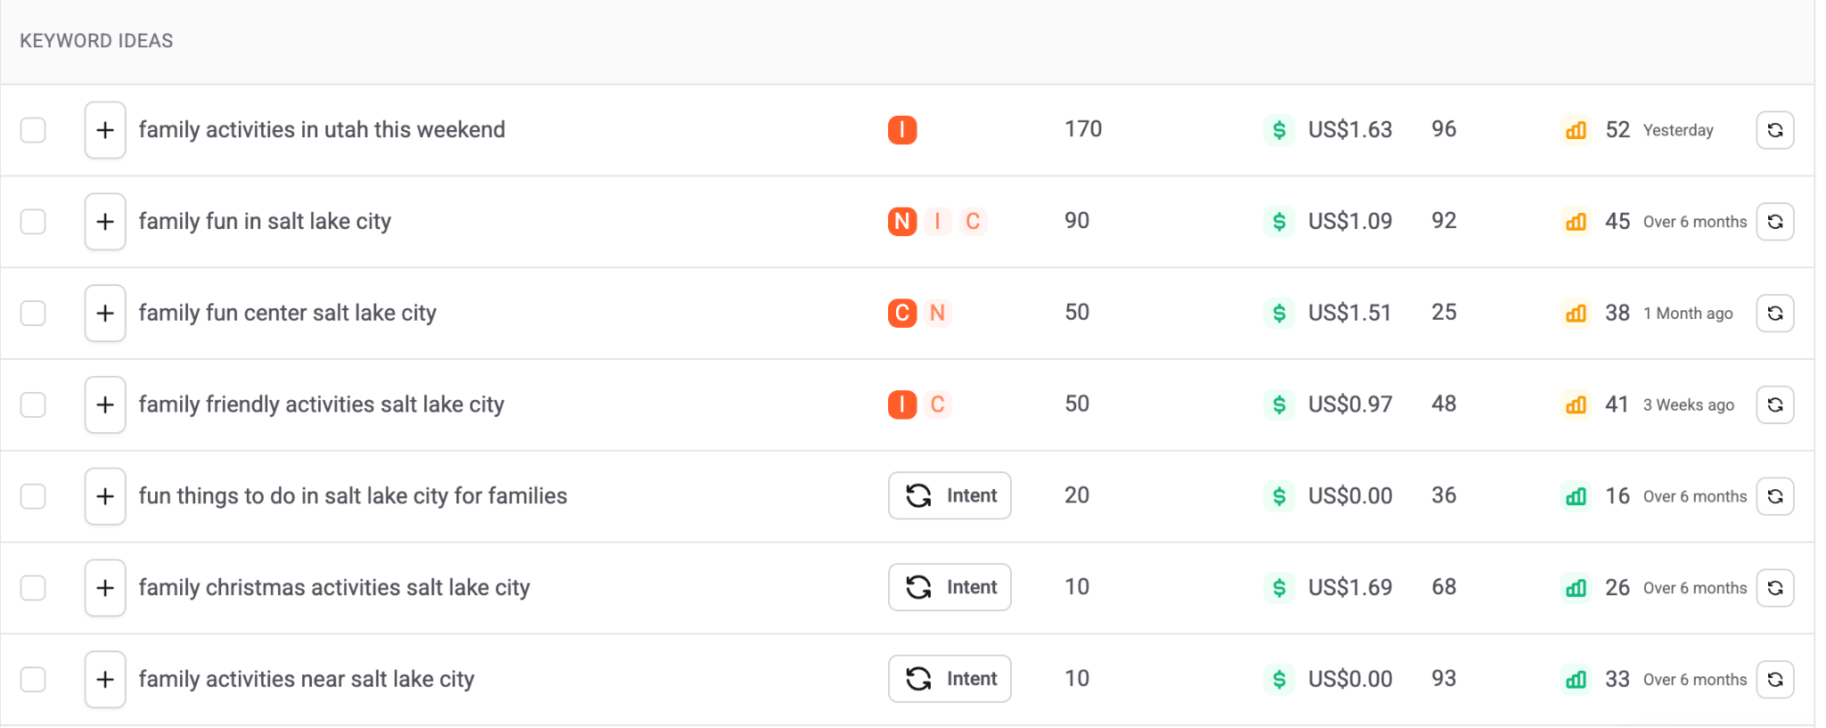
- Family activities in Utah this weekend (170 searches)
- Family fun in Salt Lake City (90 searches)
- Family fun center salt lake city (50 searches)
- Family friendly activities Salt Lake City (50 searches)
- Fun things to do in Salt Lake City for families (20 searches)
4. Supporting Content Ideas
- Our topic, Family Activities in Salt Lake City, can support a range of connected blog content that targets each user's needs and search intent differently. These supporting blog posts will link back to the main keystone page to build SEO authority.
Blog Topics:
- 4 must-visit playgrounds in the Wasatch Front
- The ultimate guide to winter fun with kids in SLC
- Discover exciting things to do in Utah: visit Hogle Zoo and Loverland Living Planet Aquarium
- The Utah Family History Center Guide
- Family fun in Utah - the 5 best mini golf locations
- Top trampoline parks in Salt Lake City
- 5 best family-friendly water activities near Salt Lake City
- Patriot park family friendly fun in Saratoga Springs
- 3 kid-friendly hikes near me in Utah
- Top 5 family-friendly activities in Salt Lake City
These 10 supported blog posts create a great foundation that expands keyword coverage, internal linking, and overall search intent for families who are searching for activities in Salt Lake City.
Related Questions:
- What free things can you do in Salt Lake City?
- The best indoor activities for kids in Salt Lake City?
- The best outdoor activities for families in Salt Lake City?
- What can kids do in Salt Lake City?
Long-Tail Keywords:
- Indoor playgrounds for kids in Salt Lake City
- Best playgrounds in Salt Lake City
- Family activities in Salt Lake City
- Family friendly restaurants in Salt Lake City
- Water park Salt Lake City
- Kids indoor playground Salt Lake City
- Family Fun Center Salt Lake City
- Kid friendly restaurants Salt Lake City
- Family friendly hikes in Salt Lake City
- Family hikes Salt Lake City
5. Competitive Insights
23 Things to Do in Salt Lake City with Kids - Utah's Adventure Family
- Content length:
  - 2,721 words
- Structure (headings, sections):
  - Title card, list of activities (including a description and link to more info), side bar site navigation tab, contact info, and links to other blogs.
- What they do well:
  - Call to action on the sidebar list has a lot of keyword potential, site information on the sidebar, links in the descriptions, links to other site content on the page and within the list, and lots of pictures.
- What they are missing:
  - Boring structure that could be more eye-catching.
11 Family-Friendly Salt Lake City Activities | Visit Utah
- Content length:
  - 3,080 words
- Structure (headings, sections):
  - Title card, site tabs, list of activities (including a description, location, and link to the activity’s website), informative video, links to other blogs, and contact information.
- What they do well:
  - An expansive list with lots of keyword potential. Easily readable and essential information is accessible. Links to exterior sites also provide convenience and validity to the user. Lots of images that depict the activities being written. Video at the end that could increase engagement. Internal links at the top of the page.
- What they are missing:
  - Internal links throughout the content. Structure is still basic and could be more eye-catching and better structured. Possibly, bullet points could allow for better readability.
Things to do in Salt Lake City with Kids | 18 Kid-Friendly Activities
- Content length:
  - 3,137 words
- Structure (headings, sections):
  - Title card, site tabs, list of activities (including a description, location, and link to the activity’s website), and contact information.
- What they do well:
  - An expansive list with lots of keyword potential. Easily readable and essential information is accessible. Links to exterior sites also provide convenience and validity to the user. Lots of images that depict the activities being written.
- What they are missing:
  - Lack of internal links throughout the content. Navigation of the page is repetitive and could be structured in a more eye-catching way.

