This program works off the formulas:
Y?AX²+BX+C
Y?A(X+B)²+C

What it does is when the number are input for one of the formulas, you go to another menu that ask the inequality, then it spits out this:
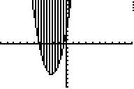

It graphes it and shades it!!!!!

If you would like to update the program in any way feel free. I have not used this in a good year so I don’t know if there are any problems in it.

