**Launch Date Outcome  
Conclusions**

1. Given the provided data, what are three conclusions we can draw about Kickstarter campaigns?
   1. Project starting between Halloween and the end of the year have a higher failure / cancelation rate based on the graph below. Perhaps this is due to the holiday season. We would need more data to be sure.
   2. There is an inverse relationship between project success rate and their goals. In other words, the higher the goal (money to raise), the less likely the project will be successful. See chart below.  
      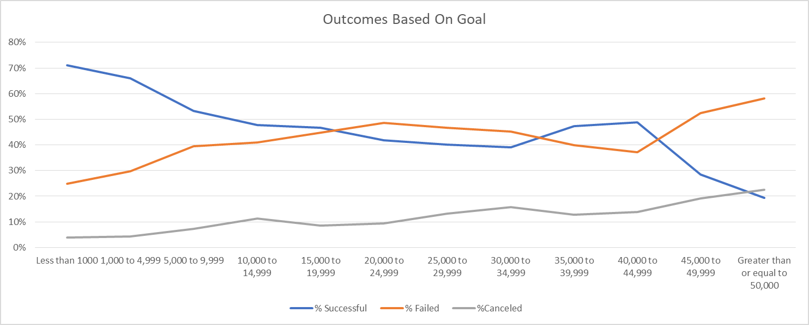
   3. Projects in the performing arts category have a much higher success rate than any other project category. Perhaps due to the target audience (and their expendable income)?  
      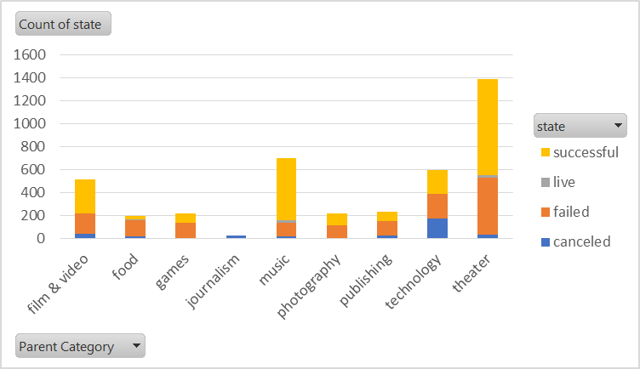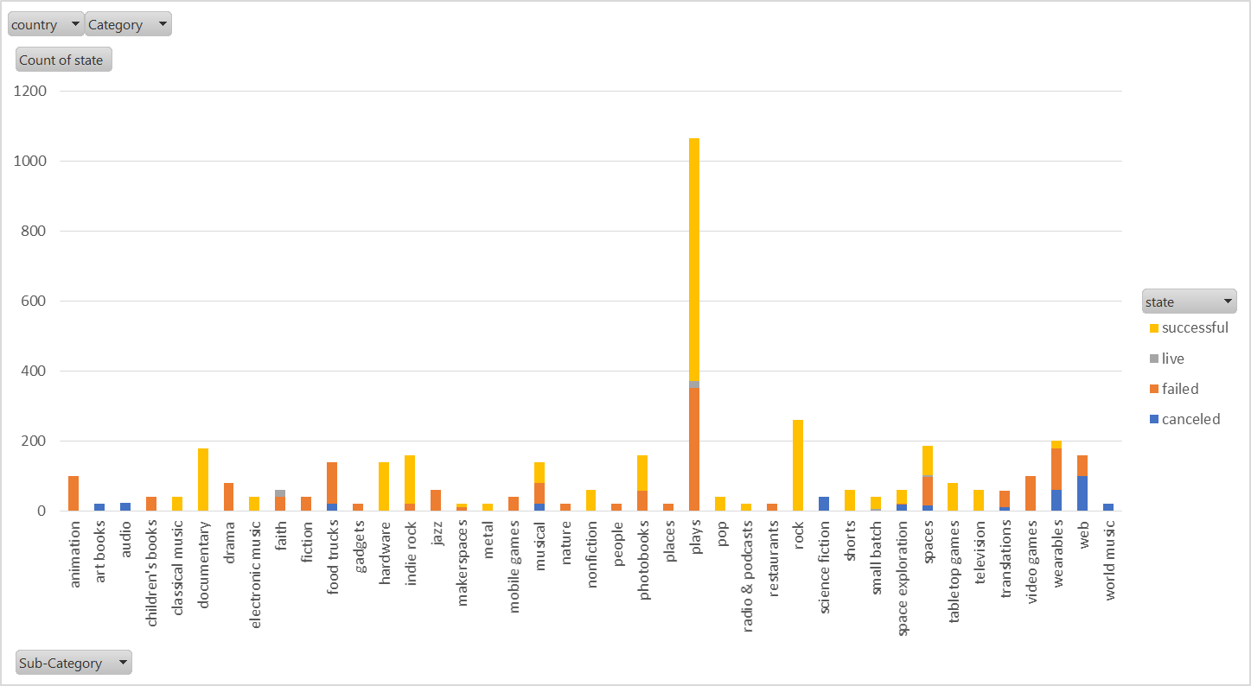
2. What are some limitations of this dataset?  
   The amount of data available is the largest limiting factor of this analysis. Kickstarter started in 2009 and the data for 2009 and 2010 are limited. In addition, demographic information about each donor is missing from our dataset.
3. What are some other possible tables and/or graphs that we could create?  
   It would be interesting to see which category and sub category had the highest average donation value and compare that to the success rate for that category and sub category. It’s possible that projects targeting a wealthier audience are more successful.