The Final Hour: Design and Ideas

Idea: A game based on the gravitational pull of objects; it takes place in space (seems fitting for the given theme). The idea was originally like angry birds in which the player would point a rocket in a direction and launch it with a certain amount of force/magnitude. The rocket could be manipulated by the gravitational pull of planetary objects, and the player’s goal was to aim the rocket in such a way that it makes it to the goal (planet Earth). Due to time constraints, this idea was reformed to a much simpler game based on gravity. Now, the idea is that the rocket is being sucked into a black hole. The player must avoid asteroids orbiting the black hole and maintain rocket fuel.

Objective: The objective is to survive as long as possible (similar to flappy bird). This means to avoid getting sucked into the black hole, and to avoid getting hit by asteroids. Maintaining rocket fuel is important because running out will certainly lead to death.

Mechanics: The player presses the space bar to give the rocket thrust. This thrust pushes the rocket upwards and away from the black hole; however, the thrust also burns rocket fuel, which is limited. The player releases space bar to stop the rocket’s thrusters.

Rules: The player cannot touch an asteroid or the blackhole. Doing so will end the game. Once the game ends, the timer in the top-right corner of the game will keep track of the farthest time the player has gone without dying. The player must also collect fuel points to keep thrusting the rocket’s engines. The fuel points are also in orbit around the black hole like the asteroids. So, the player must avoid the asteroids and collect the fuel points simultaneously to survive as long as possible.

Art Assets:

* Rocket Idle:



* Rocket Thrust:



* Asteroids:

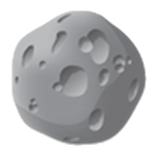

* Planets:

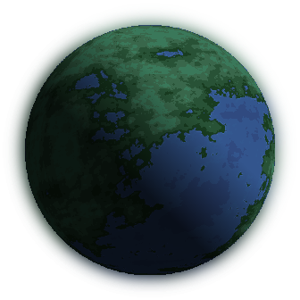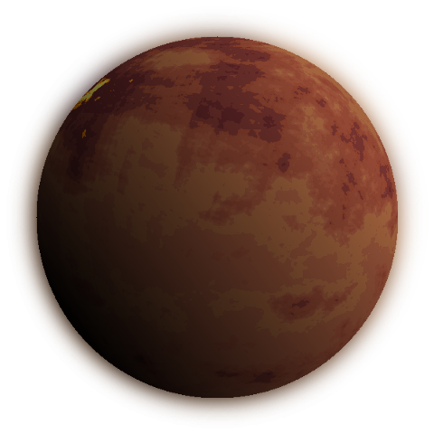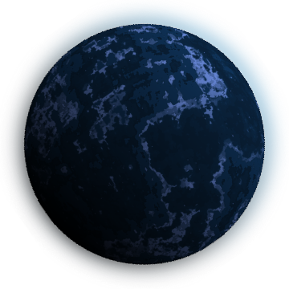

* Space Background:

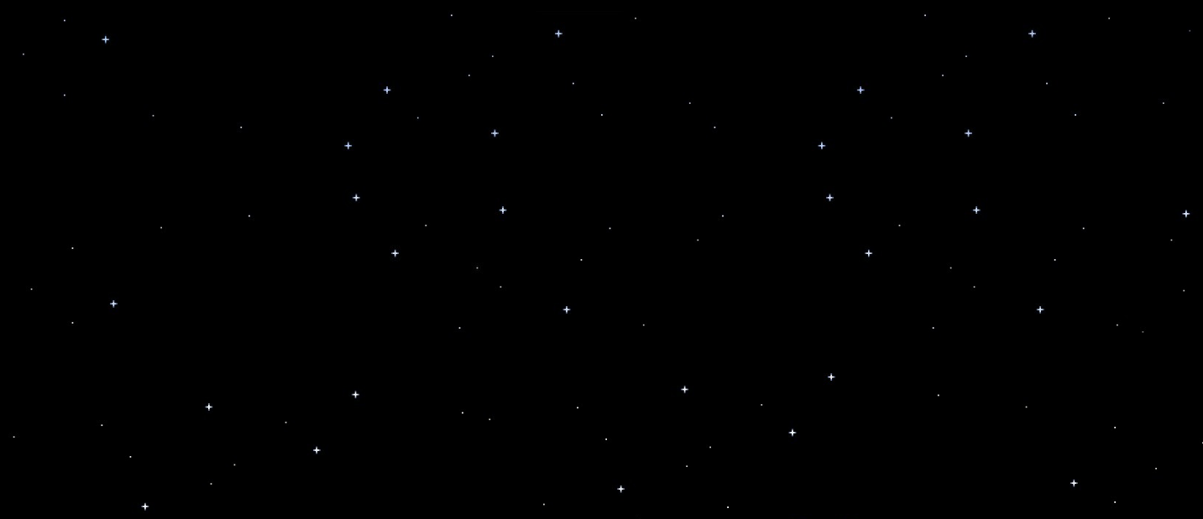

* Fuel Points:



* Black Hole:

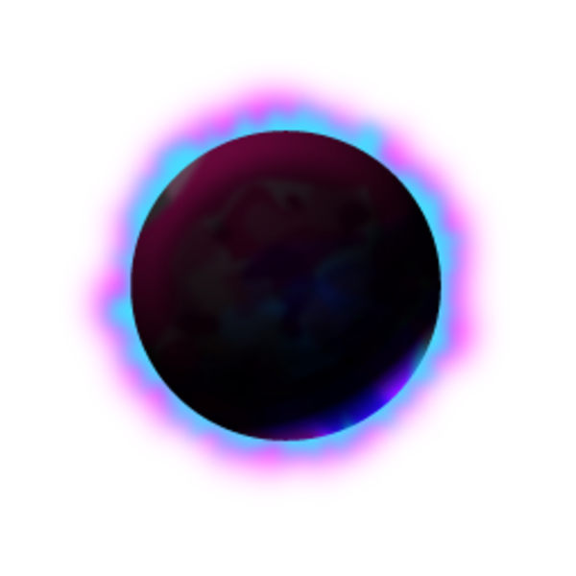

Some art assets were taken from the asset store. These assets include the background, the planets, and the fuel meter. However, many assets such as the ship, the asteroids, the fuel points, and the black hole were taken from clip art and shapes in Microsoft PowerPoint.