MSE Across different random seeds for Least Square
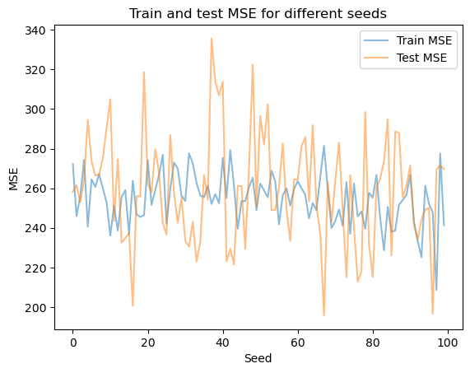

LMS Learning Curve differences due to Learning Rate selection
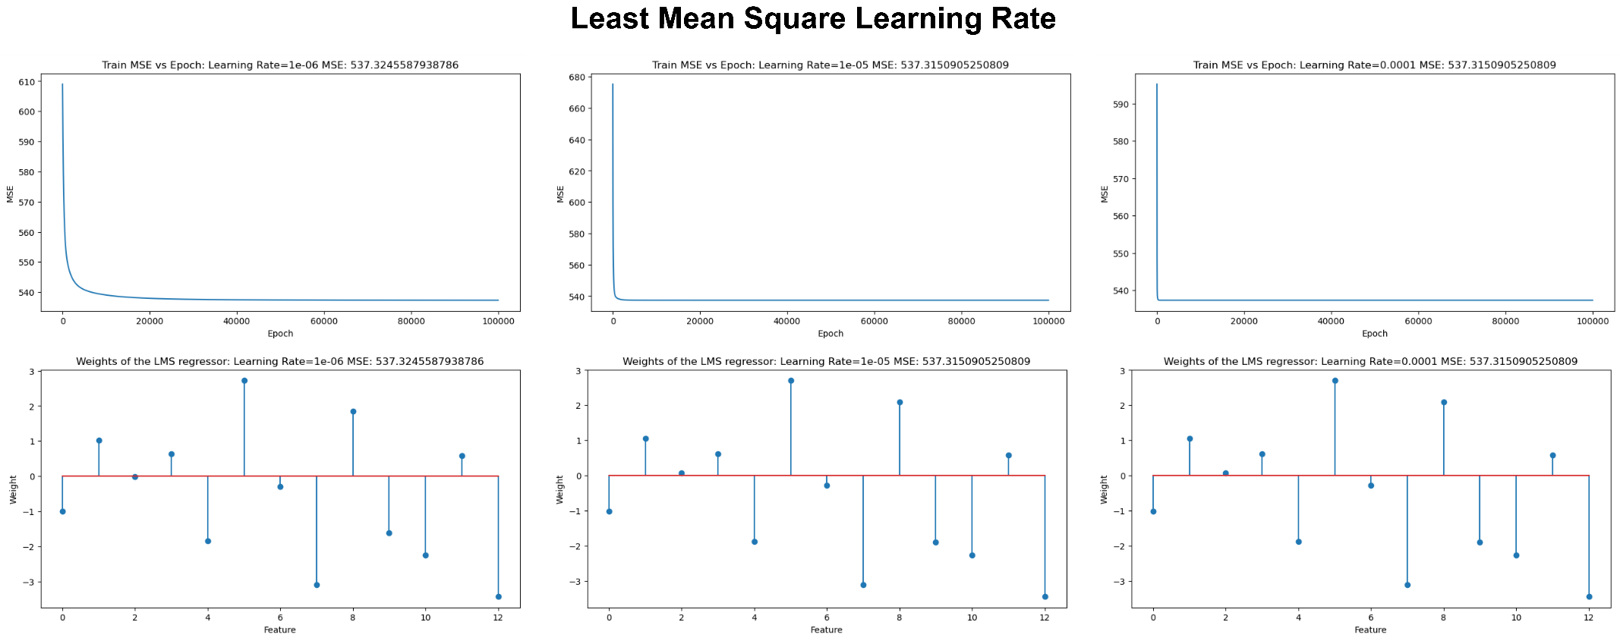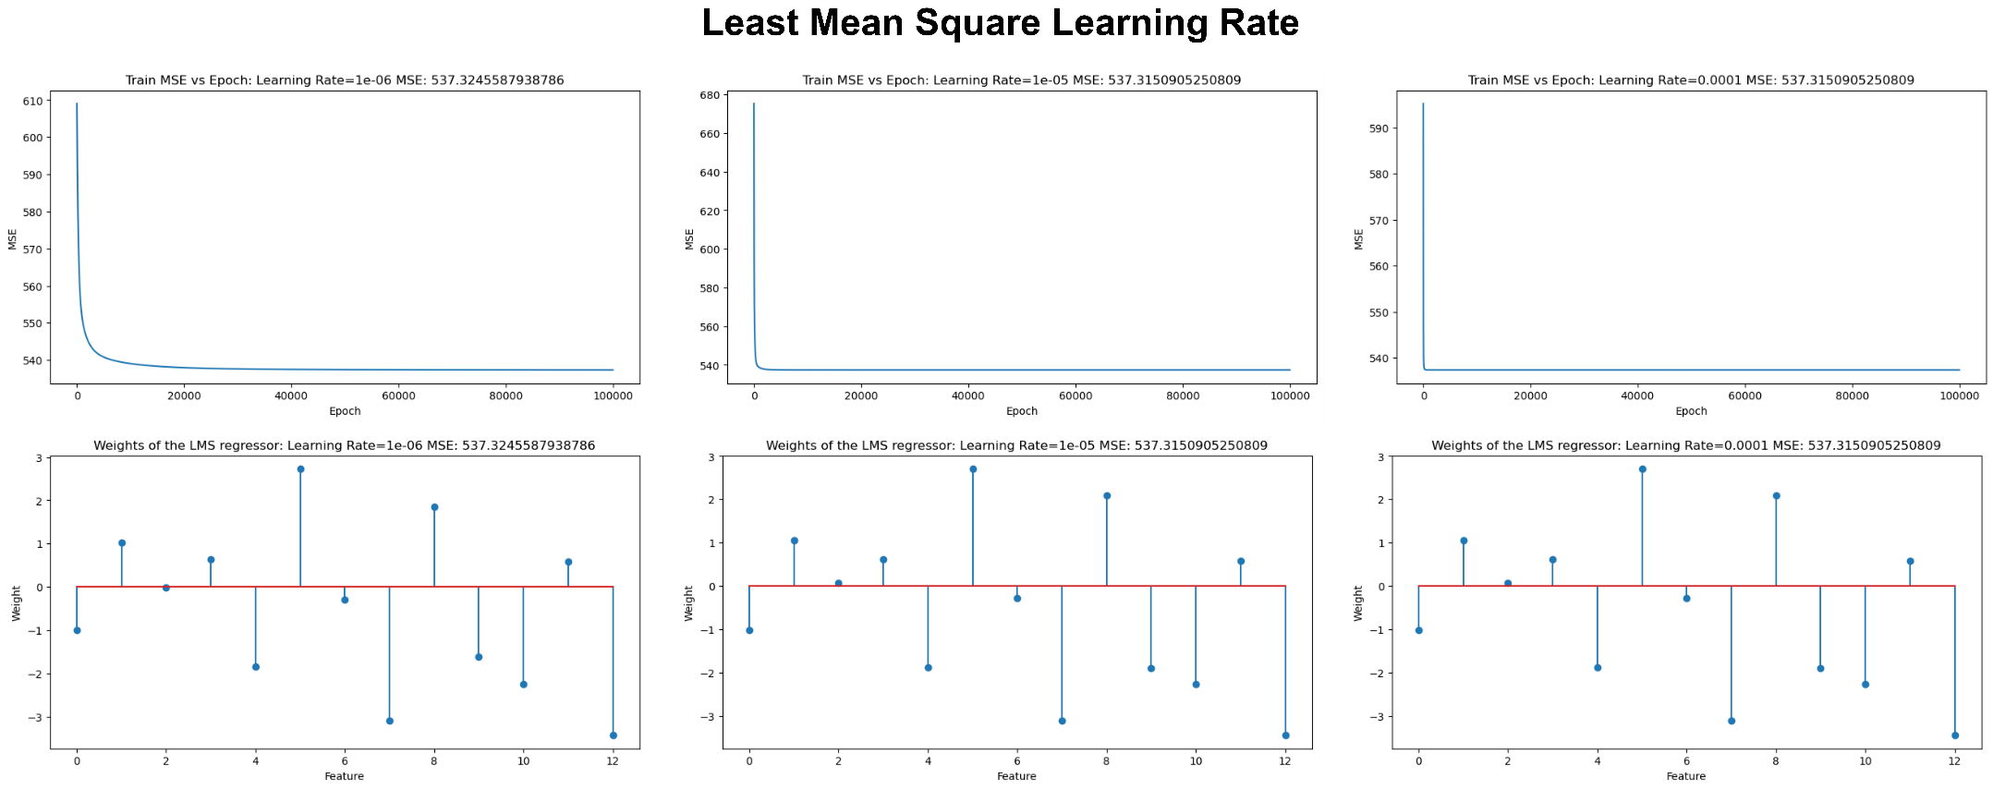

Compare LMS w/ LS for best model parameters
From the experiment presented, the best parameters were random seed=1 and LR=0.1e-3. However, LMS still converged to a worse solution.

Show the Variance between Results(Different seeding and weight initializations) and Best Train and Test Error.
Model | Train Variance | Test Variance | Train MSE | Test MSE
Least Square | 158.946 | 769.138 | 208.646 | 195.819
Least Mean Square | 36.778 | 199.398 | 522.581 | 513.532

