Brazilian E-Commerce Sales & Delivery Analysis
A Power BI Dashboard Project
Prepared by: Patrick John M. Lansangan
Project Type: Personal / Portfolio Data Analytics Project
Tools Used: SQL (data cleaning), Microsoft Power BI (data modeling, DAX, visualization)
Dataset: Brazilian E-Commerce Public Dataset by Olist (2016–2018)

1. Executive Summary
This project analyzes approximately 99,000 e-commerce orders from Olist, a Brazilian marketplace platform, covering the period from September 2016 to August 2018. The goal was to build a two-page interactive Power BI dashboard that answers two core business questions: (1) how is the business growing, and (2) how well is the business fulfilling its promise to customers, and does that affect satisfaction.
Raw data was first cleaned and validated using SQL before being loaded into Power BI, where a star-schema data model was built, custom DAX measures were written, and the final dashboard was designed with a consistent visual theme across both pages.

2. Objective
- Analyze overall sales performance, growth trends, and revenue concentration by category and region.
- Evaluate delivery performance (on-time rate, average delay) and its relationship to customer satisfaction.
- Identify actionable insights that a real e-commerce business could use to improve operations.
- Demonstrate practical skills in SQL, data modeling, DAX, and dashboard design for a data analyst portfolio.

3. Data Source
The dataset used is the publicly available “Brazilian E-Commerce Public Dataset by Olist,” containing real, anonymized order data across multiple relational tables: orders, order items, order payments, order reviews, products, product categories, customers, and sellers.

4. Tools & Methodology

4.1 SQL Data Preparation & Exploratory Analysis
Before building the Power BI data model, SQL was used to explore, validate, and pre-analyze the raw data across customer, sales, product, seller, and satisfaction dimensions. This surfaced early insights and confirmed data quality before the dashboard was built, using the following techniques:

Aggregate Functions (COUNT, SUM, AVG, ROUND)
Used throughout to summarize revenue, order counts, and review scores. Example — average customer review score:
SELECT
ROUND(AVG(review_score), 2) AS average_review_score
FROM order_reviews;

Common Table Expressions (CTEs)
Used to break multi-step revenue calculations into readable, sequential stages — first computing per-order revenue, then rolling it up by year and by month:
WITH total_revenue AS (
SELECT o.order_purchase_timestamp, SUM(ot.price) AS Revenue
FROM orders AS o
JOIN orders_items AS ot ON ot.order_id = o.order_id
GROUP BY o.order_purchase_timestamp
),
year_sales AS (
SELECT DATE_FORMAT(order_purchase_timestamp, '%Y') AS Years,
SUM(Revenue) AS total_sales_this_year
FROM total_revenue
GROUP BY DATE_FORMAT(order_purchase_timestamp, '%Y')
),
monthly_sales AS (
SELECT DATE_FORMAT(order_purchase_timestamp, '%M') AS Months,
AVG(Revenue) AS monthly_revenue
FROM total_revenue
GROUP BY DATE_FORMAT(order_purchase_timestamp, '%M')
)
SELECT * FROM monthly_sales;

Window Functions
DENSE_RANK() was used to rank sellers by total revenue generated, without collapsing tied values:
SELECT
s.seller_id,
SUM(ot.price) AS Sales,
DENSE_RANK() OVER (ORDER BY SUM(ot.price) DESC) AS Rank_Sales
FROM orders_items ot
JOIN sellers s ON s.seller_id = ot.seller_id
GROUP BY s.seller_id;

Conditional Logic for Data Cleaning & Categorization (CASE)
A CASE statement was used to bucket orders into on-time vs. late delivery, which was then compared directly against review scores — this was the earliest signal that delivery speed affects customer satisfaction, later confirmed and expanded on in the Power BI dashboard:
SELECT
CASE
WHEN o.order_delivered_customer_date <= o.order_estimated_delivery_date
THEN 'On Time'
ELSE 'Late'
END AS delivery_status,
ROUND(AVG(oe.review_score), 2) AS average_rating
FROM order_reviews oe
JOIN orders o ON o.order_id = oe.order_id
GROUP BY delivery_status;

Multi-Table Joins & Filtering
Multiple INNER JOINs across orders, order items, products, customers, and sellers were used throughout to connect the relational tables — for example, identifying the top 5 revenue-generating states:
SELECT
c.customer_state,
SUM(ot.price) AS Revenue
FROM customers c
JOIN orders o ON c.customer_id = o.customer_id
JOIN orders_items ot ON ot.order_id = o.order_id
GROUP BY c.customer_state
ORDER BY Revenue DESC
LIMIT 5;

4.2 Data Modeling (Power BI)
A star-schema model was built in Power BI, with the Orders table as the central fact table connected to Order Items, Order Payments, Order Reviews, Customers, Sellers, Products, and a Product Category translation table. A dedicated Date table was created and related to Orders to support time-intelligence calculations.
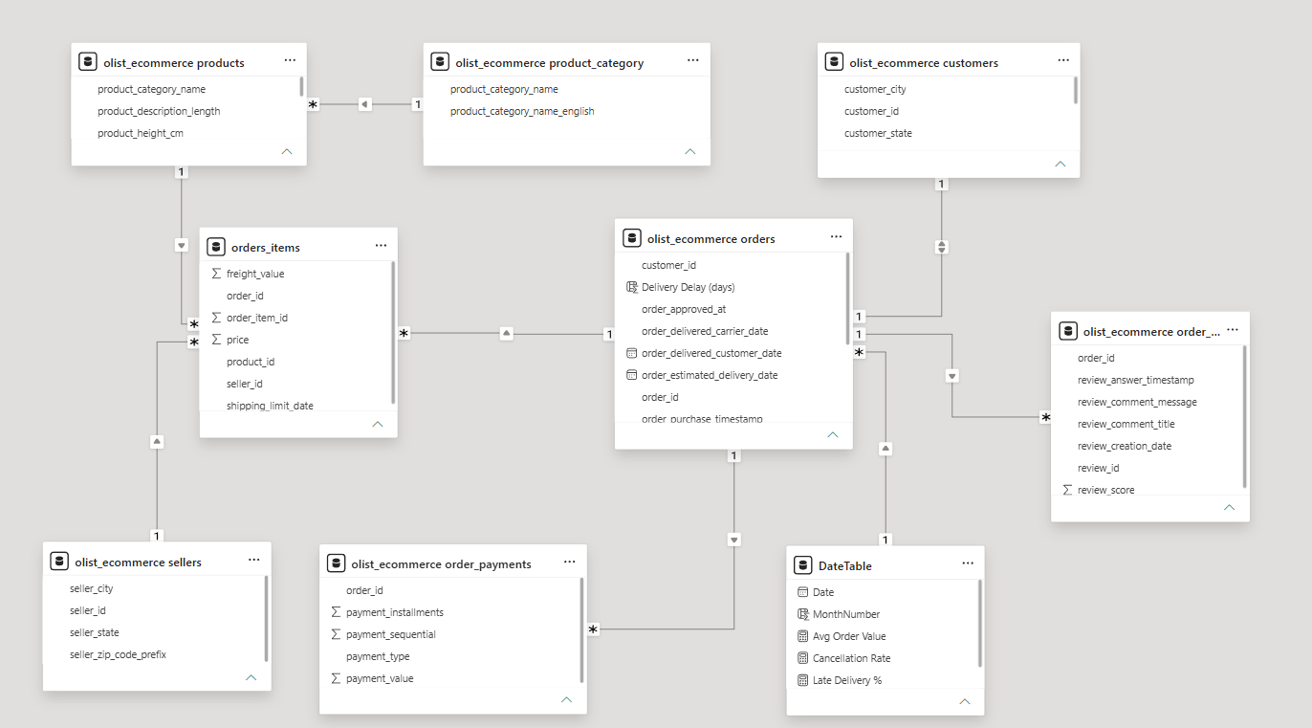

4.3 Key DAX Measures
Measure | Purpose
Total Sales | Sum of order item prices — core revenue metric
Avg Order Value | Total Sales divided by distinct order count
Delivery Delay (days) | Calculated column: estimated vs. actual delivery date difference
Avg Delivery Delay | Average delay across all delivered orders
On-Time Delivery % | Share of delivered orders that arrived on or before the estimated date
Cancellation Rate | Share of orders with a Cancelled status

5. Dashboard Overview

Page 1 — Sales Growth Dashboard
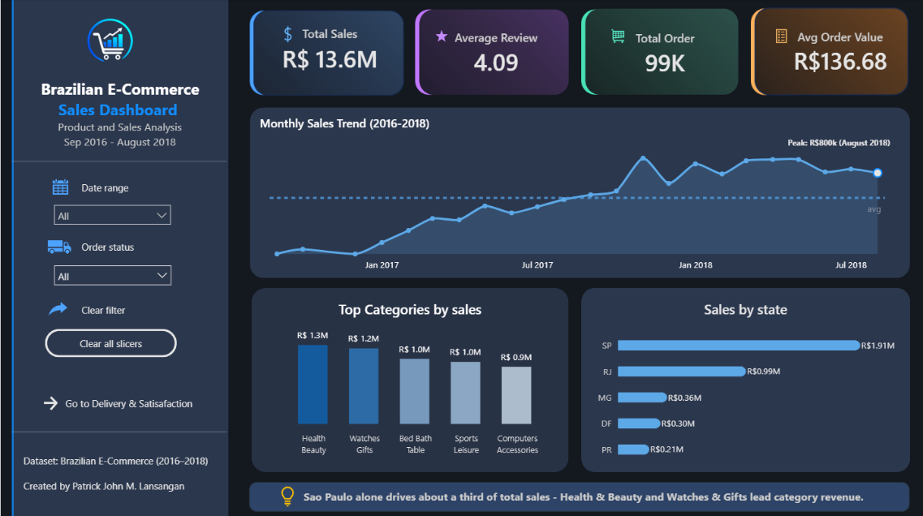
Displays total sales, average review score, total orders, and average order value as headline KPIs, alongside a monthly sales trend line, top product categories by revenue, and sales by state.

Page 2 — Delivery & Satisfaction Dashboard
Displays on-time delivery rate, average delivery delay, late delivery rate, and cancellation rate as headline KPIs, alongside a delivery delay trend over time, on-time delivery rate by state, and a scatter chart comparing delivery delay against average customer review score.
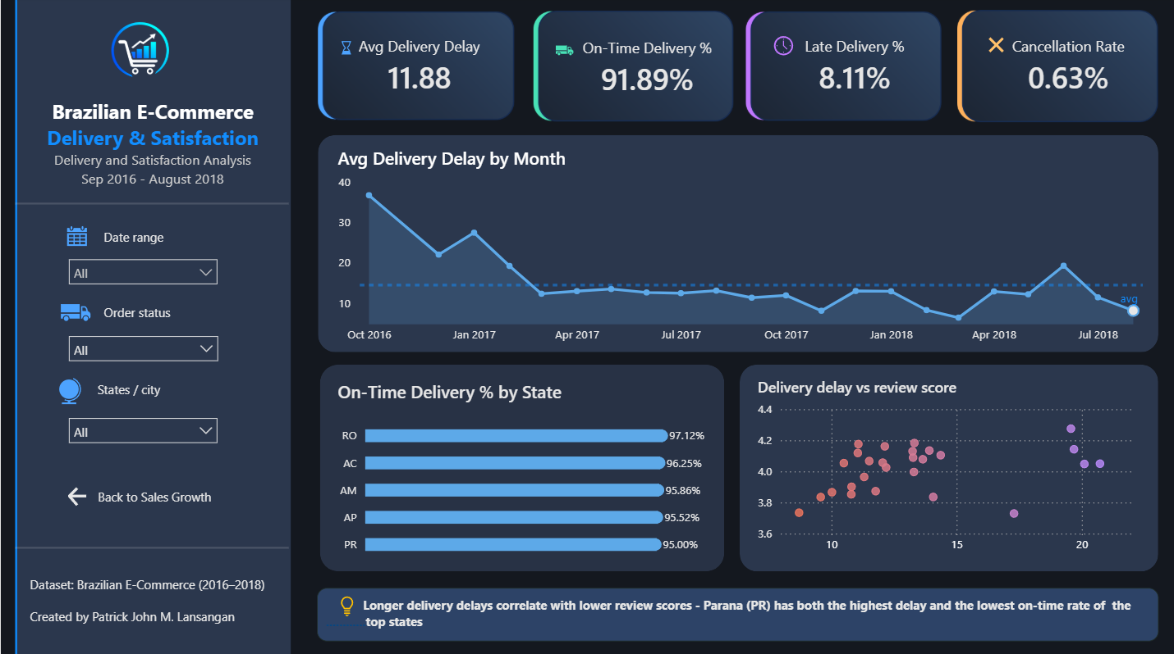

6. Key Insights
- Revenue grew consistently from late 2016 through mid-2018, with a seasonal dip around June–August 2018.
- São Paulo (SP) alone accounts for roughly a third of total revenue, with Rio de Janeiro (RJ) a distant second — sales are heavily concentrated geographically.
- Health & Beauty and Watches & Gifts are consistently the top two product categories by revenue.
- On-time delivery performance is strong overall (approximately 95%), but longer delivery delays are associated with lower average review scores, confirming that fulfillment speed materially affects customer satisfaction.
- Paraná (PR) stood out among higher-volume states as having both the highest average delivery delay and the lowest on-time delivery rate, making it a candidate for operational review.
- A data quality check revealed that order volume drops to near zero after August 2018, indicating the dataset's effective coverage ends there rather than at its nominal end date — this was corrected for in all trend visuals.

7. Challenges & Learnings
- Working through DAX filter context (CALCULATE, DIVIDE, blank handling) required careful attention to avoid statistically misleading results, such as percentages exceeding 100% due to unhandled blank values.
- Small-sample-size states produced misleadingly extreme rates (ex: 100% on-time delivery) purely due to low order volume — addressed by filtering to states with sufficient order volume before drawing conclusions.
- Verified apparent data anomalies (ex: a sharp end-of-period sales drop) against the raw source data rather than assuming a modeling error, which confirmed a genuine data coverage limitation.
- Resolved a data integrity issue during database import where the product_id field was mistakenly defined with an insufficient character length (VARCHAR(20)), causing truncated IDs and broken relationships between the Products and Order Items tables. The database schema was corrected to preserve the full product identifiers.
- Verified apparent data anomalies (such as the sharp decline in sales during the final months) against the original dataset instead of assuming a modeling error, confirming that the issue was caused by incomplete data coverage rather than incorrect calculations.
- Translated broad business questions into measurable KPIs and dashboard visuals, ensuring that each visualization directly answered a specific business objective rather than simply displaying descriptive statistics.

8. Conclusion
This project reflects an end-to-end analytics workflow: cleaning raw data in SQL, building a relational data model, writing DAX measures grounded in correct business logic, and designing a two-page dashboard that tells a clear, evidence-based story about sales growth and delivery performance. The findings point to concrete next steps a real business could act on, such as investigating delivery performance in Paraná and monitoring the relationship between delivery speed and customer satisfaction more closely.

