**Sentiment analysis of Federal Open Market Committee (FOMC) minutes: are they leading indicators of a recession similar to traditional Metrics?**

**Developing a Target Variable**

The Dataset of interest are sentiment scores that I generated using the python VADER Sentiment Analysis library to assign scores based on the minutes of Federal Open Market Committee (FOMC) meetings. Following on from this we’d like to assess whether these sentiment scores are predictive of a recession, whether as a leading indicator or a coincident one.

The methodology I’ve used to create the target variable is based largely on the factors that the National Bureau of Economic Research (NBER) Business Cycle committee uses to determine whether there is a recession or not. NBER principally consider changes in the Real Gross Domestic Product (GDP), the unemployment rate and the employment level as factors for determining a recession [1]. Essentially we develop a target variable that is reflective of the magnitude of a recession, that is when all these indicators are negative the classification will be at it’s highest and when they are all positive it will be 0. This is based largely on the concept of recession magnitude, where certain points of a particular recession show coincident indicators used by NBER are more lower than at other points [2]. Further it also serves to not treat all recessions the same.

We developed two target variables using the aforementioned data used by NBER to determine if there is a recession. For each month there is a classification ranging from 0 to 5 based on these factors. One of the target variables will be on the same dates as the data and one will be offset to 18 months prior. The one set 18 months prior is used as a proxy for leading indication of a recession. The Chart below shows the average intensity of the two target variables by year.

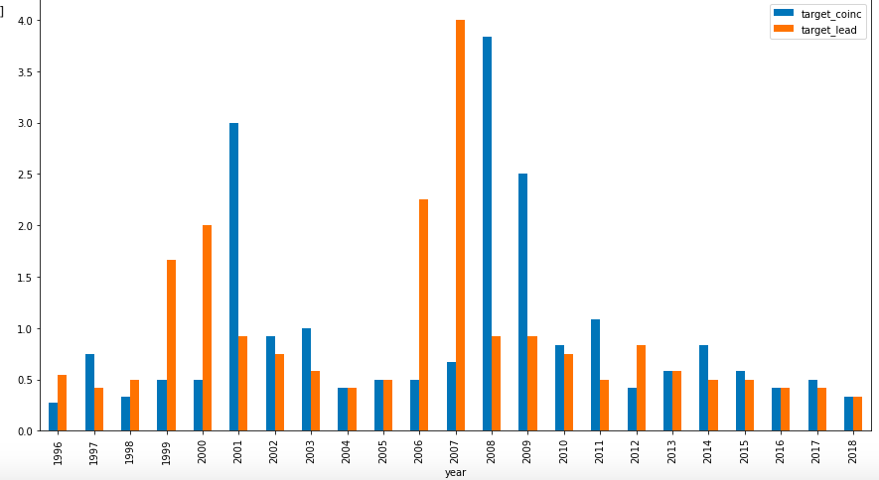

**Initial Model Evaluation**

As discussed, this is a Multiclass classification problem and we’ll be attempting to develop two separate models on two different target variables.

**1. Leading Indicator** - Firstly we’ll look at the leading target variable. This serves to assess whether we can develop a model using FOMC minutes and assessing as a leading indicator of a recession. We split the test and training data on an a four to 1 ratio or alternatively described as an 80/20 split. We start our evaluation using some of the more straightforward classification algorithms such as Naive Bayes, K-nearest neighbors and logistic regression. We then progressed to assess Random Forest Classifiers and Gradient Boosting Classifiers. Despite a great deal of parameter tuning on both Random Forest Classifiers and Gradient Boosting Classifiers, both models exhibited overfitting. The most promising predictive model on both the training and test set for leading indicator target variable was the Gaussian Naive Bayes Classifier which showed an accuracy score on the training set of 0.53 and an accuracy score on the test set of 0.56.

**2. Coincident Indicator** - Secondly we’ll look at the leading target variable. This assesses whether a model developed using FOMC minutes is coincident to a recession. We again split the test and training data on a four to 1 ratio. We used the same classification algorithms as with the leading indicator. So these included Naive Bayes, K-nearest neighbors, logistic regression, Random Forest Classifiers and Gradient Boosting Classifiers. Random Forest Classifiers and Gradient Boosting Classifiers both models exhibited overfitting, as with the leading indicators. Most of the more straightforward classification algorithms did not exhibit excessive overfitting. There were several models that were more promising with coincident indicators than with the lagging indicator. The most predictive of which was the K Nearest Neighbours Classifier which showed an accuracy score on the training set of 0.59 and an accuracy score on the test set of 0.57.

**Conclusions and Next Steps**

The Data set showed some predictive power. From here on out, we’ll assess if any parameter tuning can uncover more predictive models. The next step will also involve coming up with concrete outcomes that either support my initial hypothesis of the FOMC minutes serving as a leading indicator of a recession or not.

**Reference List:**

[1] V. Zarnowitz, “What is a Business Cycle?”. NBER Working Paper No. 3863, Issued in October 1991. <https://www.nber.org/papers/w3863>. [Accessed March 18, 2020].

[2] J. Mazurek, The Evaluation of Recession Magnitudes in EU Countries during the Great Recession 2008–2010, Review of Economic Perspectives, 16(3), 231-244, 2016. <https://doi.org/10.1515/revecp-2016-0014> [Accessed March 18, 2020].

[3] S. Ng and J. Wright, “Facts and Challenges from the Great Recession for Forecasting and Macroeconomic Modeling” Journal of Economic Literature, 51(4), 1120–1154, 2013. <http://dx.doi.org/10.1257/jel.51.4.1120>. [Accessed March 18, 2020].

[4] S. Guido and A. Muller, “Introduction to Machine Learning with Python: A Guide for Data Scientists” Boston: O’Reilly, pp 90-94, 2017.