GitHub primer and review

Videos to consider watching.

<https://www.youtube.com/watch?v=l7uo1d3R0Wo>

<https://www.youtube.com/watch?v=Oz8rtnBJHlA>

<https://www.youtube.com/watch?v=PvUexC0-D2s>

1. Create a github account if you have not already done so <https://github.com/>
2. Using github Desktop, clone the course repository. (if you do not have github desktop installed please go ahead and do so now. <https://desktop.github.com/>
   1. Course repo link
      1. <https://github.com/digitalrahmanhofstra/it030_sp_2023_lecture_docs.git>

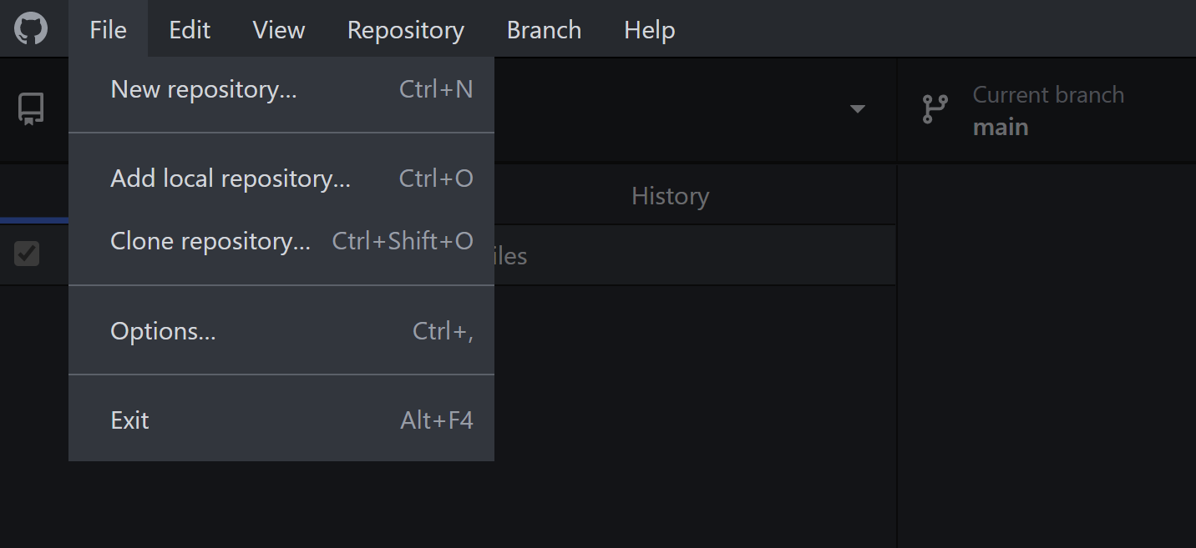



1. You should see a popup like so:
   1. Ensure you are on the URL tab
   2. URL: Is the url from 1a. above
   3. Local Path: Is where your local copy of your repository is (save this Path to your favorites, you will be accessing this all semester)

1. After the clone is done you should see something like this below



* 1. Double check the top left to ensure that the current repository you are on is the one you cloned *(you can have multiple cloned repositories on your github desktop)*
  2. For this exercise the URL to clone was:
  3. <https://github.com/digitalrahmanhofstra/it030_sp_2023_lecture_docs.git>



**Note: Switching between repositories**

On github desktop, use the drop down near current repository to view the other repositories you have cloned on your local machine.

1. Clicking on a repo. (repository) will bring that repository to forefront (when working with multiple repos. Please ensure you are in the right repo.) Example: Pulling down exercises from the course repo., then uploading the assignment to your own repository. In this instance you would pull down the course repo. To get the assignment, but then switch repos to upload your exercise to your own repo.



|  |  |
| --- | --- |
|  |  |

**Note: Pulling down repositories for updated content**

On github desktop, use the Repository menu and access Pull (Repository > Pull) to “pull” down latest content