Group Member Details
Katlego Sentsho u24876489
Patrick Simuyemba u25632354
Enock Nyamweya u25619871
Angelo Anthony u25573552
Ntando Dlamini u25591267
Angela Ramaboea u25445392
Tebogo Mokgwatsane u25042239

Task 1: Research Findings on Workflow Management Systems
What a WfMS is. The Workflow Management Coalition (WfMC) defines workflow as the computerised automation of a business process and a workflow management system (WfMS) as software that defines, manages and executes workflows, with execution order driven by a computer representation of the process logic [1]. All WfMSs share three areas: build-time definition, run-time process control, and run-time interaction with people and applications [1].
Definition vs instance. A process definition holds the activities, transition conditions, roles, workflow-relevant data, invoked applications and a version number. An engine interprets it to create and control many independent instances (“cases”) [1][2]. The instance owns control data (the state of each process and activity instance), case data used for routing decisions, and its audit trail [1]. Because processes can run for weeks, engines such as Camunda let running instances finish on the version they started with, send new instances to the latest version, and offer optional migration [5]. A change to a definition therefore never silently changes work already in progress.
Work items and nesting. Activities are either atomic or compound (sub-flows) [1][2]. The WfMC describes hierarchical nesting, where a whole process is enacted as one activity of a parent process [1], and BPMN models the same idea with embedded sub-processes and reusable call activities [4]. Control-flow constructs that recur across products are sequence, parallel split and synchronisation, exclusive choice and merge, loops and cancellation; none of the 15 products compared in [2] supported every pattern, so the set of routing constructs must be extensible.
Assignment, approval and escalation. Definitions refer to roles rather than named people, and the engine binds roles to participants at run time [1]. The resource patterns catalogue [3] separates push allocation (system chooses) from pull allocation (participant claims), and lists allocation rules such as random, round-robin and shortest-queue, plus delegation and escalation. Approvals are modelled as work items whose outcome feeds routing conditions, and BPMN adds timer, escalation and error events for deadlines and failures [4].
Events, failures and history. The WfMC treats the engine as a state machine in which process and activity instances move between states (e.g. initiated, running, suspended, completed, terminated) in response to events and control decisions, with checkpoint and recovery data kept for failure handling [1]. Audit trails, metrics and supervisory operations are exposed through an administration and monitoring interface [1].
External systems. Engines do not hard-code applications. They invoke them through an invoked-application interface or application agents, and reach other engines through gateways that map names and data [1].
Reusability and configurability. Workflow separates procedure logic from IT support [1], so a generic engine interprets definitions instead of embedding a process. Routing conditions, role binding, allocation rules, escalation rules, invoked applications and versions are all definition data, not engine code [1][3][5].
Findings that drive the TIVIDY design
Recurring responsibility | Expected to vary | Design consequence
Definition vs instance, versioning | The process blueprint; running cases | Definition built step by step (Builder); each instance owns its state, data and history (State, Memento)
Nested, parallel work | Shape and depth of the process | Uniform work-item tree (Composite)
Allocation, approval, escalation | Allocation rule; approval levels | Strategy; Chain of Responsibility
Events, audit, undo, extra behaviour | Who reacts; what is reversible | Observer; Command; Memento; Decorator
External systems, participants | Foreign APIs; who talks to whom | Adapter; Mediator; single entry point (Facade)
References
[1] Hollingsworth, D. (1995). The Workflow Reference Model (WfMC Document TC00-1003, Issue 1.1). Workflow Management Coalition. https://www.aiai.ed.ac.uk/project/wfmc/ARCHIVE/DOCS/refmodel/rmv1-16.html
[2] van der Aalst, W.M.P., ter Hofstede, A.H.M., Kiepuszewski, B., & Barros, A.P. (2003). Workflow Patterns. Distributed and Parallel Databases, 14(1), 5–51. https://doi.org/10.1023/A:1022883727209 (open copy: pure.tue.nl)
[3] Russell, N., van der Aalst, W.M.P., ter Hofstede, A.H.M., & Edmond, D. (2005). Workflow Resource Patterns: Identification, Representation and Tool Support. In CAiSE 2005, LNCS 3520, pp. 216–232. Springer. https://doi.org/10.1007/11431855_16
[4] Object Management Group. (2011). Business Process Model and Notation (BPMN), Version 2.0 (formal/2011-01-03). https://www.omg.org/spec/BPMN/2.0
[5] Camunda. (n.d.). Versioning process definitions (Best practices). Accessed 3 October 2026. https://docs.camunda.io/docs/components/best-practices/operations/versioning-process-definitions/
[6] Gamma, E., Helm, R., Johnson, R., & Vlissides, J. (1994). Design Patterns: Elements of Reusable Object-Oriented Software. Addison-Wesley. ISBN 978-0-201-63361-0.

Task 2: Define the Scenario and System

2.1 Selected Scenario: Faculty Admissions and Bursary Processing
To demonstrate and validate the generic TIVIDY engine, the system is applied to an Admissions and Bursary Processing workflow. This administrative process models an end-to-end lifecycle characterized by high-volume applications, strict academic validation rules, multi-tier financial approvals, parallel departmental coordination, and external system integrations.
The process consists of six sequential and parallel sub-processes:
- Application Intake and Document Verification:
Prospective students submit an application containing academic transcripts, national benchmark test (NBT) scores and socioeconomic financial declarations. The application is checked for completeness, and the applicant’s identity is verified against the national government identity system before the application advances.
- Academic Merit Evaluation:
The application is assigned to an available Admissions Administrator, based on role. The administrator evaluates the Admission Point Score (APS) against the faculty’s minimum requirements. If the thresholds are met, the application receives academic clearance; otherwise it is rejected and the applicant is informed.
- Bursary Assessment and Financial Need Analysis (Parallel Branch):
In parallel with enrolment preparation, applications requesting financial aid start a bursary evaluation. The household income bracket in the financial declaration determines which Financial Aid Officer receives the case.
- Multi-Tier Financial Aid Allocation and Disbursement:
Bursary awards vary in funding tiers (for example partial tuition or comprehensive full-cost bursaries). Larger awards need approval from more senior staff: if an amount exceeds the Financial Aid Officer’s authority, it escalates to a manager and then to the Dean. The approved amount is paid by electronic funds transfer through the university’s banking gateway; if the payment fails, the case is returned to its state before payment and flagged for manual follow-up.
- Offer Issuance and Student Acceptance:
Once academic clearance and the financial decision are both complete, the formal offer is made available. The applicant is notified and submits an acceptance decision.
- Final Enrollment and Student Pack Distribution:
When acceptance is confirmed, the student record is created, campus access and portal credentials are issued, the applicant receives the admission pack, and a permanent audit record of the case is written.

2.2 Initial TIVIDY System Scope and Design Rationale
A non-negotiable architectural rule of the project is that the scenario must not determine the design of TIVIDY itself. The TIVIDY architecture enforces a strict two-layer decoupling:
Layer 1: Generic Engine Core
Contains no references to universities, bursaries, students or faculties. It models every workflow as a versioned WorkflowDefinition from which independent WorkflowInstances are created. Work is a hierarchy of generic WorkItems (tasks and sub-processes), each with its own lifecycle (WorkItemState), a pluggable allocation rule (RoutingStrategy: role-based, workload-based or data-rule based), optional approval chains (ApprovalHandler) and dependency rules coordinated by DependencyMediator. Actions on work items are WorkItemAction commands, events use generic types such as ITEM_COMPLETED, external systems are reached through one ExternalService interface, and instance data is stored as named key/value fields. The same engine can therefore run insurance claims, software release pipelines or procurement without changing core code.
Layer 2: Scenario Plug-in
The Admissions scenario exists only as configuration of Layer 1. AdmissionsWorkflowBuilder (a concrete builder) defines the work-item tree, its dependencies and which generic routing strategy, approval rules and decorators each task uses; GovernmentIDAdapter and BankGatewayAdapter implement ExternalService for the two external systems. No other scenario-specific classes exist, so a second scenario would add only its own builder and adapters.

Task 3: UML Activity Diagrams
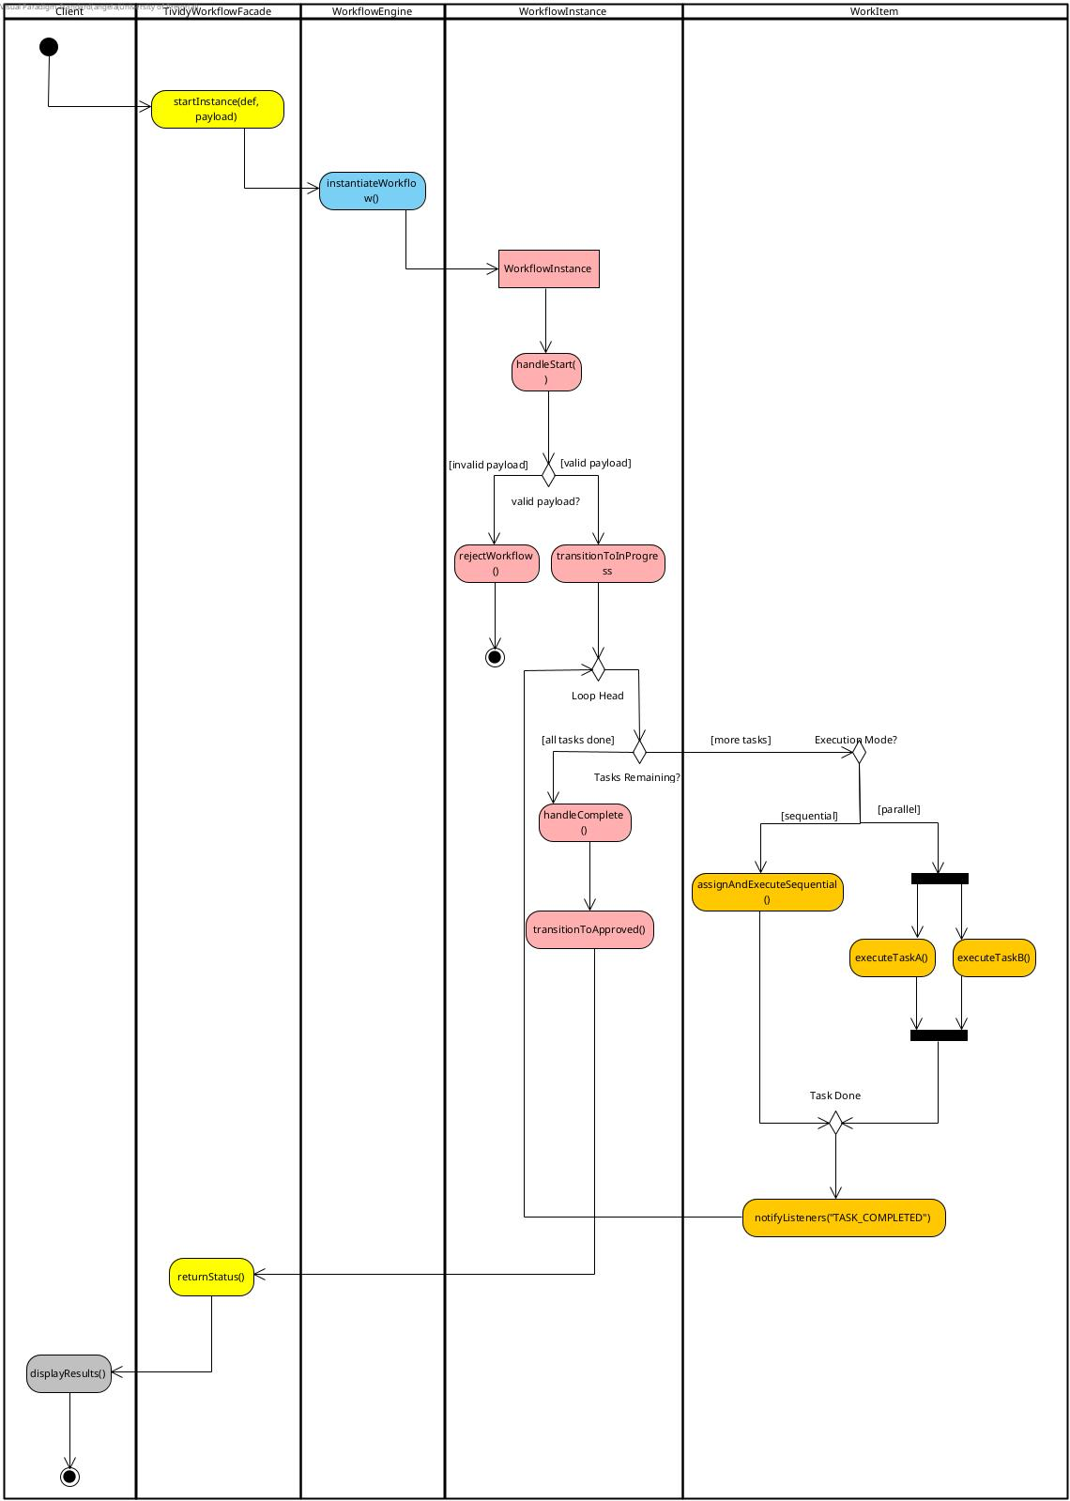
Activity Diagram 1: Generic workflow execution, from instance creation to completion
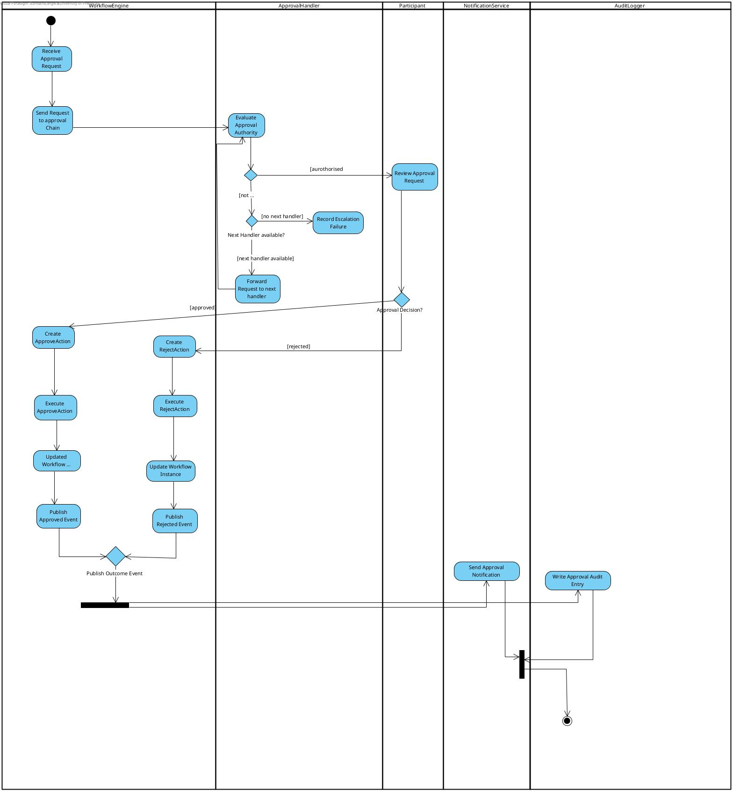
Activity Diagram 2: Approval and escalation
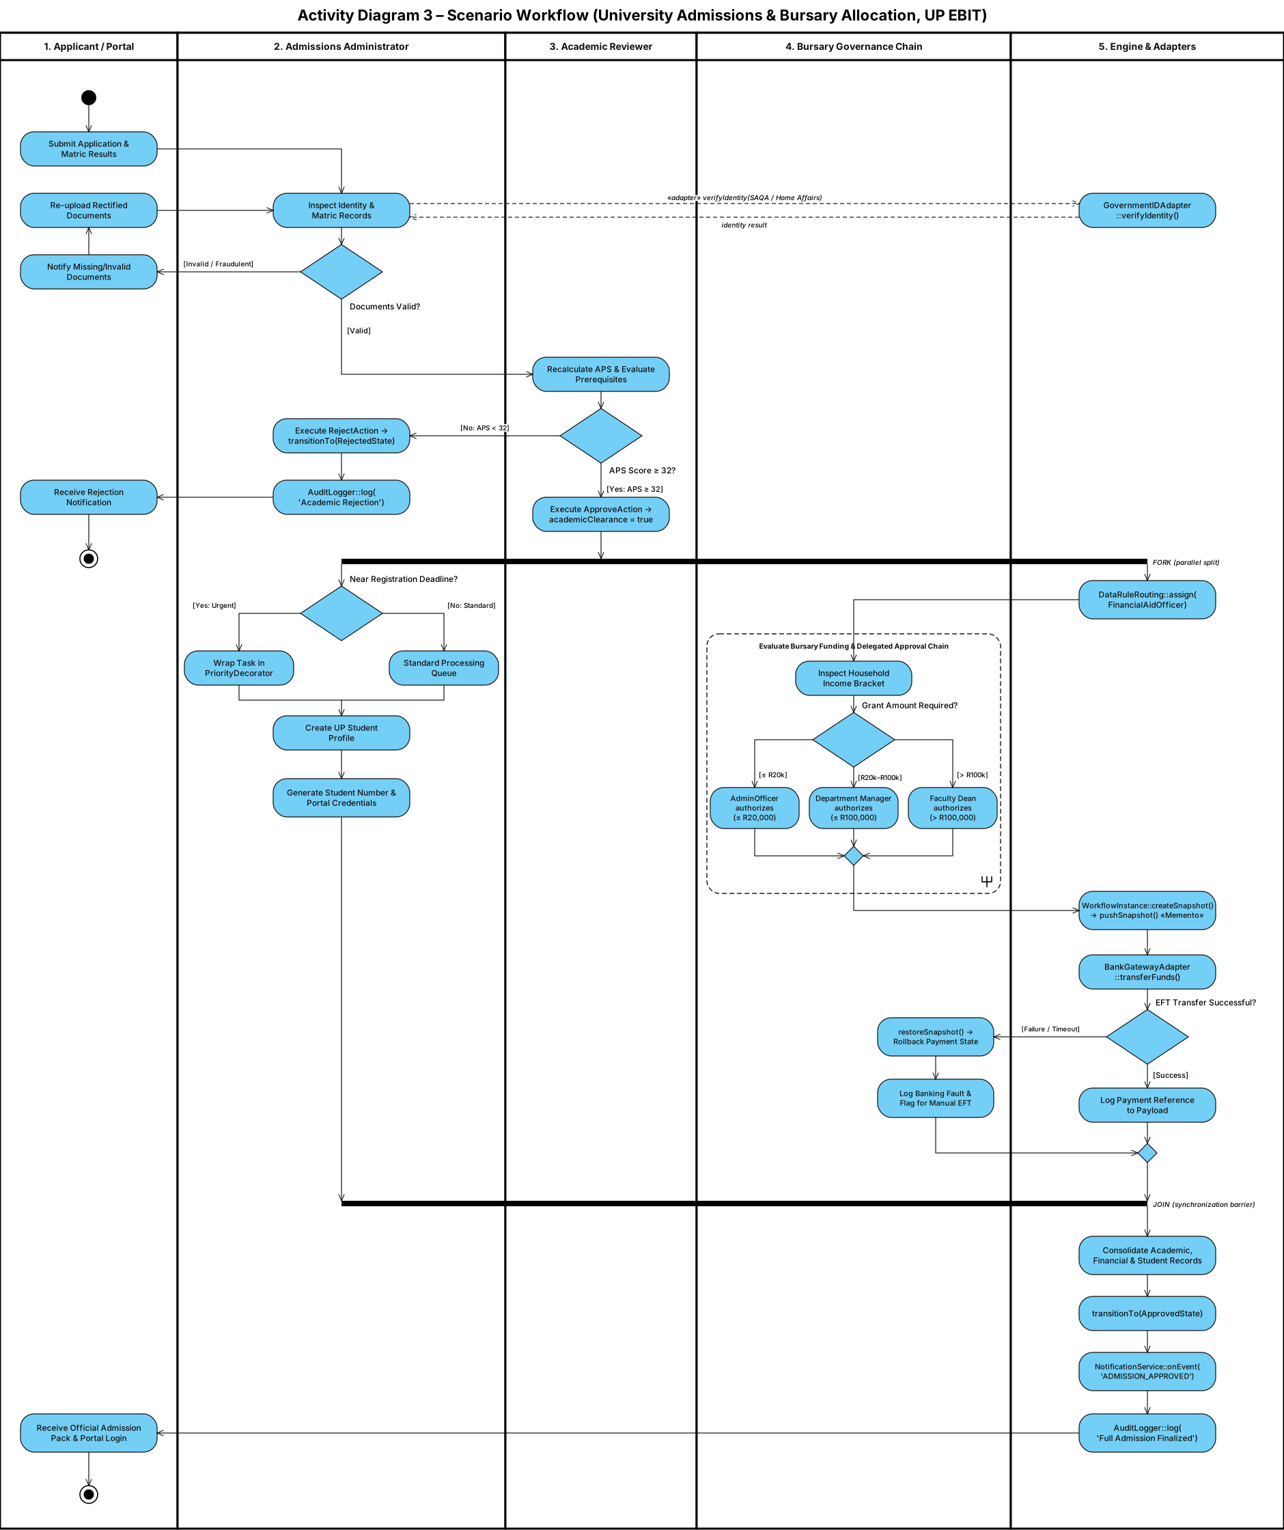
Activity Diagram 3: Scenario workflow (University Admissions and Bursary Processing)

Task 4: Design Patterns
TIVIDY is designed as a generic workflow manager, so each pattern below is justified by a problem of the engine itself, drawing on the research in Task 1. None of the participant classes refer to a specific process. The University Admissions and Bursary Processing scenario appears only in the last row of each table, as one example of how a process configures the engine; removing those rows leaves a complete design. Twelve patterns are proposed (the minimum is ten). Reference numbers refer to the list under Task 1; [6] is the GoF catalogue.
# | Pattern | Category | Workflow problem it solves
1 | Builder | Creational | Definition (blueprint) must be assembled step by step and kept separate from running instances
2 | Composite | Structural | Work is nested: tasks and sub-processes must be treated uniformly
3 | State | Behavioural | Operations valid in one work-item lifecycle state are invalid in another
4 | Strategy | Behavioural | Organisations allocate work by different rules (role, workload, data)
5 | Chain of Responsibility | Behavioural | Approval may need one or several levels, with escalation by rule or deadline
6 | Command | Behavioural | User and system actions on work items must be executed uniformly, logged and undone
7 | Memento | Behavioural | An instance must roll back to a checkpoint after a partial failure
8 | Observer | Behavioural | Several independent parts must react to the same workflow event
9 | Decorator | Structural | A work item gains extra behaviour without becoming a new kind of item
10 | Adapter | Structural | External systems expose interfaces not designed for TIVIDY
11 | Mediator | Behavioural | Work items must trigger each other without referencing each other
12 | Facade | Structural | Clients need one simple entry point to many engine subsystems

4.1 Builder (Creational)
Design problem | A workflow definition contains a work-item tree, routing rules, dependencies, approval chains and a version number [1]. It is complex to assemble, must be validated before use, and must stay separate from the instances created from it, so that many independent instances can share one blueprint [1][5].
GoF participants → TIVIDY classes | Director: WorkflowDirector  Builder: WorkflowDefinitionBuilder (addTask(), addSubProcess(), setRouting(), addDependency(), setApprovalChain(), getResult())  ConcreteBuilder: one per process, supplied as configuration outside the engine  Product: WorkflowDefinition (versioned)
Collaboration | WorkflowDirector calls the construction steps in order through the abstract WorkflowDefinitionBuilder. The concrete builder creates the work-item tree, attaches a RoutingStrategy, approval chain, decorators and dependency rules where required, and returns a versioned WorkflowDefinition.  WorkflowEngine later creates WorkflowInstance objects from that definition. Each instance receives its own copy of the tree, its own state, data and history, so a change to one instance never changes the definition or any other instance.
What varies | Which process is being defined. A new process is a new ConcreteBuilder; the Director, engine and product classes stay unchanged.
Why this pattern | It separates how a definition is assembled from what it represents, and keeps every process-specific detail out of the engine. Building step by step also keeps the blueprint separate from running instances, which the research identified as central [1][5].
Example in the scenario | AdmissionsWorkflowBuilder builds the intake, academic review, bursary and enrolment sub-processes.

4.2 Composite (Structural)
Design problem | Real processes contain stages, individual tasks and nested sub-processes, some sequential and some parallel [1][2][4]. The engine must start, track, cancel and report on a single task or a whole branch in the same way, without knowing how children are stored.
GoF participants → TIVIDY classes | Component: WorkItem  Leaf: Task  Composite: SubProcess (owns child WorkItems; execution mode sequential or parallel)
Collaboration | WorkflowInstance owns one root SubProcess. Operations such as start(), cancel() and isComplete() can be called on any WorkItem; a SubProcess forwards them to its children according to its execution mode and completes when its required children complete. Children are owned by composition and destroyed with their parent.
What varies | The shape and depth of the process. New kinds of work are new WorkItem subclasses with no change to the engine.
Why this pattern | Hierarchical sub-processes are standard in the WfMC model and in BPMN [1][4]. Composite gives work and groups of work one interface and removes any “is this a sub-process?” type checks from the engine.
Example in the scenario | The bursary branch is a SubProcess containing the income check, approval and payment tasks.

4.3 State (Behavioural)
Design problem | Every work item moves through a lifecycle: created, made available, assigned, started, completed, rejected, cancelled or escalated. Operations valid in one state are invalid in another; for example a completed item cannot be started again. Encoding this as a status flag with if/else chains is forbidden by the project rules, and the WfMC describes activity instances as state machines [1].
GoF participants → TIVIDY classes | Context: WorkItem  State: WorkItemState  ConcreteStates: CreatedState, AvailableState, AssignedState, InProgressState, CompletedState, RejectedState, CancelledState, EscalatedState
Collaboration | WorkItem delegates every lifecycle request (makeAvailable(), assign(), start(), complete(), reject(), cancel(), escalate()) to its current state object. The state either performs the transition and sets the next state, or refuses the request. WorkflowInstance keeps a simple overall status (running, suspended, completed or terminated) derived from its root work item.
What varies | The lifecycle rules: which operations are legal in which state and what each transition triggers. A new state is a new class.
Why this pattern | Each state’s rules live in one class instead of in conditionals. Approval outcomes such as approved or rejected are results of an approval task, not states of the whole workflow, so the same lifecycle applies to any process. The transitions match the State Diagram (Task 6).
Example in the scenario | The academic review task moves from Available to Assigned to InProgress, and then to Completed with the outcome “approved”, or to Rejected.

4.4 Strategy (Behavioural)
Design problem | Organisations allocate work differently: by role, by workload, or by a rule over instance data [3]. Different tasks in the same process may also need different rules. The task classes must not change when the rule changes.
GoF participants → TIVIDY classes | Context: Task  Strategy: RoutingStrategy (assign(task, participants))  ConcreteStrategies: RoleBasedRouting, WorkloadRouting, DataRuleRouting (all part of the generic engine)
Collaboration | When a Task becomes available it asks its RoutingStrategy for a Participant. RoleBasedRouting picks an available participant holding a configured Role; WorkloadRouting picks the eligible participant with the shortest queue; DataRuleRouting reads a configured field from the instance data and maps its value to a role.
What varies | The allocation algorithm, chosen per task in the workflow definition.
Why this pattern | The resource-patterns catalogue treats allocation rules (role-based, round-robin, shortest queue and others) as interchangeable choices [3]. Strategy keeps them out of Task and avoids a switch on allocation type. The strategies are generic; a process only supplies their settings.
Example in the scenario | Bursary tasks use DataRuleRouting configured on the household-income field; review tasks use RoleBasedRouting.

4.5 Chain of Responsibility (Behavioural)
Design problem | Approval may involve one person or several levels, and a request must escalate when it is beyond an approver’s authority or when nobody responds before a deadline [3][4]. The task requesting approval must not know who will decide.
GoF participants → TIVIDY classes | Handler: ApprovalHandler (handle(request), nextHandler)  ConcreteHandler: ConcreteApprovalHandler, configured with an approver Role, an ApprovalRule (canApprove(request)) and a deadline
Collaboration | An approval task passes an ApprovalRequest to the first handler. If the handler’s rule accepts the request, its approver decides; otherwise, or when the deadline passes, the request is forwarded to nextHandler. The decision returns to the task as its outcome, and the workflow continues or rejects.
What varies | The number of levels, their order, their rules and their deadlines. Changing the hierarchy means configuring handlers, not editing the engine.
Why this pattern | Hierarchical escalation is naturally a chain. Because the acceptance test is a rule object rather than a fixed amount, the same handler class serves amount limits, risk levels or any other criterion.
Example in the scenario | Bursary approval uses amount-based rules: a financial aid officer, then a manager, then the dean.

4.6 Command (Behavioural)
Design problem | Users and the system act on work items: claiming, completing, rejecting, delegating or cancelling them. These actions must be executed uniformly, recorded for audit and undone where sensible [1], and must not be coded directly into a client or a task.
GoF participants → TIVIDY classes | Invoker: WorkflowEngine (executeAction())  Command: WorkItemAction (execute(), undo())  ConcreteCommands: ClaimAction, CompleteAction (carries an outcome), RejectAction, DelegateAction, CancelAction  Receiver: WorkItem  Client: TividyWorkflowFacade (creates the action for a user’s request)
Collaboration | The facade turns a client request into an action and passes it to WorkflowEngine.executeAction(). The action calls the matching operation on the WorkItem, which delegates to its current WorkItemState (pattern 3). The engine stores executed actions as history and can call undo().
What varies | Which actions exist and how they are queued, logged or undone.
Why this pattern | Requests become objects, so the engine depends only on WorkItemAction and not on a switch over decision types. Approving is simply a CompleteAction with the outcome “approved”, so no process-specific command is needed. A new kind of action is a new subclass.
Example in the scenario | An academic reviewer’s decision is a CompleteAction on the review task.

4.7 Memento (Behavioural)
Design problem | Before a risky step, especially a call to an external system, a running instance needs a recovery point. If the step fails, the instance must return to its earlier state without exposing its internals [1].
GoF participants → TIVIDY classes | Originator: WorkflowInstance (creates and restores snapshots)  Memento: WorkflowSnapshot (state and data; opaque to others)  Caretaker: HistoryLog
Collaboration | Before any work item marked as a checkpoint runs, WorkflowInstance creates a WorkflowSnapshot and HistoryLog stores it. If the step fails, HistoryLog supplies the snapshot and the instance calls restoreSnapshot(). HistoryLog never reads inside the snapshot.
What varies | What is saved, which steps are checkpoints and how many snapshots are kept.
Why this pattern | Rollback needs the full earlier state while the instance keeps its data encapsulated. The stored snapshots also give the system a history it can use to explain what happened.
Example in the scenario | A checkpoint is taken before the bank payment task.

4.8 Observer (Behavioural)
Design problem | When something happens in a workflow (an item completes, fails or escalates), several independent parts must react, such as notification, auditing and monitoring. Work items must not know how these parts work [1].
GoF participants → TIVIDY classes | Subject: WorkItem  Observer: WorkflowEventListener (onEvent(WorkflowEvent))  ConcreteObservers: NotificationService, AuditLogger  Event: WorkflowEvent with a generic type (ITEM_COMPLETED, ITEM_FAILED, ITEM_ESCALATED and so on), the item id and the instance id
Collaboration | Listeners subscribe to a WorkItem. On each lifecycle transition the item publishes a WorkflowEvent to all of them: NotificationService informs the relevant participant and AuditLogger records the event. The same mechanism produces the final outcome notification when the workflow completes.
What varies | The set of interested parties. A new reaction is a new listener with no change to WorkItem.
Why this pattern | One event needs one-to-many notification. Direct calls would couple every work item to every reaction, and generic event types keep scenario vocabulary out of the engine.
Example in the scenario | When the offer task completes, the applicant is notified and the audit record is written.

4.9 Decorator (Structural)
Design problem | An individual work item may need extra behaviour such as priority handling, extra auditing, validation or access checks, without becoming a different kind of work item.
GoF participants → TIVIDY classes | Component: WorkItem  Decorator: WorkItemDecorator (wraps a WorkItem)  ConcreteDecorators: PriorityDecorator, AuditDecorator
Collaboration | A decorator wraps any WorkItem, delegates to it and adds its own behaviour before or after the call. Because decorators share the WorkItem interface, they can wrap any Task or SubProcess in the tree and can be stacked.
What varies | Which extra behaviours apply and in what combination, chosen per item in the definition or at run time.
Why this pattern | Subclasses for every combination (such as an urgent, audited task) would multiply classes. Decorator adds behaviour per object and leaves the base task unchanged.
Example in the scenario | The payment task is wrapped in an AuditDecorator, and late applications receive a PriorityDecorator.

4.10 Adapter (Structural)
Design problem | Workflows must call external applications whose interfaces were not designed for TIVIDY. The WfMC model keeps the engine independent of specific applications through a generic invoked-application interface [1].
GoF participants → TIVIDY classes | Target: ExternalService (invoke(ServiceRequest): ServiceResult)  Adapter: one adapter per external system, supplied as a plug-in  Adaptee: the external system’s own API  Client: Task configured with an ExternalService
Collaboration | A task calls invoke() on its configured ExternalService. The adapter translates the request into the external system’s API and converts the result back; the task stores the result in the instance data. A failure triggers a snapshot restore (pattern 7).
What varies | The external systems and their APIs. A new integration means writing a new adapter only.
Why this pattern | The external interfaces cannot be changed, and the engine should depend on one generic service interface. Adapter supplies that translation layer and keeps every integration outside the engine.
Example in the scenario | GovernmentIDAdapter (identity verification) and BankGatewayAdapter (bursary payment).

4.11 Mediator (Behavioural)
Design problem | Completing one work item can make others available, and items in parallel branches may depend on one another [2]. If items referenced each other directly, every change to the process would change the items themselves.
GoF participants → TIVIDY classes | Mediator: WorkflowMediator  ConcreteMediator: DependencyMediator (reads the dependency rules stored in the WorkflowDefinition)  Colleague: WorkItem
Collaboration | A work item notifies the mediator when its state changes. The mediator checks the definition’s dependency rules and makes the next items available, or cancels items that are no longer needed. Work items never call one another.
What varies | The dependency rules, which are definition data rather than code.
Why this pattern | Coordination rules live in one place, and because they are data, a new process needs no new mediator class. Unlike Observer, which broadcasts to listeners that do not talk back, the mediator acts back on its colleagues.
Example in the scenario | Completing academic clearance makes the enrolment and bursary branches available.

4.12 Facade (Structural)
Design problem | TIVIDY has many collaborating subsystems (builders, engine, instances, history and services). A client such as a portal or an administration console should not construct workflow objects itself or know the order of calls.
GoF participants → TIVIDY classes | Facade: TividyWorkflowFacade (registerDefinition(), startInstance(), performAction(), getStatus())  Subsystem classes: WorkflowEngine, WorkflowDirector, HistoryLog
Collaboration | The client calls one facade operation, for example startInstance(definition, data). The facade forwards the request to the right subsystems in the right order; WorkflowEngine creates the WorkflowInstance and starts it. The client never touches the internal classes.
What varies | The subsystems behind the facade. Only the small facade interface needs to stay stable.
Why this pattern | The system has many independent responsibilities; Facade gives them a single entry point and keeps clients decoupled from internal structure.
Example in the scenario | The applicant portal calls startInstance() when an application is submitted.

4.13 How the patterns form one system
The patterns form one engine. At design time a concrete builder, driven by WorkflowDirector (Builder), produces a versioned WorkflowDefinition whose WorkItem tree (Composite) carries a RoutingStrategy per task (Strategy), approval chains (Chain of Responsibility), dependency rules, decorators (Decorator) and external services (Adapter). At run time a client calls TividyWorkflowFacade (Facade), and WorkflowEngine creates a WorkflowInstance with its own copy of the tree. Each work item follows its lifecycle (State); users act on items through actions executed by the engine (Command); every transition publishes a WorkflowEvent to listeners such as NotificationService and AuditLogger (Observer) and informs DependencyMediator, which makes the next items available (Mediator). Before checkpoint steps the instance saves a WorkflowSnapshot in HistoryLog (Memento). A class may take part in several collaborations: WorkItem is the Component of Composite and Decorator, the Context of State, the Subject of Observer, the Receiver of Command and a Colleague of Mediator, and WorkflowInstance is the Originator of Memento. A new process, such as an insurance claim, therefore needs only a new concrete builder, its configuration and adapters for its external systems. These roles are shown with colours and a legend in the UML Class Diagram (Task 5).

Task 5: UML Class Diagram
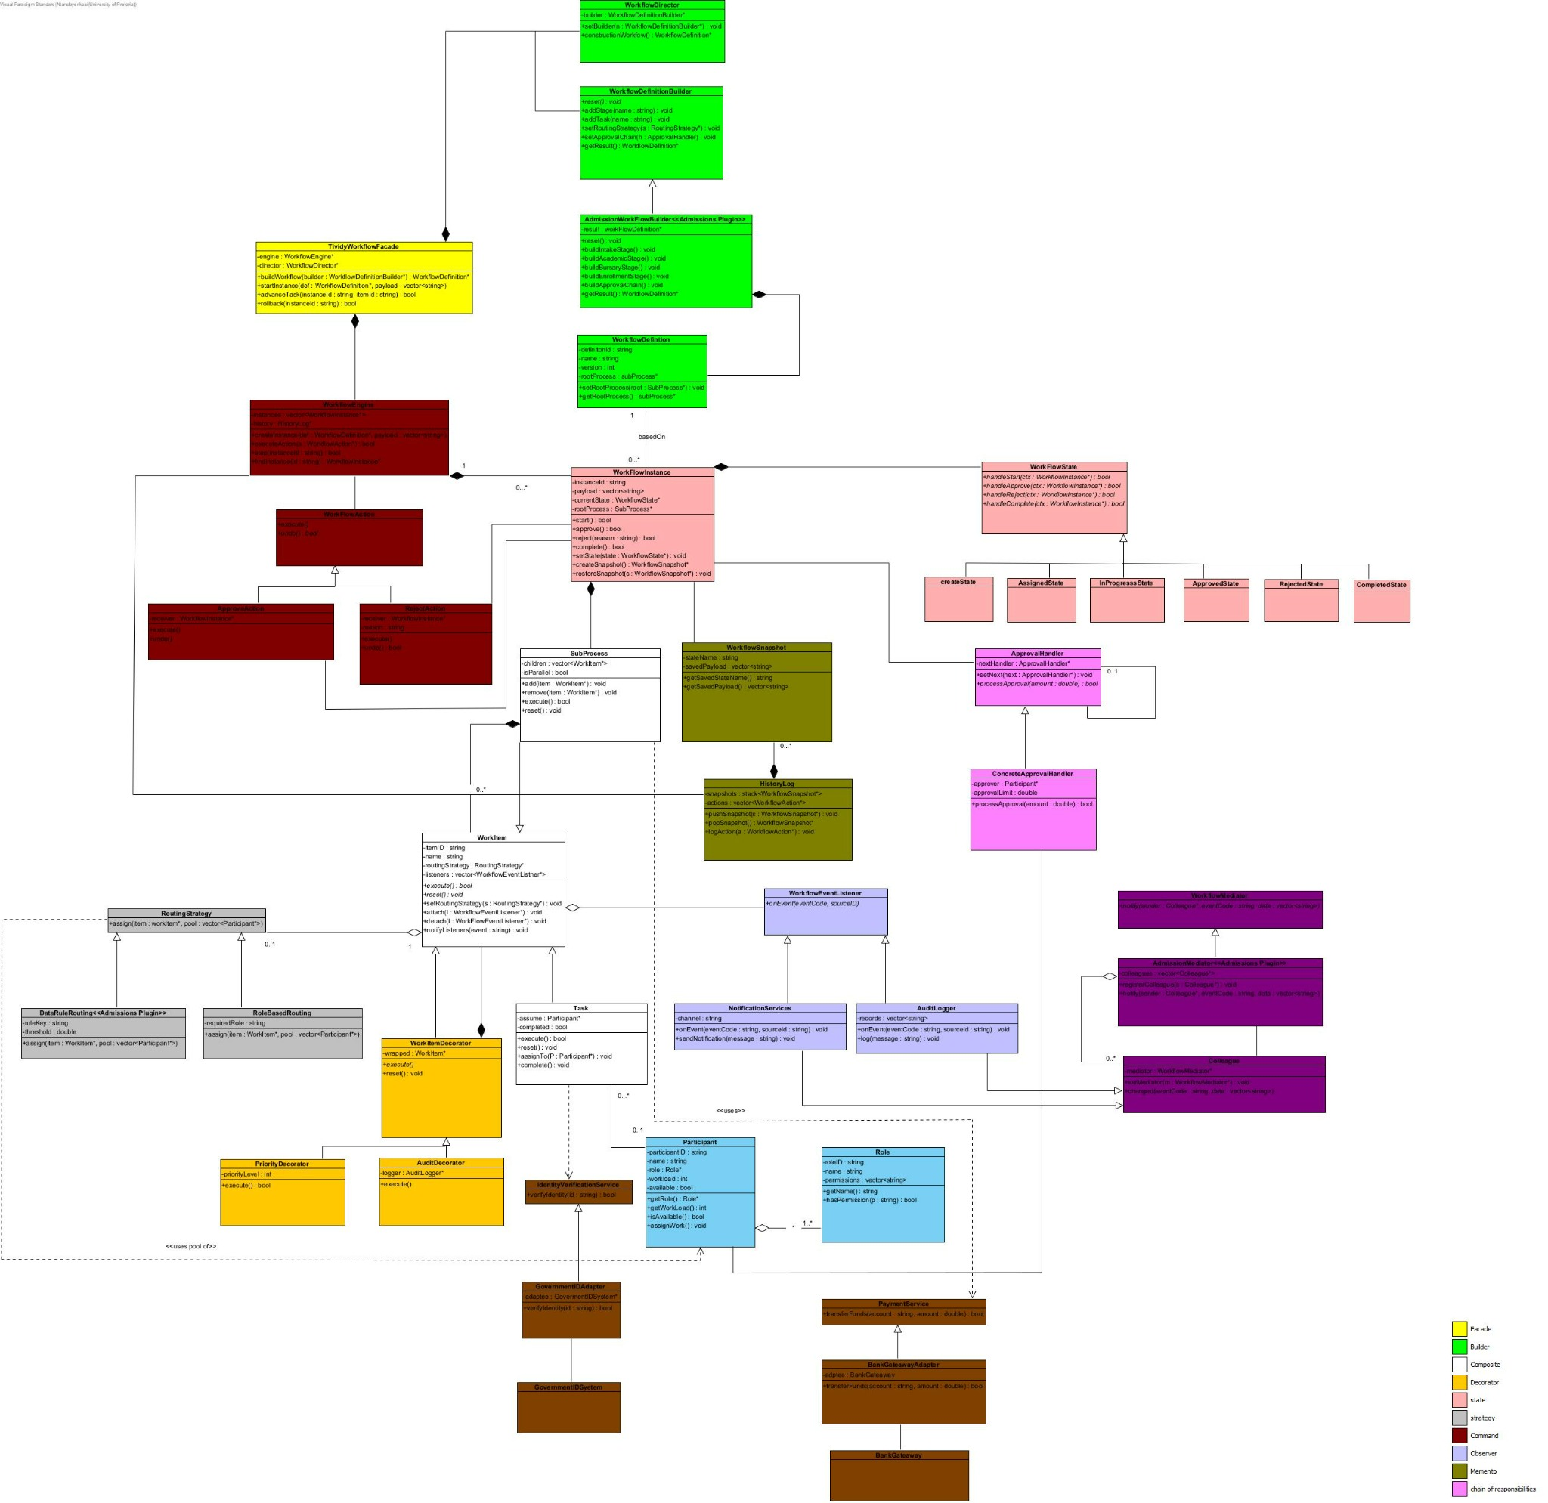
UML Class Diagram: colours mark the pattern collaborations (see legend)

Task 6: Runtime Behaviour Diagrams

6.1 UML Sequence Diagrams
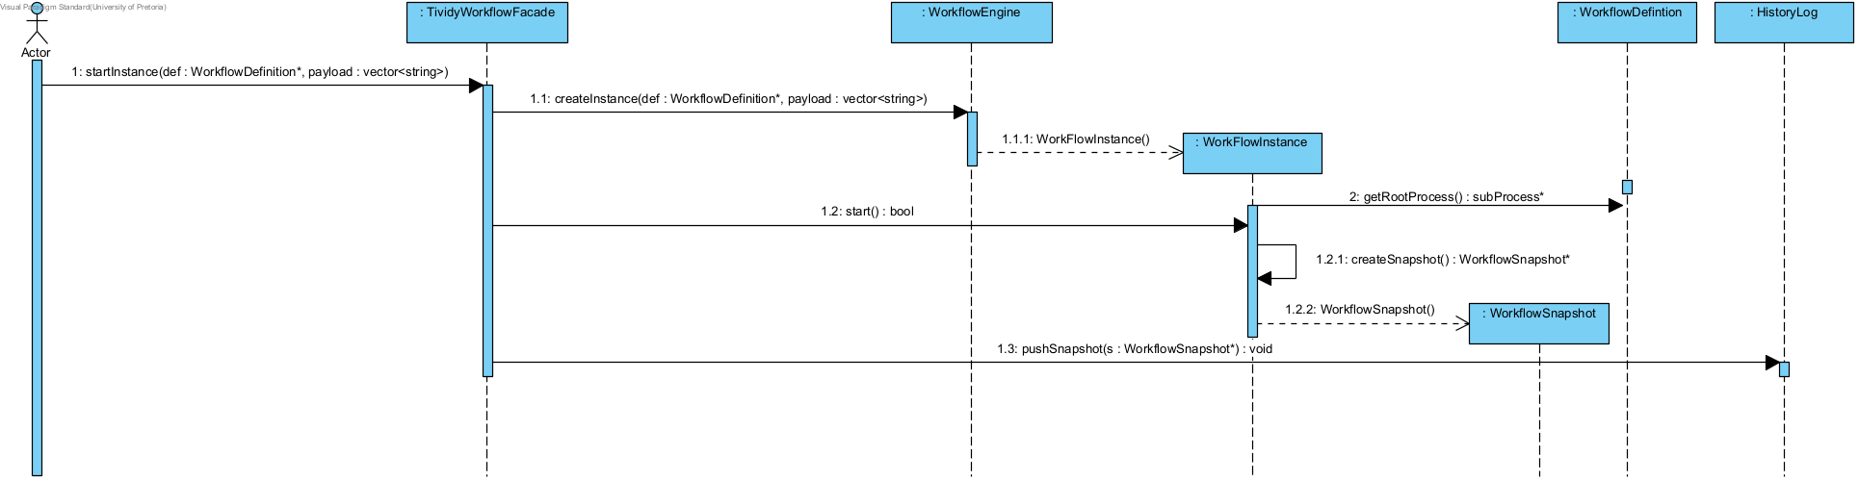
Sequence Diagram 1: Creating and starting a workflow instance
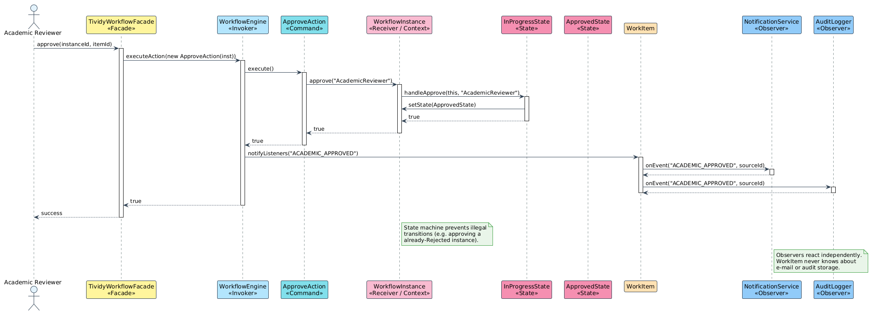
Sequence Diagram 2: Completing a review task and notifying listeners

6.2 UML State Diagram
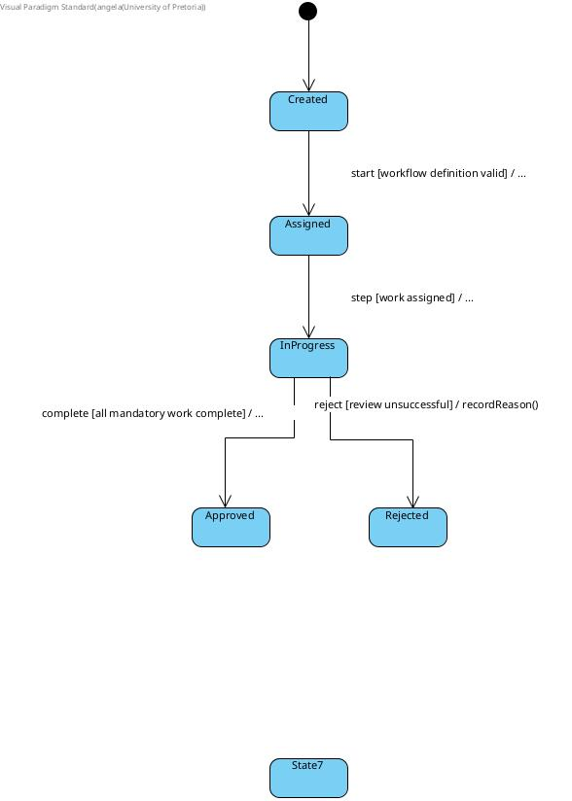
State Diagram: lifecycle of a running object

GitHub Repository
https://github.com/patrickkaleo/COS214_P6

Team Contribution Statement
Katlego Sentsho u24876489
Worked on activity diagram 2 and the state diagram.
Patrick Simuyemba u25632354
Worked on sequence diagrams 1 and Github repository creation.
Enock Nyamweya u25619871
Worked on Activity Diagram 1 and came up with the branching strategy.
Angelo Anthony u25573552
Worked on Activity Diagram 3.
Ntando Dlamini u25591267
Worked on the class Diagram and Task 2.
Angela Ramaboea u25445392
Worked on task 1 and task 4 and overall compilation of the submission document.
Tebogo Mokgwatsane
Worked on sequence diagram 2.

