Denver,Kansas-City,600
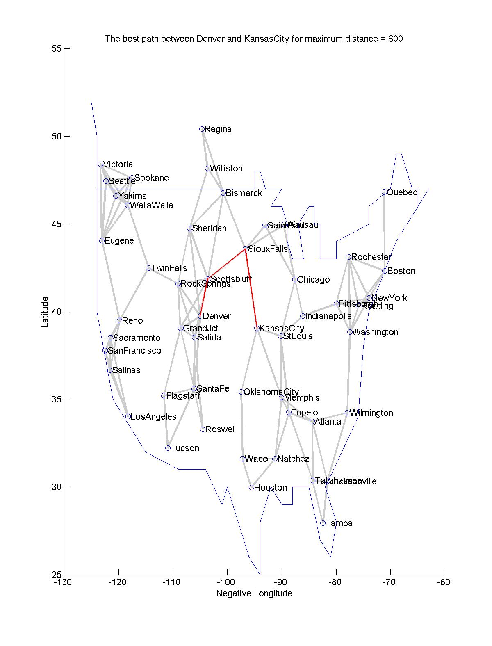
Denver
Scottsbluff
SiouxFalls
KansasCity
Distance = 1392

Denver,Tampa,800

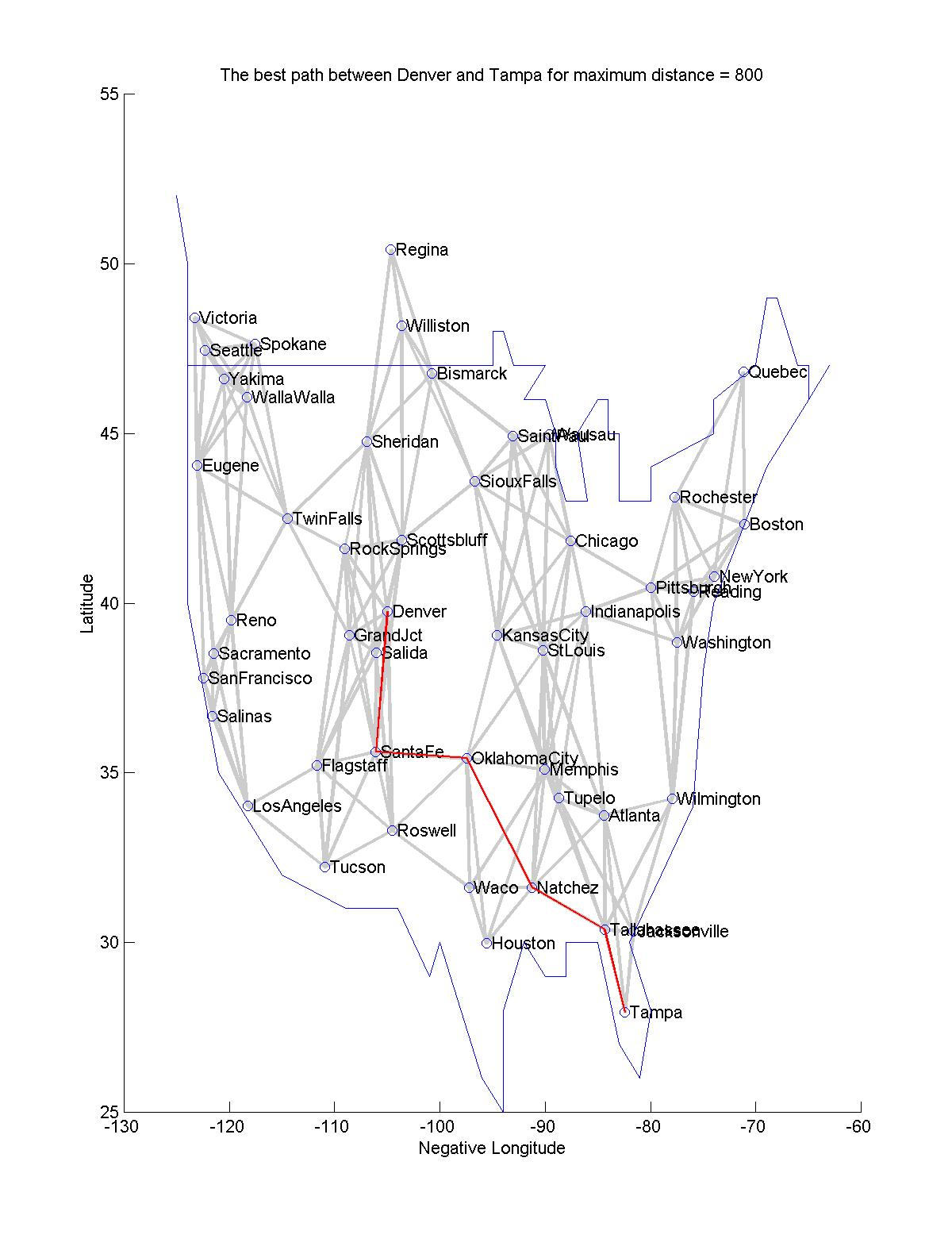
Denver
SantaFe
OklahomaCity
Natchez
Tallahassee
Tampa
Distance = 2968
New-York,San-Francisco,1000
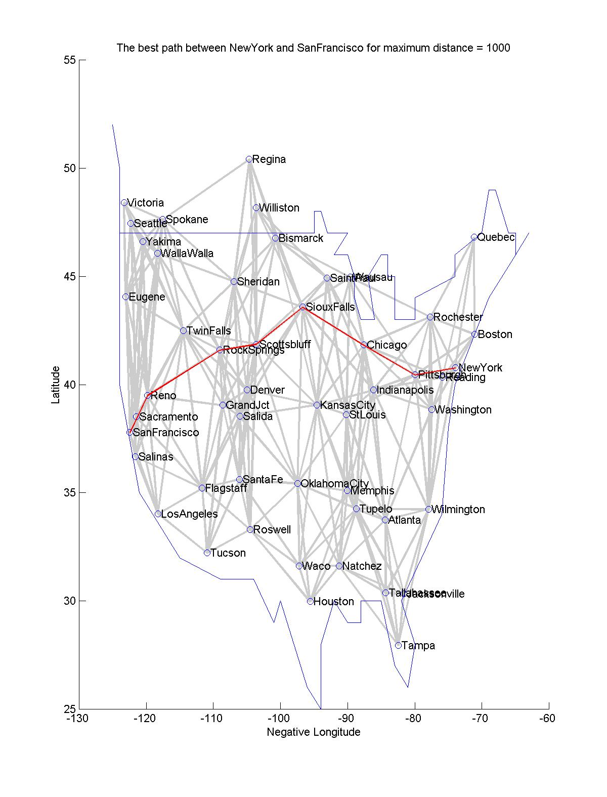
NewYork
Pittsburgh
Chicago
SiouxFalls
Scottsbluff
RockSprings
Reno
SanFrancisco
Distance = 4224

Roswell,Quebec,1000
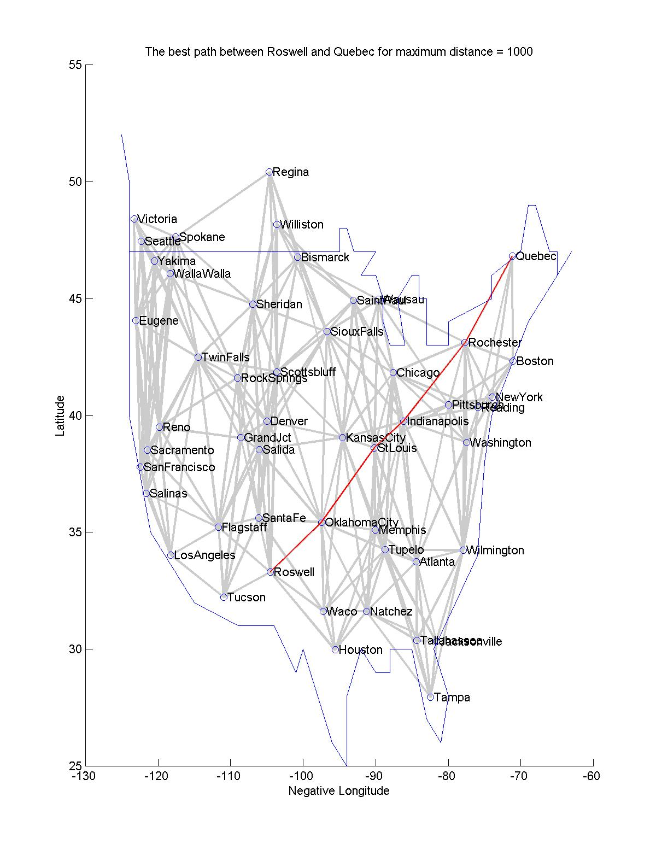
Roswell
OklahomaCity
StLouis
Indianapolis
Rochester
Quebec
Distance = 3256
Boston,Tupelo,1000

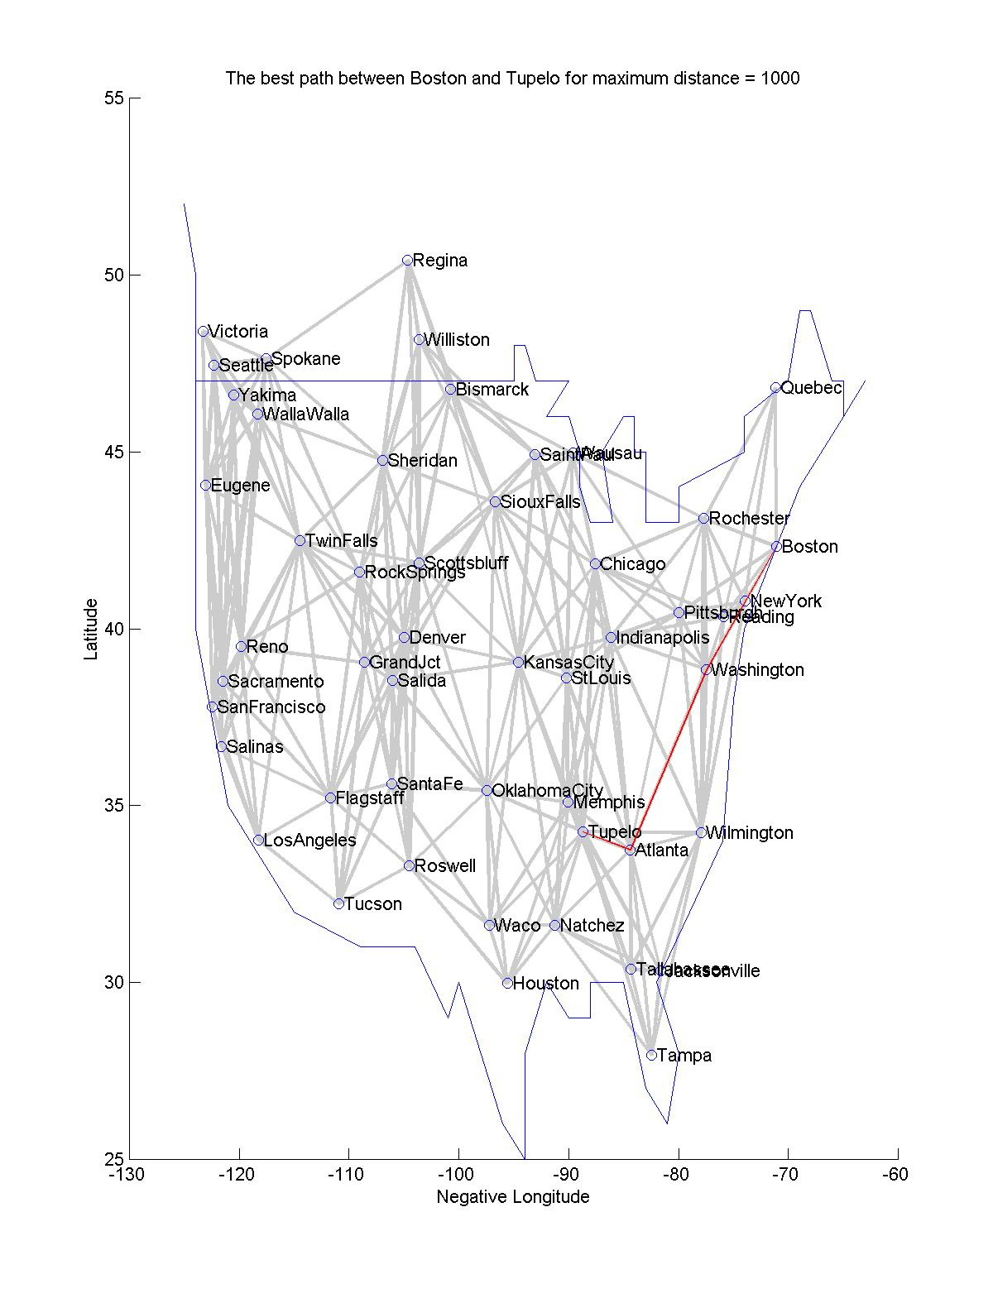
Boston
Washington
Atlanta
Tupelo
Distance = 1909

Boston,Tupelo,500

No valid path between those cities for that length

Boston,Tupelo,250

No valid path between those cities for that length

Regina,New-York,500

No valid path between those cities for that length

Wausau,Tampa,1000
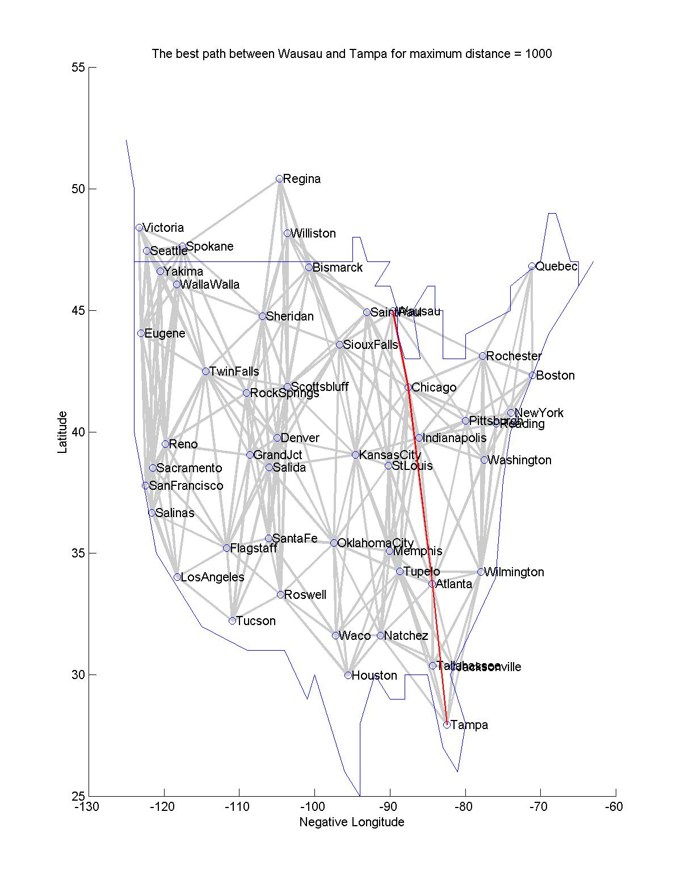
Wausau
Chicago
Atlanta
Tampa
Distance = 2001

Tampa,New-York,545

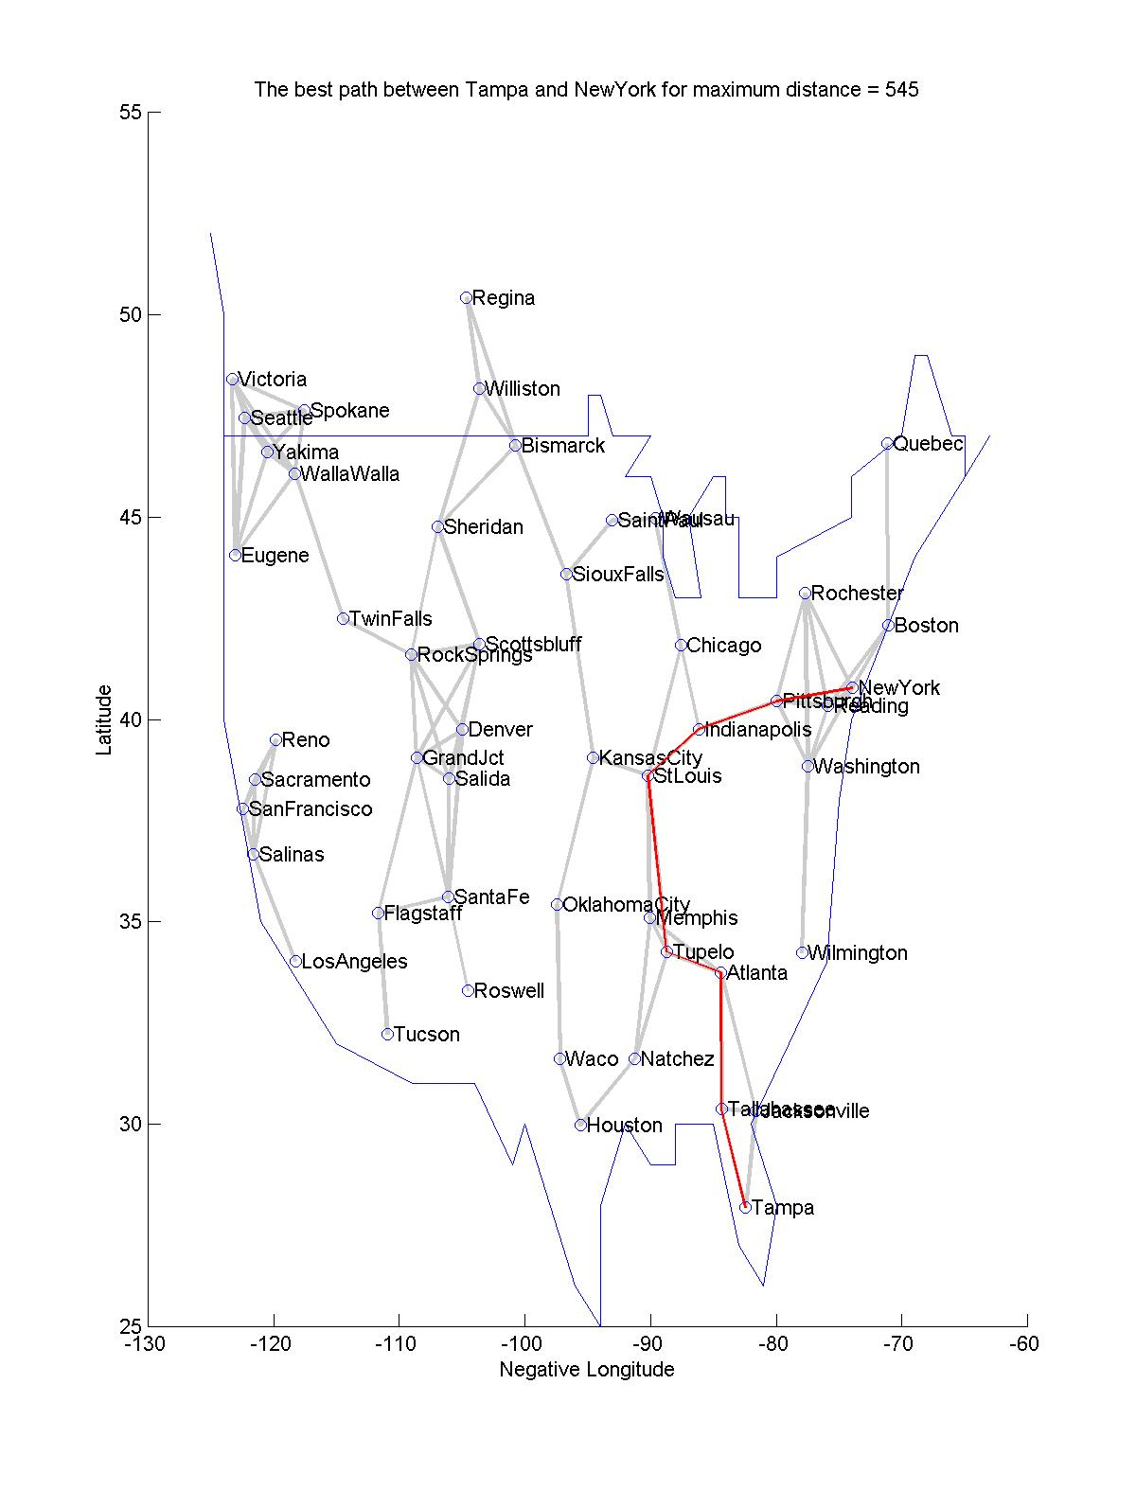
Tampa
Tallahassee
Atlanta
Tupelo
StLouis
Indianapolis
Pittsburgh
NewYork
Distance = 3024
Tampa,Regina,1150

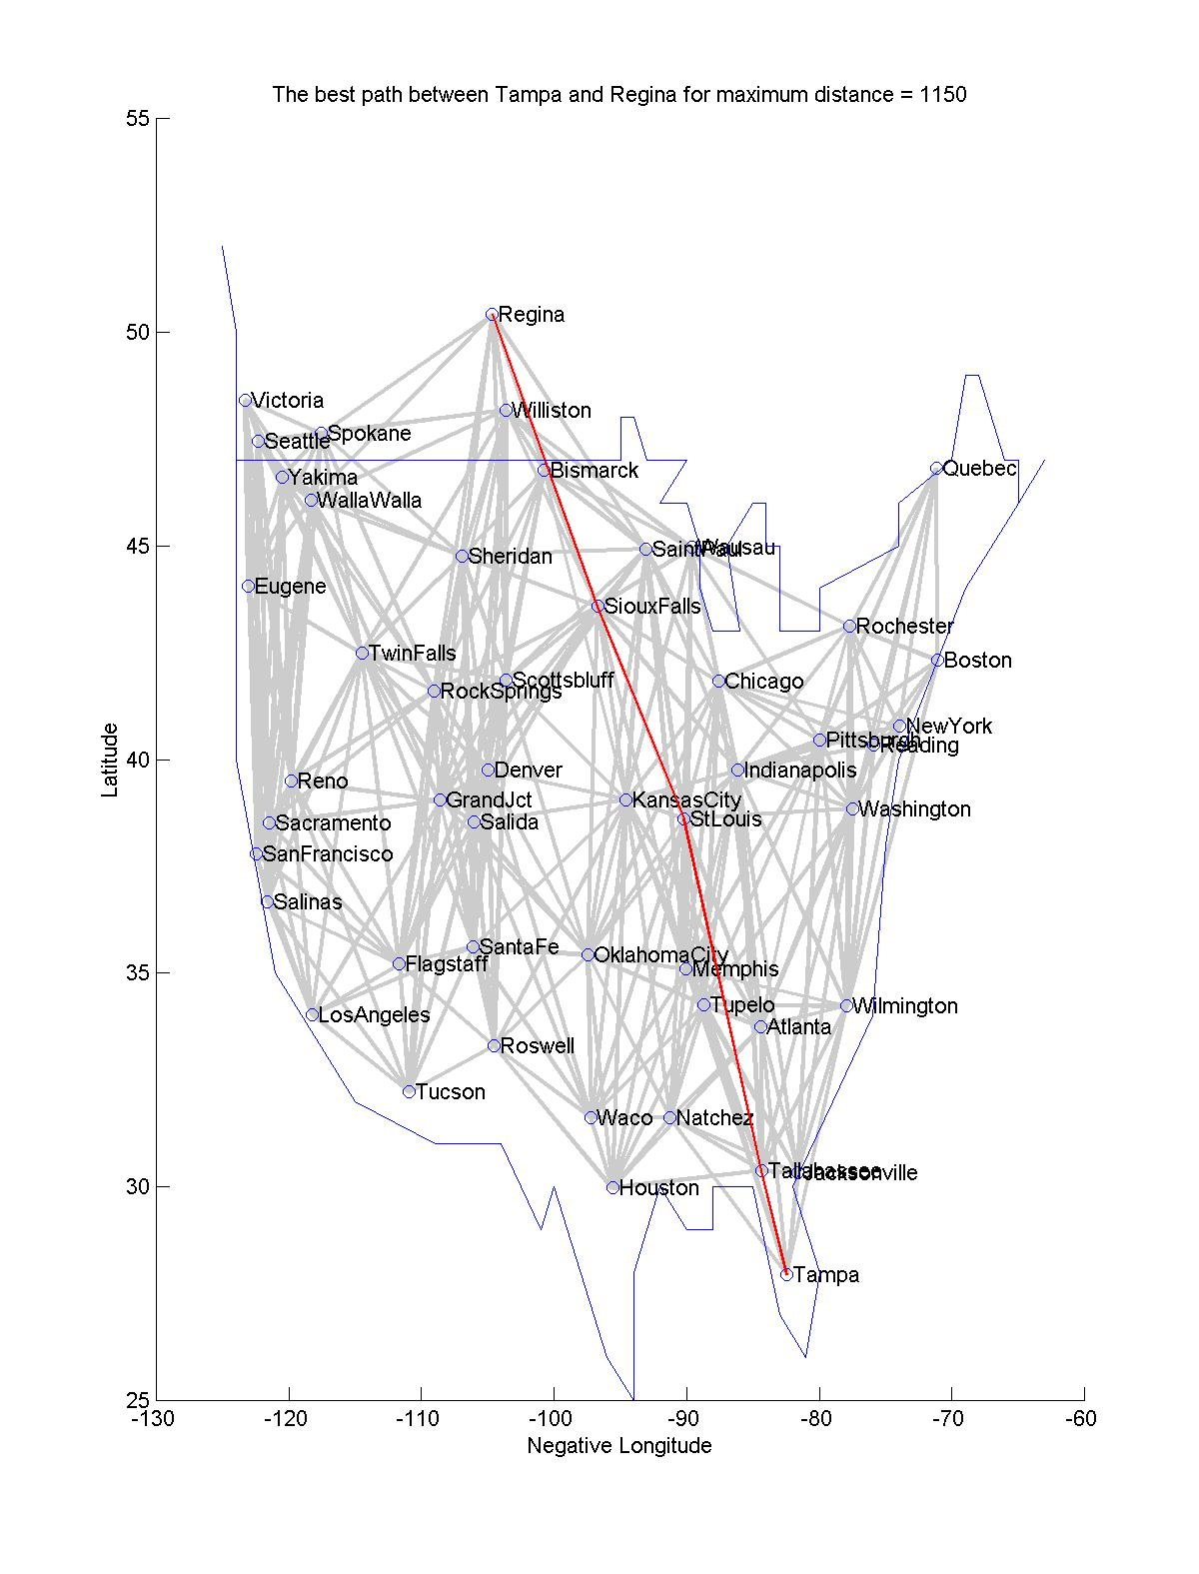
Tampa
Tallahassee
StLouis
SiouxFalls
Regina
Distance = 3138

