
PROJECT IN AUTOMATA
AND LANGUAGE THEORY
GENDER NEUTRAL LANGUAGE
RECOGNIZER
Submitted by:
Patrick Makinano
BSCS 3A
Submitted to:
ALMA MAE B. AUXTERO
Instructor
Date submitted: October 26, 2026

1 Project overview
Patch is a web application that reads a text document, finds predefined gender-specific words and phrases such as “chairman”, “stewardess”, “mankind” and “he”, and shows how many times each occurs together with suggested gender-neutral alternatives such as “chairperson”, “flight attendant” and “humankind”. It helps a writer review a document for inclusive wording; the suggestions are for review and nothing is replaced automatically unless the user clicks. Main features: opening .txt (and optionally .docx and .pdf) files, case-insensitive whole-word recognition by a finite state automaton, a results table, and clear messages for no detected terms, empty files and unsupported formats. Flagged words are highlighted in the text, and clicking one offers the suggested replacements.

2 Tools and recognition approach
Tools: HTML, CSS and JavaScript in the browser (nothing is uploaded); mammoth.js and pdf.js read the optional .docx and .pdf files; Node.js runs the automaton tests.
Approach: finite state automata. The 58 terms in lexicon.js are compiled into a deterministic finite automaton with 373 states (a trie of the terms completed with Aho-Corasick failure links, so every state has a transition for every character). The text is read once from left to right, one transition per character; a state is accepting when it completes a term.
- Capitalization: text and terms are lowercased before they enter the automaton, so “Chairman”, “CHAIRMAN” and “chairman” follow the same states; the original casing is kept in the output.
- Whole words: on reaching an accepting state, the characters just before and after the match are checked; if either is a letter, digit or apostrophe the match is rejected. So “he” is not found in “the”, “other” or “there” (the automaton accepts after “he”, but the preceding “t” rejects it), and “chairman” is not found in “chairmanship”.
State table for the sample term “chairman” (q0 is the start state; the last state is accepting):
Input | start | c | h | a | i | r | m | a | n
State reached | q0 | q86 | q87 | q88 | q89 | q90 | q91 | q92 | q93
Accepting? | no | no | no | no | no | no | no | no | yes
Terms and suggested alternatives (20 of the 58 terms in lexicon.js, including the five required samples):
Term | Suggested alternative(s) | Term | Suggested alternative(s)
chairman | chairperson / chair | salesman | salesperson
policeman | police officer | businessman | businessperson
fireman | firefighter | spokesman | spokesperson
stewardess | flight attendant | headmistress | head teacher / principal
mankind | humankind / humanity | freshman | first-year student
he | they | ladies and gentlemen | everyone / honored guests
she | they | boys and girls | children / kids
him | them | guys | folks / everyone
his or her | their | man-made | synthetic / artificial
manpower | workforce / staffing | waitress | server

3 Application screenshots
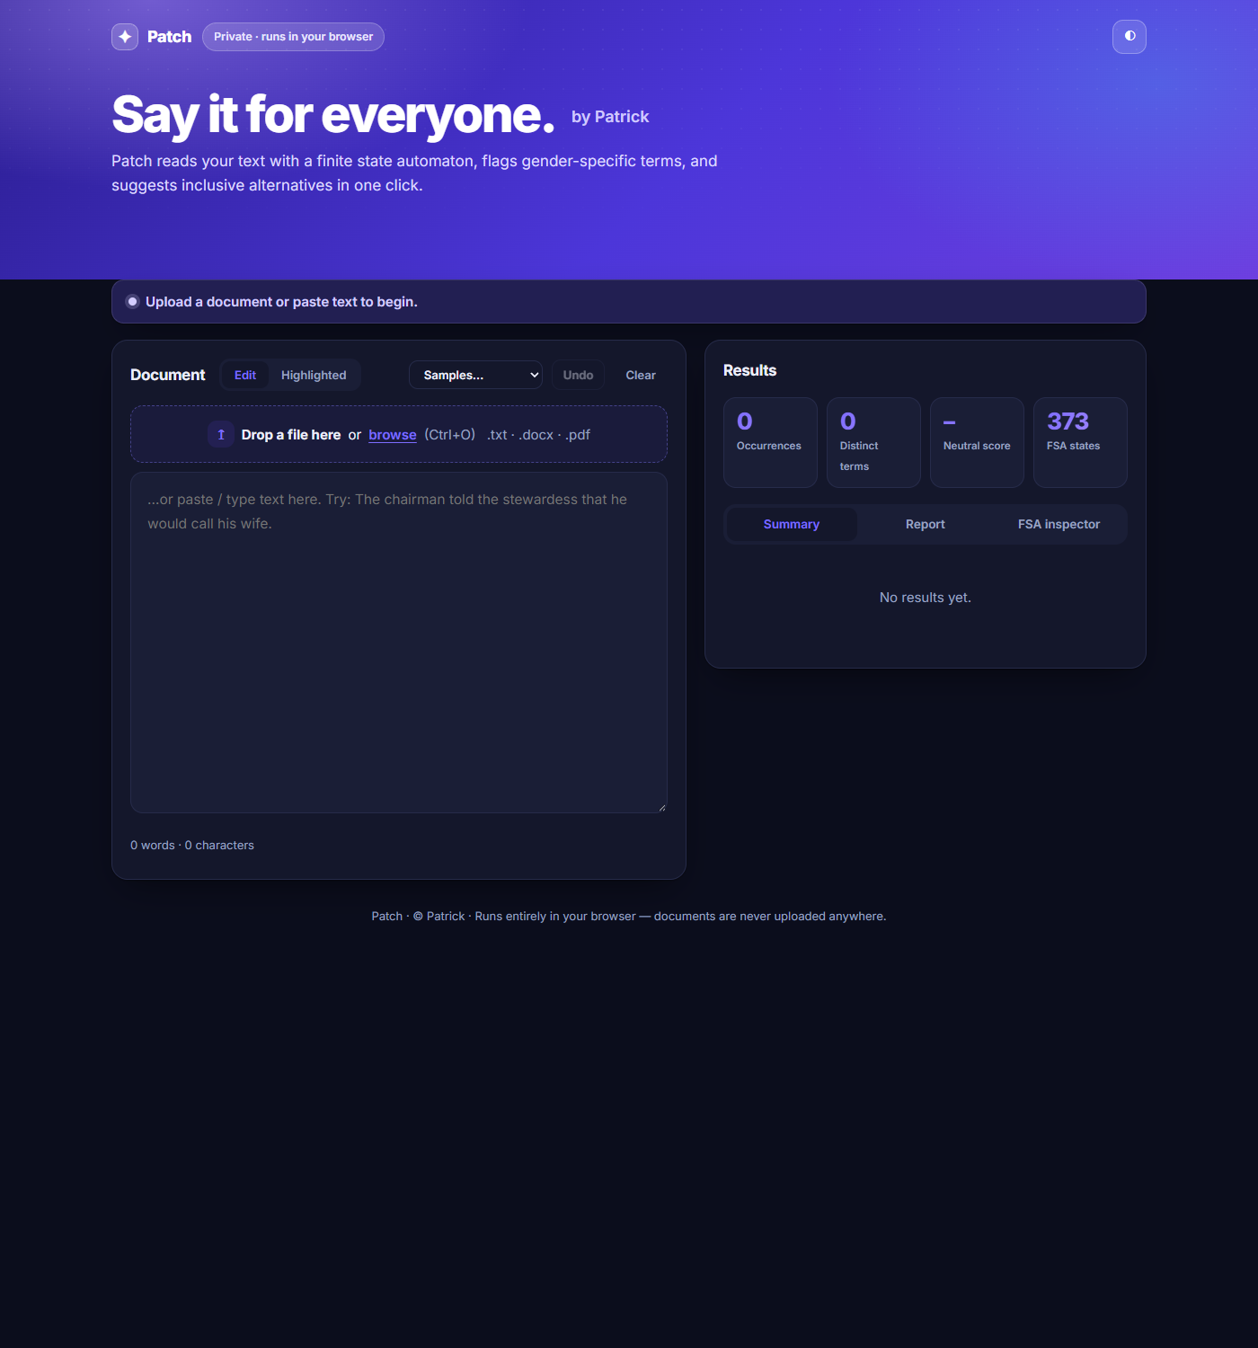
Figure 1. File selection: start screen with the control for opening or dropping a .txt, .docx or .pdf file.
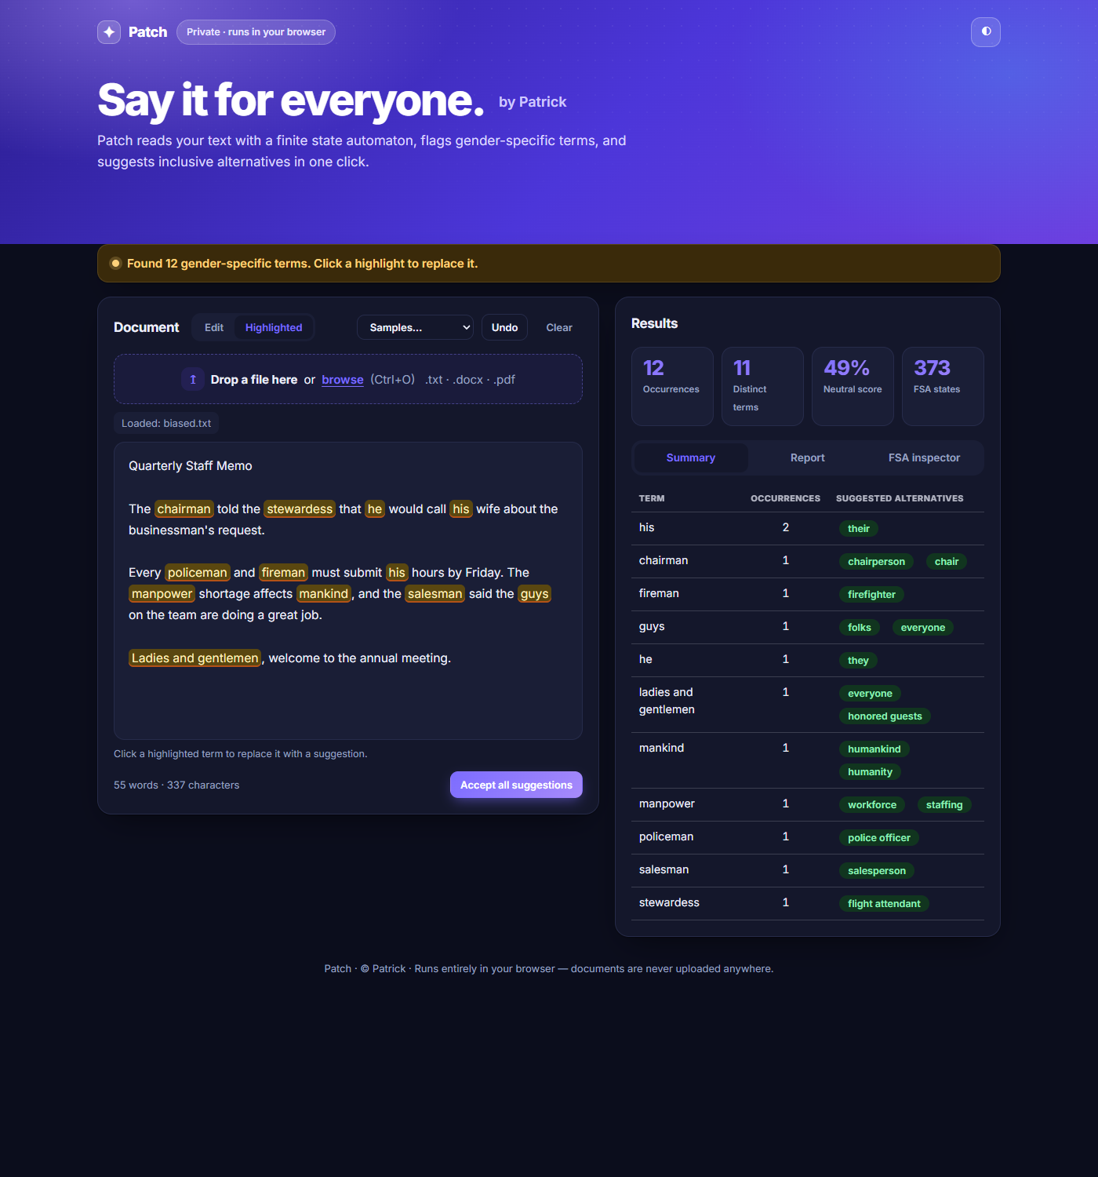
Figure 2. Detected terms: biased.txt analyzed; the results table lists each term, its number of occurrences and its suggested alternatives.
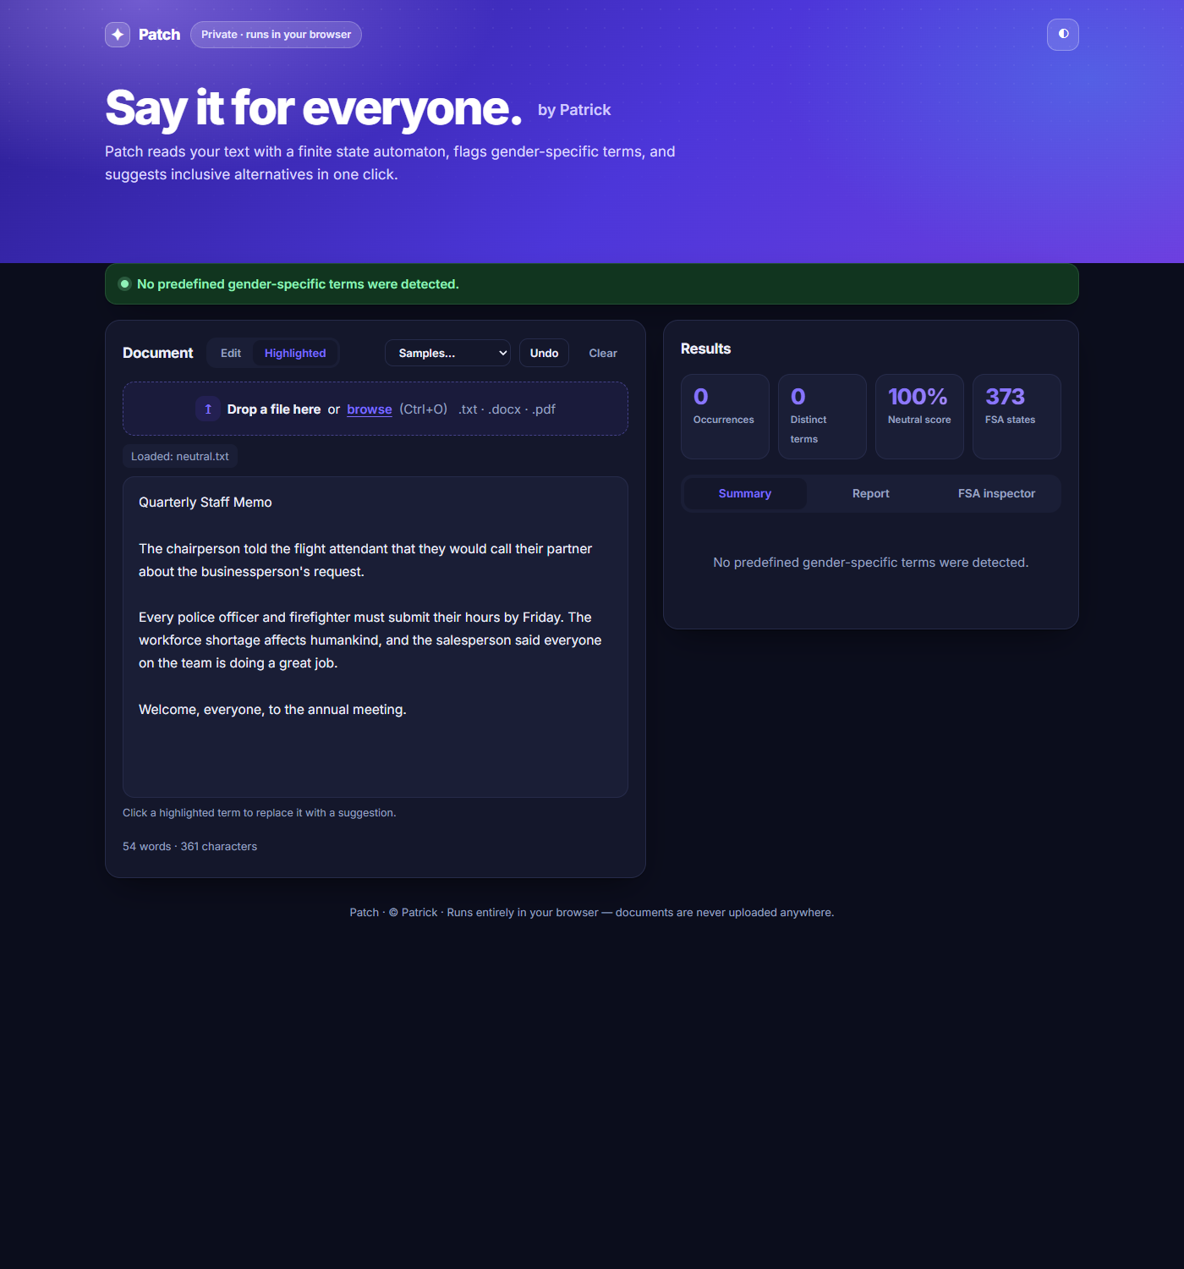
Figure 3. Document with no detected terms: neutral.txt shows “No predefined gender-specific terms were detected.”
Source code: [Insert the public GitHub repository link here]

4 Testing
Tested in the running application (Google Chrome, local web server). The actual results are what the application displayed.
# | Test | Expected result | Actual result | Result
1 | Document with listed terms (biased.txt) | All listed terms detected with counts and suggestions: 12 occurrences, 11 distinct terms. | 12 occurrences, 11 distinct terms: his ×2, chairman ×1, fireman ×1, guys ×1, he ×1, ladies and gentlemen ×1, mankind ×1, manpower ×1, policeman ×1, salesman ×1, stewardess ×1. Suggestions shown (chairman → chairperson / chair; stewardess → flight attendant). | Passed
2 | Same term repeated, different capitalization (repeated-case.txt: chairman, Chairman, CHAIRMAN, chairman) | One row, chairman, count 4. | One row: chairman, 4 occurrences, suggestions chairperson / chair. | Passed
3 | No listed terms, includes “the” (neutral.txt) | Message “No predefined gender-specific terms were detected.” and no table; “he” not detected in “the”. | Displayed: “No predefined gender-specific terms were detected.” Occurrences: 0. | Passed
4 | Empty .txt file (empty.txt, 0 bytes) | Clear empty-file message. | Displayed: “The file is empty. It contains no text to check.” | Passed
5 | Unsupported format (notes.md, data.csv) | Clear unsupported-format message. | notes.md: “Unsupported file type ".md". Use .txt, .docx or .pdf.” data.csv: “Unsupported file type ".csv". Use .txt, .docx or .pdf.” | Passed
Additional checks: edge-cases.txt (other, there, the, theme, chairmanship, mother … must not be flagged) gave 8 occurrences of 7 terms with no false hits; biased.docx and biased.pdf each gave the same result as test 1 (12 occurrences, 11 terms).

5 Conclusion
This project delivers Patch, a working gender-neutral language recognizer built on a finite state automaton. It detects 58 predefined terms and phrases regardless of capitalization and only as whole words, lists each with its count and suggested alternatives, and shows clear messages for documents with no detected terms, empty files and unsupported formats; all five required tests passed. I learned how many patterns can be compiled into one automaton that reads the text in a single pass, and why a word-boundary check is needed to stop “he” matching inside “the”. Limitations: matching is lexical, so it cannot tell how a word such as “her” is used; only the predefined terms are detected; scanned PDFs and legacy .doc files cannot be read; and the .docx and .pdf readers need an internet connection.

6 Sources and contributions
- Libraries: mammoth.js and pdf.js (from cdnjs.cloudflare.com); fonts from Google Fonts.
- Algorithm: Aho-Corasick string matching, used to build the automaton's failure links.
- AI assistance: Claude (Anthropic) helped review the application against the project requirements, fix the no-terms and empty-file messages, add the results table, run the tests in section 4 and prepare this document. [Add any other AI assistance used.]
- Contribution: [State Patrick Makinano's contribution.]

