DATA FLOW DIAGRAM
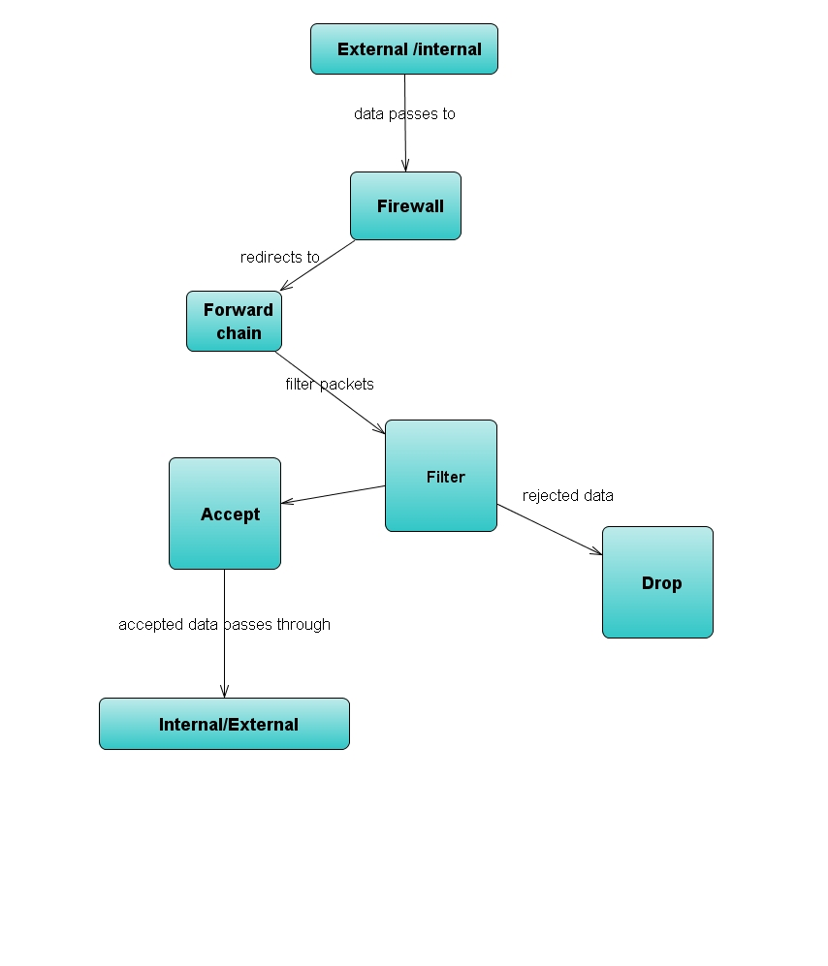
PSEUDOCODE

Firewall

- Configuration
  - Get user configuration
    - External device
    - Internal device
    - External address space
    - Internal address space
    - Internal IP Address
    - TCP services to allow
    - UDP services to allow
    - ICMP services to allow
- Implementation
  - Setup connection
    - Route incoming packets to internal machine
    - NAT outgoing packets from internal machine
  - Create filter
    - Set default policies to DROP
    - Drop outside packets with IPs matching the internal network
    - Drop telnet and FTP packets
    - Drop packets with SYN and FIN bits set
    - Allow DNS and DHCP packets
    - Allow specified TCP services that belong to an existing connection
    - Allow specified UDP services
    - Allow specified ICMP services

