Radio Modem Protocol

Authorization

This is a certification that the following names listed have authorized and approved with all certainty the wireless protocol design. Any modifications and enhancements addressed to the protocol has been reviewed and revised with the permission and approval of the following individuals:

1._____________________________________

2._____________________________________

3._____________________________________

Definitions

Frame

SOT | DATA | DATA-SIZE = 2KB | EOT | CHECKSUM

RVI
  - use the DC1 ASCII Character

State Transition Diagram

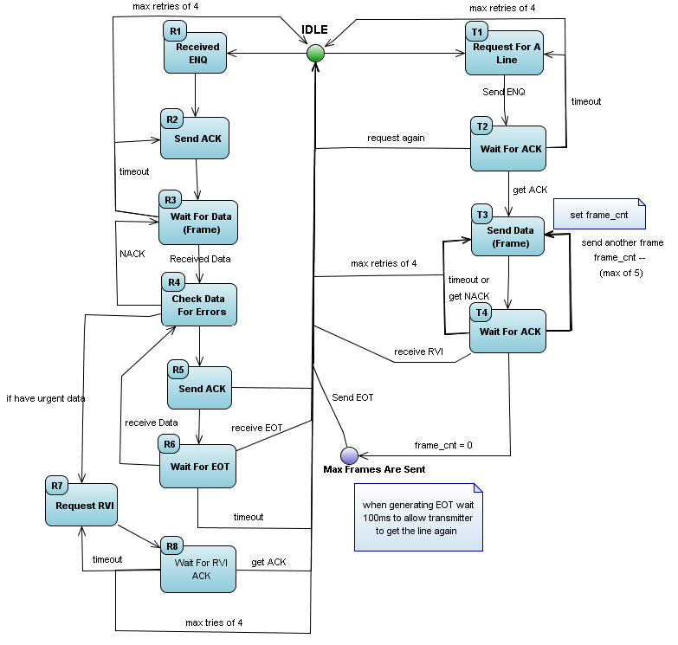
Analysis and Design

Transmitter

T1 – Request for a Line
Send ENQ, indicating a request for the line

T2 – Wait for ACK
Wait 250ms for an ACK
-If an ACK is received, proceed to T3
-If ENQ is received, return to IDLE state and wait 1000ms before requesting the line again
-If in timeout (no response is received)
-If process is repeated more than 4 times, return to IDLE
-if not repeated more than 4 times, return to T1

T3 – Send Frame
Send a frame and proceed to T4

T4 – Wait for ACK
Wait 250ms for an ACK
-If ACK is received
-If less than 5 frames are sent, return to T3
-if 5 frames are successfully sent, return to IDLE and wait 100ms before requesting the
line again
-If NACK is received, return to T3
-If RVI is received, send ACK to acknowledge last frame, return to IDLE and wait 100ms before
requesting for the line again
-if in timeout (no response is received)
-if process is repeated more than 4 times, return to IDLE
-if not repeated more than 4 times, return to T3

Receiver

R1 – Receive ENQ
If ENQ is received and proceed to R2

R2 – Send ACK
Send ACK and proceed to R3

R3 – Wait for Frame
Wait 250ms for a frame
-if a frame is received, proceed to R4
-if in timeout (no response is received)
-if process is repeated more than 4 times, return to IDLE
-if not repeated more than 4 times, return to R2

R4 – Check Data for Errors
Check frame for corruption
-If corrupted, send NACK and return to R3
-if not corrupted
-If Receiver has urgent data to process, proceed to R6
-If Receiver does not have any urgent data, proceed to R5
R5 – Send ACK
Send ACK and proceed to R6

R6 – Wait for EOT
Wait 250ms for an ACK
-if a frame is received, return to R4
-if EOT is received or in timeout, return to IDLE

R7 – Request RVI
Send RVI, proceed to R8

R8 – Wait for RVI ACK
Wait 250ms for an ACK
-If ACK is received, return to IDLE
-if in timeout (no response is received)
-if process is repeated more than 4 times, return to IDLE
-If not repeated more than 4 times, return to R7

