Patrick Mamaid

COMP 4981 Assignment 2

LINUX/UNIX IPC

A00609663

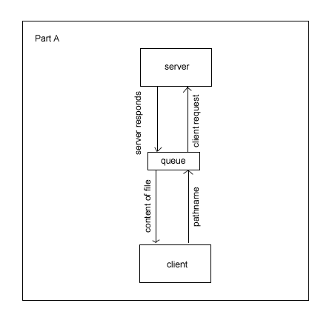

**Part A Design Diagram**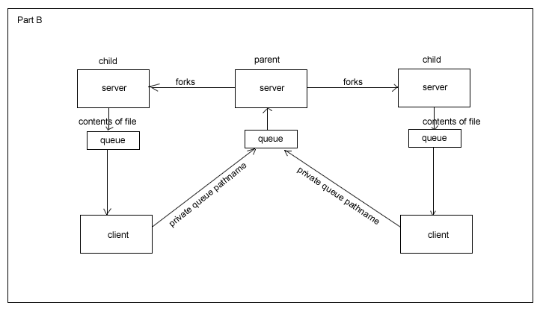  
**Part B Design Diagram**

**Part A Design Description:**

Client(){

Create a connection to the server by using its IPC channel id  
type a filename  
send filename to server using mesg_send  
receive Message from server using mesg_recv  
end client

}

Server(){

Open an IPC channel so that a client can connect

Infinite loop{  
 wait for a client to connect  
 receive a filename from client using mesg_recv  
 try to open the file using fopen  
 if(can open){  
 send client the file contents using mesg_send

} else{

send the client an error message

}

}

}

**Part B Design Description:**

Client(){

Create a connection to the server by using its IPC channel id  
type a filename  
send filename to server using mesg_send  
receive Message from server using mesg_recv  
end client

}

Server(){

Open an IPC channel so that a client can connect

Infinite loop{  
 wait for a client to connect  
 receive a filename from client using mesg_recv

FORK(){ //this is now the child  
 try to open the file using fopen  
 if(can open){  
 send client the file contents using mesg_send

} else{

send the client an error message

}

}

}

}