# Abstract

This document has been produced as part of Phase 1 of ACE1 for CS413 – Embedded Systems. It describes the idea and assess the capabilities and functionality of the device we have decided to produce. It identifies all of the components we require to build the device and the cost of each individual component. In addition, the document includes a detailed hardware and software design of the device. Finally, it outlines a plan of which team member(s) will take on each task and the time assigned to each task involved in building the hardware and software.

# Idea

## We have decided to create a device which we have named [NAME] Portable Analytic Economic Device for On-board diagnostics ([NAME]). [NAME] will allow a user to connect to their cars on-board system and extract real-time data while they are driving. Most extracted data will be stored and the rest of the data - real-time data such as current miles per hour, current miles per gallon - will be displayed on a digital screen viewable to the user. A full description of the data which will be displayed to the user while driving is described in [LINK]. When the user completes their journey they will be able to remove the [NAME] from their car and upload the data extracted from their journey onto a web server. Each user of [NAME] will be able to create their own unique user account where they can upload their journey data to and have access to all the journey data they have ever uploaded to the web server. This allows each user of [NAME] to track their driving over time. The main benefit of this is that a user will be able to assess with ease, whether they are driving more efficiently.

# Main Components

## OBDII

An On-board Diagnostics II (OBDII) kit will be used to extract any data from the on-board system of the car that the device is running on. An OBDII kit is a device that can connect to most cars produced after 1996 and can access data from the Engine Control Unit (ECU). Figure 1[REF] shows the OBDII device that we will be using.

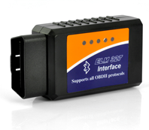

Figure : OBDII device

The full range of the data which is extractable by OBDII can be found on Wikipedia [REF].

## Raspberry Pi

A Raspberry Pi will be a key component of the [NAME] device. A Raspberry Pi is a small, low-cost computer which has the standard capabilities of most desktop PC’s.

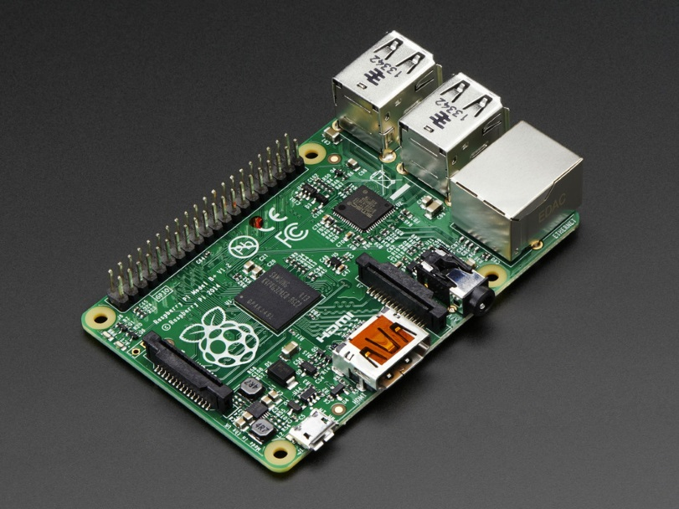

GPIO Headers

512 MB RAM

HDMI port

Ethernet port

USB ports

Data will be passed back from the OBDII device to the Raspberry Pi. Some of this data, all of which is listed in section [LINK] will be displayed on a Digital LCD Display, detailed in section [LINK]. The rest of the data will be stored as a [FILETYPE] file on the Raspberry Pi. The extracted data file will be transferrable from the Raspberry Pi via USB onto the user’s computer once they have completed their journey. Once the extracted data file is on the user’s computer they will be able to upload the file onto the [NAME] web server into their own unique account. Here the user will be able to view all previously uploaded data and the data from the journey they have just completed. A full list of the data viewable to them from the web server can be found in section [LINK].

### Raspberry Pi Digital Display Monitor

A 3.2-inch Raspberry Pi LCD Digital Display will be used to display real-time data when the device is being used. The OBDII device returns data every one second, so the LCD display will be updated every one second.

### Raspberry Pi Bluetooth Receiver

Do we need this?

## GPS Receiver

[NAME] will use journey tracking. In order to allow for this, it is crucial that a GPS receiver is installed into the [NAME] device. A [GPSDEVICENAME] will be connected directly into the Raspberry Pi.

## Battery

TBD

# References

OBDII Device Image:  
<http://www.plusbuyer.com/OBD2-Car-Diagnostic-Tool---Bluetooth-Connect-to-Windows-Device-p-2905.html>

Full list of OBDII extractable data:  
<http://en.wikipedia.org/wiki/OBD-II_PIDs>

Raspberry Pi website:  
<http://www.raspberrypi.org/>