Blue Box CD/Blu-Ray Rentals

Software Requirements Document

Version: 1.0

Date:11/10/19

Prepared by EZ Software

Table of Contents

1. Preface 4
1.1. Modification History 4
1.2. Intended Audience 4
2. Introduction 4
3. Glossary 4
4. User Requirement Definition 4
5. System Requirements Specification 5
6. System Architecture 5
7. System Models 5
7.1. Use Case Diagram 5
7.2. Sequence diagram 5
7.3. Class diagram 5
8. System Evolution 5
9. Appendices 5
10. Index 5

Table of Figures

Figure 1 ABC 8
Figure 2 DEF 18
Figure 3 XYZ 20

- Preface:

- Modification History:

Date | Version | Author | Summary of Changes
10/10/19 | V1.0 |  | Started software requirement document
10/13/19 | V1.1 |  | Finished software requirement document
10/30/19 | V1.2 |  | Started Database Design Document
11/03/19 | V1.3 |  | Finished Database Design Document

- Intended Audience:
This Document is intended for the Client, PM, BA, System Engineers and the Development team.

- Introduction:
- Purpose of the Requirement Document:
The purpose of this document is to build a platform where customers could rent out DVD or Blu-Ray copies of their favorite movies and watch them in the comfort of their homes and then be able to return the copies.

- Scope of the Product:
The customer should be able to search for the desired movie in either DVD or Blu-Ray form. If found, they should be able to rent it and return it in a timely manner. The program should be able to keep track of how long a customer had a copy of a movie for and then be able to charge them for it. It should also be able to validate the payment method and if invalid then deny the request to rent out a movie.

- Overview of the remainder of the Document:
The remainder of this Document will show the User and System requirement, functional and non-functional. It will also provide the system architecture and relational diagrams. It will have system models in the form of:
- Use Case diagrams
- Sequence diagrams
- Class diagrams.
You will also find an appendix and index towards the end of the document to help you better understand it and to guide you through the document.

- Glossary:
Term | Meaning
Product Users | These are users who interact with the system directly. For instance employees, supervisors, system engineers
PM | This is the abbreviated form of Project Manager
BA | This is the abbreviated form of Business Analyst
Customer | The group of people for whom the finished product in intended for
DVD Copies | Physical discs of the of the movie in DVD version that would be dispensed out, once the customer rents it
Blu Ray Copies | Physical discs of the of the movie in Blu-Ray version that would be dispensed out, once the customer rents it
User Requirements | The User requirements are the requirements of the what the business needs for what the users require from the system.
System Requirements | System requirements are the configuration that a system must have for a hardware or software application to run smoothly and efficiently
Functional Requirements | Functional requirements are the desired operations of a program
Non-Functional Requirements | Non Functional requirements describe how a desired operation is carried out
Class Diagrams | A class diagram shows the structure of a system by showing the system's classes, their attributes, operations, and the relationships among objects.
Sequence Diagrams | A sequence diagram shows object interactions in time sequence
Use Case Diagrams | A use case diagram is a graphic depiction of the interations among the elements of a system
4.User requirements:
The user is expected:
- to have signed up online and have access to log in credentials
OR
- to have a debit card to checkout with
- to be able to use a search bar to find specific movie titles
- to be able to apply filters on a search by selecting genre or some other filter
- to be able to confirm the purchase on behalf of the account and know that the agreed upon price per day will be charged in full upon return
- to be able to clear the cart and not rent at any time
- to be able to rent up to 3 movies at a time, all shown in cart

Nonfunctional requirements:
The software will be used on a kiosk with an interactive touch screen display and a guest friendly user interface that will allow easy renting. The interface will display movie info as fast as it can with the database search. The system is scalable by the size of the kiosk and adding more inventory space. It will take best available measures to keep clients data secure. Will report errors in the logic as they happen for ease of maintenance. Employees should be able to easily update inventories and add/remove movies from inventory. In order to remove the likelihood of damaged copies, older inventory will be taken from rotation after a set number of rentals.

Functional:
- Employees will also update associated inventory dbs and movie dbs accordingly
- Will provide login functionality for ease of checkout.
- Will search our database by movie title for the search bar, or other specified filter displayed on UI; genre, rating. Will show the description, starring actor(s), genre(s), rating, cover art, and availability upon selection of a movie. Will add to cart and return you to browsing upon rent option, for either bluray or dvd.
- Will upon checkout have a confirmation of the total and applicable tax, and either the accounts associated card is charged, or the guest user will insert a charge card to be pay with before proceeding. Will upon customer info dispense the product and update inventory db, and customer db to account for the dispensing of the dvds.
- Will generate return date and calculate total cost of rental after the dvd with an associated id to that rental is returned, updates the inventory db, customer db, and updates the customer info through the customer db to stop accruing charges and make finalized rental receipt
- Will have time outs, where if the screen isn’t interacted with for five minutes the screen reverts to base and signs out of any accounts that weren’t logged out of

Name | Search Movie
Trigger | The browser assesses the movie selection
Precondition | User is on the starting screen
Basic path | 1) User reads the various selections and makes one based on rating (drop down), genre (buttons along top), or by typing in the search bar and checking relevance to title  2) If its selected by genre then the system creates and presents an alphabetical list of all movies in the specified genre in the database  3) The User selects a movie  4) System returns relevant movie info (description, director(s), lead actor(s), etc)  5) User proceeds to rental (adding bluray or movie to cart) or returns to search
Alternate path(s) | In step 2, if the User selects to search by rating, the system creates and presents an alphabetical list of all movies of the rating in the database.  3) Return to step 3  In step 2, if the User selects to search by keyword, the system presents a dialog box to enter the keyword or phrase.  3) The User enters a keyword or phrase.  4) The system searches the titles for all movies with that keyword or phrase and creates and presents a list of all such articles in the database. Return to step 3.
Post condition | Adds movie to cart for later checkout
Exception paths | User may abandon search at anytime
Other | The categories list is generated from the information provided when movies are posted and not predefined in the movie db.

5 System requirements

5.1 Search Movie
Name | Rent movie
Trigger | User clicks checkout button by cart
Precondition | User has movies in cart
Basic path | - User selects the checkout button  - Selects login or card  - Displays price per day on screen  - User selects rent and inputs payment option for card  - Processes and stores payment info  - Dispenses movie and updates inventory db (DVD or bluray)  - Displays thank you message on screen restarts to title
Alternate path(s) | Selects login in step 2  3) Brings up two textboxes in a small login screen  4) Checks credentials against customer db  5) Returns bool canRent(no outstanding problems w payments)  Proceeds to step 6
Post condition | Movie is dispensed by machine and up
Exception paths | Renter can cancel at anytime, timeouts will reset cart (inactive screen), pressing clear will reset cart
Other | None
5.1.2 Rent movie

5.1.3 Return
Name | Return
Trigger | Disk return at kiosk
Precondition | None
Basic path | 1) User inserts movie into dispense/return slot  2) Movie is returned to rightful place and appropriate inventory db for its ID is updated another copy  3) Updates customer db and stops rental charges, calculating a cost based on the daily amount and how many full 24 hour cycles its been out of the kiosk  4) Displays this total and says thank you for your return, calculatedtotal will be charged to your card  5) Processes payment
Alternate path(s) | If problem with payment method given at rental occurs in step 5, customer gets CanRent turned false until charge is cleared
Post condition | Movie is back in inventory and charges have stopped accruing on customers account
Exception paths | None
Other | None

5.1.4 Login
Name | Login
Trigger | Clicking login, either at checkout or in the cart display
Precondition | Being at start screen
Basic path | - Text boxes will pop up with login and password  - User inputs username and password  - System accesses customer account and determines if that account exists, and that the credentials are correct  - Displays a welcome message to them, returns them to screen they clicked login on
Alternate path(s) | If in step 3 the password, username combination is incorrect  4) Display username and password are incorrect  5) Return to step 1
Post condition | Customer account and payment details ready for kiosk to generate a rental
Exception paths | None

Use Case Description
Role | Type | Required functionality
Stocker | Contributor | Can access disks to be added or removed from machine, updating inventory db as they’re added;
Admin | Contributor | Adds or removes movies from movie db, and updates necessary data in said db; can manually update inventory dbs to “remove” a disk from circulation so it can be pulled by the stockers;
Renter | Consumer | Access and view movie selection; Search for movies; Rent movies; Return movies; pay for movies with card; Login to preexisting account for improved checkout speed and deals;

6.Software architecture
The system will have the vending machine working by themselves, making independent rents and returns. However, they will need to report to a central system
where all the transactions will be saved and processed. A client-server model is well suited. The vending machines, geographically distributed clients,
will be connected to a network and offer the services of rent and return. Choosing this architecture model assures us of the following advantages:
1. Distribution of data is straightforward.
2. Powerful client processing capability.
3. User friendly graphic interface
4. Easy to add existing servers or upgrade existing servers.

However, the client-server model comes with disadvantage such as
1. Scalability and performance problems.
2. Redundant management for each client and server.
3. No central registers of names and services - it may be hard to find out what
servers and services are available.

All the operations performed by the vending machines are straightforward and rely on information available locally, thus the performance disadvantage won't affect us
at all. The network will be mainly used for backup and payment.

7.System Models
ARCHITECURE MODEL
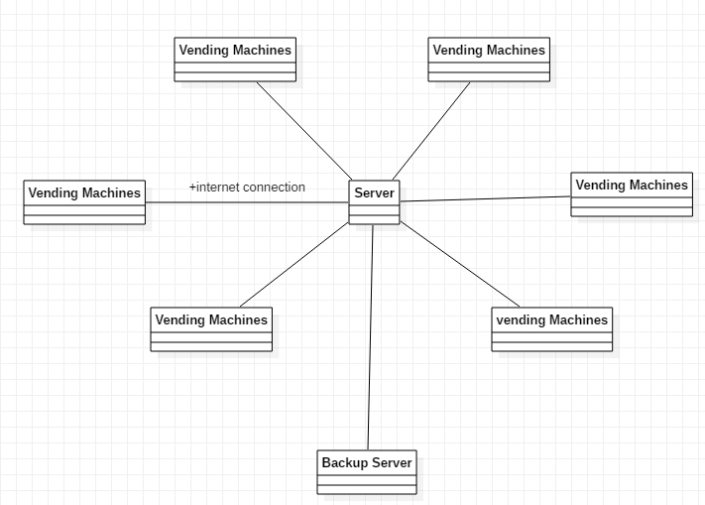
UML CLASS DIAGRAM

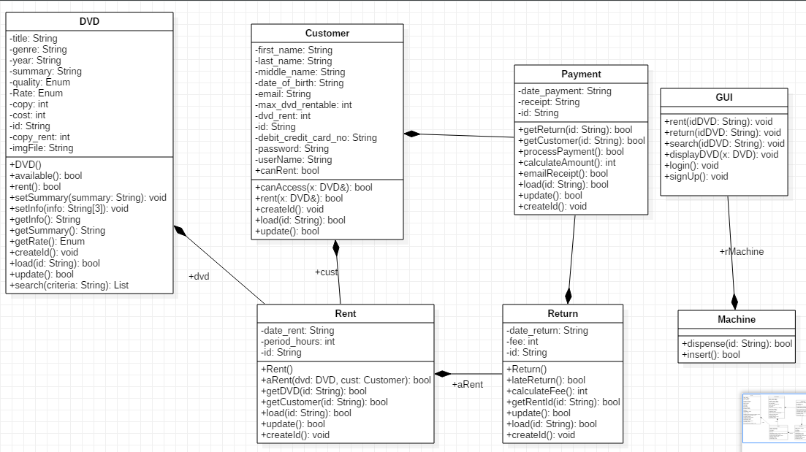

LOGIN CLASSES UML
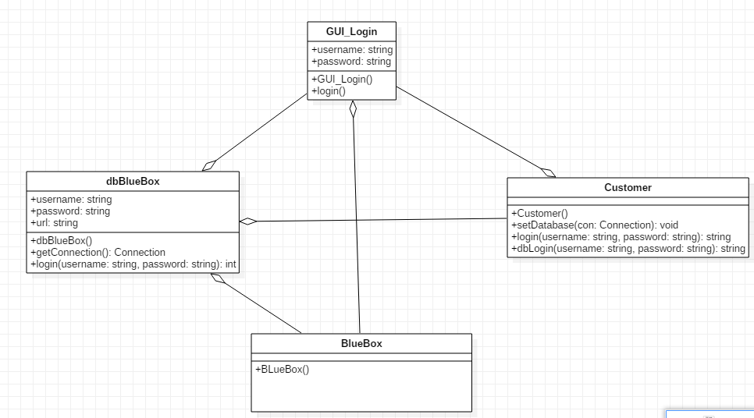

LOGIN SEQUENCE
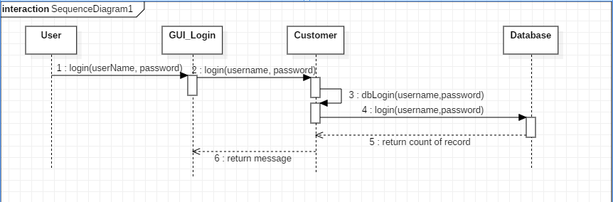

BROWSE SEQUENCE
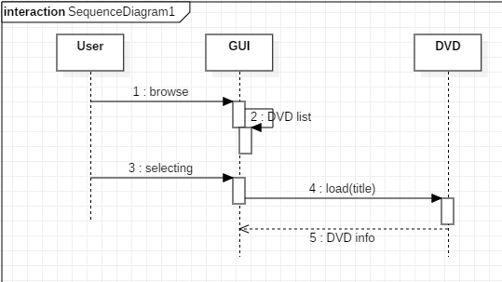

SEQUENCE RENT
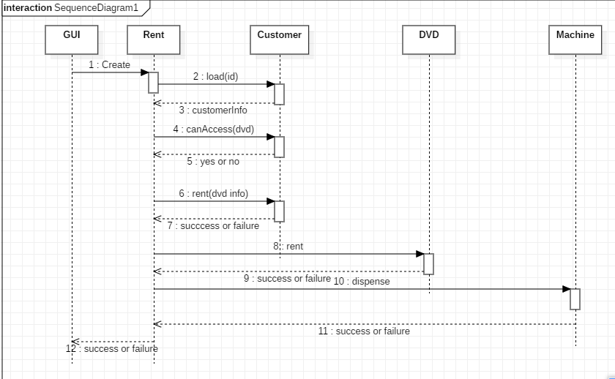

SEQUENCE RETURN
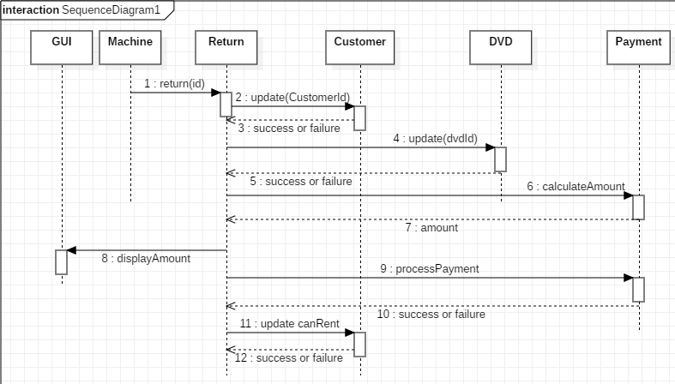

USE CASE DIAGRAM
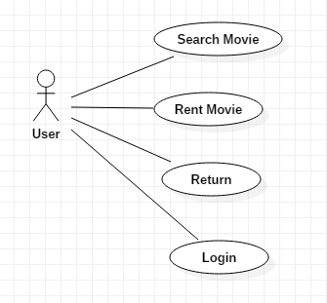

8.System Evolution

The system is based on movies using CD or Blu Ray format, and the CD movie industry is not doing well. So, the evolution can go in two ways. The system can evolve into a web-based movie streaming service, which would be a viable evolution but with the growth of streaming services we would need a way to differentiate ourselves from other services. An alternate path we could go for instead is using a CD format that isn’t out of date, CD video games. Video Games are probably the most profitable use of the CD in today’s market. So, using the same system but changing it for Video Game renting instead would make more sense. Video Games could be integrated as well as the existing movie, then eventually when the movies become unprofitable, we could switch completely to video game CD rentals. A hardware upgrade could be integrating a mobile app to make renting movies a bit easier. Our system is a very simple design so evolution is possible and there are many evolution paths we can take thanks to the simple design.

9.Appendices

Design of CD vending machine- The machine for renting the CDs is built like a vending machine but with CDs and Blu-Rays. This is a very simple design and should be easy to incorporate. Also, since we are using CDs, we can fit many CDs into the machine since they do not take up a lot of space.

