Machine Learning Engineer Nanodegree¶

Capstone Project¶
Patrick Poon
May 25, 2018

I. Definition¶

Project Overview¶
Most people...the interaction that they're going to have with a police officer is because [...] they're stopped for speeding. Or, forgetting to turn their blinker off.[1]
-- Cheryl Phillips, Journalism Professor at Stanford University
On a typical day in the United States, police officers make more than 50,000 traffic stops.[2] In recent years, there have been numerous incidents that have made national headlines that involved an officer shooting and, in some cases, killing the driver or an occupant. Many cite racial biases against Blacks and Hispanics for the disproportionate number of such incidents. Here are some relevant articles:
- Was the Sandra Bland traffic stop legal -- and fair? (https://www.cnn.com/2015/07/23/opinions/cevallos-sandra-bland-traffic-stop/index.html)
- Philando Castile shooting: Dashcam video shows rapid event (https://www.cnn.com/2017/06/20/us/philando-castile-shooting-dashcam/index.html)
This Capstone project will not attempt to prove or disprove this controversial topic, and will attempt to avoid making any controversial or provocative statements on either side of the conversation.

Problem Statement¶
Instead, this project aims to create a multi-class classifier that takes various discrete traffic stop situational values to predict the outcome of a traffic stop, specifically in the state of Connecticut (CT). Given a driver's age, gender, race, traffic stop violation, and the county in which a traffic stop occurs, can we reliably predict whether the traffic stop will result in a verbal/written warning, a ticket, a summons to appear in court, or an arrest?
To accomplish this task, I will parse and process traffic stop data for the state of Connecticut, and feed it into a supervised learning algorithm that I will train and tune to predict these outcomes. The data comes from the Stanford Open Policing Project (SOPP) at https://openpolicing.stanford.edu/data/. SOPP has collected data for 31 states, but the CT dataset was the cleanest and most consistent.

Metrics¶
For this project, I will use accuracy classification score as my evaluation metric. According to the scikit-learn page for the accuracy_score function[3], in the context of multiclass classification, the function is equivalent to the jaccard_similarity_score function which calculates the Jaccard index[4], also known as "Intersection over Union," as illustrated in the following formula:
![Intersection over Union formula](./images/IoU.svg)

II. Analysis¶

Data Exploration & Exploratory Visualization¶
In this section, I will break down and decompose the raw data into its basic elements. In doing so, I will attempt to gain insights that may guide me at different points in my journey to develop an effective and accurate classifier. I will start by presenting some sample records, then discuss why certain columns should be dropped, and finally explore characteristics of some columns that may provide predictive power for my classifier.
The raw data is available at https://stacks.stanford.edu/file/druid:py883nd2578/CT-clean.csv.gz, and is comprised of 318,669 records with 24 feature columns, collected over a period of 1 year and 5 months from 2013 to 2015. A few of those columns, namely driver_age, driver_race, and search_type, have overlapping information as these fields have two columns with the name format of "X" and "X_raw", where the "X" values are cleaned or adjusted "X_raw" values.
Here are a few sample rows with the feature columns broken down into three sections (Please note: Different rows have been selected for each section to provide a sense of the complexity involved with the different columns in this dataset):
 | id | state | stop_date | stop_time | location_raw | county_name | county_fips | fine_grained_location
0 | CT-2013-00001 | CT | 2013-10-01 | 00:01 | westport | Fairfield County | 9001.0 | 00000 N I 95 (WESTPORT, T158) X 18 LL
1 | CT-2013-00002 | CT | 2013-10-01 | 00:02 | mansfield | Tolland County | 9013.0 | rte 195 storrs
2 | CT-2013-00003 | CT | 2013-10-01 | 00:07 | franklin | New London County | 9011.0 | Rt 32/whippoorwill
3 | CT-2013-00004 | CT | 2013-10-01 | 00:10 | danbury | Fairfield County | 9001.0 | I-84
4 | CT-2013-00005 | CT | 2013-10-01 | 00:10 | east hartford | Hartford County | 9003.0 | 00000 W I 84 (EAST HARTFORD, T043)E.OF XT.56
 | police_department | driver_gender | driver_age_raw | driver_age | driver_race_raw | driver_race | violation_raw | violation
24500 | State Police | M | 39 | 39.0 | White | White | Speed Related | Speeding
24501 | State Police | M | 62 | 62.0 | White | White | Cell Phone,Other | Cell phone,Other
24502 | State Police | F | 31 | 31.0 | White | White | Registration | Registration/plates
24503 | State Police | F | 50 | 50.0 | Hispanic | Hispanic | Other | Other
24504 | State Police | M | 28 | 28.0 | White | White | Registration | Registration/plates
 | search_conducted | search_type_raw | search_type | contraband_found | stop_outcome | is_arrested | officer_id | stop_duration
242 | False | NaN | NaN | False | Verbal Warning | False | 1000002364 | 1-15 min
243 | False | NaN | NaN | False | Ticket | False | 1000001904 | 16-30 min
244 | False | NaN | NaN | False | Summons | False | 41354688 | 1-15 min
245 | False | NaN | NaN | False | Written Warning | False | 348145142 | 1-15 min
246 | False | NaN | NaN | False | Ticket | False | 1000001914 | 1-15 min
The dataset is primarily comprised of discrete categorical values with only three columns that contain numerical data, namely driver_age, driver_age_raw, and county_fips. However, county_fips is unlikely to yield any predictive benefit numerically as the values are simple label identifiers for values in the county_name column. The county_fips column can be dropped, and the county_name column will be one-hot encoded. The driver_age column can also be dropped as it duplicates information in the driver_age_raw column. driver_age also has missing values, as the following table shows:
In [104]:
df.isnull().sum().to_frame('null values count')
Out[104]:
 | null values count
id | 0
state | 0
stop_date | 0
stop_time | 222
location_raw | 41
county_name | 42
county_fips | 42
fine_grained_location | 1663
police_department | 0
driver_gender | 0
driver_age_raw | 0
driver_age | 274
driver_race_raw | 0
driver_race | 0
violation_raw | 0
violation | 0
search_conducted | 0
search_type_raw | 313823
search_type | 313823
contraband_found | 0
stop_outcome | 5356
is_arrested | 5356
officer_id | 0
stop_duration | 0
One glaring observation with this table is that the search_type_raw and search_type columns mostly contain null values and should be dropped. These fields provide supplementary information when a search is conducted, with both columns containing one of the following values: "Consent", "Other", "Inventory", or nan (not a number). The search_conducted boolean column, by itself, should provide an adequate signal about a probable outcome when a car search is involved.
The next two columns that have the highest number of null values are stop_outcome and is_arrested. The is_arrested column should be dropped, because "Arrest" is one of the outcome values, and keeping this column would defeat the purpose of creating this classifier. It would also be cheating in a sense. Next, the rows that contain null values for stop_outcome should be dropped, since the main objective of this project is to predict the outcome of a traffic stop. It would not make sense to replace the null values for this field with a median or average value.
There are a few other columns that make sense to drop as well:
- id column values, like "CT-2013-00001", provide no predictive value.
- state and police_department columns only have one value each, "CT" and "State Police" respectively.
- location_raw contains the specific city in which a traffic stop occurred. But, this data may be too granular, and better insight might be gained by using the county_name instead.
- fine_grained_location values are inconsistent and non-standardized, as the values appear to be simple notes that the officer took about the spot where the traffic stop was conducted.
- driver_race_raw column duplicates data in the driver_race column.
- officer_id has 2,105 unique values and might be too granular, making overfitting likely, so it will be dropped.
One could make a case that location_raw and/or officer_id should be kept. Even though these fields contain granular data that may be too specific to the point that it may contribute to overfitting, they may provide signals for certain biases that lead to certain outcomes. For example, certain officers may have a propensity to issue a Verbal Warning to certain demographics instead of issuing a Ticket. If my classifier's prediction accuracy seems to reach a ceiling during model development and exhaustive hyperparameter tuning, I will consider adding one or both of these columns back into the training data.
In the following sub-sections I will discuss the columns that comprise the input features that will be used to train my classifier.
In [24]:
# Drop columns that clearly should be dropped

drop_cols = [
'county_fips',
'driver_age',
'driver_race_raw',
'fine_grained_location',
'id',
'is_arrested',
'officer_id',
'police_department',
'search_type_raw',
'search_type',
'state',
]

df.drop(drop_cols, axis=1, inplace=True)
In [ ]:
#df.shape
In [ ]:
#df.isnull().sum().to_frame('null value count')
In [25]:
# Drop empty stop_outcome and county_name/county_fips rows
df.dropna(subset=['stop_outcome', 'county_name'], axis=0, inplace=True)
In [ ]:
df.shape
In [ ]:
df.isnull().sum()

Traffic Stop Outcome Breakdown¶
The values from the stop_outcome column will serve as the output labels for my classifier. Graphing the value distribution for this column makes it clear that the data set is highly imbalanced.
In [31]:
outcome_breakdown = df['stop_outcome'].value_counts(normalize=True).mul(100).plot.bar(figsize=(15, 3), table=True, fontsize=14, title="Traffic Stop Outcome Breakdown")
outcome_breakdown.axes.get_xaxis().set_visible(False)
outcome_breakdown.axes.set_ylabel('%', fontsize=14)
outcome_breakdown.tables[0].auto_set_font_size(False)
outcome_breakdown.tables[0].set_fontsize(14)
outcome_breakdown.tables[0].scale(1, 2)
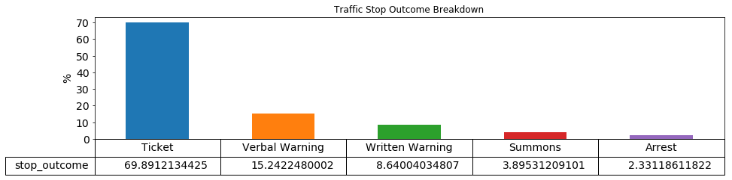
A vast majority of traffic stops result in the officer issuing a "Ticket" in 69.89% of the cases. "Arrest"s comprise only 2.33% of traffic stops. Some lucky drivers are issued warnings, verbal or written, 23.9% of the time, while a few unfortunate drivers receive a "Summons" to appear in court in 3.9% of traffic stops. There is a high risk that a trained model using this dataset unaltered will have a strong bias towards predicting "Ticket" as the outcome if not handled properly.

Proportion of Searches Conducted Relative to All Stops¶
One interesting data point that CT officers collect is whether a search was conducted during the traffic stop, as captured in the search_conducted column. When True, these traffic stops should correlate with a higher number of outcomes resulting in an "Arrest".
In [33]:
searches = df['search_conducted'].value_counts(normalize=True).mul(100).plot.bar(figsize=(8, 2), table=True, title="Proportion of Searches Conducted Relative to All Stops")
searches.axes.get_xaxis().set_visible(False)
searches.axes.set_ylabel('%')
searches.tables[0].set_fontsize(14)
searches.tables[0].scale(1, 2)
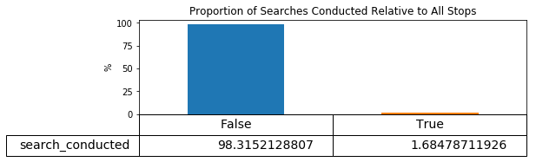

Outcomes When Vehicle Searched¶
Indeed, the proportion of Arrests rises to 27.69% of traffic stops when a search is conducted.
In [44]:
outcome_when_searched = df[df['search_conducted'] == True]['stop_outcome'].value_counts(normalize=True).mul(100).plot.bar(figsize=(15, 5), table=True, title="Outcomes When Vehicle Searched")
outcome_when_searched.axes.get_xaxis().set_visible(False)
outcome_when_searched.axes.set_ylabel('%')
outcome_when_searched.tables[0].auto_set_font_size(False)
outcome_when_searched.tables[0].set_fontsize(14)
outcome_when_searched.tables[0].scale(1, 2)
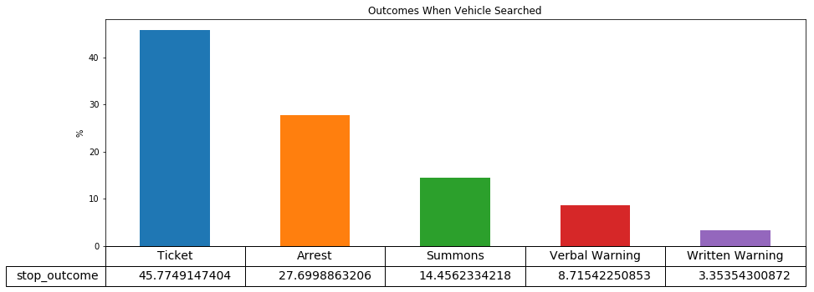
Still, searches only comprise 1.7% of all traffic stops, so the fact remains that the data set is highly imbalanced.

Outcome by stop_duration¶
Another interesting data point is the duration of the traffic stop in the stop_duration column, which may provide another predictive signal about the likely outcome. Logically speaking, the longer the duration of a traffic stop, the more likely the outcome will be an "Arrest", as the officer may need to ask more questions, search the vehicle, conduct a sobriety test, and perform other duties that take time and extend the duration of the traffic stop.
In [114]:
# duration_outcomes = df.groupby(['stop_duration', 'stop_outcome'])
# duration_outcomes.agg({'id': 'count'}).groupby(level=0).apply(lambda x: 100 * x / float(x.sum())).rename(columns={'id': '%'})
In [43]:
duration_dummies = pd.get_dummies(df.stop_duration)
outcomes_by_duration = pd.concat([df.stop_outcome, duration_dummies], axis=1)
outcomes_by_duration_grouped = outcomes_by_duration.groupby(['stop_outcome']).agg({x: 'sum' for x in duration_dummies.columns.values}).apply(lambda x: 100 * x / float(x.sum())).T
ax = outcomes_by_duration_grouped.plot.barh(figsize=(15, 5), width=0.9, fontsize=14, title="Outcome by stop_duration")
ax.set_xlabel('%', fontsize=14)
ax.set_ylabel('Stop Duration', fontsize=14)
Out[43]:
Text(0,0.5,'Stop Duration')
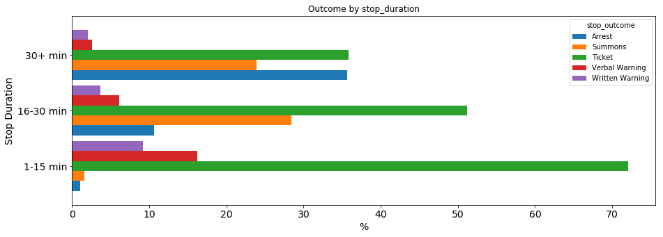
As suspected, the chances of a traffic stop resulting in an "Arrest", as illustrated by the blue bars, is much higher when the stop lasts longer than 30 minutes at 35.64% than 1.01% when the stop lasts only 15 minutes or less.

Race Breakdown¶
Another potential signal for the outcome of a traffic stop is race.
In [47]:
stops_by_race = df['driver_race'].value_counts(normalize=True).mul(100).plot.bar(figsize=(15, 4), table=True, title="Race Breakdown", fontsize=14)
stops_by_race.axes.get_xaxis().set_visible(False)
stops_by_race.axes.set_ylabel('%', fontsize=14)
stops_by_race.tables[0].set_fontsize(14)
stops_by_race.tables[0].scale(1, 2)
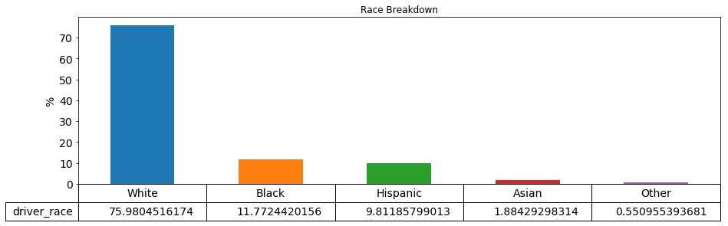
The barchart shows that the majority (76%) of traffic stops involved "White"s, with "Black"s at 11.75%, "Hispanic"s at 9.78%, "Asian"s at 1.87%, and a catch-all value of "Other" at 0.55%. This approximately matches the 2010 census figures for Connecticut[5], where the racial composition is 77.57% "White", 10.14% "Black", 13.4% "Hispanic", 3.79% "Asian", and roughly 5.55% "Other". Hispanics are separated out by Ethnicity, so the numbers I provided have some overlap and sum to more than 100%.

One interesting note about the "Other" value is that in the driver_race_raw column of the dataset, this value was denoted as "Native American" and was subsequently replaced with "Other" in the driver_race column.

Arrests by County by Race¶
Looking for further insights, I thought it might be interesting to analyze racial breakdown of traffic stops that resulted in an "Arrest" by county. Please note that the values are in percentages.
In [117]:
# df.loc[df['stop_outcome'] == 'Arrest'].groupby(['county_name', 'driver_race']).agg({'id': 'count'}).groupby(level=0).apply(lambda x: 100 * x / float(x.sum())).rename(columns={'id': '%'})
In [49]:
arrested = df.loc[df['stop_outcome'] == 'Arrest']
arrested_dummies = pd.get_dummies(arrested.county_name)
arrested_races_by_county = pd.concat([arrested.driver_race, arrested_dummies], axis=1)
county_races = arrested_races_by_county.groupby(['driver_race']).agg({x: 'sum' for x in arrested_dummies.columns.values}).apply(lambda x: 100 * x /float(x.sum())).T
county_races
Out[49]:
driver_race | Asian | Black | Hispanic | Other | White
Fairfield County | 1.007049 | 16.918429 | 28.700906 | 0.604230 | 52.769386
Hartford County | 1.319797 | 23.553299 | 19.289340 | 0.507614 | 55.329949
Litchfield County | 1.140065 | 3.094463 | 10.097720 | 0.325733 | 85.342020
Middlesex County | 1.206897 | 12.586207 | 13.103448 | 0.000000 | 73.103448
New Haven County | 0.922819 | 17.533557 | 22.315436 | 0.251678 | 58.976510
New London County | 1.277235 | 8.715252 | 9.541698 | 0.450789 | 80.015026
Tolland County | 1.121076 | 7.735426 | 9.865471 | 0.112108 | 81.165919
Windham County | 0.698324 | 4.748603 | 17.318436 | 0.418994 | 76.815642
In [50]:
# races_by_county
county_graph = county_races.plot.barh(figsize=(15, 8), width=0.9, fontsize=14)
county_graph.axes.set_xlabel('%', fontsize=14)
Out[50]:
Text(0.5,0,'%')
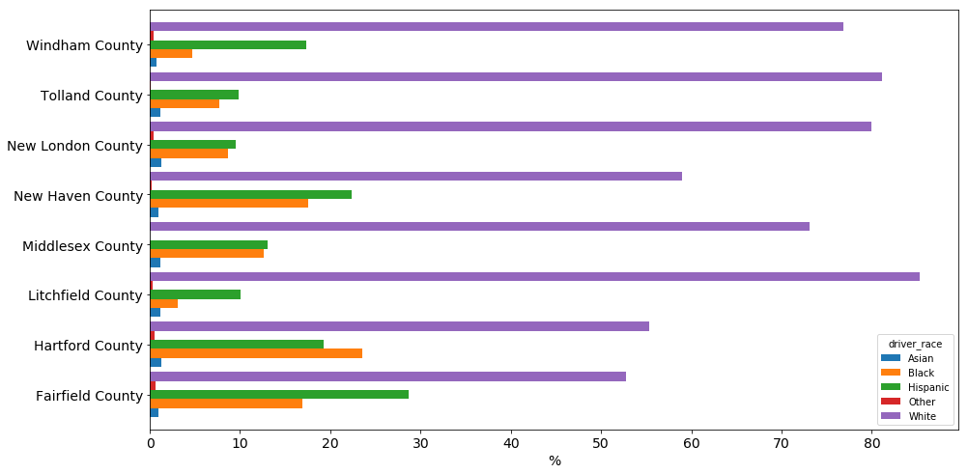
While the racial breakdown of traffic stops for the state overall are, for the most part, consistent with 2010 census data, these figures suggest that there are certain counties where Blacks and Hispanics are pulled over disproportionately higher than their composition in the 2010 census, namely in the Fairfield, Hartford, and New Haven counties. This is not to suggest that they are being pulled over because of racial bias but is simply stated as an observation.

Traffic Stops by County¶
The distribution of traffic stops by county is moderately distributed. Almost half of traffic stops occurred in New Haven, New London, and Tolland counties.
In [51]:
outcomes_by_county = df['county_name'].value_counts(normalize=True).mul(100).apply(lambda x: float('{:.6f}'.format(x))).plot.bar(figsize=(15, 5), table=True, fontsize=12, title="Traffic Stops by County")
outcomes_by_county.axes.get_xaxis().set_visible(False)
outcomes_by_county.axes.set_ylabel('%', fontsize=18)
outcomes_by_county.tables[0].auto_set_font_size(False)
outcomes_by_county.tables[0].set_fontsize(10)
outcomes_by_county.tables[0].scale(1, 3)
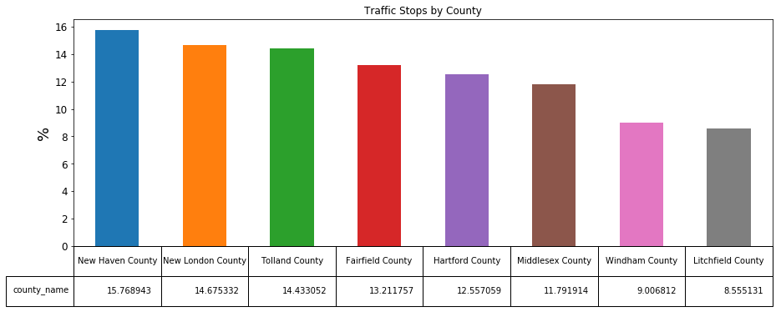

Outcomes by Violations¶
Two columns, violation and violations_raw, provide information about the related violation(s) involved in a traffic stop outcome. Unfortunately, these columns suffer from repetitive values and inconsistent data entry issues. For example, some values are phrased differently yet have the same meaning. I will need to settle on a standard value for these duplicate values and perform one-hot encoding for each class value, since multiple violations can be associated with a single traffic stop.
In [121]:
def normalize_violation(violation):
"""Normalize violation values
"""
if violation == 'defective lights':
return 'lights'
elif violation == 'equipment violation':
return 'equipment'
elif violation == 'other/error':
return 'other'
elif violation == 'registration/plates':
return 'registration'
elif violation == 'seat belt':
return 'seatbelt'
elif violation == 'speed related':
return 'speeding'
elif violation == 'stop sign/light' or violation == 'stop sign':
return 'bad_stop'
return violation.replace(' ', '_')

def merge_violations(violations):
"""Merge violation and violation_raw columns
"""
merged = []
tokens = violations.lower().split(',')
return list(set([normalize_violation(violation) for violation in tokens]))

def onehot_encode_violations(arr_violations):
row = np.zeros(len(violations))
for v in arr_violations:
row[violations.index(v)] = 1
return row

violations = []

for violation in list(df.violation.unique()) + list(df.violation_raw.unique()):
tokens = violation.lower().split(',')
violations.extend([normalize_violation(token) for token in tokens])

violations = sorted(set(violations))

merged = df[['violation_raw', 'violation']].apply(lambda x: ','.join(x), axis=1).apply(merge_violations)

violation_col_headers = ['violation_{}'.format(violation.replace(' ', '_')) for violation in violations]

df_violations = merged.apply(onehot_encode_violations).apply(lambda x: pd.Series(x, dtype=int))
df_violations.columns = violation_col_headers
The distribution of violation values shows that a majority of traffic stops involve speeding. Unfortunately, "Other" represents a large portion of violations, which is not descriptive and may add noise to the training set.
In [122]:
violations = df_violations.copy(deep=True)
violations.columns = [x.replace('violation_', '') for x in violations.columns.values]
violation_breakdown = violations.sum().sort_values(ascending=False).plot.bar(figsize=(17, 5), fontsize=14)
violation_breakdown.axes.set_ylabel('Number of traffic stops', fontsize=14)
Out[122]:
<matplotlib.text.Text at 0x22817a8d8d0>
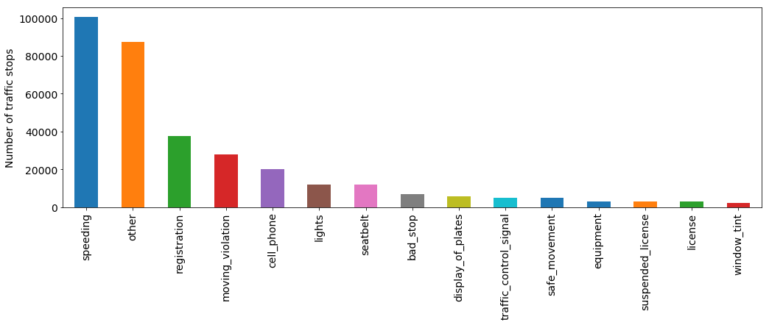
The bar chart below shows the outcome percentages by violation type.
In [123]:
violation_outcomes = pd.concat([df.stop_outcome, df_violations], axis=1)

agg_dict = {}
outcomes_counts_by_violation = violation_outcomes.groupby(['stop_outcome']).agg({x: 'sum' for x in violation_col_headers}).apply(lambda x: 100 * x /float(x.sum())).rename(columns={x: x.replace('violation_','') for x in violation_col_headers}).T

outcomes_counts_by_violation_chart = outcomes_counts_by_violation.plot.barh(figsize=(15,15), width=0.9, fontsize=14)
outcomes_counts_by_violation_chart.axes.set_xlabel('%', fontsize=18)
Out[123]:
<matplotlib.text.Text at 0x227d9fa3860>
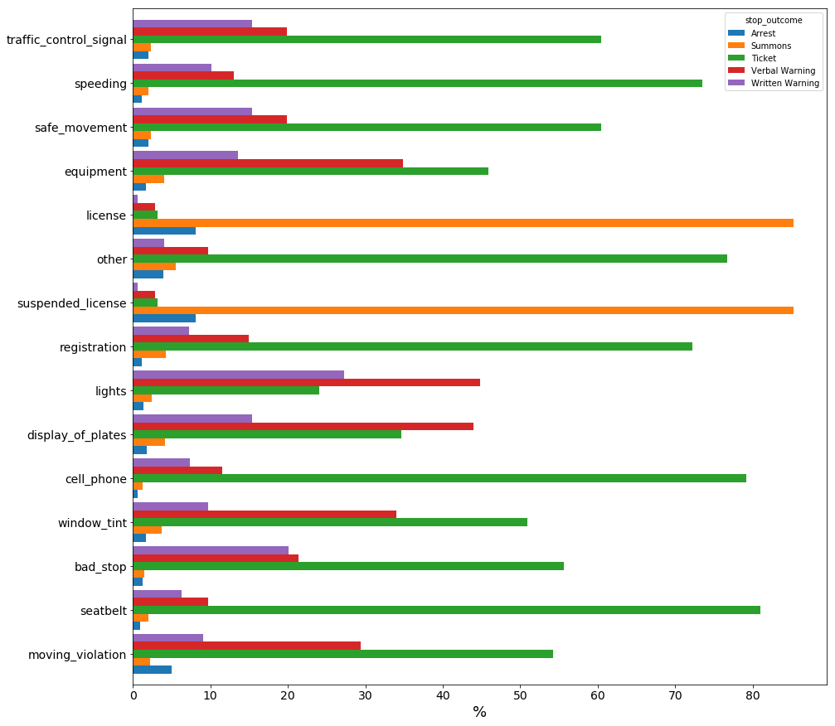
Not surprisingly, most violations resulted in a "Ticket", but there are a few exceptions:
- Expired and suspended driver's licenses were more likely to result in a "Summons" to appear in court, as shown by the two elongated orange-colored bars.
- Improper display of license plates and non-functional lights were likely to result in a "Verbal Warning."

Date and Time¶
The stop_date and stop_time columns specify when a traffic stop occurred. In the hopes of detecting potential time patterns, I will transform these into four columns: month, day, hour, and minute.
In [42]:
# [TODO: REMOVEME?]
# import pandas as pd
# %matplotlib inline
# df = pd.read_csv('./data/CT-clean.csv', header=0)
# day_freq = df['stop_date'].apply(lambda x: x.split('-')[2])
# month_freq = df['stop_date'].apply(lambda x: x.split('-')[1])
# dt_outcomes = pd.get_dummies(df['stop_outcome'])
# dt = pd.concat([month_freq, day_freq, df['stop_outcome']], axis=1)
# cols = ['month', 'day', 'outcome']
# # cols.extend(list(dt_outcomes.columns.values))
# dt.columns=cols
# grouped = dt.groupby(['day'])['outcome'].count().plot.barh(figsize=(15, 15), fontsize=14)
# grouped.axes.set_xlabel('outcome count', fontsize=14)
# grouped.axes.set_ylabel('day', fontsize=14)

Gender Breakdown¶
Twice as many men got pulled over compared to women, as men comprised almost exactly two-thirds (66.5%) of this dataset.
In [124]:
# gender_vbar = df['driver_gender'].value_counts(normalize=True).mul(100).plot.bar(figsize=(8, 4), table=True)
# xaxis = gender_vbar.axes.get_xaxis()
# xaxis.set_visible(False)
# gender_vbar.axes.set_ylabel('%')
# table = gender_vbar.tables[0]
# table.scale(1, 2)
In [125]:
gender_vbar = df['driver_gender'].value_counts(normalize=True).mul(100).plot.pie(figsize=(4, 4), fontsize=16)
xaxis = gender_vbar.axes.get_xaxis()
xaxis.set_visible(False)
gender_vbar.axes.set_ylabel('')
# gender_vbar.axes.set_ylabel('%')
# table = gender_vbar.tables[0]
# table.scale(1, 2)
Out[125]:
<matplotlib.text.Text at 0x227ee600a90>
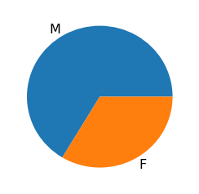

Age Breakdown¶
Those in their 20's have the highest percentage of traffic stops at 30.66%, with those in their 30's and 40's following suit, at 20.9% and 18.9% respectively.
In [126]:
# df['driver_age_raw'].describe()

# [TODO: Remove or make a pretty table]
Out[126]:
count 313274.000000
mean 38.066325
std 14.428419
min 0.000000
25% 26.000000
50% 35.000000
75% 49.000000
max 99.000000
Name: driver_age_raw, dtype: float64
In [56]:
age_bins = pd.cut(df['driver_age_raw'], bins=[0, 10, 20, 30, 40, 50, 60, 70, 80, 90, 100], include_lowest=True)
ax = age_bins.value_counts(sort=False, normalize=True).mul(100).plot.bar(rot=0, color="b", figsize=(16,4), title="Age Breakdown (10-year Bins)", fontsize=14)
ax.axes.set_ylabel('%', fontsize=14),
Out[56]:
(Text(0,0.5,'%'),)
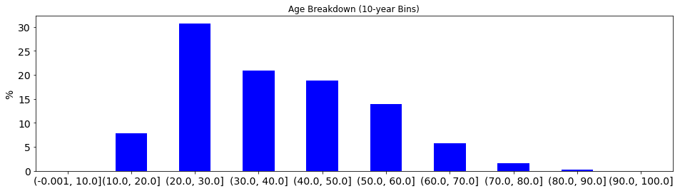
274 records specify ages that are less than 15 years old, which appear to be typos and will be removed in the pre-processing stage.
In [52]:
weird_ages_rows = df[df["driver_age_raw"] < 15]['driver_age_raw']
weird_ages = weird_ages_rows.value_counts(sort=False).plot.bar(figsize=(13, 4), table=True, title='Age Values Count')
xaxis = weird_ages.axes.get_xaxis()
xaxis.set_visible(False)
weird_ages.axes.set_ylabel('Count')
table = weird_ages.tables[0]
table.set_fontsize(14)
table.scale(1, 2)
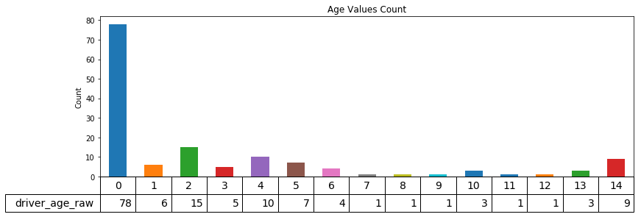

Algorithms and Techniques¶
Since this is a multi-class classification problem, I will experiment with the following algorithms that scikit-learn lists as multi-class at http://scikit-learn.org/stable/modules/multiclass.html:
Classifier | Description
**GaussianNB** | - Implements the Gaussian Naive Bayes algorithm.  - Known to work well with large datasets such as this one.  - assumes that the presence of a particular feature in a class is unrelated to the presence of any other feature
**RandomForestClassifier** | - Meta estimator that fits a number of decision tree classifiers on dataset sub-samples, using averages to improve predictive accuracy and minimize over-fitting.  - Intrinsically suited for multiclass problems.  - Works well with a mixture of numerical and categorical features
**DecisionTreeClassifier** | - Non-parametric learning method that predicts the value of a target variable by learning simple decision rules inferred from data features.  - Works well with regression and classification problems.  - Some regard as "set it and forget it" due to the minimal optimization needed
**GradientBoostingClassifier** | - Builds an additive model in a forward stage-wise fashion, allowing for the optimization of random differentiable loss functions.  - Generally performs better than `random forest`.  - Provides a plethora of tuning parameters.
For the most part, I used the default parameters for each classifier, with the exception of the n_jobs, verbose, and random_state parameters when available, which are specified as follows:
 | Classifier
Parameter | GaussianNB | RandomForestClassifier | DecisionTreeClassifier | GradientBoostingClassifier
bootstrap |  | True
class_weight |  | None | None
criterion |  | gini | gini | friedman_mse
init |  |  |  | None
learning_rate |  |  |  | 0.1
loss |  |  |  | deviance
max_depth |  | None | None | 3
max_features |  | auto | None | None
max_leaf_nodes |  | None | None | None
min_impurity_split |  | 0.0000001 | 0.0000001 | 0.0000001
min_samples_leaf |  | 1 | 1 | 1
min_samples_split |  | 2 | 2 | 2
min_weight_fraction_leaf |  | 0 | 0 | 0
n_estimators |  | 10 |  | 100
n_jobs |  | 8
oob_score |  | False | best
presort |  |  | False | auto
priors | None
random_state |  | 0 | 0 | 0
splitter |  |  | best
subsample |  |  |  | 1
verbose |  | 3 |  | 3
warm_start |  | False |  | False
After experimenting with different configurations of the dataset, I will move forward with the best performing model and tune its hyperparameters.

Benchmark¶
As far as I know, there is no external benchmark to assess the accuracy of a traffic stop outcome prediction. From my analysis of the data, generating a naive predictor that predicts the outcome to be most common value, "Ticket," should suffice as a benchmark. "Ticket" comprises ~70% of all outcomes as described in the following table:
Outcome | Count | %
Arrest | 7,312 | 2.33%
Summons | 12,205 | 3.90%
Ticket | 218,973 | 69.89%
Verbal Warning | 47,753 | 15.24%
Written Warning | 27,070 | 8.64%
 | 313,313
To ensure that I am doing a fair comparison, I will run this model against the same test set that will be used as input to the score() functions of the classifiers specified above.

III. Methodology¶

Data Preprocessing¶
I performed the following preprocessing steps on the raw dataset to generate training and testing sets for classifier development:
- Dropped the data columns that I believed were unnecessary, namely:
county_fips
driver_age
driver_race_raw
fine_grained_location
id
is_arrested
location_raw
officer_id
police_department
search_type
search_type_raw
state
- Removed rows where stop_outcome and county_name had empty values, as well as rows which had driver_age_raw values below 15.
- Calculated the median traffic stop time and used it to fill in the null values for the stop_time field.
- Split stop_date and stop_time string values into month, day, hour, and min numerical value columns then dropped the stop_date and stop_time columns.
- Normalized the violations data by combining values from the violation and violation_raw columns, merging similar values into a common value, then manually one-hot encoded the values into their own binary columns, which were then appended to the main dataframe as additional features. I subsequently dropped the violation and violation_raw columns.
- Converted search_conducted and contraband_found columns to binary values in-place.
- Normalized driver_age values to values between 0.0 and 1.0 using sklearn.preprocessing.MinMaxScaler in-place.
- Performed one-hot encoding on the following categorical value fields: county_name, driver_gender, driver_race, stop_duration.
In [129]:
# Append one-hot encoded violations
df = pd.concat([df, df_violations], axis=1)

# Remove records with age less than 15
df.drop(index=weird_ages_rows.index, inplace=True)

# Fill in empty **`stop_time`** with median value
populated = df[df.stop_time.notnull()]['stop_time'].sort_values()
median_stop_time = populated.iloc[populated.shape[0] // 2]
df['stop_time'].fillna(median_stop_time, inplace=True)
In [130]:
# df.shape
Out[130]:
(313129, 28)
In [131]:
# Categorize stop_time into time-of-day: "morning, afternoon, evening, small hours"
def day_period(time_str):
hour = time_str.hour
if hour >= 0 and hour < 6:
return 'Small Hours'
elif hour >= 6 and hour < 12:
return 'Morning'
elif hour >= 12 and hour < 18:
return 'Afternoon'
else:
return 'Evening'

df['day_period'] = pd.to_datetime(df['stop_time']).apply(day_period)
In [132]:
# df.shape
Out[132]:
(313129, 29)
In [133]:
# Categorize stop_date by season
def season(stop_date):
month = datetime.strptime(stop_date, '%Y-%m-%d').month
if month >= 3 and month < 6:
return 'Spring'
elif month >= 6 and month < 9:
return 'Summer'
elif month >= 9 and month < 12:
return 'Fall'
return 'Winter'

df['season'] = df['stop_date'].apply(season)
In [134]:
# Transform driver_gender to binary
df['is_male'] = df['driver_gender'].apply(lambda x: 1 if x == 'M' else 0)
In [135]:
# Experiment: See whether labelencoding location_raw improves performance
from sklearn.preprocessing import LabelEncoder

le = LabelEncoder()
df['location_raw'] = le.fit_transform(df['location_raw'])
In [136]:
# df.shape
Out[136]:
(313129, 31)
In [137]:
# Drop columns no longer needed due to normalization
drop_cols = [
'driver_gender',
# 'county_name',
# 'location_raw',
# 'officer_id',
'stop_date',
'stop_time',
'violation_raw',
'violation',
]

df.drop(drop_cols, axis=1, inplace=True)
In [138]:
# df.shape
Out[138]:
(313129, 26)
In [139]:
# Convert booleans to 0 and 1
df['search_conducted'] = df['search_conducted'].apply(lambda x: int(x))
df['contraband_found'] = df['contraband_found'].apply(lambda x: int(x))
In [ ]:
# Normalize driver_age
from sklearn.preprocessing import MinMaxScaler

scaler = MinMaxScaler() # default=(0, 1)
features_transformed = pd.DataFrame(data=df)
features_transformed['driver_age_raw'] = scaler.fit_transform(features_transformed['driver_age_raw'].reshape(-1, 1))
# features_transformed
In [141]:
features_transformed.shape
Out[141]:
(313129, 26)
In [142]:
features_transformed.drop_duplicates(inplace=True)
In [143]:
# features_transformed.shape
Out[143]:
(277733, 26)
In [144]:
# Prefix officer id numbers as dtype is object and get_dummies() creates some duplicate columns
# features_transformed['officer_id'] = le.fit_transform(features_transformed['officer_id'].apply(lambda x: 'no_{}'.format(x)))
In [145]:
# One-hot encode categorical variables
cols_to_encode = [
# 'location_raw',
'county_name',
'driver_race',
# 'officer_id',
'stop_duration',
'day_period',
'season',
]
final_features = pd.get_dummies(features_transformed, columns=cols_to_encode)
# final_features.columns.values
Out[145]:
array(['location_raw', 'driver_age_raw', 'search_conducted',
'contraband_found', 'stop_outcome', 'violation_bad_stop',
'violation_cell_phone', 'violation_display_of_plates',
'violation_equipment', 'violation_license', 'violation_lights',
'violation_moving_violation', 'violation_other',
'violation_registration', 'violation_safe_movement',
'violation_seatbelt', 'violation_speeding',
'violation_suspended_license', 'violation_traffic_control_signal',
'violation_window_tint', 'is_male', 'county_name_Fairfield County',
'county_name_Hartford County', 'county_name_Litchfield County',
'county_name_Middlesex County', 'county_name_New Haven County',
'county_name_New London County', 'county_name_Tolland County',
'county_name_Windham County', 'driver_race_Asian',
'driver_race_Black', 'driver_race_Hispanic', 'driver_race_Other',
'driver_race_White', 'stop_duration_1-15 min',
'stop_duration_16-30 min', 'stop_duration_30+ min',
'day_period_Afternoon', 'day_period_Evening', 'day_period_Morning',
'day_period_Small Hours', 'season_Fall', 'season_Spring',
'season_Summer', 'season_Winter'], dtype=object)
In [164]:
from datetime import datetime

timestamp = datetime.now().strftime('%Y%m%d%H%M%S')

non_oversampled = final_features.copy(deep=True)
non_oversampled_outcomes = non_oversampled.pop('stop_outcome')

# non_oversampled.to_pickle('./final_features-{}-non_oversampled.pkl'.format(timestamp))
# non_oversampled_outcomes.to_pickle('./labels-{}-non_oversampled.pkl'.format(timestamp))
# print('timestamp = {}'.format(timestamp))

Implementation¶
As part of my implementation, I performed an 80/20 split of the preprocessed data into training and test sets, respectively. Feeding the training set into the selected classifiers' fit() functions and subsequently calling the resulting fitted models' score() functions with the test set achieved the following accuracy scores:
Algorithm | Accuracy Score
(Benchmark) | 0.6912
GaussianNB | 0.643051
DecisionTreeClassifier | 0.537262
RandomForestClassifier | 0.685543
GradientBoostingClassifier | 0.718311
Only the GradientBoostingClassifier performed better than the benchmark, and only by .027111 or 2.71%. In an effort to improve performance, I tested different modifications to the data set. To make this task easier to understand and track, I created the following flags and then tested different combinations between them in different stages:
<!-- | Flag | Description | |:-----|:------------| | include_location_raw | Add location_raw column to the data set | | include_driver_race | Add driver_race column to the data set | | label_encode_categoricals | Use sklearn.preprocessing.LabelEncoder to encode categorical column values. If False, use pandas.get_dummies() to one-hot encode each categorical column value into its own binary value column | | oversample | Oversample the data to address data set imbalance | | undersample | Undersample the data to address data set imbalance |
-->

