PRODUCT PLAN | OCTOBER 2026
Pweb
A multi-practice booking platform for surgeries
Plan, architecture, page designs and roadmap
Prepared for Patrick Lubisi

1. The idea
Build one Pweb application that many surgeries can use, each with its own branding, specialists, opening hours and data. A patient books online, gets reminders, completes pre-admission forms and manages appointments. Reception and specialists run the day from a simple dashboard.

Why practices will pay
- Fewer no-shows through automatic SMS or WhatsApp reminders.
- Less reception time spent on phone bookings and rescheduling.
- Patients can book at night and on weekends, which a phone line cannot offer.
- A modern, branded patient experience for each practice.

Verdict
Worth pursuing. The hard parts are less the code and more validation, compliance and support. Start narrow, prove value with one pilot practice, then widen.

2. Validate before building
Talk to 3 to 5 surgeries before writing the real product.
- How do you take bookings today (phone, WhatsApp, paper, software)?
- What practice management software do you already use?
- What costs you the most time or money (no-shows, double bookings, admin)?
- Would you replace your current system or want something that sits beside it?
- What would you pay per month if it removed that pain?
Integration with existing software is often what decides adoption, so find out early.

3. Version 1 scope
A narrow product that never double-books beats a wide one that is flaky.
In version 1 | Later
Online booking and live availability  Specialist calendars and leave  SMS / WhatsApp reminders  Patient login, reschedule and cancel  Reception dashboard  Practice branding and settings | Pre-admission forms (version 1.5)  Medical insurance quotes and purchase  Payments and deposits  Waitlist and cancellation fill  Reports and analytics  Custom domains  Integrations with other software

4. Architecture for many practices
One codebase and one database. Every row carries a practice_id and Postgres row-level security keeps practices apart, even if a query has a bug.
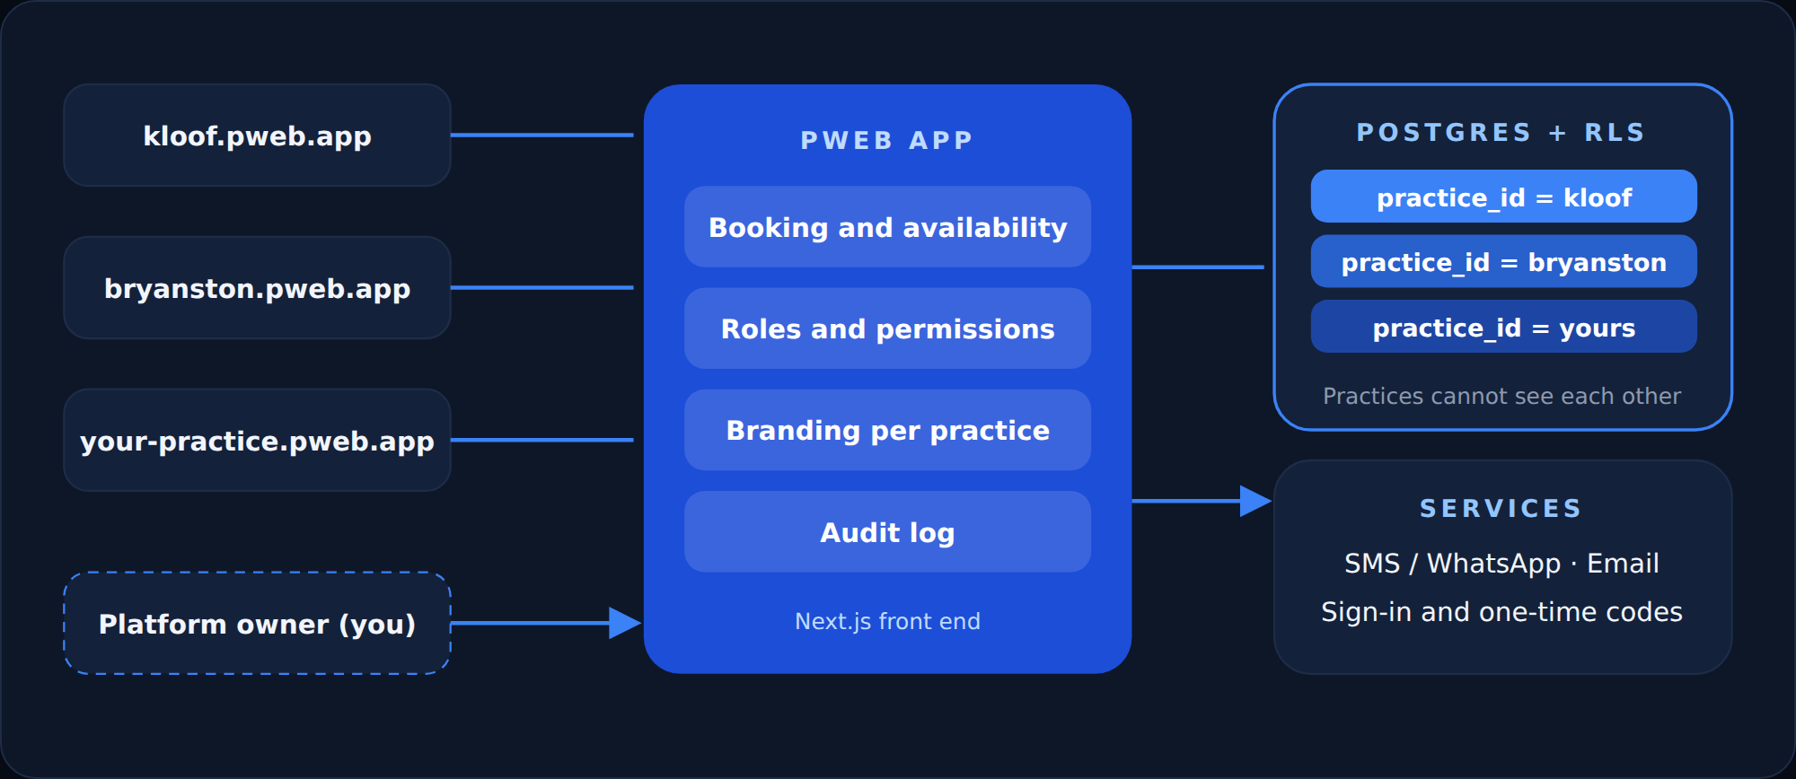
Topic | Approach
Multi-tenancy | One codebase and one database. Enforce isolation with Postgres row-level security so a buggy query cannot leak data.
Per-practice settings | Name, logo, colours, specialists, services, hours and messaging stored as data.
Addressing | Subdomain per practice at first (example: kloof.pweb.app). Custom domains later.
Roles | Platform owner, practice admin, reception, specialist, patient. Build roles from day one.
Booking integrity | Create bookings inside a database transaction with a unique slot constraint so two people can never take the same slot.
Audit log | Record who viewed or changed what, and when. Essential for health data.
Suggested stack | Next.js front end, Supabase (Postgres, auth, row-level security), an SMS or WhatsApp provider, an email provider, hosting in a region that matches your compliance needs.

5. One app, different interfaces by role
This is one application, not one for surgeries and another for patients. The login decides what each person sees, and the server and database enforce what they may access. Hiding a button is only cosmetic.
Role | Device | Lands on | Main actions | Must not see
Patient | Mostly phone | My dashboard | Book, reschedule, finish forms | Other patients
Reception | Desktop | Today calendar | New booking, mark arrived, move a slot | Billing and settings
Specialist | Tablet or desktop | My schedule | See today list, block time, add leave | Other specialists calendars
Practice admin | Desktop | Overview | Branding, users, hours, reports | Other practices
Platform owner (you) | Desktop | Practices list | Add a practice, check status, support | Patient detail unless logged support access

- Patients use the public booking pages and sign in with a one-time code.
- Staff use /staff or /admin after signing in with email, password and multi-factor authentication.
- Both can live on the same practice address, for example kloof.pweb.app and kloof.pweb.app/staff.
- Two apps only make sense later, for example a native patient app in the app stores, and it would still use the same backend.

6. Where to start: build order
Navigation is done. Build these as simple linked HTML pages first with fake data, so you have a clickable prototype to show practices.
Step | Page | What it contains | Size
0 | Navigation | Top bar, search, login, appointment button | Done
1 | Home page | Hero, search and the four quick actions | Small
2 | Find a specialist | Cards with sample time slots | Small
3 | Booking flow | Pick a day and time, confirm. The heart of the product | Medium
4 | Confirmation and My dashboard | What patients see after booking | Small
5 | Reception calendar | The day view staff would use | Medium
6 | Branding admin | Change colours and logo and see it live | Small

File structure: now (prototype)
pweb-prototype/
index.html Home
specialists.html Find a specialist
book.html 3-step booking
confirmed.html Confirmation
account.html My dashboard
staff/calendar.html Reception
admin/branding.html Branding
css/ tokens.css base.css components.css
js/ nav.js slots.js (fake availability)
data/ specialists.json (sample doctors)
img/

File structure: later (real app)
pweb-app/
app/
page.tsx Home
specialists/ list and [id]
book/ booking flow
account/ patient area
staff/ calendar, patients
admin/ branding, users
components/ Nav SpecialistCard SlotPicker Stepper
lib/ availability.ts supabase.ts
styles/ tokens.css (same file as the prototype)

Design tokens (edit these)
Name | Hex | Used for
Ink | #0B1220 | Text and dark screens
Deep | #1D4ED8 | Gradients
Blue | #2563EB | Buttons and links
Sky | #38BDF8 | Highlights
Soft | #93C5FD | Small accents
Page | #F4F7FB | Page background
White | #FFFFFF | Cards

Font: Space Grotesk. Radius 12 to 18 px. Pill-shaped buttons. White cards with a thin border. One blue accent per screen.

7. Page designs
Clean white screens, deep blue accents, big readable type, rounded cards. Design sketches with sample content.

Page 1: Home
First impression with the four quick actions front and centre.
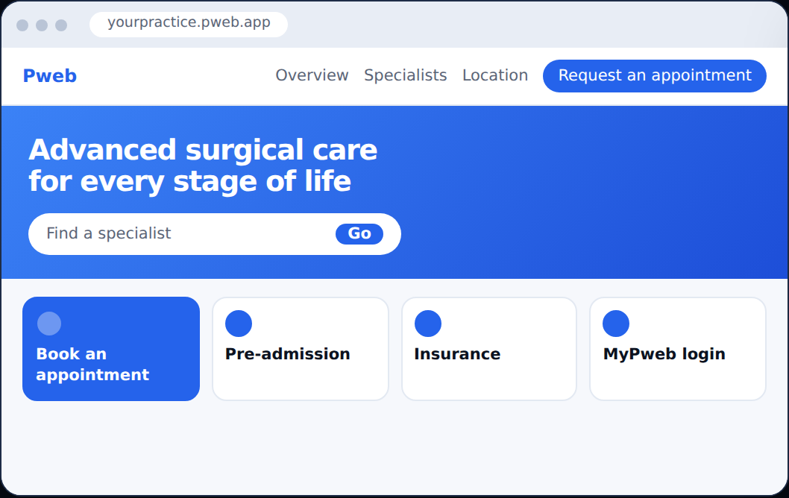

Page 2: Find a specialist
Filter by specialty and see next available times on each card.
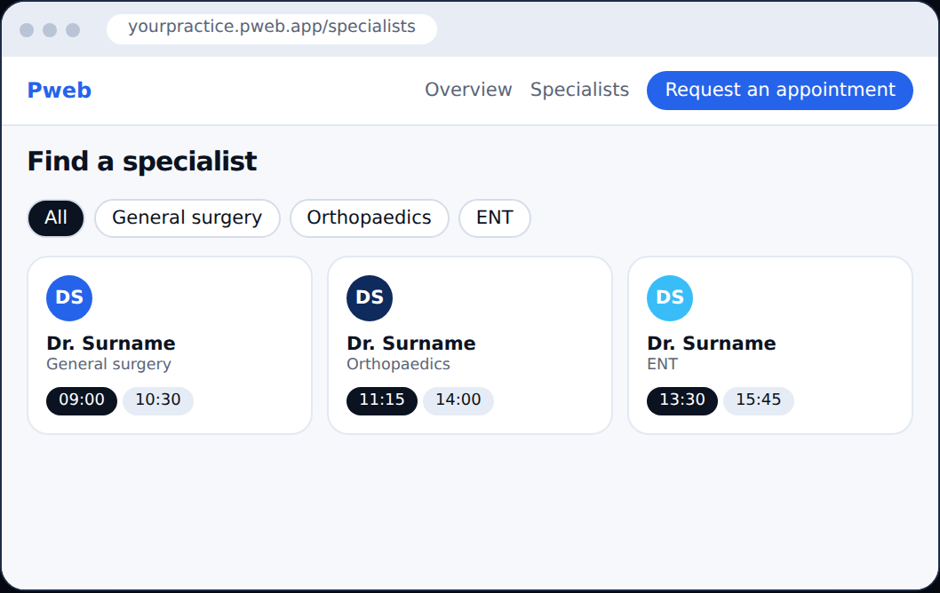

Page 3: Book an appointment
Three simple steps with a live summary. The most important page to get right.
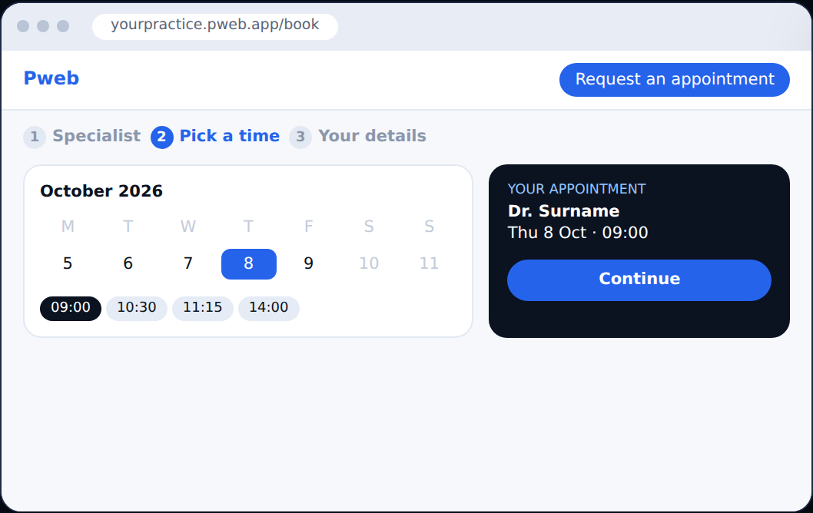

Page 4: Confirmation
Reassure the patient and tell them what to bring.
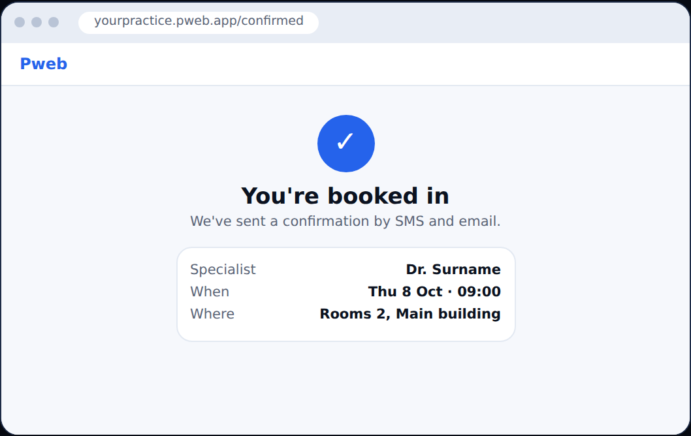

Page 5: My dashboard
Upcoming visits, forms to finish, reschedule and cancel in one place.
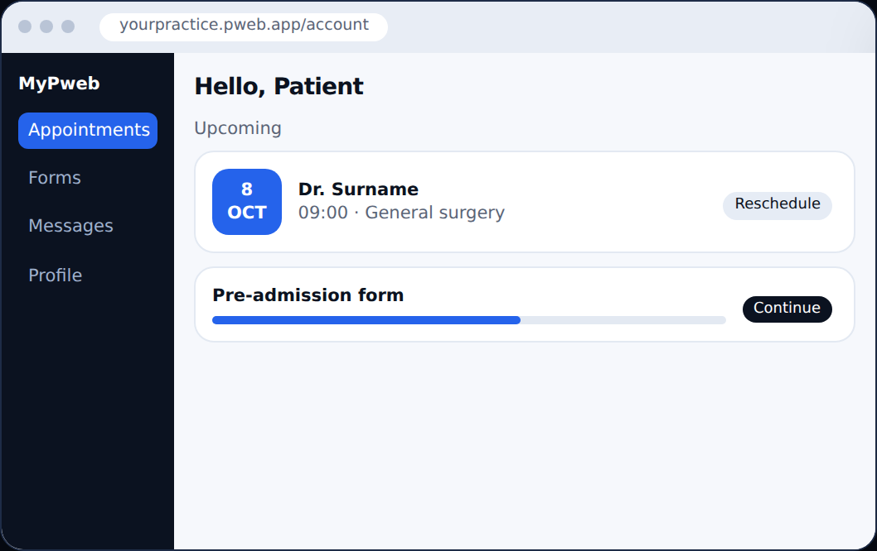

Page 6: Reception calendar
One column per specialist. Drag to move, colour shows the type of visit.
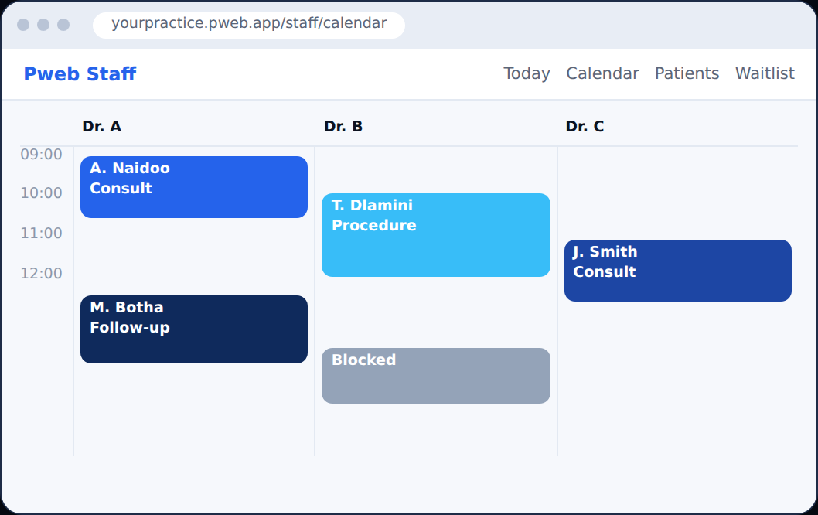

Page 7: Branding admin
Each practice sets its own name, logo and colour and sees a live preview. This is your selling point.
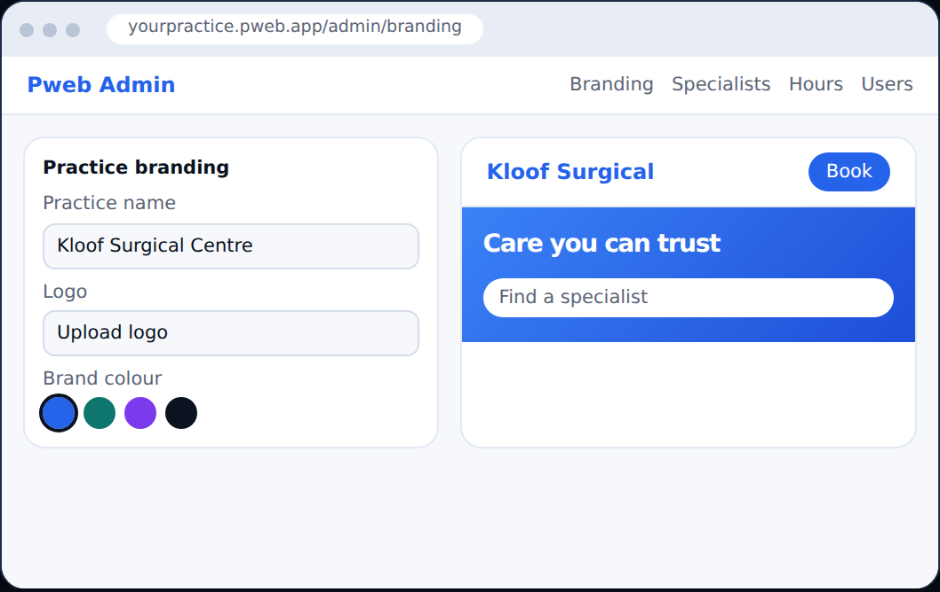

8. Full page list
Four areas: what patients see, what reception sees, what specialists see, and what practice admins and you control.

8.1 Patient-facing pages (public site per practice)
Page | Purpose and key content
Home | Hero ("Advanced surgical care for every stage of life"), quick actions, emergency number, trust signals.
Find a specialist | Search and filter by name, specialty or location. Cards show photo, specialty and next available times.
Specialist profile | Bio, qualifications, services, rooms, availability preview, Book button.
Book appointment | 3-step flow: choose specialist and service, pick a time, enter details and consent. Slot is held for a few minutes.
Booking confirmation | Summary, add-to-calendar, directions, what to bring, SMS and email sent.
Pre-admission forms | Secure forms for history, medication and consent, saved as progress is made. Reception sees completion status.
Login and register (MyPweb Online) | Email or phone sign-in with one-time code. Optional password.
My dashboard | Upcoming and past appointments, reschedule, cancel, forms to complete, messages.
Insurance | Plain information first, quote request later. Do not sell insurance in version 1.
Locations and contact | Map, hours, parking, accessibility, phone and emergency instructions.
About and careers | Practice story, team, open roles.
Privacy and terms | Privacy policy, consent wording, cookie notice, how patient data is used.

8.2 Reception and staff pages
Page | Purpose and key content
Today dashboard | Day calendar by specialist, arrivals, no-shows, quick actions.
Calendar | Day, week and month views. Drag to reschedule. Colour by status.
New booking (phone) | Fast form for bookings taken by phone or in person, using the same availability rules.
Appointment detail | Patient contact, status, forms completed, notes, history of changes.
Patients | Search with minimal visible fields. Every view is logged.
Waitlist | Patients wanting earlier times. Offer freed slots by SMS.
Messages and reminders | Template editor, send log, delivery status.

8.3 Specialist pages
Page | Purpose and key content
My schedule | Their own appointments, patient forms, notes.
Availability | Working hours, theatre days, leave, blocked time, slot length per service.

8.4 Practice admin and platform pages
Page | Purpose and key content
Branding | Logo, colours, practice name, home page text and slides.
Specialists and services | Add or edit specialists, specialties, services, durations and rooms.
Hours and holidays | Opening hours, public holidays, closures.
Users and roles | Invite staff, set role, deactivate.
Reports | Bookings, no-show rate, busiest days, reminder performance.
Audit log | Who viewed or changed what, exportable.
Platform: practices | Create a practice, set subdomain and plan, status.
Platform: billing and support | Subscriptions, invoices, support tools with logged access, uptime status.

9. Client view: patient booking experience
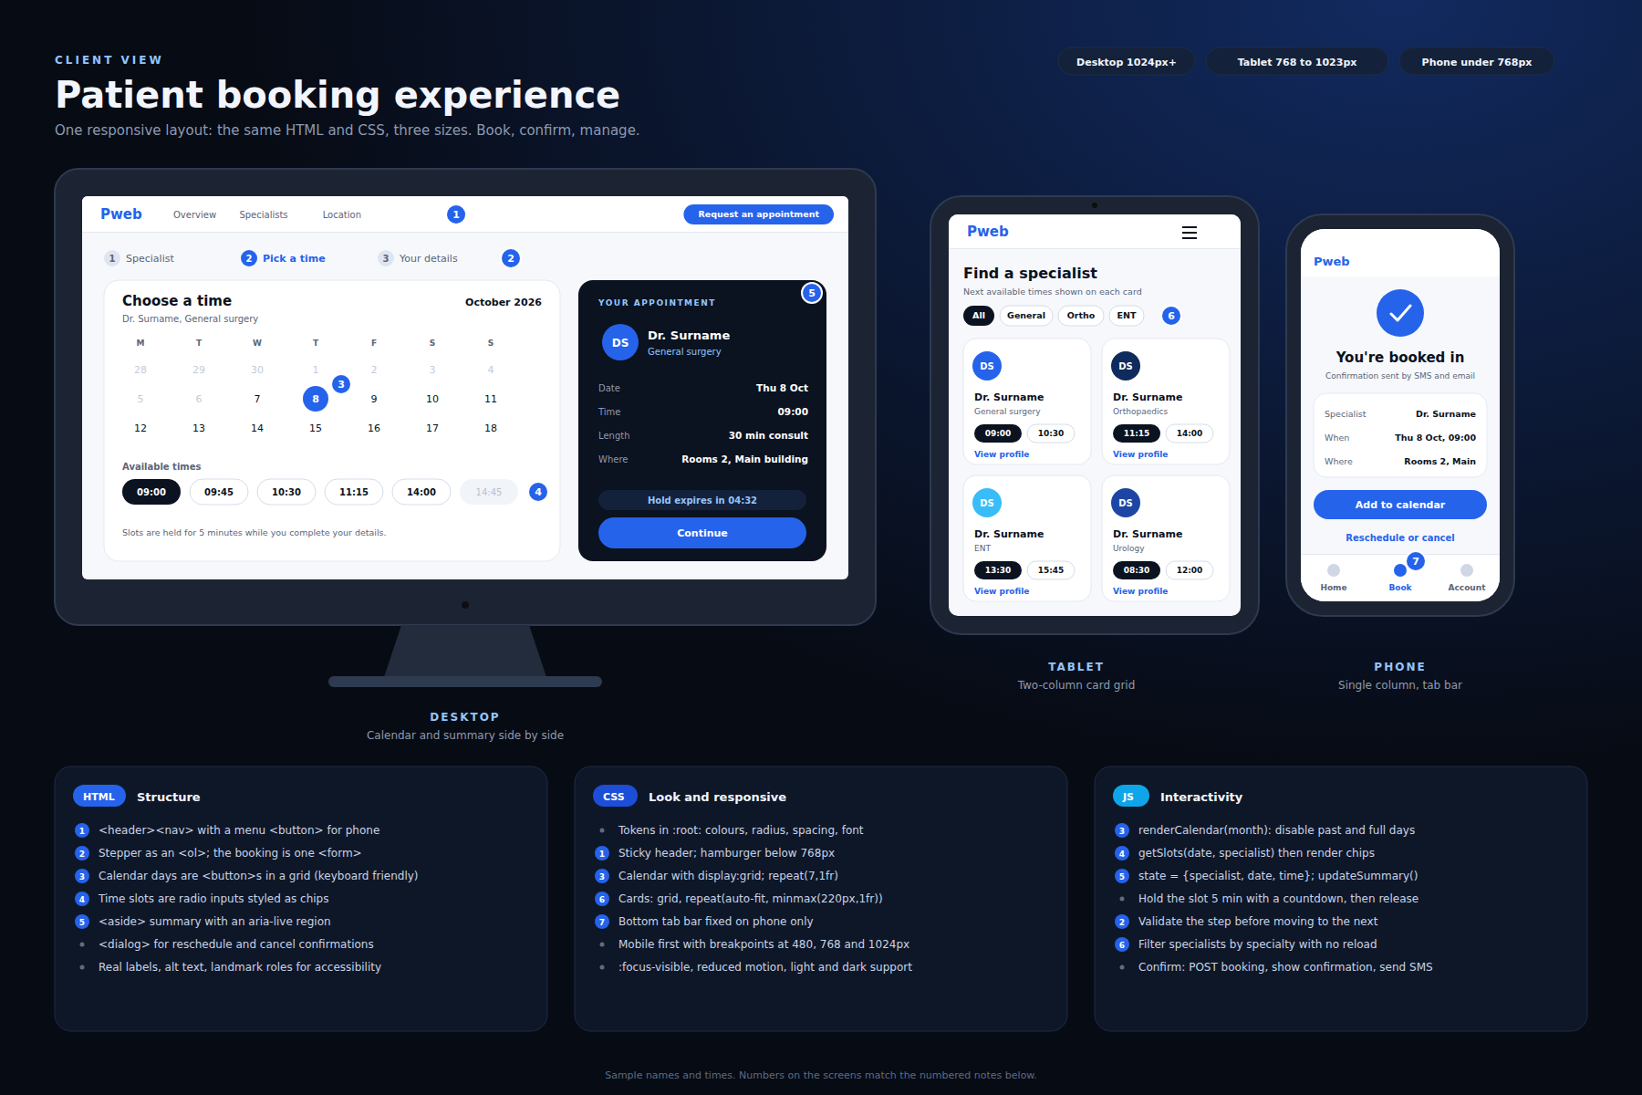

10. Admin view: reception and practice control
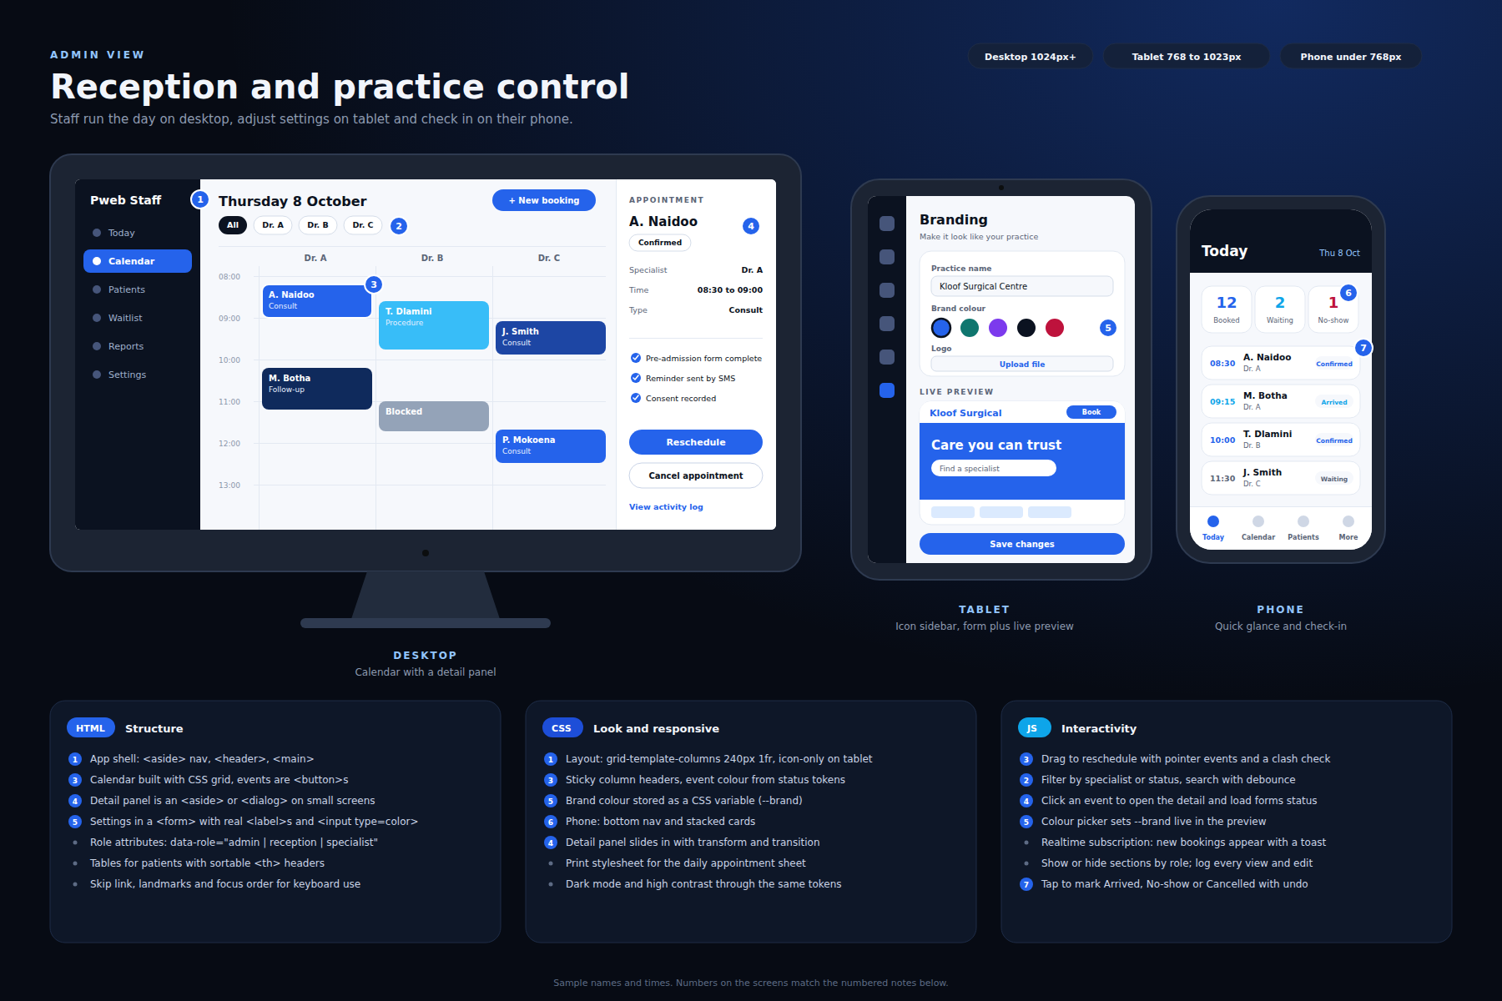

11. Security and liability basics
Hosting platforms protect the building, not what you put in it. They secure the data centres, servers and network, and usually encrypt data at rest. You still own your code, your logins and what you choose to store.
- HTTPS everywhere, encryption at rest, and a database never open to the public internet.
- Row-level security so each practice only sees its own rows.
- Multi-factor sign-in for every staff account, using the provider auth and not your own password code.
- Least access by role, with your own admin access logged.
- Store as little as possible: collect only what a booking needs and keep clinical notes out of version 1.
- No secrets in code, regular dependency updates, automated backups and a tested restore.
- Rate-limit logins and booking requests, and keep an audit log.

When to bring in a professional
- Before real patient data goes in: an independent security review of your setup.
- Before the second or third practice: a penetration test.
- When a practice or insurer asks for proof: a security questionnaire or certification such as SOC 2 or ISO 27001, usually later.
- After any incident: you need a plan for who to call and how to notify patients and the regulator.

Protecting yourself
- Set up a company (a Pty Ltd in South Africa) so claims are aimed at the business. Check with an accountant or lawyer.
- Sign an operator agreement with each practice: the practice is normally the responsible party and you are the operator.
- Limit liability in your contract, drafted by a lawyer.
- Keep a breach plan. Prompt, honest reporting counts in your favour.
- Consider cyber liability insurance once you have paying practices.
Being breached despite taking reasonable care is not itself a crime. The realistic risks are regulator action, civil claims, contract loss and reputation. I am not a lawyer, so spend an hour with one who knows POPIA before the first real patient is on the system.

12. Compliance and trust
This is health data, so compliance matters as much as features. If you target South Africa, POPIA applies and health information is special personal information. Other regions bring GDPR or HIPAA.
- Explicit patient consent captured and stored with a timestamp.
- Encryption in transit and at rest, strong access control, multi-factor sign-in for staff.
- Access and change logs, data retention and deletion rules.
- Decide where data is hosted and document it.
- A data processing (operator) agreement with each practice.
- A written breach response plan and backups that are tested.

13. Business and rollout
- Run a pilot with one friendly surgery, free or discounted, in exchange for weekly feedback.
- Price as a flat monthly fee per practice, with setup help included at first.
- Sales are local and relationship based. Let the pilot practice refer you.
- Plan for support and uptime. Once reception depends on it, outages matter.
- Keep a clear scope in the agreement so custom requests do not swamp you.

14. Roadmap
Phase | Goal | Outcome | Time
0. Discover | Interview 3 to 5 practices | Confirmed pain points and a pilot partner | 2 weeks
1. Prototype | Clickable booking flow using your template | Feedback from reception and patients | 3 to 4 weeks
2. MVP | Booking, calendars, reminders, reception dashboard, branding | Pilot practice live with real bookings | 6 to 8 weeks
3. Harden | Audit log, backups, role checks, legal review | Safe to onboard more practices | 4 weeks
4. Grow | Pre-admission forms, payments, reports, custom domains | Second and third practice, recurring revenue | Ongoing
Timeframes are rough estimates for one developer and will change once scope is confirmed.

15. Next steps this week
- Pick 3 surgeries to interview and book the conversations.
- Choose the pilot candidate and agree what success looks like.
- Turn the current template pages into a clickable prototype.
- Sketch the database tables: practices, specialists, services, availability, appointments, patients, users.
- Speak to a lawyer about POPIA and the practice agreement.
- Sketch each role landing screen on paper before building.

