HW8 Patrick Neyland

Patrick Neyland

2022-10-27

## Question 1

Positive bias if you drop risk tolerance

## Question 2

### Part i

model1_1 <- lm(wage ~ educ + exper + tenure, data = wage1)  
res_model1_1 <- resid(model1_1)  
hist(res_model1_1, breaks = 20)

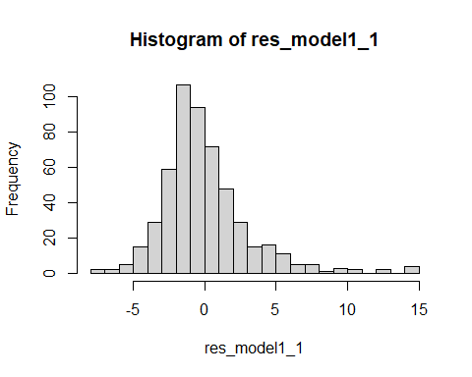

### Part ii

model1_2 <- lm(log(wage) ~ educ + exper + tenure, data = wage1)  
res_model1_2 <- resid(model1_2)  
hist(res_model1_2, breaks = 20, c = "blue")

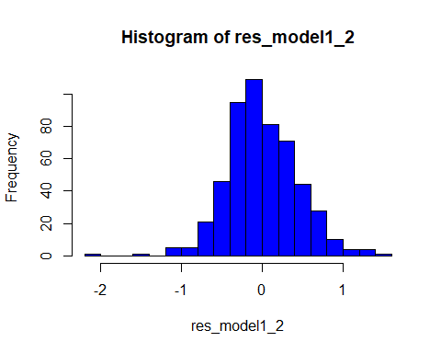

### Part iii

I believe that MLR.6 is closer to being satisfied in the log-level model

## Question 3

### Part i

Logically, the range of scores would be 0 to 100.

range(econmath$score)

## [1] 19.53 98.44

In the sample, the scores range form 19.53 to 98.44.

### Part ii

reg3_1 <- lm(score ~ colgpa +actmth + acteng, econmath)  
hist(reg3_1$residuals)

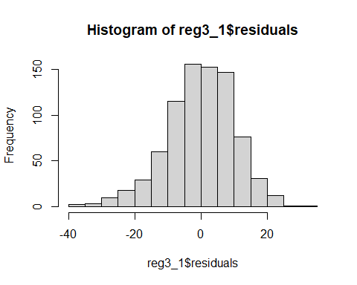 Because the histogram for the residuals is not normally distributed. This means that the t-statistic is not going to have a t distribution.

### Part iii

summary(reg3_1)

##   
## Call:  
## lm(formula = score ~ colgpa + actmth + acteng, data = econmath)  
##   
## Residuals:  
## Min 1Q Median 3Q Max   
## -39.855 -6.215 0.444 6.812 32.670   
##   
## Coefficients:  
## Estimate Std. Error t value Pr(>|t|)   
## (Intercept) 16.17402 2.80044 5.776 1.09e-08 ***  
## colgpa 12.36620 0.71506 17.294 < 2e-16 ***  
## actmth 0.88335 0.11220 7.873 1.11e-14 ***  
## acteng 0.05176 0.11106 0.466 0.641   
## ---  
## Signif. codes: 0 '***' 0.001 '**' 0.01 '*' 0.05 '.' 0.1 ' ' 1  
##   
## Residual standard error: 10.35 on 810 degrees of freedom  
## (42 observations deleted due to missingness)  
## Multiple R-squared: 0.3972, Adjusted R-squared: 0.395   
## F-statistic: 177.9 on 3 and 810 DF, p-value: < 2.2e-16

The t-stat is 0.4684685. The p-value is 0.641. We don’t need MLR.6 if the sample size is large enough. The central limit theorem kicks in and the distribution of the error term does not matter.