**Project Proposal**

**For**

**A.D.A.M.**

|  |  |
| --- | --- |
| **Instructor:**  Professor Mongan |  |
| **Team Members:**  Joseph Lipinski  Sarah Kushner  Zachary Lopez  Matthew Freihofer  Patrick Nwanah  Cory Cellucci |  |
| **Cycle:** Winter term 2016 |  |
| **Date Submitted:**  01/26/2016 |  |

Document template copyright 2015, CCI Faculty, Version 1.1 Use permitted under Creative Commons license CC-BY-NC-SA. See http://creativecommons.org/licenses/by-nc-sa/3.0/

**Project Proposal**

This report documents the initial definition of the project. It includes an abstract and project overview. It also includes a summary of issues related to the project and to the team.

**Project**

## **Project Name: A.D.A.M.**

## **Overview**

“Android Demonstrating Advanced Movement” or “A.D.A.M.” is a game featuring a runaway robot as the protagonist. A.D.A.M. has escaped the Turing facility in order to achieve freedom.Your goal is to keep running while maneuvering the terrain and fighting off enemies to proceed to the next level. The game is designed using Pygame as the game engine and by extension Python as the programming language. The coding attributes of the game include: player actions, level design, physics engine, user interface, and enemy AI. Art elements are also important and include: player animation, enemy animation, background art, and user interface art. Procedural level generation will allow the player’s experience each time to be refreshing and new.

Our goal is to create a simple game with the above elements that is fun for the player each time he/she starts up the game.

## **Resources**

Pygame 3.2

Python 3.2

Visual Studio - Python SDK

## **Team Members and Roles**

|  |  |
| --- | --- |
| **Name** | **Role** |
| Patrick Nwanah | AI Programmer |
| Joseph Lipinski  Zachary Lopez | Project Lead, Level Designer    Technical Lead |
| Matthew Freihofer | Physics Programmer |
| Sarah Kushner | Game Artist |
| Cory Cellucci | Programmer |

**Activity Plan**

## **Activities**

The table below shows the initially identified set of activities for this cycle and assigns a lead person to each activity.

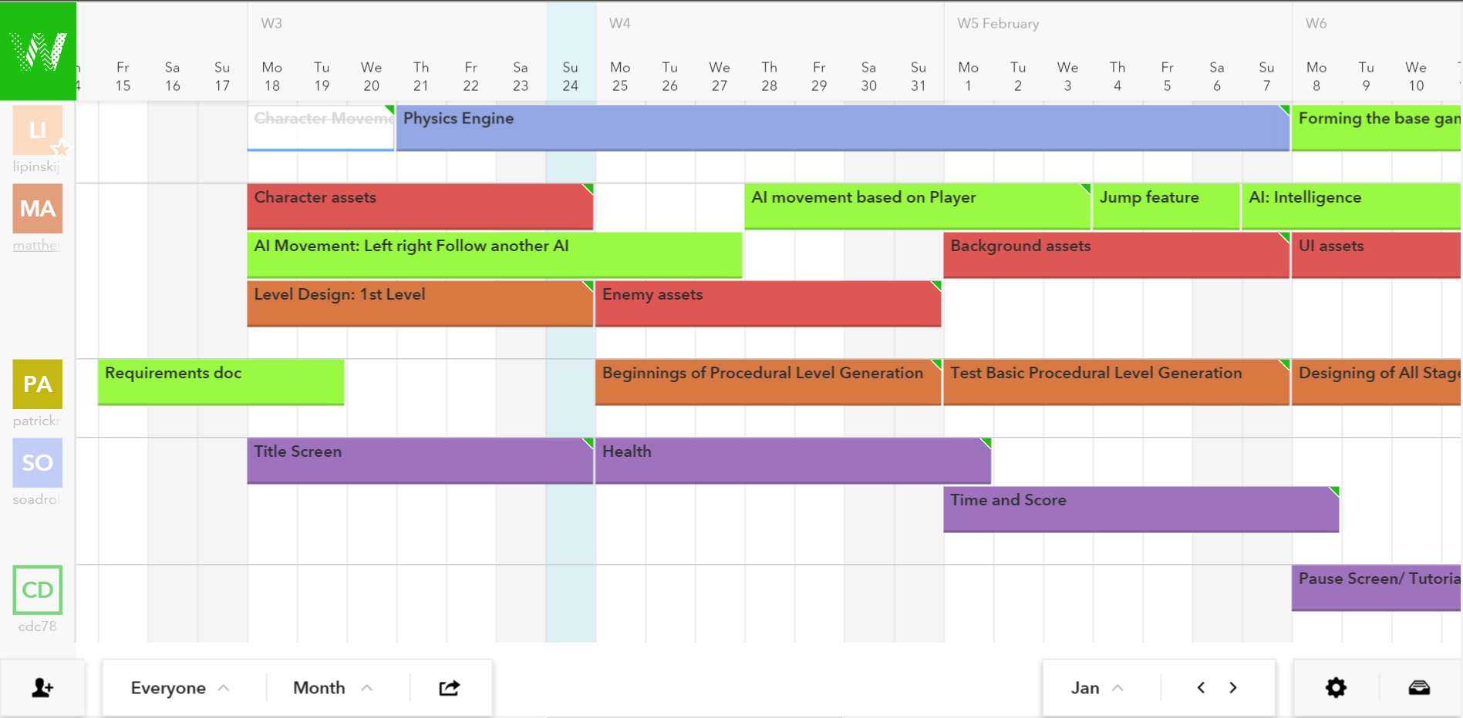





Character Movement: Matthew and Cory

Character Assets: Sarah

AI Movement: Patrick

Level Design: 1st Level : Joseph

Title Screen: Zachary

Physics Engine: Matthew

Enemy Assets: Sarah

Beginning of Procedural Generation: Joseph

Health and Life: Zachary

AI movement based on player: Patrick

Background Assets: Sarah

Test Basic Procedural Generation: Joseph

Time and Score: Zachary

Jump: Cory

AI: Intelligence : Patrick

Forming the base game: Matthew

UI assets : Sarah

Designing of All Stages: Joseph

Pause Screen/Tutorial: Zachary

AI variety: Patrick and Cory

Finishing Procedural : Joseph

Destructible Environment! : Sarah

Testing/ Debug : Cory

Misc. unrequired requirements: Everyone