**LABs SCREENSHOTS**

**Course: Hybrid Cloud Infrastructure Foundations with Anthos**

**Module**: Managing Hybrid Clusters using Kubernetes Engine

AHYBRID020 Managing Hybrid Clusters using Kubernetes Engine

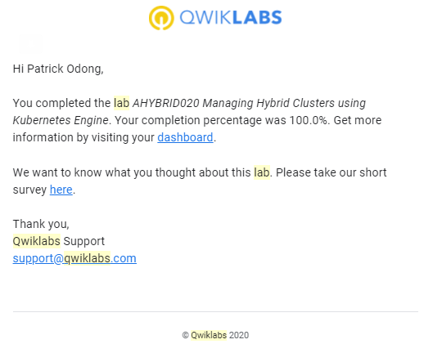

**Module**: Introduction to Service Mesh

AHYBRID035 Installing Anthos Service Mesh on Google Kubernetes Engine

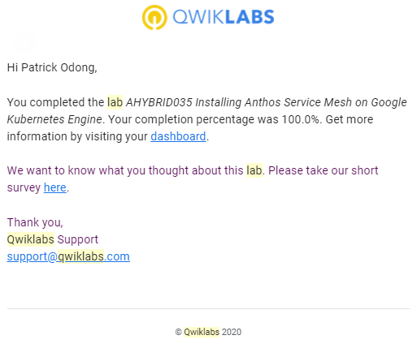

**Course: Getting Started With Application Development on Google Cloud**

**Module**: Google Cloud Client Libraries, Google Cloud SDK, and Google Firebase SDK

App Dev: Setting up a Development Environment v1.1

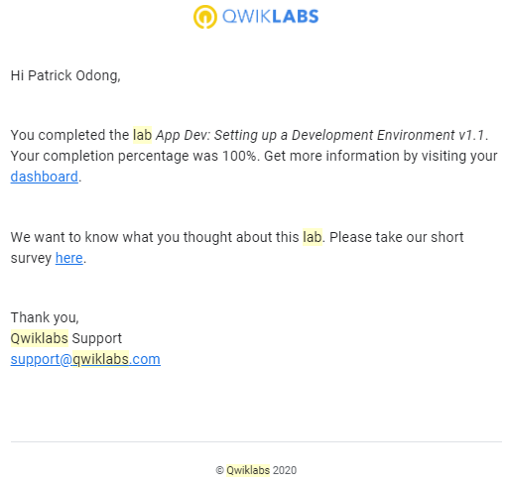

**Module**: Best Practices for Using Cloud Datastore

App Dev: Storing Application Data in Cloud Datastore v1.1

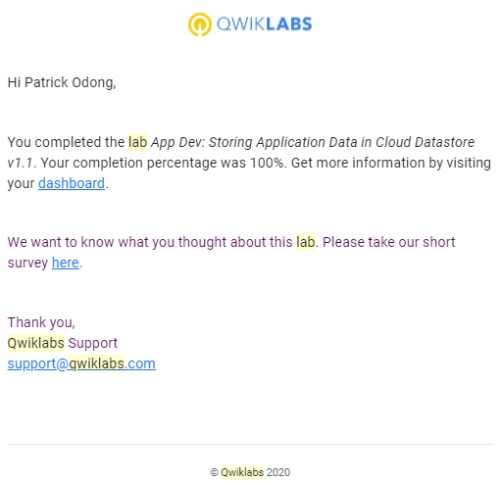

**Course: Google Cloud Platform Fundamentals - Core Infrastructure**

**Module**: Getting Started with Google Cloud Platform

GCP Fundamentals: Getting Started with Cloud Marketplace -

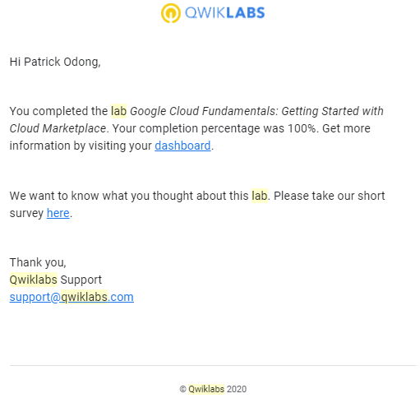

**Module**: Getting Started with Google Cloud Platform

GCP Fundamentals: Getting Started with Compute Engine -

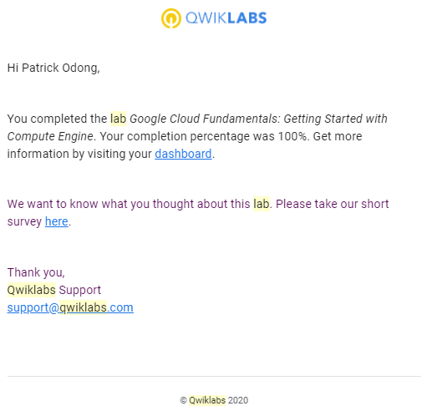

**Module**: Storage in the Cloud

GCP Fundamentals: Getting Started with Cloud Storage and Cloud SQL -

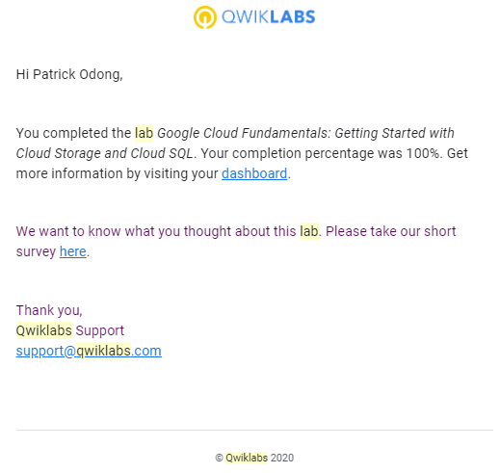

**Module**: Containers in the Cloud

GCP Fundamentals: Getting Started with Kubernetes Engine -

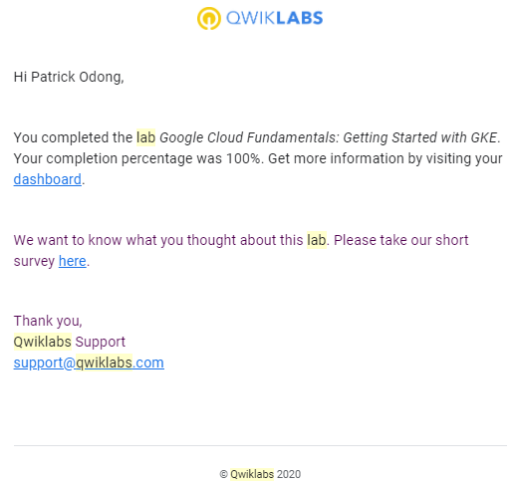

**Module**: Applications in the Cloud

GCP Fundamentals: Getting Started with App Engine -

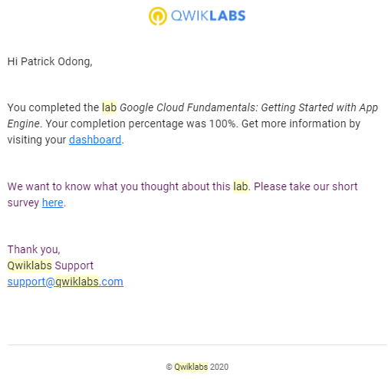

**Module**: Developing, Deploying and Monitoring in the Cloud

GCP Fundamentals: Getting Started with Deployment Manager and Stackdriver -

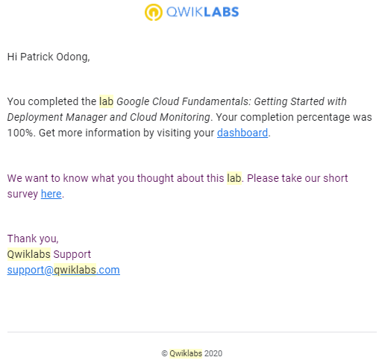

**Module**: Big Data and Machine Learning in the Cloud

GCP Fundamentals: Getting Started with BigQuery -

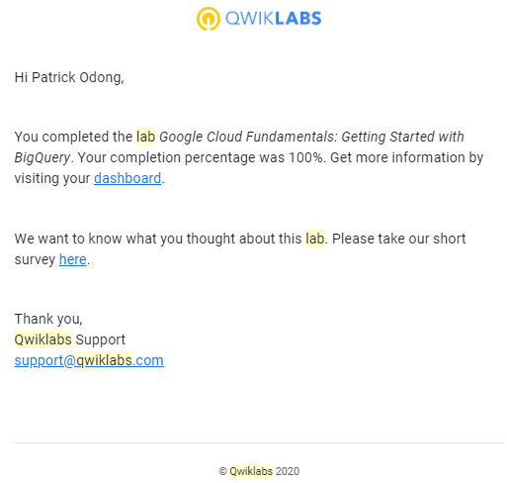

**Course: Essential Google Cloud Infrastructure: Foundation**

**Module**: Introduction to Google Cloud

Console and Cloud Shell -

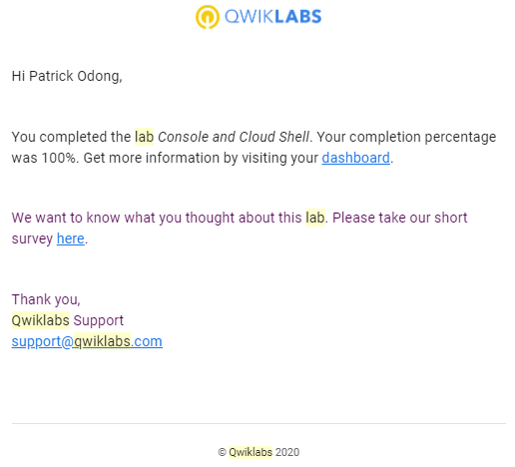

**Module**: Introduction to Google Cloud

Infrastructure Preview

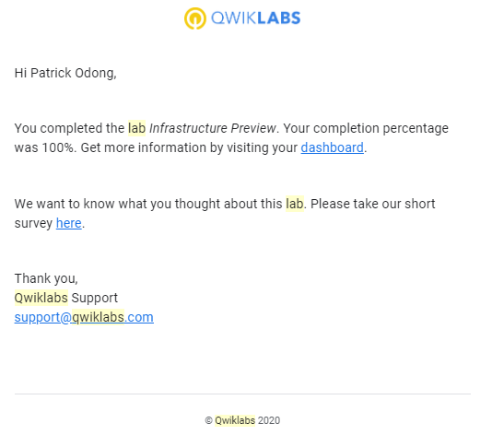

**Module**: Virtual Machines

Working with Virtual Machines

