Contact Database using CoreData and UITableView

1. Create a new single view project & make sure Coredata is checked, Universal, Swift
2. Name Project: MyContacts > Next > Save to Desktop

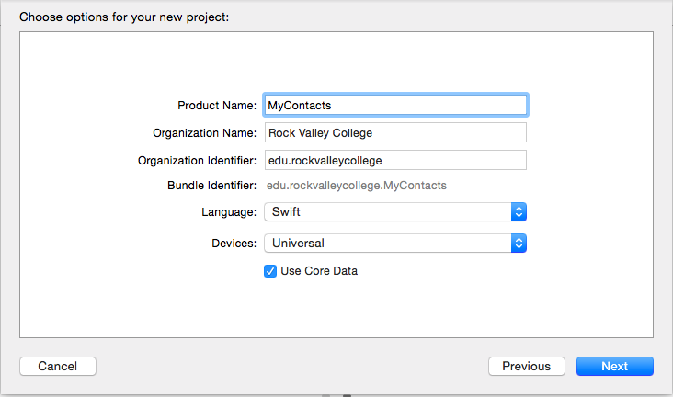

1. Uncheck ALL but “Portrait Orientation” under Device Orientation
2. Click on CoreData Model “MyContacts.xcdatamodeld”
   1. Click **Add Entity +** and create one named **Contact**
   2. Click **+** Attributes and add below (Must start with lowercase)
      1. email Type:STRING
      2. fullname Type:STRING
      3. phone Type: STRING
3. Create NSManaged SubClass
   1. While in Entities click on **Editor** > **Create NSManagedObject Subclass**..
   2. Select Data Model **MyContact > Next**
   3. Select Entities **Contact > Next > Create**
   4. Should see a new file: **Contact.swift** This is the class for the database
4. Place objects on ViewController
   1. Click on storyboard file
   2. Place below objects on ViewController

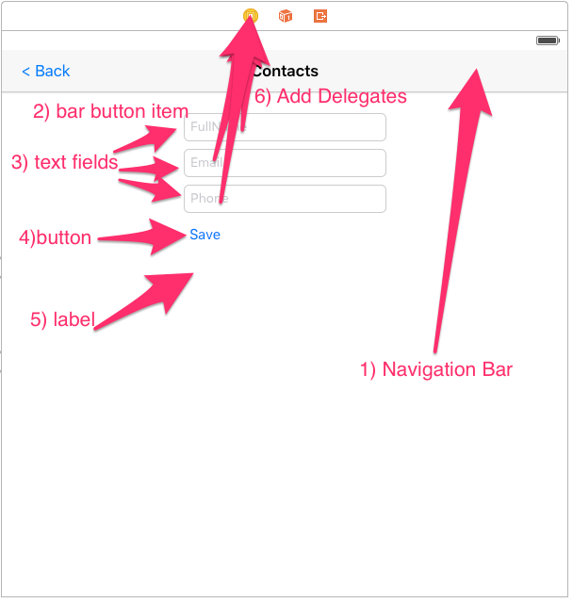

1. Bind Objects to code
   1. Outlets
      1. fullname
      2. email
      3. phone
      4. btnSave
      5. status
   2. Actions
      1. btnSave
      2. btnBack
   3. Delegates from View Controller (Control + Drag to ViewController)
      1. fullname
      2. email
      3. phone
2. Use Placeholder property of textfields to add FullName, Email, Phone
3. Add UITableViewController
   1. Select UITableViewController > Editor > Embed In > Navigation Controller
   2. Select Navigation Controller > Attributes Inspector
      1. Title: My Contacts
      2. Check (Is initial View Controller)
   3. Add **Bar Button Item**
      1. Style: **Bordered**
      2. Identifier: **Add**
      3. **CNTRL + Drag to View Controller > Present Modally**
   4. Select  **Table View Cell** 
      1. Style: **Right Detail**
      2. Identifier: **Cell**
      3. **CNTRL + Drag Table** View Cell to **View Controller > Present Modally**
      4. **Click  > Storyboard Segue Identifier:** UpdateContacts  
         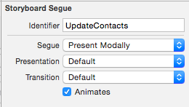
   5. Select **Navigation Item** 
      1. Title: **My Contacts**
   6. Save: Command + S
4. Add UITableViewClass and Bind to TableView
   1. Right-Click on ProjectName
   2. Select **New File**
   3. **iOS Source > Cocoa Touch Class > Next**
   4. **SubClass:** UITableViewController**, Class:** ContactTableViewController
   5. **Next** > **Create**
   6. Click on StoryBoard **> UITableView**
   7. Select **Identity Inspector** > Class: > Select **ContactTableViewController**
5. Code for **ViewController.** See [code](https://github.com/ioscourse/MyContacts/blob/master/ViewController.swift.txt)
6. Code for **ContactTableViewController.** See [code](https://github.com/ioscourse/MyContacts/blob/master/ContactTableViewController.swift.txt)
7. Auto Resize Objects
   1. Select StoryBoard
   2. Select Top Part of ViewController and ContactTableViewControler
   3. **Editor** > **Resolve AutoLayout Issues** > **Reset to Suggested Constraints**
8. **Test**
   1. Add: clicking + symbol to add contact
   2. Update: clicking existing table row > Edit > Update
   3. Delete: Swipe left on table row and delete