Components of yield protocol:

Components of yield (COY) is a term used to refer to budbreak percentage and flower numbers in spring. The metrics derived from the information can be used to compare flower production between seasons, and help with forecasting labour requirements for flower thinning etc., to achieve a desired crop load.

COY is typically measured after shoot growth has proceeded to a point where it is easy to count flowers (see photo below), but flowers have not yet begun to open, generally early-mid October in Gold3 (approx. 4 weeks after budbreak).

The standard methodology is to work in either pairs or solo. When working in pairs, one person is assessing the monitored/tagged canes (assessor), and one person is recording the string of data on a PDA (recorder). When starting to assess a new cane, the assessor calls out the cane ID (e.g. 322), which is confirmed by the recorder as the correct cane to be on. It is standard protocol for the recorder to begin the string with a comma (,) to ensure that the string is stored as text. The assessor then starts at the distal end of the cane, and begins calling out king flower numbers for each shoot, proceeding down to the base of the cane. The assessor is also simultaneously tallying total number of lateral flowers on the cane, using a tally counter.

Assessor call-outs are as follows:

“dot” (.) = a winter bud which has not burst

0 = a shoot with no flowers

1 = a shoot with 1 king flower

2 = a shoot with 2 king flowers

…

9 = a shoot with 9 king flowers.

N.B. This notation system is only able to assign a maximum of 9 king flowers to a shoot. This is acceptable for Hayward and Gold3, but may not be for more flower cultivars. In the rare cases of a shoot having more than 9 flowers, the additional flowers are added to the count of the next floral shoot.

When the assessor reaches the basal end of the cane, there will be several buds with fruit stalks attached, but some stalks may have broken off. These buds, or any buds more basal than these should not be counted in the assessment. Upon reaching the end of the cane, the assessor will call out “L” – followed by a number, which is the total number of tallied laterals.

An example of a COY string:

|  |  |
| --- | --- |
| Cane 322 | ,0.0574250.240.6.5.00347.21.6L23 |

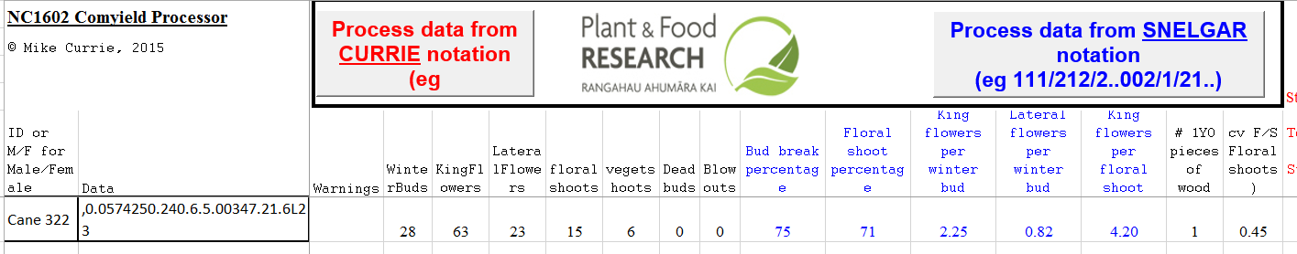

The COY processing macro (above) counts and calculates several metrics from these strings.

WinterBuds = count of characters between the “,” and “L”, e.g. = 28.

KingFlowers = sum of integers between the “,” and “L”, e.g. = 63

LateralFlowers = face value of the string after the “L” e.g. = 23

floralshoots = count of all characters between the “,” and “L”, except 0 and “.” e.g. = 15

vegetshoots = count of 0’s between the “,” and “L” e.g. = 6

Dead buds and blow outs are probably defined by other characters, we’ve never used them.

The following COY metrics are then calculated:

Budbreak percentage = (floralshoots+vegetshoots)/WinterBuds e.g. (15+6)/28 = 75%

Floral shoot percentage = floralshoots/(floralshoots+vegetshoots) e.g. 15/(15+6) = 71%

King flowers per winter bud (KFWB) = KingFlowers/WinterBuds e.g. 63/28 = 2.25

Lateral flowers per winter bud (LFWB) = LateralFlowers/WinterBuds e.g. 23/28 = 0.82

King flowers per floral shoot (KFFS) = KingFlowers/floralshoots e.g. 63/15 = 4.2

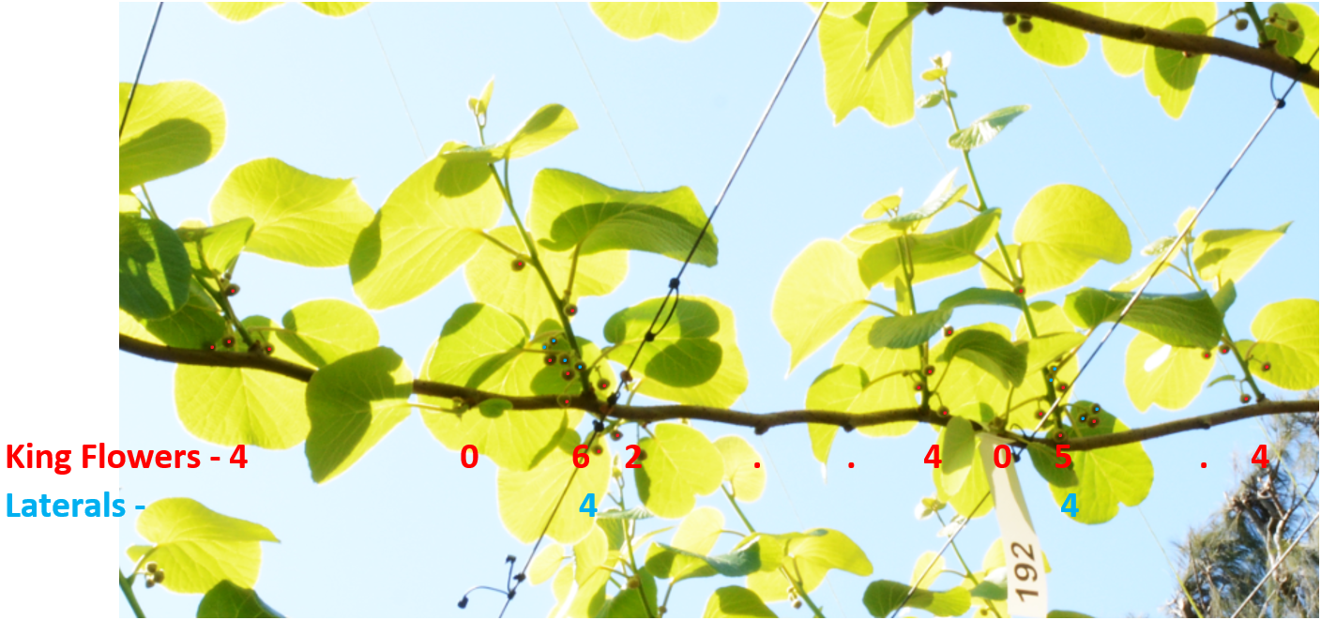

Example of a “monitor cane” with ID tag. The distal end of the cane is out of shot on the left, and the leader/cordon is out of shot on the right. A COY string from this section of cane only would read: ,4062..405L8