WKU Smart Parking
Patrick O’Boyle
Documentation

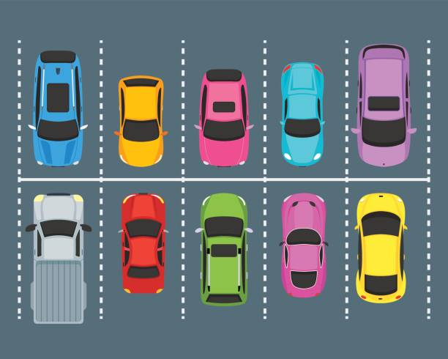

22 May 2019

Table of Contents
SYSTEM & PROGRAM DESIGN 4
Behavioral Diagrams 4
Structural Diagrams 10
Object-Oriented Design Patterns 11
APPENDIX 12

SYSTEM & PROGRAM DESIGN

Behavioral Diagrams
It is important to define what the proposed system should do before beginning implementation. This ensures that all the listed technical requirements are met so that external actors, such as users or other software, receive what is expected.

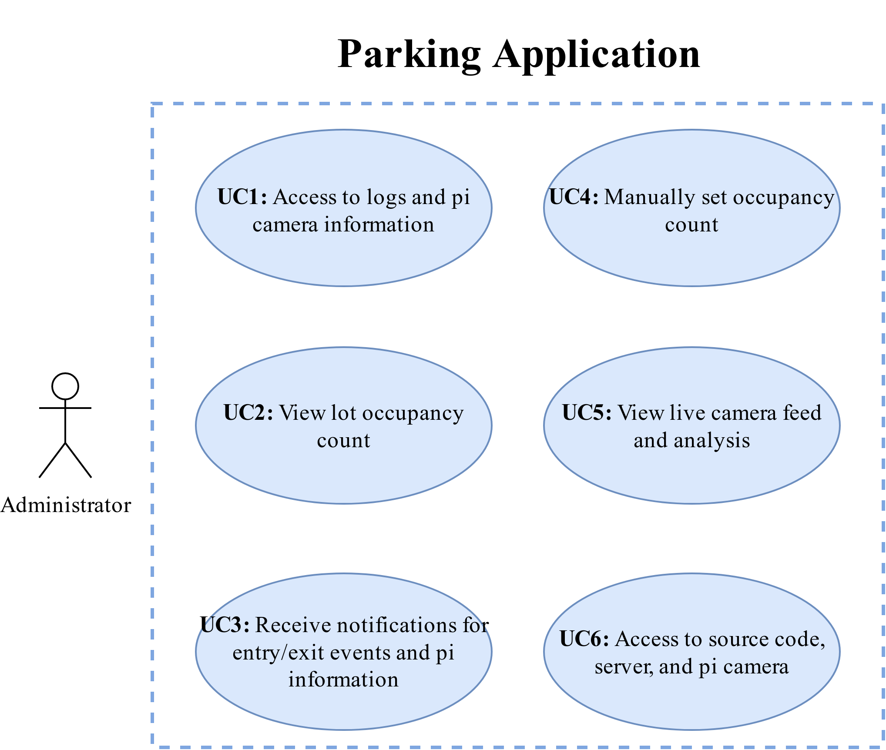Figure 1: Use Case Diagram
Figure 1 demonstrates how the parking application will be used by the administrator. The external actors (the admin) are connected to use cases #1-6 by arrows to illustrate how each actor uses the software.

Requirements |  | UC1 | UC2 | UC3 | UC4 | UC5
Requirements | R1.1 |  |  |  |  | X
Requirements | R1.2 |  |  |  |  | X
Requirements | R1.3 |  |  |  |  | X
Requirements | R1.4 |  |  |  |  | X
Requirements | R1.5 |  |  |  |  | X
Requirements | R1.6 |  | X |  |  | X
Requirements | R1.7 |  |  |  | X
Requirements | R1.8 |  | X
Requirements | R1.9 | X |  |  |  | X
Requirements | R2.1 | X |  |  |  | X
Requirements | R2.2 | X |  |  |  | X
Requirements | R2.3 | X |  | X
Requirements | R2.4 |  |  | X
Table 1: Requirements Tracing

Table 1 maps technical requirements to use cases to ensure that the requirements will be met. R1.1-1.9 are from the Counting Program’s technical requirements. R2.1-2.4 are from the Pi Camera’s technical requirements. This information can be found in the requirements section of the Feasibility Report.

Tables 2 and 3 outline primary and secondary scenarios for each use case. Primary scenarios are how the intended use cases are meant to be carried out. Secondary scenarios list possible errors and exceptions.
Use Case: Camera info and logs | Use Case: View parking lot occupancy count
ID: UC1 | ID: UC2
Actors: Admin | Actors: User (admin can do this in back end)
Preconditions: | Preconditions:
Primary Scenario:  1. A script runs on the Pi periodically. Temperature, bandwidth , time, and voltage are measured and outputted to a log file(s).  2. An automated script using a file transfer protocol sends the logs to the server (workstation).  3. SSH is setup on both the pi and the workstation so the pi can be remotely accessed if more information is needed. | Primary Scenario:  1. A lightweight web server is hosted on the workstation.  2. The user connects to the website using a browser.  3. The count for the parking lot is displayed.
Secondary Scenario:  - Pi runs out of battery power, so logs are not submitted.  - The workstation is not on, so logs are not received. | Secondary Scenario:  - The website is down.  - An incorrect or meaningless count is displayed.
Table 2: Use Cases 1&2 Scenarios

Use Case: Notifications | Use Case: Manually Set Count
ID: UC3 | ID: UC4
Actors: Admin | Actors: Admin
Preconditions: | Preconditions:
Primary Scenario:  1. Whenever an event occurs, an email notification will be sent to the administrator with the updated parking lot occupancy count.  2. If the pi is low on battery and needs charging, an email notification will be sent to the admin. | Primary Scenario:  1. An Event Handler interface available to the server script will handle count data.  2. The admin will be able to enter a positive integer after a key press during video streaming.  3. This integer will set the new count through the Event Handler, updating the current count.
Secondary Scenario:  - The workstation or pi are down.  - False-positive and false-negative events.  - Inaccurate battery level detection due to absence of chip/component for measuring it directly. | Secondary Scenario:  - Pi runs out of battery power, so no streaming is available.  - InvalidCountInput
Table 3: Use Cases 3&4 Scenarios
Use Case: Real-time view
ID: UC5
Actors: Admin
Preconditions:
Primary Scenario:
1. The server and client files are executed.
2. The admin is has access to a window on the server, allowing them to see the live recording of the parking lot.
3. Object detection and tracking (analysis) are shown on the video feed along with the current parking lot occupancy count.
Secondary Scenario:
- No view due to client-side issues (on raspberry pis)
Table 4: Use Case 5 Scenarios

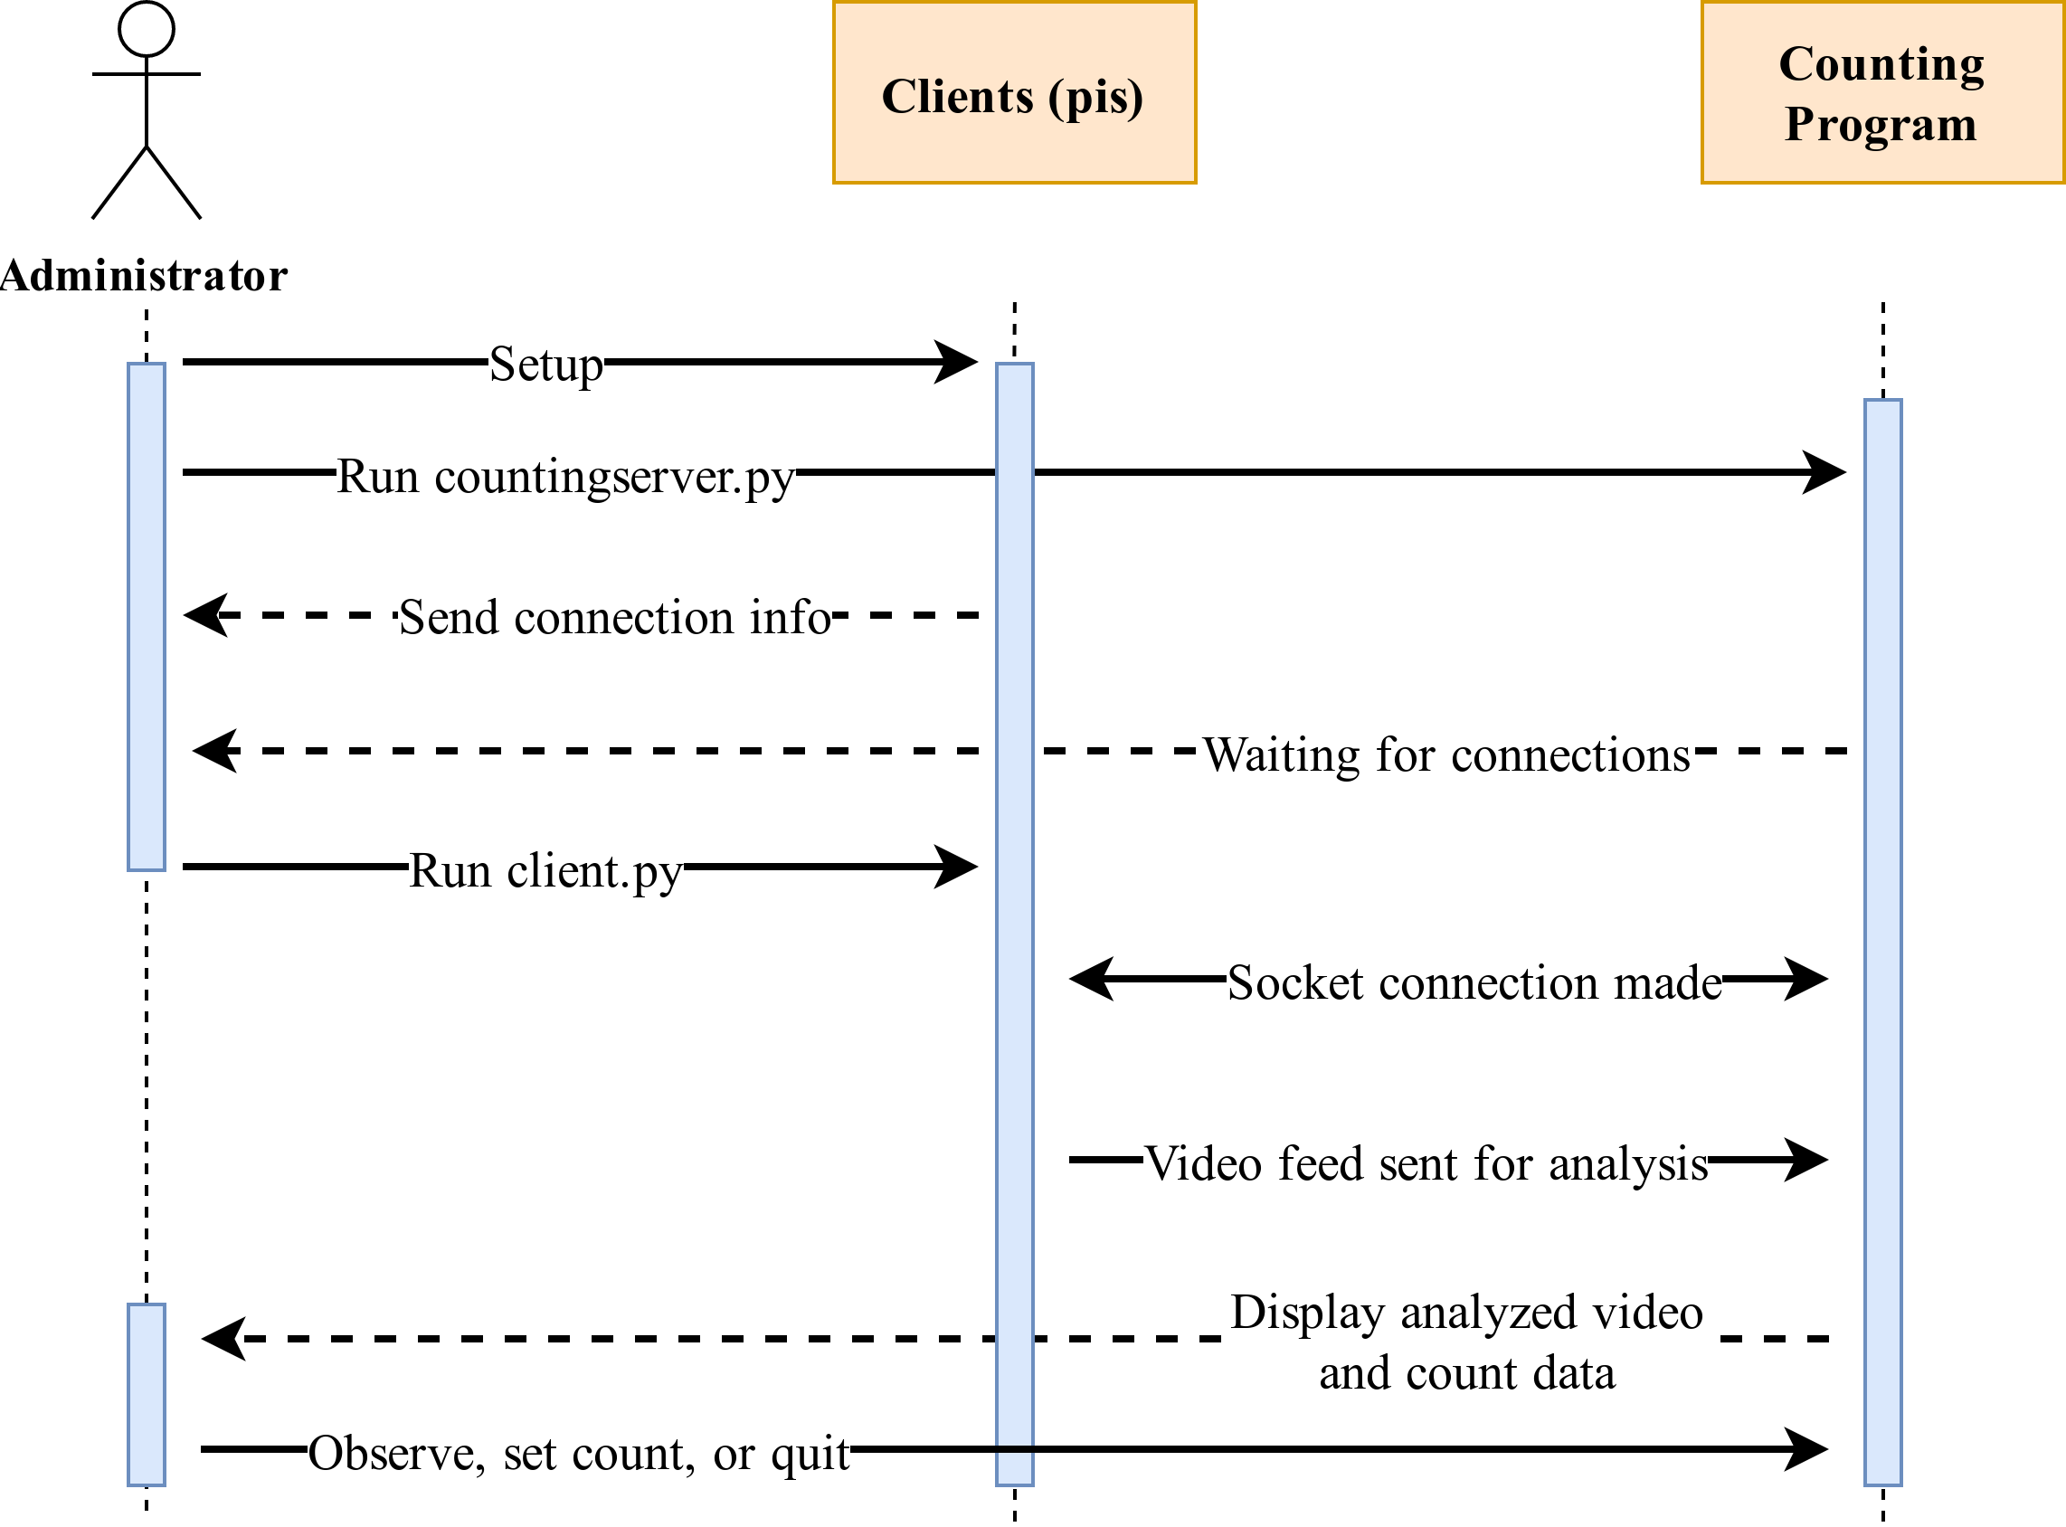Figure 2: Sequence Diagram
Figure 2 shows how the system will operate by detailing the interactions between the different actors and instances.

Structural Diagrams
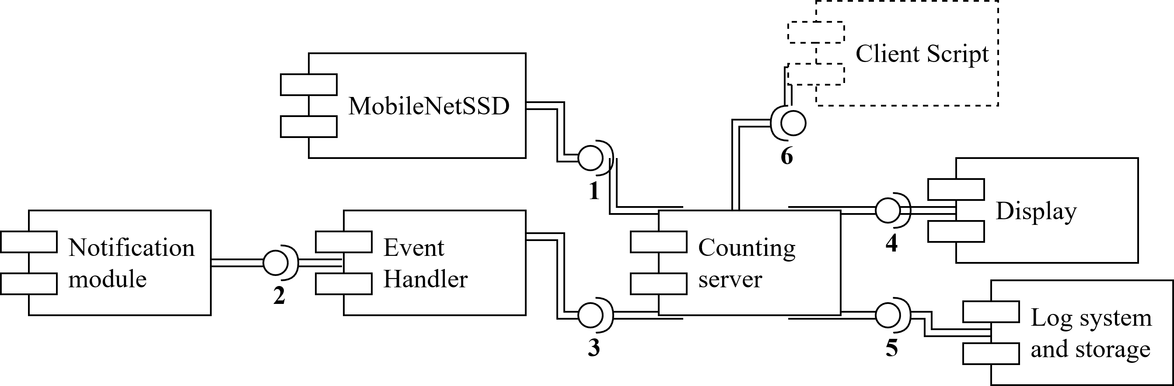Figure 3: Server Component Diagram

Figure 3 displays an overview of the component structure for the software on the workstation/server.
Connections:
1. OpenCV loads the caffe and prototxt files found in the "mobilenetssd" directory to initialize the model used for object detection.
2. The Notification Module is a simple python script that uses Google's SMTP servers to send messages. The Event Handler module uses the notification module to send lot occupancy logs.
3. The Event Handler is integrated into the counting server script to manage lot occupancy data, notifications, and user interaction.
4. Incoming frames from the pi client are displayed along with the timestamp, client name, current vehicle count, vehicle centroids, and the current status (waiting, detecting, or tracking).
5. The Event Handler outputs log data that simple shell scripts organize. Written video footage is organized as well.
6. After establishing a TCP socket connection, the client script sends frames over ZeroMQ to the counting server for analysis.
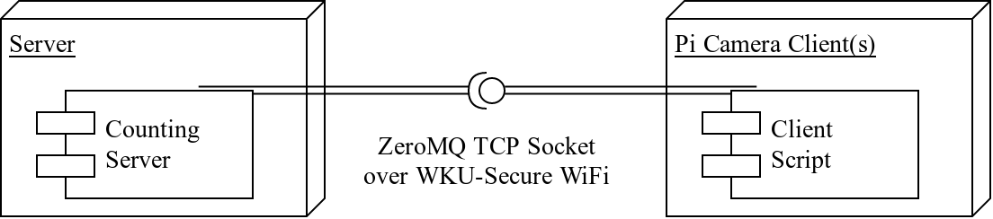Figure 4: Deployment Diagram
Figure 4 provides an overview of the Client/Server architecture for the application. ZeroMQ is ideal for real-time frame transfer because of its low latency and high throughput (new frames arrive quickly). ZeroMQ will be implemented using the ImageZMQ library for ease of use. ImageZMQ, a Python implementation of ZeroMQ, was made for Raspberry Pi computer vision applications using OpenCV. The pi camera client will provide frame data to the Counting Server program over WiFi. The footage will be analyzed to determine parking lot occupancy counts.

Object-Oriented Design Patterns

The Event Handler is the only object-oriented module in the application. The Event Handler will follow the factory pattern and the publish/subscribe pattern. Specific Event Handler instances will be created based on the name of the lot being monitored because each parking lot has its own occupancy data. The Event Handler will also import the Notification Module in order to send emails periodically to notify administrators of occupancy updates.

APPENDIX

Commands are italicized. Example:
cat /etc/passwd

Use raspi-config to setup ssh and the Pi Camera

Pip and virtualenvwrapper are needed for the software. However, Ubuntu and other Debian systems don’t work well with Pip and advise using apt python-<package> instead.
Follow this guide for setting up virtual environments and pip on Debian-based systems:
http://matthew-brett.github.io/pydagogue/installing_on_debian.html
“ParkingProject” and “ParkingClient” were used in this project as environment names on the server and client respectively.
If you follow the guide exactly, your environments will either be in ~/.virtualenvs/ or in a folder you defined.

Now go through the “Configuring your system and installing required packages” and the “Preparing Clients” sections of this guide. Skip the imagezmq cloning part of the first section:
https://www.pyimagesearch.com/2019/04/15/live-video-streaming-over-network-with-opencv-and-imagezmq/

Install dlib and ensure imutils is up to date. Use this guide:
https://www.pyimagesearch.com/2018/08/13/opencv-people-counter/

Pull my code from github:
https://github.com/patricksoboyle/ParkingProject/tree/master

Modify rc.local on raspberry pi to run the send ip script on boot
After setup, running the system:
Get client info and start the server:
- Get the pi’s ip address
  - nc -l 55555 (run this before pi is powered on)
  - The ip will be printed to the terminal after the pi is turned on
- workon <env_name> (the environment you defined that contains the required python libraries)
- Alternatively, source the activate file in the bin of the environment directory
  - Ex: source Envs/ParkingProject/bin/activiate
- python countingserver.py --prototxt MobileNetSSD_deploy.prototxt --model MobileNetSSD_deploy.caffemodel
  - The .prototxt and .caffemodel files may vary in location depending on where you place them
Start the client:
- ssh pi@<pi ip address>
- workon <env_name>
- python client.py -s <counting server ip>

A socket connection should now be established between the client and server over ImageZMQ.
Pressing ‘Q’ on the display will quit and clean up the data. Pressing ‘M’ will allow you to manually enter the current count in the terminal while the program is running.

If there are issues with dependencies when running client.py or countingserver.py run the following as needed:
If you’re having dependency issues, these commands will act as a band-aid, but it indicates that you did not setup the virtual environments correctly.
sudo apt-get install libatlas-base-dev
sudo apt-get update
sudo apt-get install libhdf5-dev
sudo apt-get update
sudo apt-get install libhdf5-serial-dev
sudo apt-get install libilmbase-dev
sudo apt-get install libopenexr-dev
sudo apt-get install libgstreamer1.0-dev
sudo apt-get install libqtgui4:amd64
sudo apt install libqt4-test
python -m pip install --user numpy scipy

If you’re using the wattsup meter for electrical tests:
The software for the meter is in the powerMeterUtility.zip file. Instructions for use are included within it. Make sure the ttyub0 is added to the dialout group, otherwise it won’t work

Testing Folder:
The testinterface script has some automated sysbench and iperf tests that send logs to their respective folders. It contains comments for usage.

