WKU Smart Parking
22 May 2019
Patrick O’Boyle
Feasibility Report

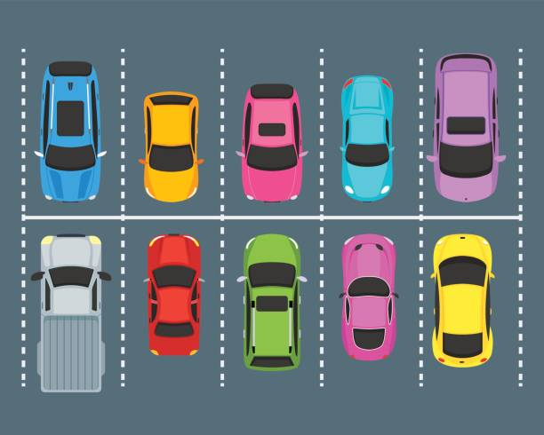

Table of Contents
I. EXECUTIVE SUMMARY 3
II. TECHNICAL REQUIREMENTS 4
III. PROCESS TO BE FOLLOWED 9
IV. RISK ANALYSIS 10
V. SCHEDULE AND TIMELINE 12
VI. COSTS AND BUDGET 13
VIII. STAKEHOLDERS 14
IX. EXISTING MARKET 15
X. SYSTEM & PROGRAM DESIGN 16
XI. CONCLUSIONS AND FUTURE WORK 16

I. EXECUTIVE SUMMARY
The proposed system is intended to help solve parking issues on the Western Kentucky University (WKU) campus by using a computer vision-based approach. A camera will monitor a campus parking lot and transmit the frame data to a server. The server will then process the frame data to identify cars and track their movements to determine if they are entering or exiting the lot. Once entry or exit is determined, the given count of cars in the parking lot will be updated to reflect the current number of cars. In the original proposals, there were plans to integrate the system with WKU’s security camera network and the iWKU app. The security cameras already in place on campus cannot be utilized because they are operated by a third-party company. Integration with the iWKU app is possible but will not be expected for the first prototype. The first prototype of the system will be able to identify cars versus other objects correctly, track their motion, and combine these two principles in order to figure out if an entrance (going into the lot) or exit (leaving the lot) is occurring. Entries and exits will be used in a counting program that tracks lot occupancy. The counting program will also give the administrator the ability to manually set the car count in order to counteract drift in the system, and other support modules for the counting program will also be implemented. Examples of support modules include email scripts that return notifications for entry/exit events and camera battery data. Data for varying types of cameras, angles, and lots will not be included in the first prototype. The cars themselves will only be identified, not their license plates or models. Also, specific vehicle data will not be collected, and individual parking spots will not be monitored. The parking lot will only be monitored between the hours of 9:00am and 6:00pm during the business week.
The first prototype will be implemented by July 10th. The software, which includes the counting program and its dependencies, will be available in addition to the camera assembly design.
The project will be extendable. Timestamps will be collected for each entry and exit, and this information can be data-mined to establish trends based on WKU schedules. These trends would then be used to suggest where and when the user should park. The parking suggestions can be further improved by integrating the Google Maps API, so the user knows roughly how much time they have to park before leaving their home.

II. TECHNICAL REQUIREMENTS
Overview
The following two sections are split into readouts for functional and non-functional requirements. Each section contains tables for requirements specific to different components. After the tables, additional explanations/justifications are provided for each numbered or stated requirement.
Requirements

The system needs to meet the following functional requirements:

Counting Program:
1. | Be able to listen for and store frame-data from the Pi.
2. | Identify cars that appear in a frame.
3. | Filter out (disregard) objects that are not cars.
4. | Track car motion by comparing frames.
5. | Detect entry and exit events.
6. | Update lot occupancy counter to reflect changes after entries and exits.
7. | Have a manual car count setter.
8. | Have a basic interface for viewing the lot occupancy count.
9. | Display live feed and store recorded footage and clips of events.

- It is better to have the workstation handle the processing to minimize the Pi’s workload. Readily available battery data and event data will be helpful for physical maintenance and debugging.
- The first step of tracking parking lot occupancy is car detection, so the program should be able to accomplish this.
- Other objects in the frame, such as people, should be filtered out. Cars are the only objects being detected.
- Differences between frames will be analyzed to determine car movement. This is important for differentiating between entrances and exits.
- Frames will be analyzed (#4) to determine if an event is an entrance or exit.
- When an entry or exit event occurs, the counter will be updated to reflect the new change. For example, if a car enters the lot, the number of cars increases by one. If a car exits the parking lot, the number of cars decreases by one.
- Sometimes it will be necessary to manually set the current number of actual cars in the lot due to mistakes in entrance/exit recognition. A simple function can accomplish this.
- The users need some way to access the data. This can be accomplished with a very simple website that updates the count periodically.
- Storing footage is important for debugging and maintenance. Event recordings can be analyzed to determine how accurate the system is. A display of the live feed confirms that the system is working correctly.

Raspberry Pi + Camera + Battery Assembly:
1. | Capture video feed of the parking lot’s entry/exit point(s).
2. | Transmit frame-data to workstation for processing.
3. | Send other important information to workstation (battery levels, events, etc).
4. | Send Email/SMS notifications for events and battery info.

- A video feed needs to be recorded so that the footage can be analyzed to track parking lot occupancy. In future versions, multiple cameras will be used to monitor different entrances and exits on the parking lot.
- See the explanation for #1 under “Counting Program”
- See #2
- Another convenient monitoring method. Makes maintenance and debugging easier because the operator receives important information instantly.

The system needs to meet the following non-functional requirements:

Workstation Specifications:
OS: | Ubuntu 18.04.2 LTS
CPU: | Intel Core i5-7500 Kaby Lake Quad-Core 3.4 GHz LGA 1151 65W BX80677I57500 Desktop Processor
GPU: | EVGA GeForce GTX 1050 GAMING, 02G-P4-6150-KR, 2GB GDDR5, DX12 OSD Support (PXOC)
RAM: | G.SKILL Ripjaws V Series 16GB (2 x 8GB) 288-Pin DDR4 SDRAM DDR4 2400 (PC4 19200) Desktop Memory Model F4-2400C15D-16GVB
Power Supply: | CORSAIR CX Series CX650 650W ATX12V 80 PLUS BRONZE Certified Active PFC Power Supply
Motherboard: | ASRock H270 Pro4 LGA 1151 Intel H270 HDMI SATA 6Gb/s USB 3.0 ATX Motherboards – Intel
Storage (SSD): | Plextor M8Pe AIC 256GB NVMe PCI-Express 3.0 x4 MLC Internal Solid State Drive (SSD) PX-256M8PeY

Raspberry Pi 3 B+ Specifications:
CPU | Broadcom BCM2837B0, Cortex-A53 (ARMv8) 64-bit SoC @ 1.4GHz
RAM | 1GB LPDDR2 SDRAM
Wifi Adapter | 2.4GHz and 5GHz IEEE 802.11.b/g/n/ac wireless LAN, Bluetooth 4.2, BLE
Storage | 32gb Sandisk microSD card

5MP Pi Camera Specifications:
Field of View | 2.0 x 1.33 m at 2 m
Angle of View | 54 x 41 degrees
Static Image | 2592 x 1944 pixels
Recording | 1080p/30fps, 720p/60fps, 480p/90fps

The workstation will be used for development and data processing. The specifications are more than adequate for the project. Because the GPU is powerful, CUDA could later be used to further improve processing speeds. Linux will be used on the workstation because it is preferred for development. Linux has more open-source software and libraries, a package management system, and the terminal, which makes development more efficient.
Software / Execution Requirements:
1. | Python will be used for processing image data.
2. | OpenCV will be implemented within the Python programs to analyze frames.
3. | Vim will be used for development.
4. | SSH will be used to access the Pi and workstation for development and maintenance.
5. | A wireless network and TCP sockets will be used for transferring frames.

- Python is a high-level, object-oriented language that aims to represent code simply to communicate information efficiently. It will be used because it contains many libraries for machine learning and can be integrated with OpenCV. Additionally, socket programming will be used to send data to the workstation, and this is easiest to setup with Python. Most applications of computer vision use Python.
- OpenCV is an open-source library that allows for real-time computer vision and machine learning. It has over 2500 algorithms for computer vision and machine learning. OpenCV is used in many applications by research groups and companies.
- Vim is a powerful, lightweight text-editor that can be fully customized and quickly installed on any machine if it is not already. I am using it because learning Vim is a good investment.
- SSH is convenient because I will not always have physical access to the machines.
- A wireless network will be needed for transferring data from the Raspberry Pi to the workstation for processing. TCP sockets will be used to transfer frame-data from the Pi to the workstation for their reliability.

Counting Program:
1. | Accuracy: Successfully identify car objects at least 90% of the time
2. | Accuracy: Successfully determine correct events 90% of the time (entry/exit)
3. | Performance: Receive and process frames close to real-time (max 10-second delay)
4. | Usability: New users should be able to install and operate the system after reading the software section of the appendix. (3 hours)
5. | Adaptability: Slight camera angle deviations (15º, rotational) should not affect detection and tracking.
6. | Size: The software should be lightweight. (2gb max size)

- 90% is a reasonable number for the first prototype, and it will keep the error margin relatively constrained.
- See #1.
- A short delay in video processing is fine because lot occupancy will not change significantly minute-to-minute.
- The project should be relatively easy to replicate and test.
- If the camera is nudged, it should be able to adapt and still operate correctly.
- Keeping the software lightweight allows for easier optimization. For example, experimenting with the Pi Zero, an extremely small Pi model, would be worthwhile for lowering the cost and decreasing the assembly’s size. The software directory does not include data or log files.

Raspberry Pi + Camera + Battery Assembly:
1. | Usability: New users should be able build new cameras after ordering the listed supplies and reading the camera assembly section of the appendix. (30 minutes)
2. | Durability: The assembly needs to be weatherproof and heat-resistant. Water should not be able to enter the camera, and the assembly should be able to withstand high outdoor temperatures without performance degradation. (80ºF-100ºF)
3. | Structure: The assembly should be mountable on signs and poles. The camera must be stable. Water streaks cannot cover the lens view.
4. | Durability: The battery should be capable of powering the Pi for at least 16 hours with no downtime or performance degradation.
5. | Cost: The assembly cost should be cheaper than $120.

- The project should be easy to replicate and test.
- The camera assembly should be able to operate outdoors in varying conditions without any issues.
- Mount ability provides more options for camera placement. Camera stability helps ensure video feed quality. Preventing water from covering the lens is also necessary to preserve feed quality. Feed quality is important because poor frame-data will make object identification and tracking impossible.
- A 16-hour battery life allows for plenty of flexibility to gather enough data each day. Most activity will happen around 9:00am to 6:00pm. The battery will be replaced each day.
- The camera assembly should be reasonably priced so that replacement parts and new cameras can be installed over the duration of the project.

III. PROCESS TO BE FOLLOWED
The project will follow an introductory formal software engineering approach suitable for one person.
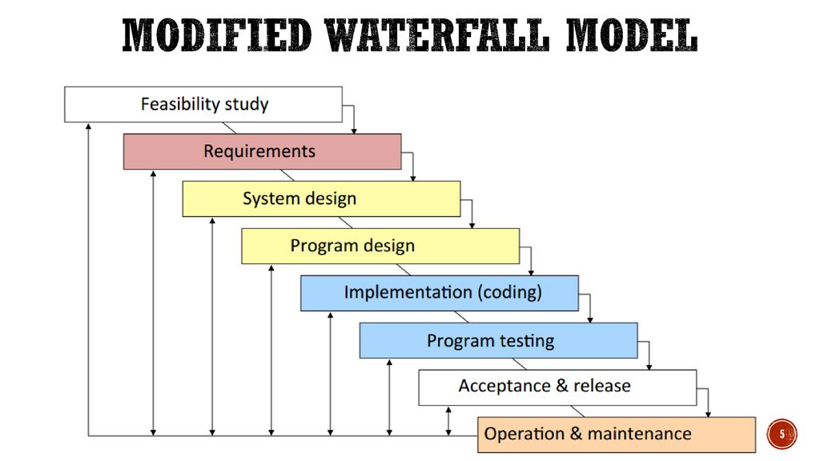
Benefits
- Visibility: A formalized approach will ensure all parties are aware of the extent of progress being made. It will also help to better communicate the project’s goals and design.

- Organization: Following a systematic design process helps organize project planning, design, and development. Better documentation also makes the project easier to debug and extend.
- Quality: The waterfall model has an extensive planning phase which allows for a better understanding of the project and its objectives. Additionally, because feedback is included, previous steps are expected to be revisited and refined in order to adapt to new circumstances. These may result from possible misunderstandings or discovery of new technical requirements.

IV. RISK ANALYSIS
- Storage Failure:
Risk: The workstation hard drive has the possibility of failing, which means all the data stored on it related to the project would be lost.
Solution: Dropbox and GitHub will be used to store files/data related to the project.

- Workstation Failure:
Risk: Other components, such as the power supply or network interface, may fail, which means processing will not be able to occur.
Solution: Other unused workstations are available in the lab and funding is available to quickly replace components. There is also plenty of available networking equipment.

- Raspberry Pi/Camera Setup Requirements:
Risk: The design for the Pi/Cam setup is not set and may change after the first prototype, due to the many design constraints.
Solution: Additional parts/supplies can be ordered, and the design will be carefully planned so that it meets the technical requirements

- Raspberry Pi/Camera Failure:
Risk: Because the camera is outdoors, it can fail for a variety of reasons. Also, the bandwidth needed to transmit the frame-data may not be high enough.
Solution: Different ways to combat heat/weather exposure will be researched to ensure the camera setup can operate outdoors. WiFi dongles can be purchased to help increase bandwidth. Multiple Pis, cameras, and batteries will be available to replace broken components.

- Drift:
Risk: False-positives and false-negatives may accumulate, leading to inaccurate car counts.
Solution: The counting program will have a feature that allows the user to manually set the lot occupancy count. This will require a manual survey of the parking lot. Multiple Pis could also be used on the same parking lot to verify events.

- Processing Interruption:
Risk: Changes to available bandwidth in addition to the possibility of workstation/camera failure may interrupt frame-data processing, leading to inaccurate car counts.
Solution: The administrator will shut down the counting program and data transfer programs, work on maintenance, replace components as needed, and then restart the systems. The previously mentioned WiFi dongle solution can be implemented to solve bandwidth issues.

- Changing/Incomplete Requirements:
Risk: Because background knowledge is still being acquired for the tools used in the project, requirements may be incomplete or change due to assumptions or misunderstandings.
Solution: It is normal to go back to previous steps in the “Modified Waterfall Model” and refine documents in order to document changes. The overhead for background knowledge is also expected.

- Human Resources and Knowledge:
Risk: A lack of background knowledge for the project means the length of some tasks in the project timeline are unpredictable, and development may take longer.
Solution: The timeline is flexible to a certain extent, and problems will be communicated to the primary research mentor as they arise in order to complete the project.

V. SCHEDULE AND TIMELINE
Timeline Report
The report was made using GanttProject, an open source application.
The report is in a separate file, 5-21-19GanttReport.pdf.
Key:
Grey: Tasks for Regeneron STS Report
Purple: Learning background knowledge
Pink: Planning/setup
Light Blue: Tasks for “Modified Waterfall Model” development process
Black Diamonds: Important event markers
Black brackets: Sprint groupings

VI. COSTS AND BUDGET
Part | Price | Quantity
CanaKit Raspberry Pi B+ | $79.99 | 3
Pi Camera Module and Case | $14.29 | 3
Replacement Monitor | $119.99 | 1

Time:
Most of the work will occur during the summer period (May 15th – July 10th). At least 320 hours (40 hours a week for 8 weeks) will be spent working on the project over the summer. Additional time will be spent afterwards working on the Regeneron STS submission and other conference papers.
Other Resources:
A workstation in the Cloud Lab has been provided by Dr. Galloway for development and processing.
Budget:
Project funding is provided by the Gatton Research Internship Supplies Grant and the WKU FUSE grant. A total of $5,500 will be available for travel, supplies, and other project-related expenses. An additional $3,200 will cover the cost of summer housing, food, and other expenses for living on campus. $442 will go towards tuition for the independent research course.

VII. PROJECT VISIBILITY AND COMMUNICATION
Efforts will be taken to maximize the visibility of the development process and system to the stakeholders. This will guarantee that a systematic design process is followed to meet the established requirements. Any misunderstandings or deviations from the design process will be caught and corrected through feedback from the stakeholders. Different methods of communication will be used to ensure visibility.
Meetings will take place at least twice a week with the primary mentor over the course of the summer period to discuss progress, written reports, and other project-related topics. Additional meetings to review report drafts for the Regeneron STS Competition with Gatton staff will also be scheduled.
Continuously updated Gantt charts with descriptions, quick demonstrations, reports, in-code comments, and other forms of documentation will be used to help communicate progress and guarantee project visibility.

VIII. STAKEHOLDERS
The stakeholders are Dr. Galloway, the Gatton Academy staff, and Western Kentucky University.
Dr. Galloway is the primary research mentor and will be providing guidance for the project.
The Gatton Academy has provided funding through the Research Internship Grant and will assist with the submission to the Regeneron competition.
WKU has provided funding through the FUSE Grant and will assist with scholarship opportunities.

IX. EXISTING MARKET
The existing market and background are discussed in the ACM Car Counting research paper available in the github presentation folder.

X. SYSTEM & PROGRAM DESIGN
Behavioral Diagrams:
It is important to define what the proposed system should do before beginning implementation. This ensures that all the listed technical requirements are met so that external actors, such as users or other software, receive what is expected.

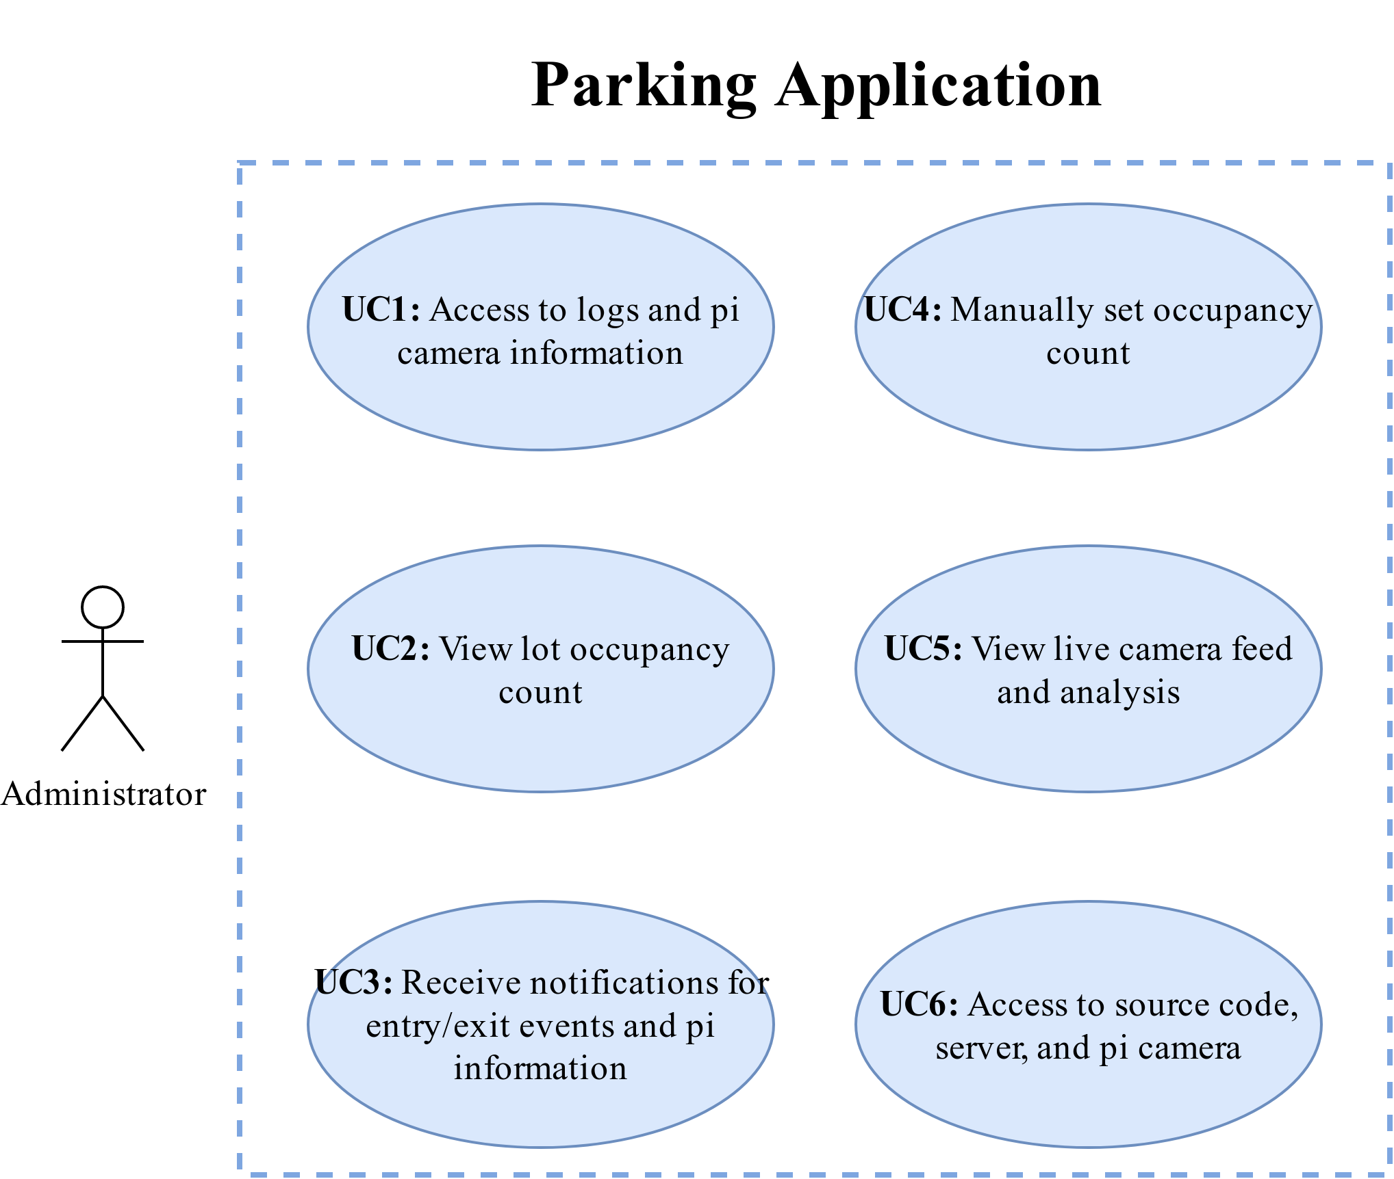Figure 1: Use Case Diagram
Figure 1 demonstrates how the parking application will be used by end users and the administrator. The external actors (the admin and user) are connected to use cases #1-6 by arrows to illustrate how each actor uses the software.

Requirements |  | UC1 | UC2 | UC3 | UC4 | UC5
Requirements | R1.1 |  |  |  |  | X
Requirements | R1.2 |  |  |  |  | X
Requirements | R1.3 |  |  |  |  | X
Requirements | R1.4 |  |  |  |  | X
Requirements | R1.5 |  |  |  |  | X
Requirements | R1.6 |  | X |  |  | X
Requirements | R1.7 |  |  |  | X
Requirements | R1.8 |  | X
Requirements | R1.9 | X |  |  |  | X
Requirements | R2.1 | X |  |  |  | X
Requirements | R2.2 | X |  |  |  | X
Requirements | R2.3 | X |  | X
Requirements | R2.4 |  |  | X
Table 1: Requirements Tracing

Table 1 outlines primary and secondary scenarios for each use case. Primary scenarios are how the intended use cases are meant to be carried out. Secondary scenarios list possible errors and exceptions.
Use Case: Camera info and logs  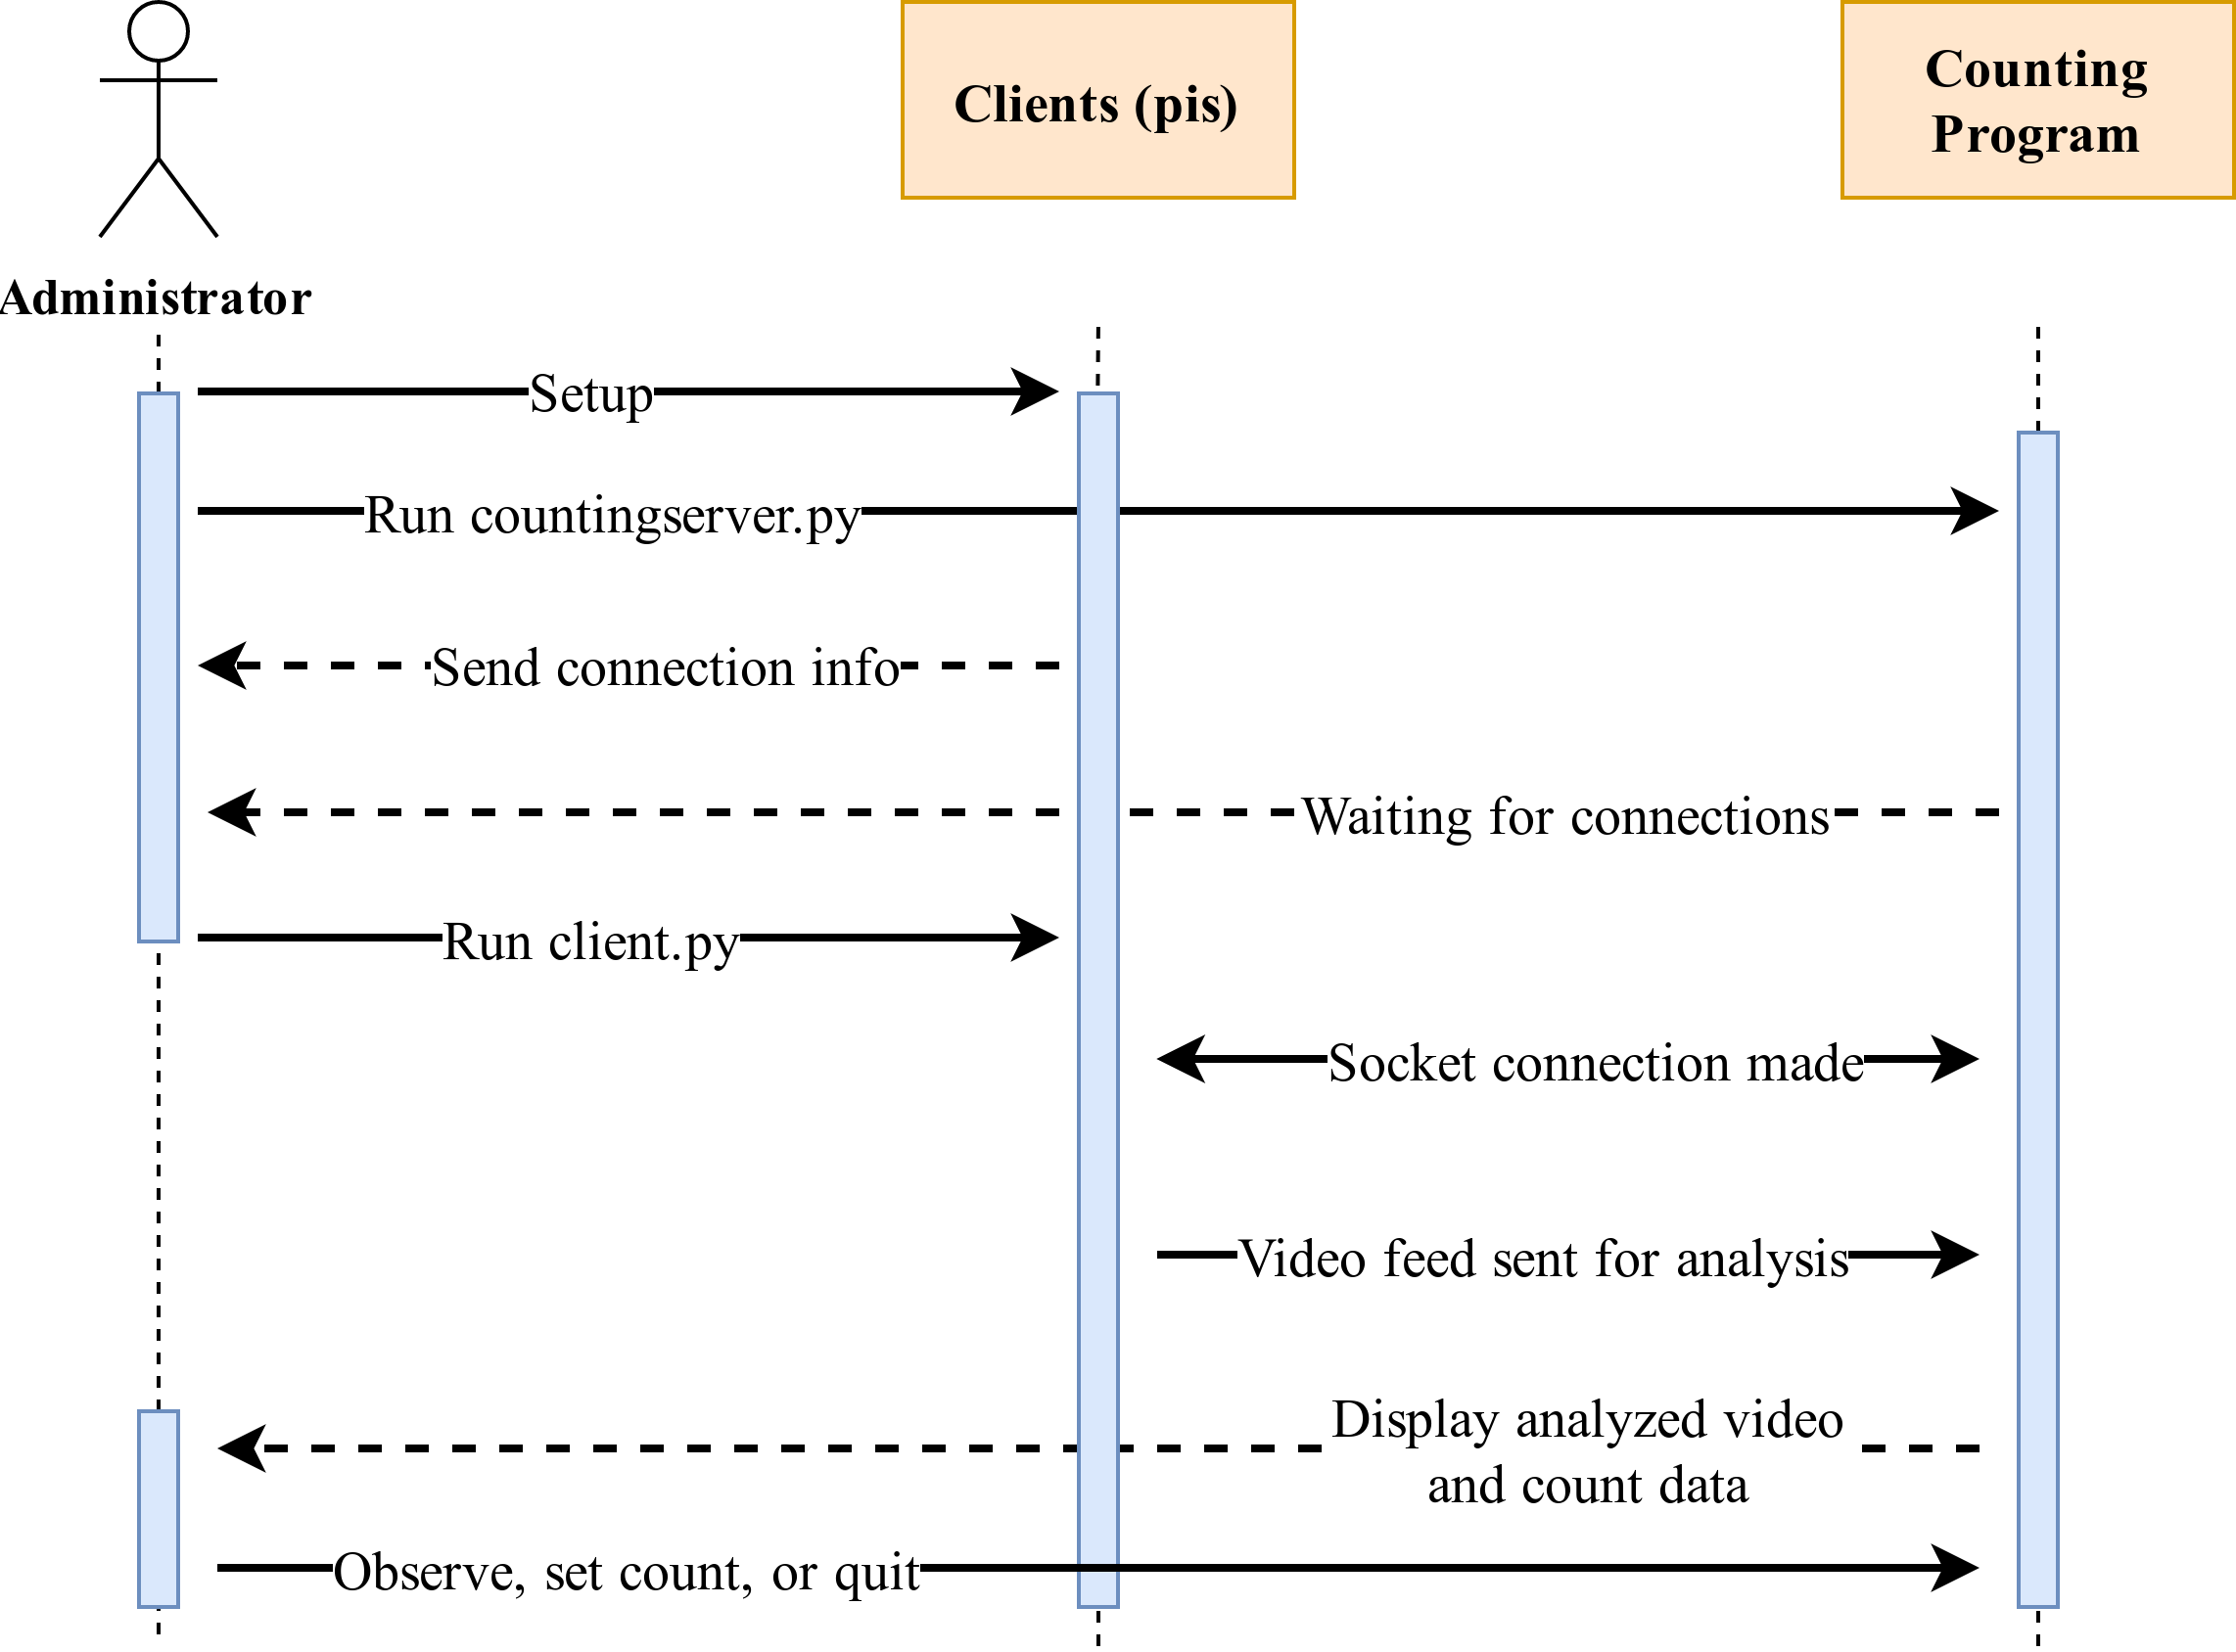  Figure 2: Sequence Diagram | Use Case: View parking lot occupancy count
ID: UC1 | ID: UC2
Actors: Admin | Actors: User (admin can do this in back end)
Preconditions: | Preconditions:
Primary Scenario:  1. SSH is setup on both the pi and the workstation so the pi can be remotely accessed if more information is needed.  2. A boot script runs on the pi to send the ip to the server. This makes accessing the pi easy when it’s setup | Primary Scenario:  1. The counting program outputs a simple display.  2. The user can view the display and the current count.
Secondary Scenario:  - Pi runs out of battery power, so ip is not submitted.  - The workstation is not on, so the ip is not received. | Secondary Scenario:  - Counting program crashes or freezes.  - An incorrect or meaningless count is displayed.
Table 2: Use Cases 1&2 Scenarios

Use Case: Notifications | Use Case: Camera info and logs
ID: UC3 | ID: UC4
Actors: Admin | Actors: Admin
Preconditions: | Preconditions:
Primary Scenario:  1. Whenever an event occurs, a SMS/email notification will be sent to the administrator with the updated parking lot occupancy count.  2. If the pi is low on battery and needs charging, a SMS/email notification will be sent to the admin. | Primary Scenario:  1A script runs on the Pi periodically. Temperature, bandwidth , time, and voltage are measured and outputted to a log file(s).  2. An automated script using a file transfer protocol sends the logs to the server (workstation).  3. SSH is setup on both the pi and the workstation so the pi can be remotely accessed if more information is needed.
Secondary Scenario:  - The workstation or pi are down.  - False-positive and false-negative events.  - Inaccurate battery level detection due to absence of chip/component for measuring it directly. | Secondary Scenario:  - Pi runs out of battery power, so logs are not submitted.  - The workstation is not on, so logs are not received.
Table 3: Use Cases 3&4 Scenarios
Use Case: Real-time view
ID: UC5
Actors: Admin
Preconditions:
Primary Scenario:
1. The server and client files are executed.
2. The admin is has access to a window on the server, allowing them to see the live recording of the parking lot.
3. Object detection and tracking (analysis) are shown on the video feed along with the current parking lot occupancy count.
Secondary Scenario:
- No view due to client-side issues (on raspberry pis)
Table 4: Use Case 5 Scenarios

Figure 2 shows how the system will operate by detailing the interactions between the different actors and instances.

XI. CONCLUSIONS AND FUTURE WORK
Based on the findings of the study, the WKU Smart Parking project is feasible. My current skills, along with the available resources, will be enough to meet the project’s requirements and goals in the allotted time. The necessary background knowledge for completing the project will be obtained before and during the implementation phase as necessary. The first prototype (the bulk of the project) is to be completed by July 10th, and the Regeneron report will be completed by August 15th.

