# Address:

https://server.claritytechnologies.com/demoddas

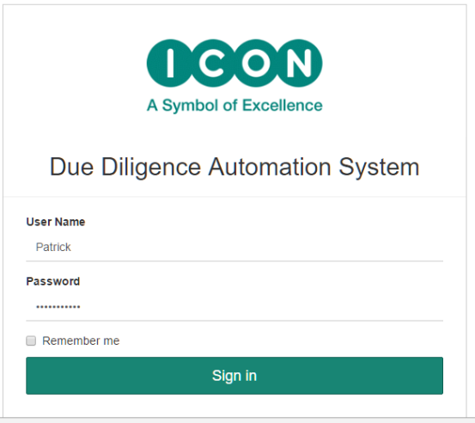

Usernames / Password:

(User Name and Passwords are case sensitive)

User1 / User1!234

# Open Compliance Form

Successful login will open the Compliance Forms view. The user can then open a Compliance Form, view the Search Summary for each Investigator and add Findings (Observations)

The Compliance Forms view comprises of:

1. ‘Create’ button creates a new compliance form. The user fills in the data and then clicks on ‘Search’ to search for matching records.
2. ‘Download Compliance Form Template’ button downloads an empty template that is later used for uploading Compliance Form Details.
3. ‘Upload Compliance Form Inputs’ uploads the template. Compliance Forms are generated and searched for matches for all the Investigator names when the template is uploaded.
4. List of Compliance Forms.
   1. Status column indicates if the Review process is completed / pending, Issues found etc.
   2. Download button generates a Compliance Form as a word document and displays the download link.
   3. Edit Button opens the Compliance Form.

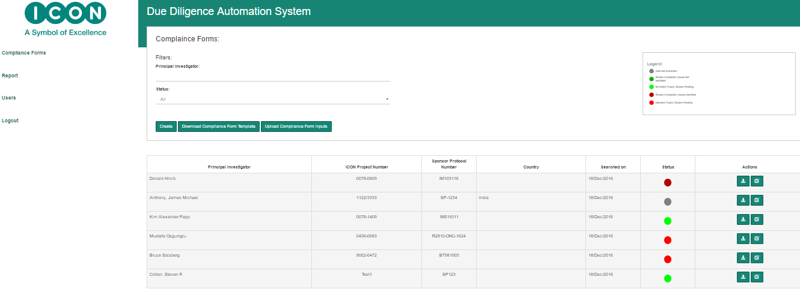

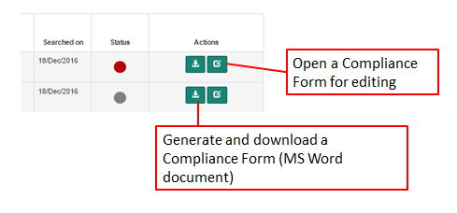

# Compliance Form

The Compliance Form layout in the application is identical to the layout of the Compliance Form and comprises of the following sections.

1. General
   1. Text boxes for editing ICON Project Number, Sponsor Protocol Number, Address and Country are provided.
2. Investigators
   1. Displays the list of Investigators.
   2. Editing of Investigator name is disabled after the search is completed for the Investigator.
   3. Additional Investigators can be added at any time and the Search Option is available. The search is not repeated for previously searched Investigators and therefore any observations recorded against that investigator are not lost
3. Sites Participating in the Search.
   1. The list of sites participating in the search are displayed.
   2. The Application automatically adds the mandatory sites (currently 12) when the Compliance Form is created and these sites cannot be removed.
   3. User can add additional sites if required and these sites can be removed at any time.
   4. The columns in the list are:
      1. Source
      2. Source Name. User can navigate to the site by clicking on the link on this column.
      3. Extraction Mode. This column is displayed in the generated Compliance Form.
         1. DB – The matching records are retrieved from the previously stores data. The data for these sites is stored in a Data Base. These sites are checked at regular intervals (once a day) and the data from the site is downloaded if found modified after the previous download.
         2. Live – The matching records are retrieved directly from the site because matching records can be retrieved only for known Investigator names.
         3. Manual – These sites are not searched for matching records. The user records the findings directly in the application.
      4. Issues Identified.
         1. Yes – if at least one finding for any of the investigator for this site is marked as ‘Is An Issue’ . ‘Is An Issue’ check box is provided in the Findings page.
      5. ‘X’, remove button is available only for sites that are added by the user.
4. Findings (Issues Identified).

This view displays the list of findings that are included or recorded in the Findings page.

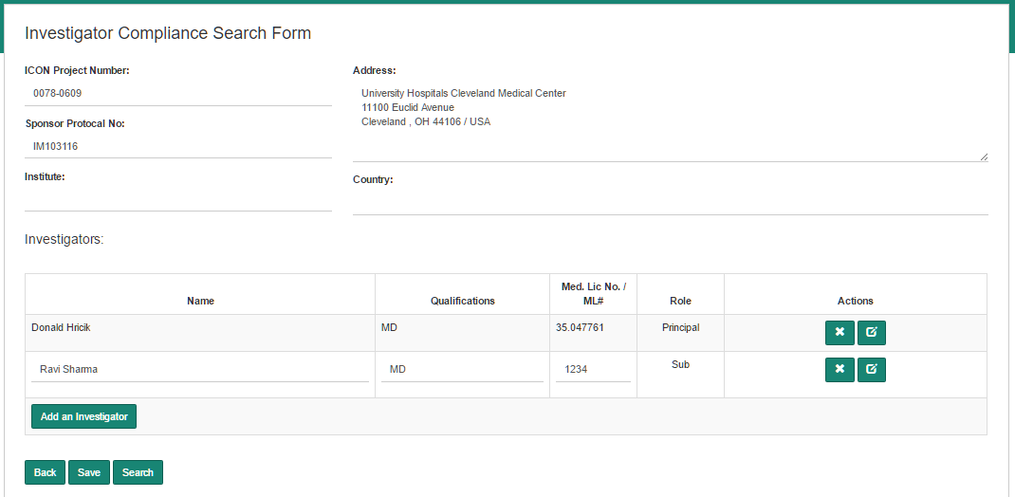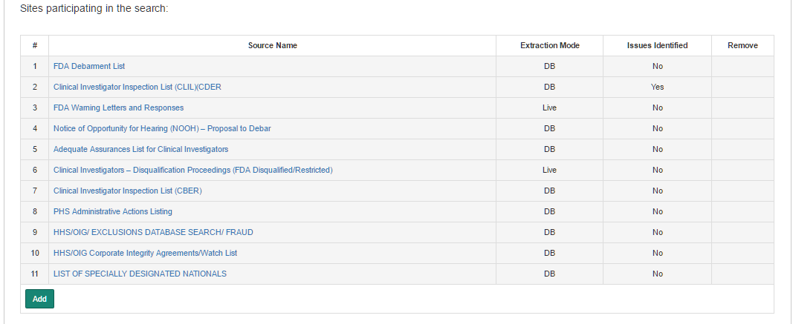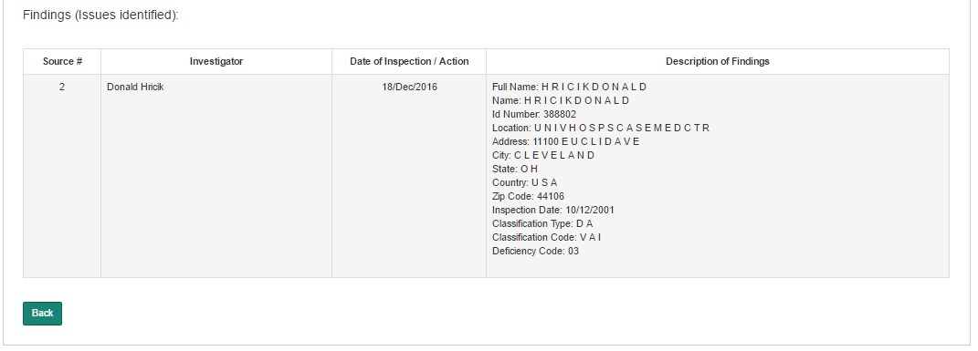

# Search Summary

The Search Summary view displays all the search results for a selected Investigator.

Full Match indicates the number of matching records found for that site where all the components of a name are found in the site.

Partial Match indicates the number of partially matching records found for that site. A match is considered as partial if two or more components of the name, but not all, are found in site.

Examples:

Investigator Name: John David Copperfield

|  |  |
| --- | --- |
| Record found in site | Match Status |
| John David Copperfield | Full Match |
| John Copperfield David | Full Match |
| David Copperfield John | Full Match |
| David John Copperfield | Full Match |
| Copperfield James David | Partial Match |
| James David William | No Match |
| William James David | No Match |
| David William Anthony | No Match |

Issues Identified – the number of Findings which are flagged as ‘Is an issue’

Review Completed – indicates that the user has completed recording the findings against the selected Investigator - Site.

The ‘Findings’ button opens the Findings page.

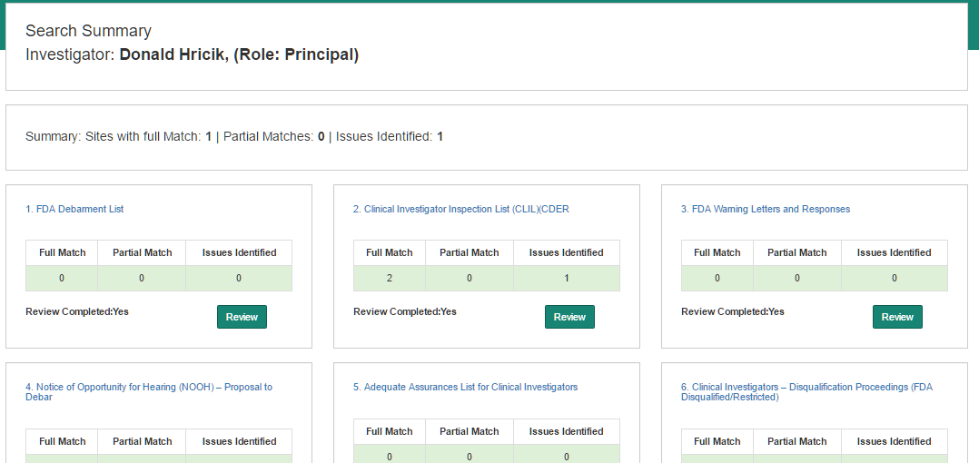

# Findings

The View contains the following fields

Record Details:

Record details are extracted from the site’s matching records.

Findings:

User can add finding/observations. These appear in the Compliance Form, under the section Findings.

Is an Issue:

If one or more findings in a site are marked as Issue then the Compliance Form will indicate that the site has an Issue.

Remove:

The Remove button will remove the Observation.

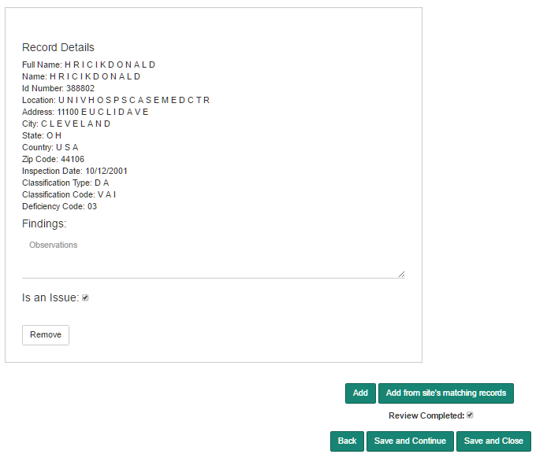

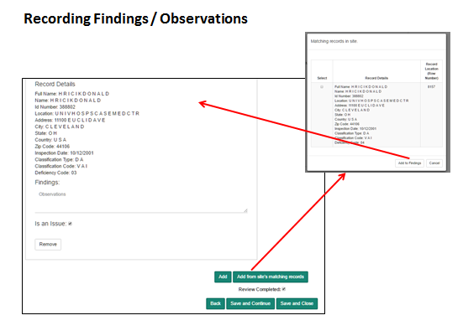

1. Adding Findings (Observations):
   1. Use ‘Add’ button to record observations.
   2. Use ‘Add from site’s matching records’ to add and then record observations
   3. The Findings will appear in the Compliance form under section ‘Findings’
2. Identify if this observation is ‘Is an Issue’. If one or more findings are marked as ‘Is an Issue’ then ‘Issues Identified’ is flagged for that site.
3. Check ‘Review Completed’ check box if the recording of findings is completed for this site
4. ‘Save and Close’ to return to the previous screen.