Application: DDAS.IconPlc.com

Test evidence

Changes

The DDAS.Iconplc.com is unable to extract data from FDS Debar Pate. This is indicated at two locations.

1. Home Page – red circle indicating the number of sites unable to extract data

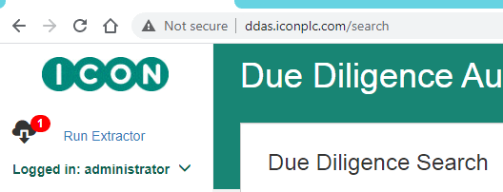

1. Data Extractor page: item underlined in read, indicating that the last extraction was done on 4 Jan, 2021.

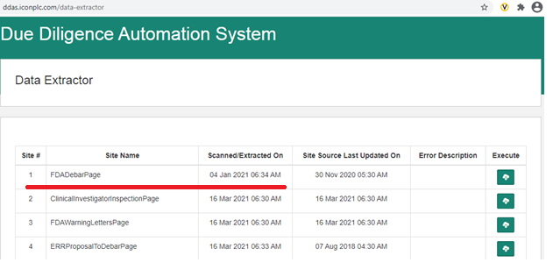

Evidence of correction carried out in DDASTest.Iconplc.com

1. The below screen shot taken shows that the issue is resolved.

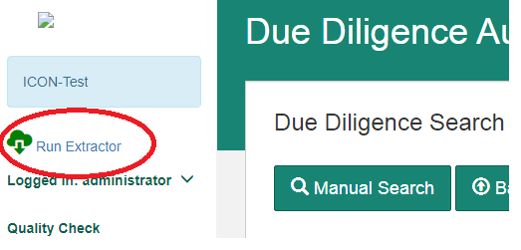

1. The below screen shot shows that the data extraction is carried out **as expected** on 16-Mar-2021.

