Implementation details of ‘Enhancements to DDAS Web Application’ Rev 1, 13 Nov, 2017, Test Server Version: T1.0.19 updated on 24th November, 2017

# Prepared by: Pradeep Chavhan

Version: 1.0

Date: 29 November, 2017

# The requirements are shown in italics and the implementation details in bold

# Input Template Enhancement

* 1. *The Investigator Compliance Search Form will include an additional field ‘ICON Project Number’, completed as shown below:*

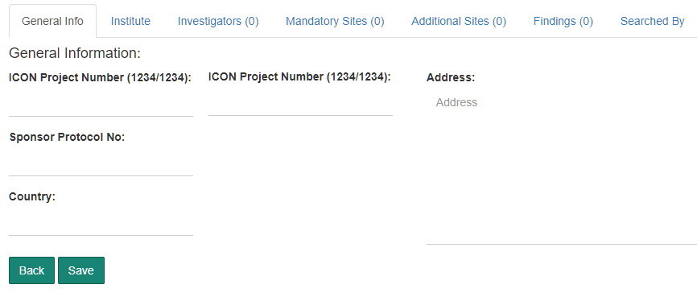

* 1. *Input template as well as the tool will accept one or two study numbers and the same will be displayed in the fields shown above. –* **Completed.**
  2. *The generated Compliance Form will display both ICON Project Numbers wherever two ICON Project Numbers are available. –* **Completed.**

## QC Work Flow

1. *The ‘Search Resource’ (auditee) will be able to assign a Compliance Form for audit and identify an Auditor.*
2. *The application will send an email alert informing the Auditor to take up the Audit.*
3. *The Auditor can login and open the Compliance Form for Audit*
4. *The Auditor will not be permitted to modify the contents of the Compliance Form created by the Auditee.*
5. *The following fields will be provided for the Auditor to provide observations.*
   * 1. *Comments*
     2. *Accepted / Rejected*

*These fields will be available at Compliance Form level and against each finding.*

1. *The Auditor will mark the Audit as completed and an email alert will inform the Auditee about the status.*

### The QC Workflow implementation is described below.

### Requesting Audit

**Navigate to ‘Closed Reviews’**

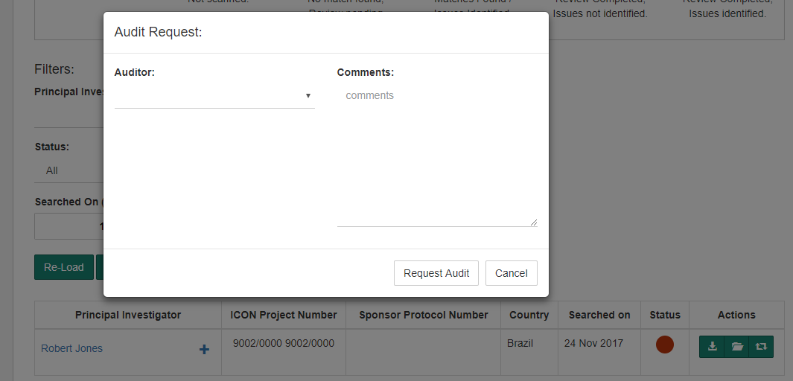

1. **Select a compliance form to be audited**
2. **Select Auditor name and comments (if any)**
3. **Request for Audit. The compliance form will then appear under ‘QC Audit’ with Auditor details**

### Audits Assigned Page

**Navigate to ‘QC Audit’**

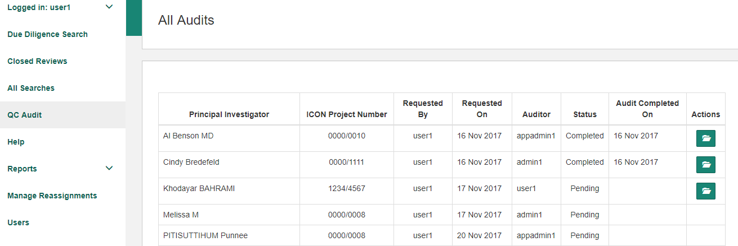

1. **Displays all Audits requested**
2. **Action button appears only when**
   1. **An audit is completed**
   2. **Logged in user is the ‘Auditor’ of a compliance form**

### View/Edit Audit Page

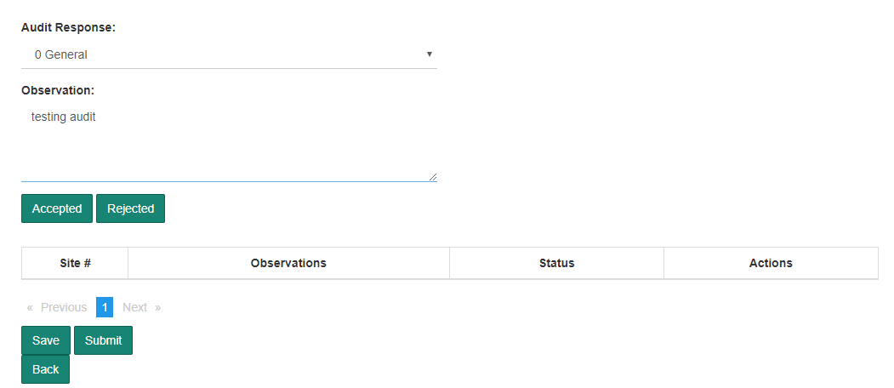

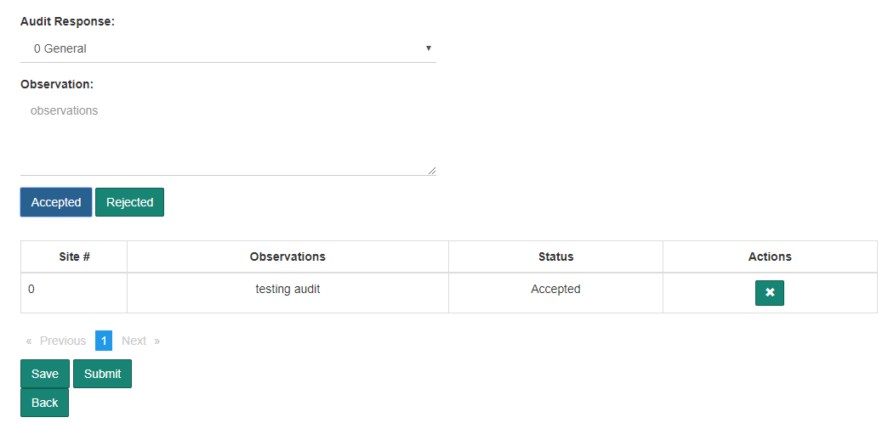

1. **Auditor can add the observations against a site or as a General observation by selecting respective values from the drop down provided**
2. **Auditor either Accepts or Rejects the findings identified by the Auditee. Auditor has to provide his/her observations and either ‘Accept’ or ‘Reject’ the same**
3. **The observations - ‘Accepted’ or ‘Rejected’ are displayed in the below table**
4. **User can ‘Save’ the observations any time and resume his/her audit. Unsaved observations will be lost**
5. **Once user has identified all the observations, user has to ‘Submit’ his/her audit**
6. **Submitted audit will be marked as ‘Audit Completed’ and further edits will not be allowed. Also, only the ‘Submitted’ or ‘Completed’ audits will be accessible by other users.**

## *Admin Dashboard*

1. *A dashboard with current status will be available for the Admin.*

|  |  |  |  |  |
| --- | --- | --- | --- | --- |
| ***User*** | ***Opening Balance*** | ***Compliance forms uploaded*** | ***Compliance forms completed*** | ***Closing Balance*** |
| *David* | *5* | *9* | *7* | *7* |
| *Naveen* | *2* | *6* | *3* | *5* |
| *Maya* | *3* | *7* | *8* | *2* |

*Include the graphical representation or any presentable form for management purpose.*

**Implementation details of Admin Dashboard are described below:**

**Navigate to Reports/Admin Dashboard**

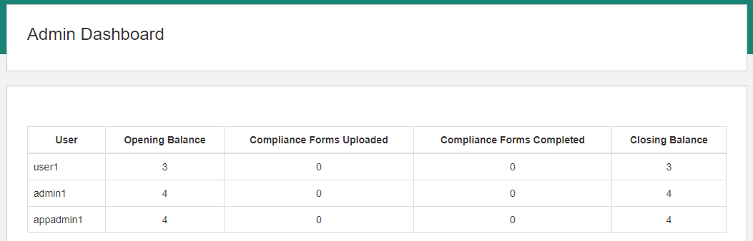

**This report shows number of compliance forms open, uploaded and completed real time.**

**(A button will be provided to check the real time values)**

## *Advanced Reports*

1. *A detailed report on all investigators based on the findings status (after review) for a Specified Period / Resource / Studies*
2. *Filters*
   * + 1. *Review Completed On – From and To*
       2. *Resource Name*
       3. *Study Number*
       4. *Finding Status (No Findings, Findings)*
3. *Columns*
4. *Name of the Investigator*
5. *Study Number*
6. *Review Completed On*
7. *Findings Status (Issues Identified / Issues Not Identified)*
8. *Investigated by (Resource Name)*

**The implementation of above report is:**

**Navigate to Reports/Investigators by Findings**

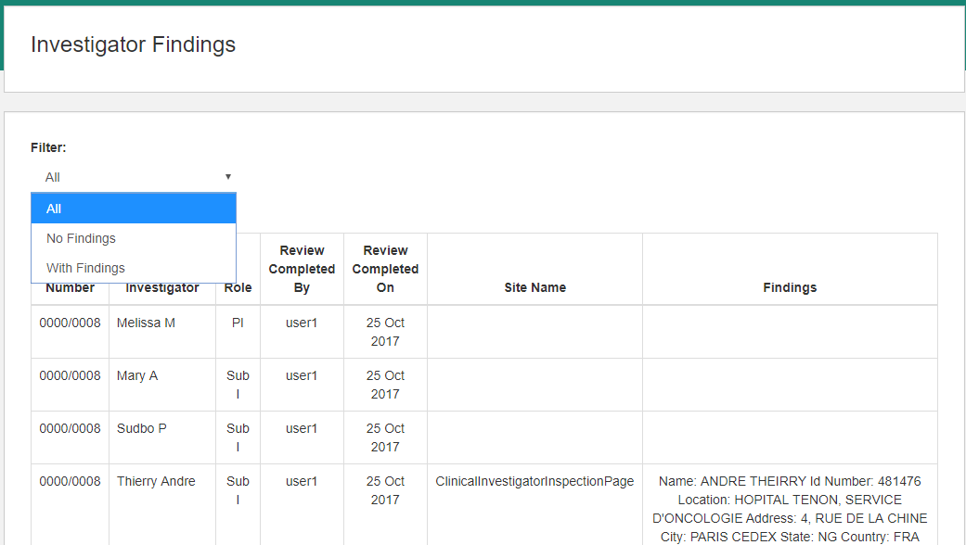

**This report by Default, lists all investigator details with or without findings. User can select ‘No Findings’ or ‘With Findings’ to view the respective records.**

1. *Reassignment report to understand how many investigators were reassigned for Specified Period / Resource*
2. *The application workflow will be arranged to record Date and Time of Assignment of the Compliance form to a Resource.*
3. *When the Compliance Form is uploaded the Resource is automatically assigned to the uploaded Compliance Form*
4. *The Date and Time when the Compliance form is taken out from the current Resource will be recorded.*
5. *A report will be generated with the following columns.*
6. *Project Number*
7. *Principal Investigator*
8. *Resource*
9. *Resource Assigned on – Date and Time*
10. *Resource Removed on – Date and Time*

***The implementation of the above report is:***

**Navigate to Reports/Assignment History**

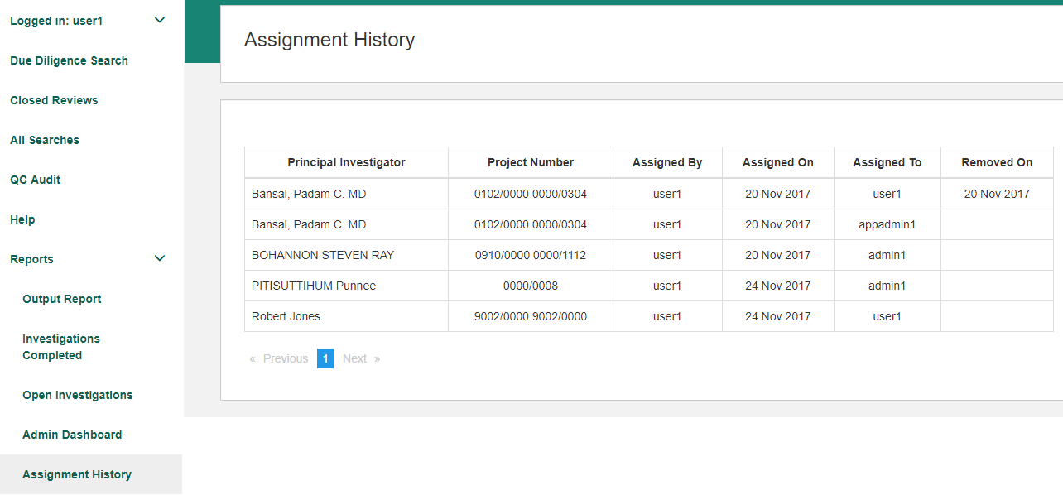

**This page displays the users to whom a compliance form was assigned to, assigned by along with the date when it was assigned.**

**‘Removed On’ date is updated only when a compliance form is assigned to any user.**

1. *Study Specific report with all investigators completed along with the Date of Review Completed, Findings status with Resource Names*

*Study Number[ 1111/2222 ]*

|  |  |  |  |
| --- | --- | --- | --- |
| *Investigator Name* | *Date Review Completed* | *Findings Status* | *Resource Name* |
| *David Jones* | *5-Sep-2017* | *Issues Identified* | *Ram* |
| *William Joseph* | *12-Oct-2017* | *Issues Not identified* | *Shyam* |

**The implementation of the above report is:**

**Navigate to Reports/Study Specific Report**

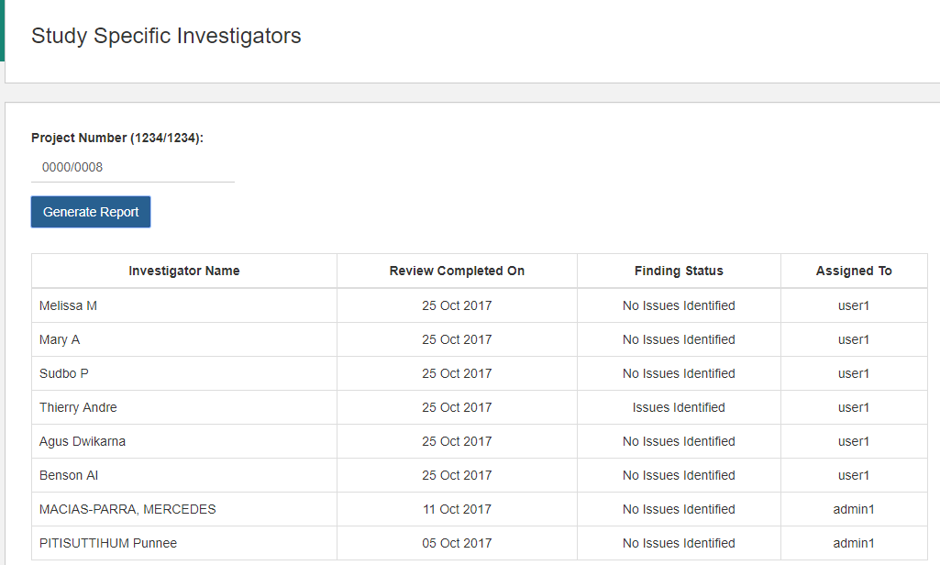

**This report displays the details of the investigator whose review is completed. User has to enter ‘Project Number’ and the application will list all investigators whose review completed and whose project number matches with the provided project number. Application uses both project number fields to locate the compliance form.**

1. *A report with details of all investigators completed for a specific period of time along with time taken for each review for each investigator. This report is to be available for all Users as well.*

*Review completed during [ from date ] and [ to date ]*

|  |  |  |  |
| --- | --- | --- | --- |
| *Investigator Name* | *Review Completed On* | *Status* | *Time Taken (in minutes)* |
|  |  |  |  |
|  |  |  |  |

* + - * *Time Taken is the time duration between Date and Time the Compliance Form is uploaded and searched AND the Date and Time when the Investigator Review is completed.*
      * *The above computation does not take into consideration the actual time used by the Resource to carry out the review of that specified Investigator.*
      * *A Compliance Form that is carried over to the next day will result in a inaccurate result.*

**The implementation details are:**

**Navigate to Reports/Review Completed Time**

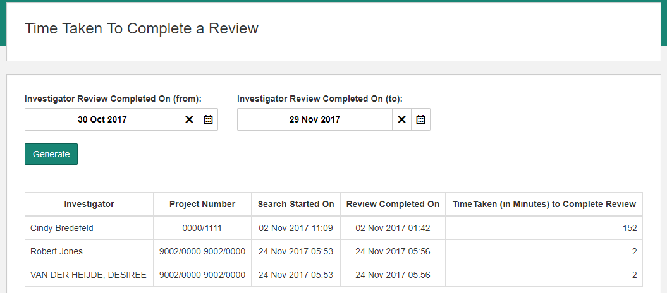

**This page displayed the time taken by all the users in minutes, to complete an investigator’s review between a given date period.**