**ICON**

Enhancements to DDAS Web Application

**Screen Shorts of Implementation in Production Application**

**Brief Business Requirements**

Rev 3

8 Dec, 2017

Prepared by:

**Clarity Information Technologies Pvt. Ltd.**

Tel: +91-080-2529 1698, 4115 5410

Email: mail@claritytechnologies.com

# Revision History

|  |  |  |  |  |
| --- | --- | --- | --- | --- |
| **Revision** | **Date** | **Sections Changed** | **Summary/Description of Change** | **Author(s) of Change** |
| 1 | Nov/13 | All | First Release | Patrick/Pradeep |
| 2 | Nov/30 | Requirements/Input Template | Additional Protocal Number required in Input Template | Patrick/Pradeep |
| 2 | Nov/30 | Proposed Solution/ Input Template | Input Template Enhancements | Patrick/Pradeep |
|  |  |  |  |  |
| 3 | Dec/8/2017 | All | Additions and deletions based on discussion with DD Team on December 7, 17. | Patrick/Pradeep |

# Summary:

Implemented in Production: Items tested and working. – 9 items.

Not working: - 1 item.

# Requirements

The existing DDAS Web application needs to be enhanced with the following additions.

1. Input Template Enhancement
   1. Capability of the tool to be modified to include 2 study numbers as the Due Diligence checks are requested for investigators who would be participating in 2 studies at once.
   2. Input template as well as tool should accept 2 study numbers at once so 1 compliance search form should be generated for investigators with 2 studies in it.
   3. Capability of the tool to be modified to include 2 Protocol Numbers.
   4. Input template as well as tool should accept 2 Protocal Numbers at once so 1 compliance search form should be generated for investigators with 2 Protocol Numbers in it.
2. QC Work Flow – Requirement under discussion and not finalized.
   1. Arrangement to allow the junior resource to pass on their works to senior resource for review along with any comments and similarly, senior resource allowed to review as well as pass this back on junior resource with any review comments
   2. Provision for users to upload files during QC work flow, before the QC is completed with maximum file size being 5MB
   3. All comments from auditee and auditor should be stored in the tool for internal purposes and should be archived after 6 months along with the ICSF
3. Admin Dashboard
   1. A new dashboard to be incorporated into tool for all Admins.
   2. Include the admin related results in table formats
   3. Drill down view.
   4. Report must be downloadable in CSV and Excel Format.
4. Advanced Reports
   1. A detailed report on all investigators based on the findings status (after review) for a Specified Period / Resource / Studies
   2. Report ‘Investigators with No Findings’ listing investigators with no Findings
   3. Report ‘Investigators with Findings’ listing investigators with Findings.
   4. ‘Reassignment Report’ to understand how many investigators were reassigned for Specified Period / Resource
   5. Study Search Report with all investigators completed along with the Date of Review Completed, Findings status with Resource Names, Role, Institute, Country, Medical license number and Sponsor protocol number
   6. Time Taken to Complete a Review. A report with details of all investigators completed for a specific period of time along with time taken for each review for each investigator. Date Range filters must be provided. This report is to be available for all Users as well.
   7. A report showing the upload activity during the day.
   8. All advanced reports must be downloadable in CSV and Excel Format.
5. Minor Corrections
   1. Corrections in Search Filters
      1. Currently tool is searching based on the full name of the investigators, but would need the individual filters as First and Last name.
   2. Automated Text inclusion in ICSF
      1. Tool to automatically add text “NA” in final ICSF for Medical License Number field if there were no Medical license provided by User.
   3. Reset keyword in filter
      1. When User uses any keyword on the review page to filter matches, currently tool retains the keyword typed by User earlier even after user moves & comes back to same later. This should be reset by tool so the User doesn’t get confused on the filter search.
   4. Bright Highlights
      1. The provided highlights on the matches are mild and User facing difficulties viewing on screen. The highlight needs to be improved further to make it more bright or dark to improve this.
   5. Increased Page Size

Currently, tool provides the matches in quite smaller page which leads User to scroll down quite lot or more to different page to find all matches. So this page layout or page needs to be increased to incorporate larger no. of matches to help user review more stress-free.

* 1. Increased Page Size

1. Download facility for Data Files downloaded from Search Sites.

# Proposed Solution

## Input Template Enhancement

* 1. The Investigator Compliance Search Form will include an additional field ‘ICON Project Number’ and an additional field ‘Sponsor Protocol No.’ as shown below:

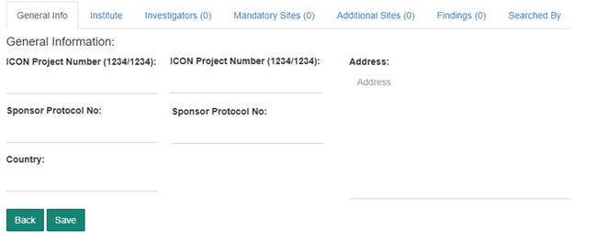

* 1. Input template as well as the tool will accept one or two ICON Project Numbers (study numbers).
  2. Input template as well as the tool will accept one or two Sponsor Protocol Nos. and the same will be displayed in the fields shown above.
  3. The generated Compliance Form will display both ICON Project Numbers wherever two ICON Project Numbers are available.
  4. The generated Compliance Form will display both Sponsor Protocol No. wherever two Sponsor Protocol Nos. are available.
  5. ICON Project number and Sponsor Protocol Number will be displayed in the below format in compliance search format

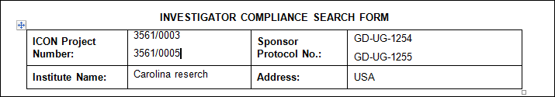

Implemented in Production:

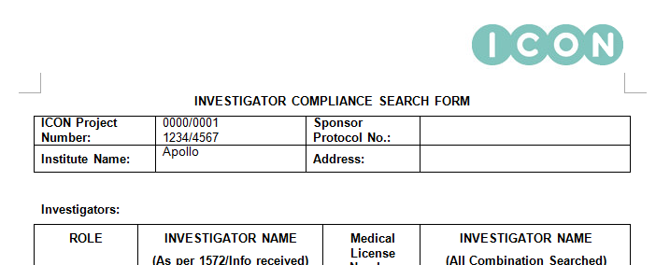

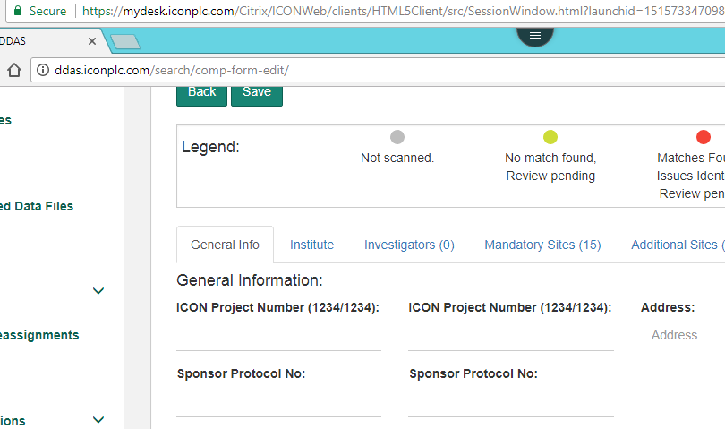

## QC Work Flow –under discussion

1. The ‘Search Resource’ (auditee) will be able to assign a Compliance Form for audit and identify an Auditor. Working
2. If possible tool should allow to attach any supporting documents(ML copies etc) for the review
3. The application will send an email alert informing the Auditor to take up the Audit. – not working
4. The Auditor can login and open the Compliance Form for Audit not working, auditor is not able to find the compliance search form to be audited DD Team Comment – The assigned Auditor able to see the request, but no action button visible (see below screenshot).
5. 
6. The Auditor will not be permitted to modify the contents of the Compliance Form created by the Auditee.
7. The following fields will be provided for the Auditor to provide observations.
   * 1. Comments
     2. Accepted / Rejected

These fields will be available at Compliance Form level and Investigator level against each finding.

* + 1. Auditor will be able to view the whole ICSF
    2. Auditor will be able to view the review page to check if there were any findings missed by the Auditee

1. The Auditor will mark the Audit as completed and an email alert will inform the Auditee about the status.
2. Auditee and auditor should only be able to view the forms related to them but admin should have access to all.
3. Auditee and Admin will be allowed to change the auditor name/ reassign to different auditor if required
4. All comments from auditee and auditor will be stored for a minimum of 6 months.
5. All comments from auditee and auditor can be archived

Implemented in Production:

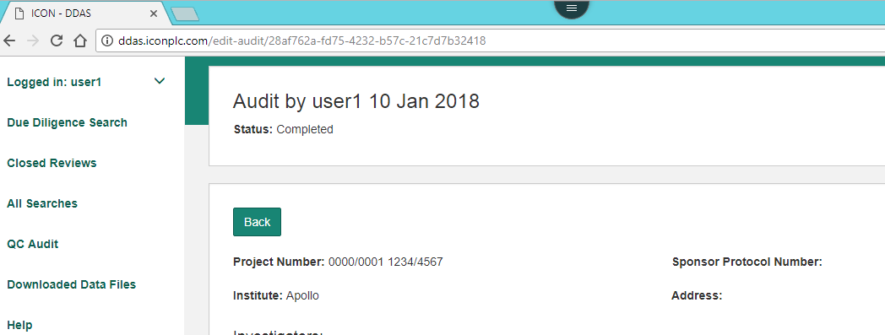

## Admin Dashboard

1. A dashboard with current status will be available for the Admin in tabular / block layout style

Layout: Tabular :

|  |  |  |  |  |
| --- | --- | --- | --- | --- |
| **User** | **Opening Balance** | **Compliance forms uploaded** | **Compliance forms completed** | **Closing Balance** |
| David Brown | 5 | 9 | 7 | 7 |
| Naveen | 2 | 6 | 3 | 5 |
| Maya | 3 | 7 | 8 | 2 |

Implemented in Production:

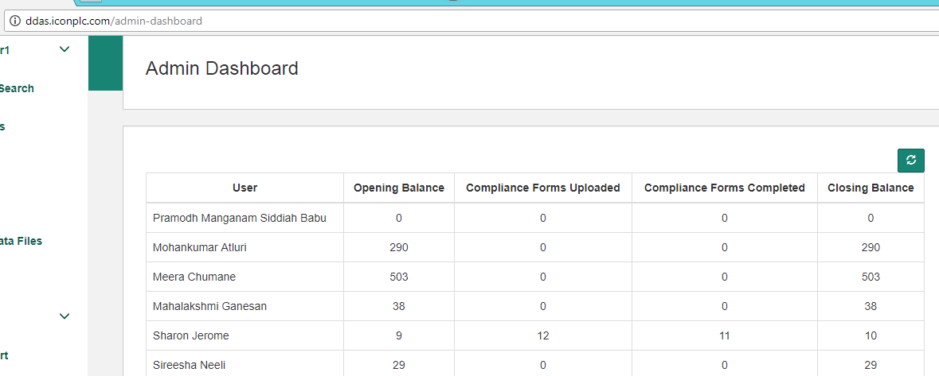

## Advanced Reports

1. Investigator Findings Report. (requirements 4a, 4b and 4c)
   1. A detailed report on all investigators based on the findings status (after review) for a Specified Period / Resource / Studies
   2. Filters
      * 1. Review Completed On – From and To
        2. Resource Name
        3. Study Number
        4. Finding Status (No Findings, Findings)
2. Columns
3. Name of the Investigator
4. Study Number
5. Review Completed On
6. Findings Status (Issues Identified / Issues Not Identified)
7. Investigated by (Resource Name)
   1. This report will be downloaded in CSV and Excel(xlsx)

Implemented in Production: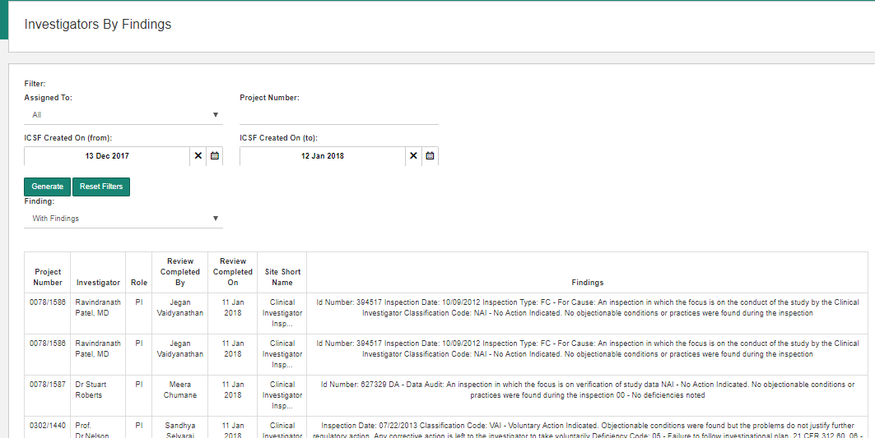

1. ‘Reassignment report’ (requirement 4d)

Reassignment report to understand how many investigators were reassigned for Specified Period / Resource

1. The application workflow will be arranged to record Date and Time of Assignment of the Compliance form to a Resource.
2. When the Compliance Form is uploaded the Resource is automatically assigned to the uploaded Compliance Form
3. The Date and Time when the Compliance form is taken out from the current Resource will be recorded.
4. This report will not list the first assignment and will list on the re-assigned records.
5. The report will be generated with the following columns.
6. Project Number
7. Principal Investigator
8. Uploaded On
9. Assigned By
10. Assigned From
11. Assigned To
12. Assigned On
13. This report can be downloadable in CSV and Excel(xlsx)

Filter: Assigned On : [start date] [end date]

|  |  |  |  |  |  |  |
| --- | --- | --- | --- | --- | --- | --- |
| Project Number | Principal Investigator | Uploaded On | Assigned on | Assigned By | Assgined From | Assigned To |
| 1234/5678 | David Jones + 2 | 30-Dec-2016, 5:30 PM | 1-Jan-2017, 2:30 PM | Ram Patel | Sam Leo | Kunal Sharma |
| 1234/5678 | David Jones + 2 | 30-Dec-2016, 5:30 PM | 5-Jan-2017, 7:00 AM | Shyam Rao | Kunal Sharma | Deepa Chandra |

Not working

1. Study Search Report (requirement 4e)
   1. Study Specific report with all investigators completed along with the Date of Review Completed, Findings status with Resource Names, Role, Institute, Country, Medical license number and Sponsor protocol number

This report can be downloadable in CSV and Excel (xlsx)

Filters: Study Number[ 1111/2222 ]

|  |  |  |  |  |  |  |  |  |
| --- | --- | --- | --- | --- | --- | --- | --- | --- |
| Investigator Name | Role | Date Review Completed | Findings Status | Resource Name | Institute | Country | Medical License Number | Sponsor Protocol Number |
| David Jones | PI | 5-Sep-2017 | Issues Identified | Ram | St. John’s | India | 9912B | 1535 |
| William Joseph | PI | 12-Oct-2017 | Issues Not identified | Shyam | Columbia Asia | USA | 9933C | 1893 |

Implemented in Production:

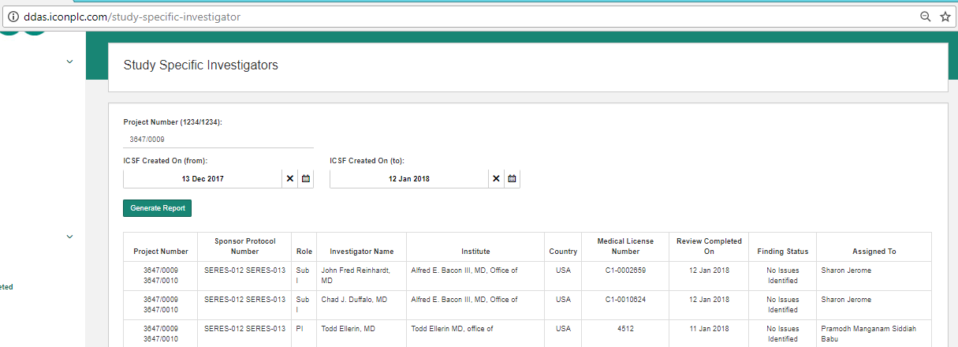

1. Time Taken to Complete a Review (requirement 4f)
   1. A report with details of all investigators completed for a specific period of time along with time taken for each review for each investigator.
   2. This report will be available for all Users as well.
   3. The application stores the full and partial match count as found at the time of processing the search results. In addition it will now store the ‘single match’ count.
   4. Report will display the number of matches (full, partial and single),
   5. Report will display Issues identified status, ‘Issues Identified / Issues Not Identified’
   6. Role of the investigator will be displayed.
   7. The count of investigators will be displayed next to the PI
   8. This report will be downloaded in CSV and Excel (xlsx)

Filters:

Review completed during [ from date ] and [ to date ]

Resource Name [ ]

|  |  |  |  |  |  |  |
| --- | --- | --- | --- | --- | --- | --- |
| Investigator Name | Review Completed On | Status | Full Matches | Partial Matches | Single Matches | Time Taken (in minutes) |
|  |  |  |  |  |  |  |
|  |  |  |  |  |  |  |

* + - * Time Taken is the time duration between Date and Time the Compliance Form is uploaded and searched AND the Date and Time when the Investigator Review is completed.
      * The above computation does not take into consideration the actual time used by the Resource to carry out the review of that specified Investigator.
      * A Compliance Form that is carried over to the next day will result in a inaccurate result.

Implemented in Production:

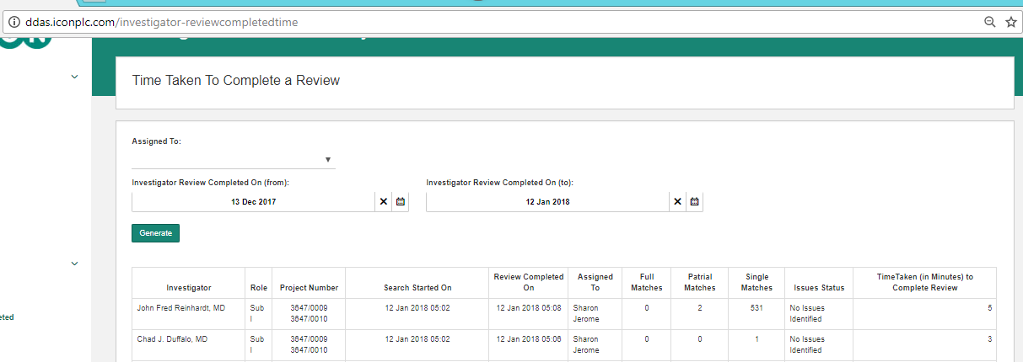

## Minor Corrections

1. Corrections in Search Filters
2. Currently tool is searching based on the full name of the investigators, but would need the individual filters as First and Last name.

This facility is currently available. The application user can paste any part of the name, First Name or Last Name to get filtered records.

1. Automated Text inclusion in ICSF
2. Tool to automatically add text “NA” in final ICSF for Medical License Number field if there were no Medical license provided by User.

This will be provided.

Implemented in Production:

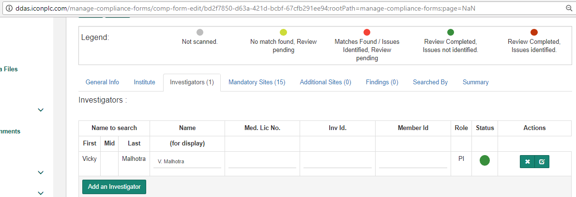

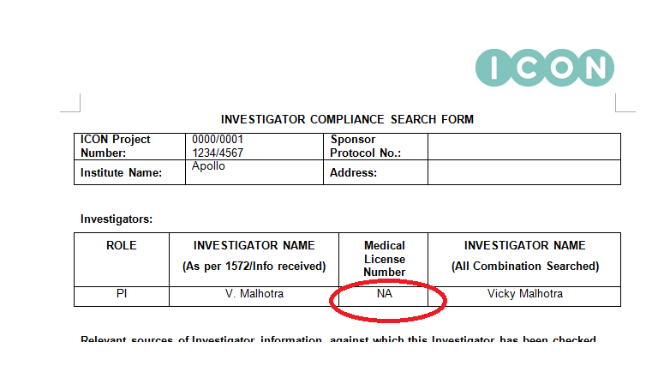

1. Reset keyword in filter
2. When User uses any keyword on the review page to filter matches, currently tool retains the keyword typed by User earlier even after user moves & comes back to same later. This should be reset by tool so the User doesn’t get confused on the filter search.
3. This will be corrected.

Implemented in Production:

1. Bright Highlights
2. The provided highlights on the matches are mild and User facing difficulties viewing on screen. The highlight needs to be improved further to make it more bright or dark to improve this.

This will be provided.

Implemented in Production:

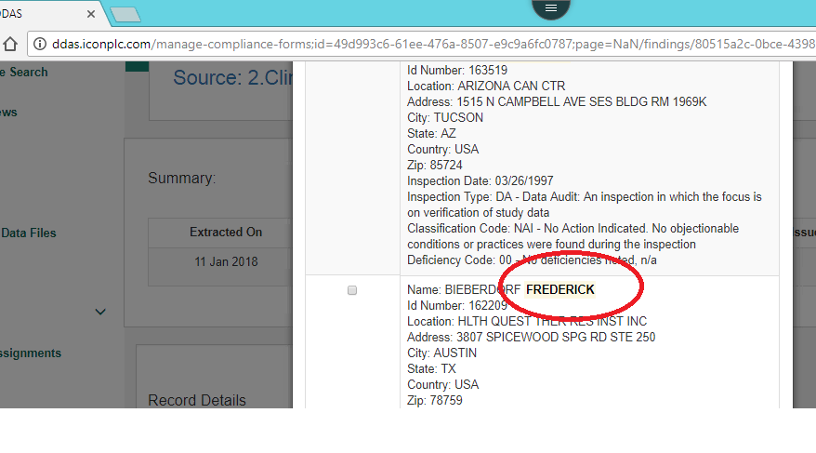

1. Increased Page Size

Currently, tool provides the matches in quite smaller page which leads User to scroll down quite lot or more to different page to find all matches. So this page layout or page needs to be increased to incorporate larger no. of matches to help user review more stress-free.

An option to select the number of items per page (5, 10, 25, 50, 100) will be provided.

Implemented in Production:

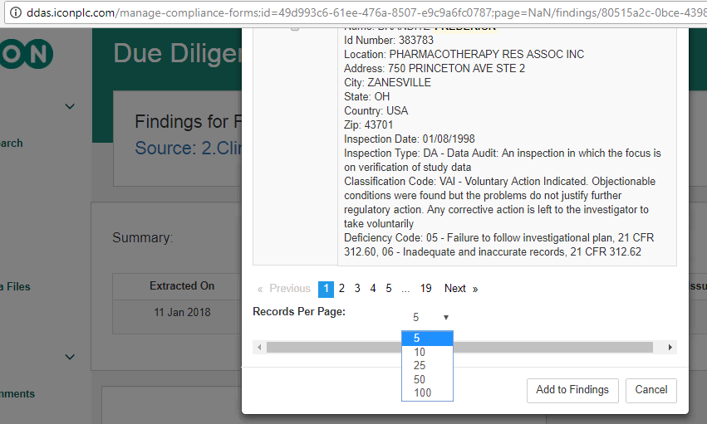

1. Investigator Name on Match Review Page will be provided.

Implemented in Production:

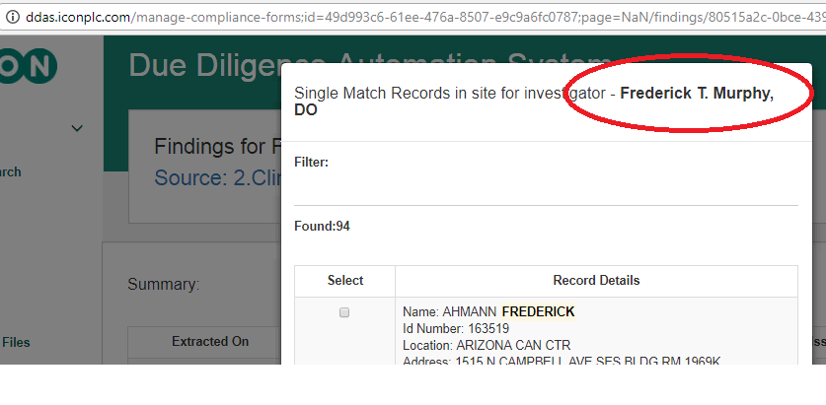

## Download facility for Data Files downloaded from Search Sites.

Archive data files from all Search Sites and make them available for download.

Implemented in Production:

