Implementation details of

iSprint to DDAS Integration

Version: 1.0.9 updated on 17th April, 2018

# Prepared by: Pradeep Chavhan

Date: 25 April, 2018

# The iSprint to DDAS Integration functionality is described below.

The iSprint to DDAS Integration provides transfer of raw Compliance Form data from iSprint to DDAS and transfer of Compliance Form Review results from DDAS to iSprint.

This document describes the functionality found in DDAS Application for transfer of data between DDAS and iSprint.

# iSprint to DDAS

iSprint application posts Compliance Form data to DDAS Application. The Compliance Form data received from iSprint is marked as ‘Unassigned’ and can be picked up by a DDAS user for Review.

The ‘Select from Unassigned …’ button displays the list of ‘Unassigned’ Compliance Forms. Unassigned compliance forms include Compliance Forms received from iSprint and other Compliance Forms currently not assigned to a DDAS user.

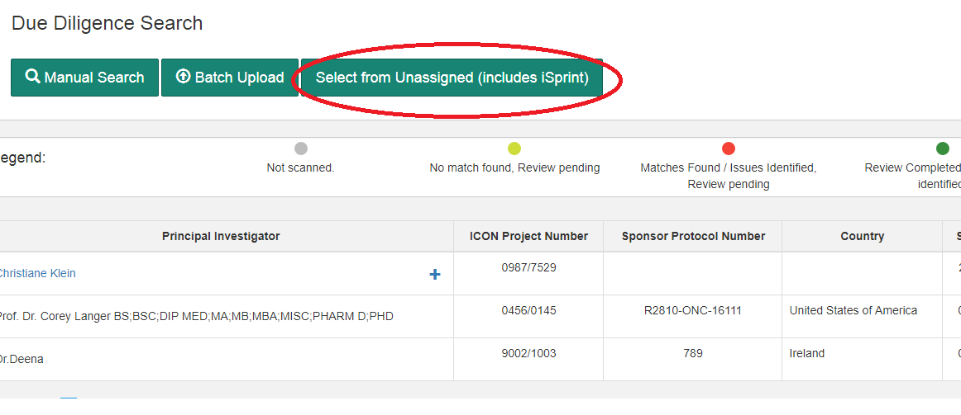

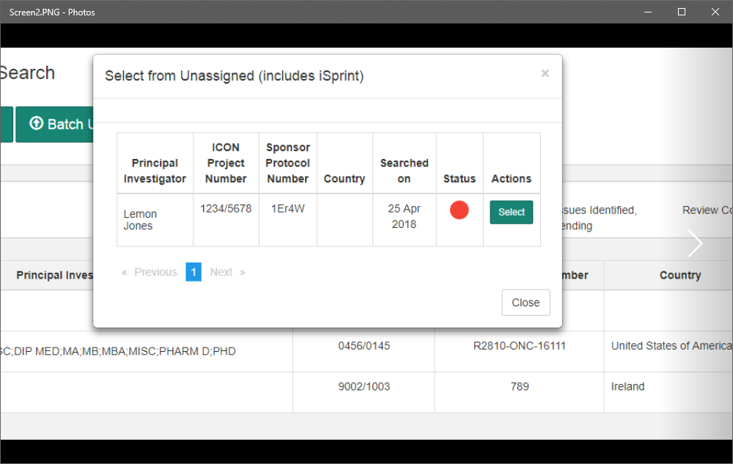

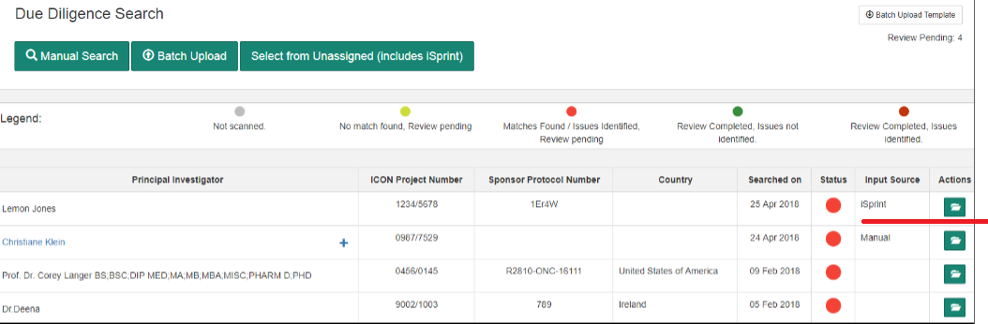

# DDAS to iSprint

The ‘Completed Compliance Forms’ data can be exported to iSprint by clicking on the button  ‘Export to iSprint’. All Compliance Form Data, Compliance Form Data received from iSprint and Compliance Form data generated by DDAS users can be exported to iSprint. There is no restriction to the number of exports of Compliance Form Data to iSprint.

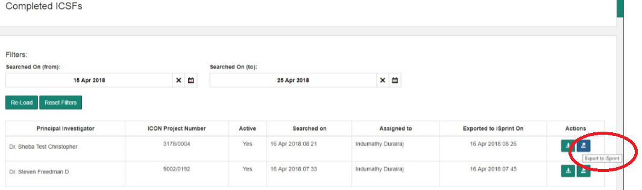

# Logs

The data transfer between iSprint and DDAS is logged. The logs are accessible to Application Admins.

