Screen shots of DDAS application’s Site Source Dates and values in the web portals.

As on 3 June, 2020

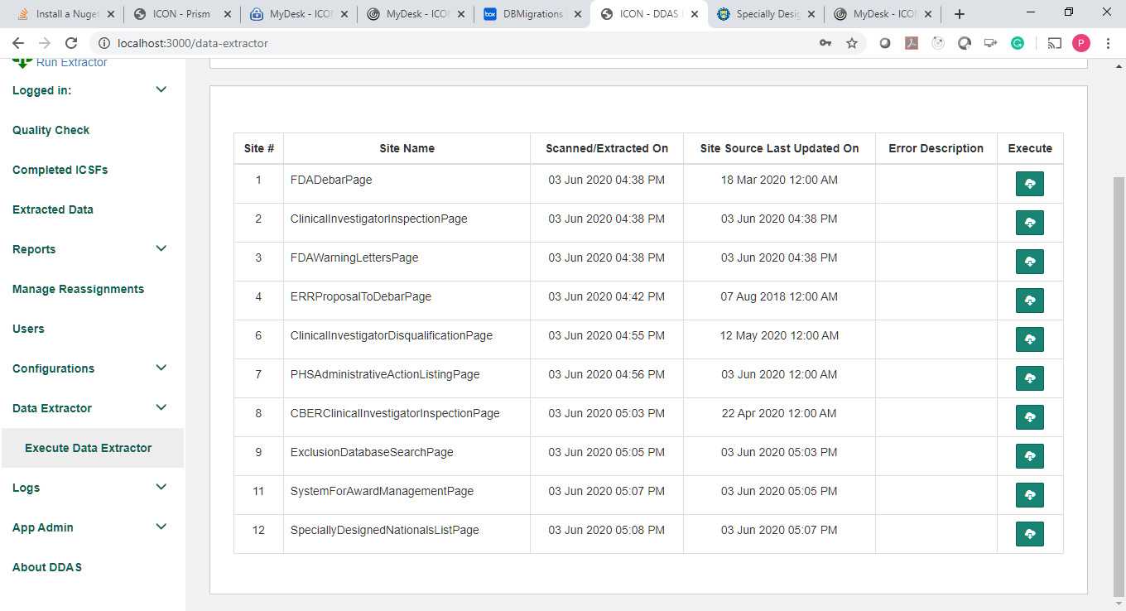

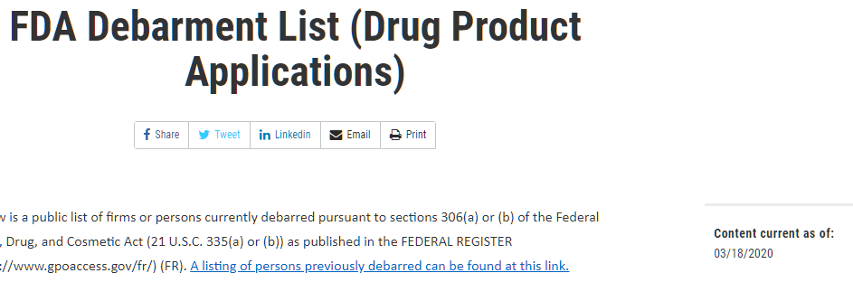

Matching.

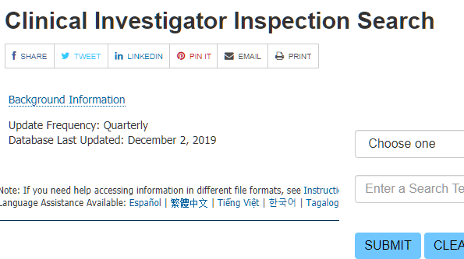

Not applicable. File download.

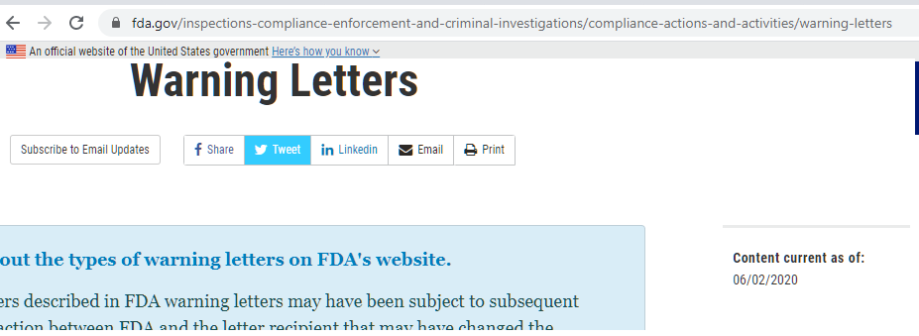

Not applicable. File download

http://www.fda.gov/RegulatoryInformation/FOI/ElectronicReadingRoom/ucm143240.htm

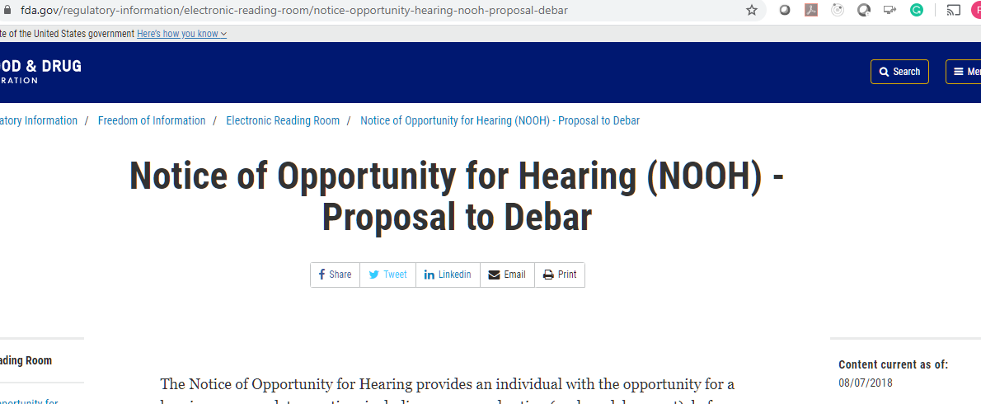

Matching.

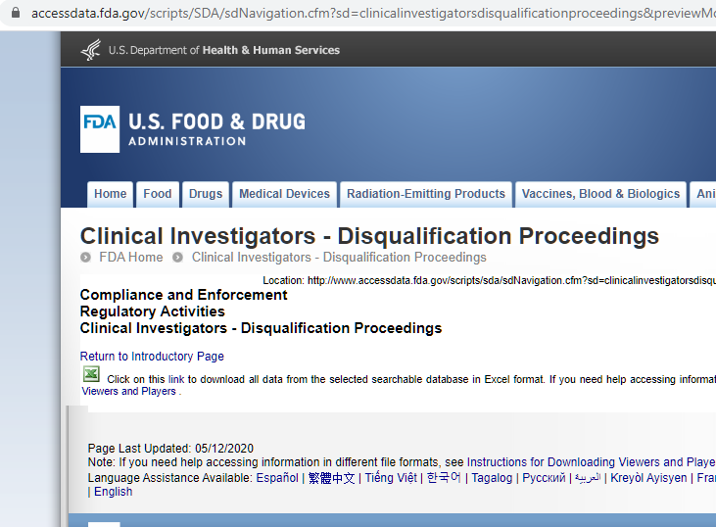

Matching

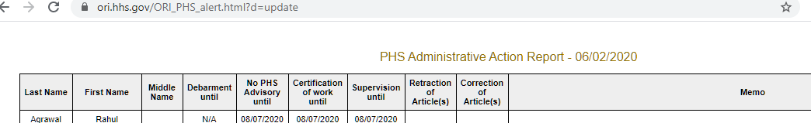

??

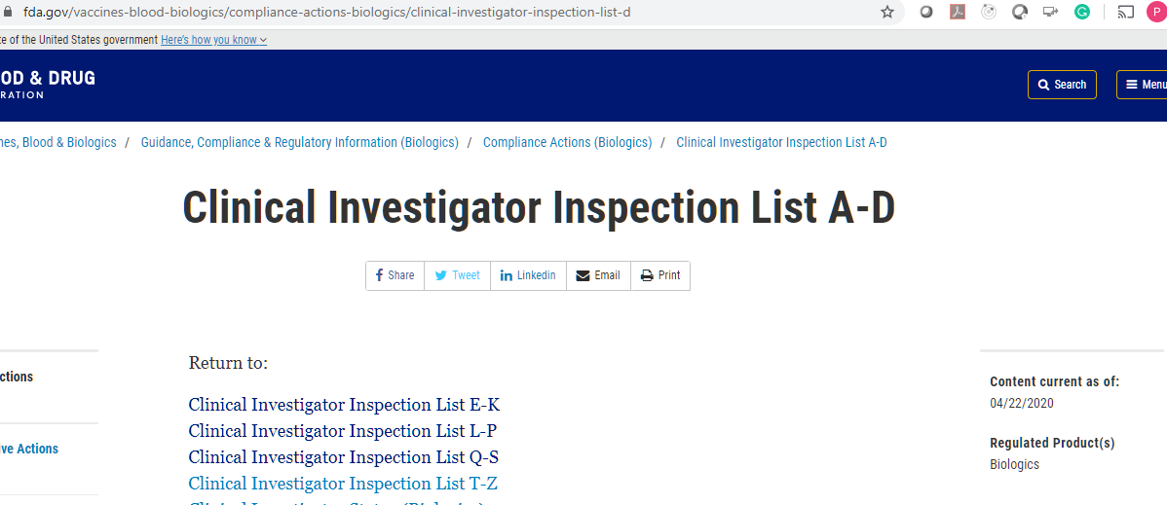

Matching

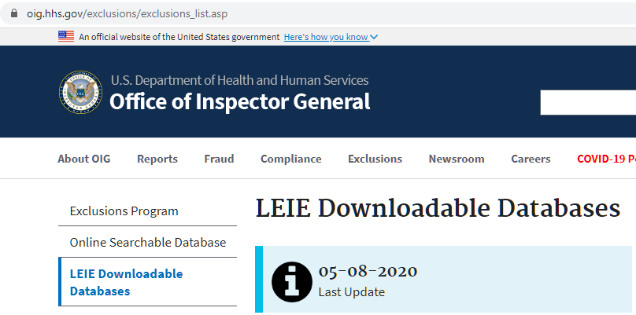

Not applicable – file download

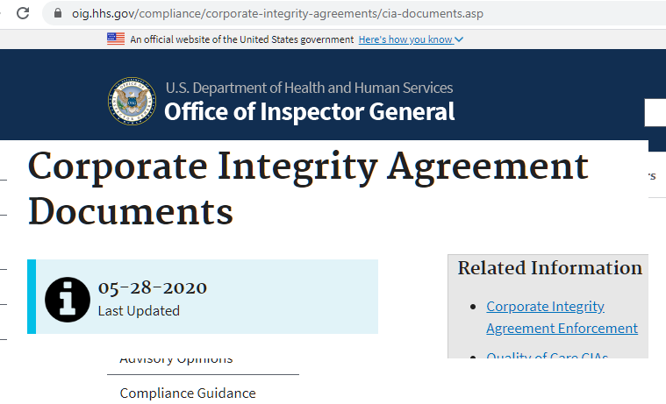

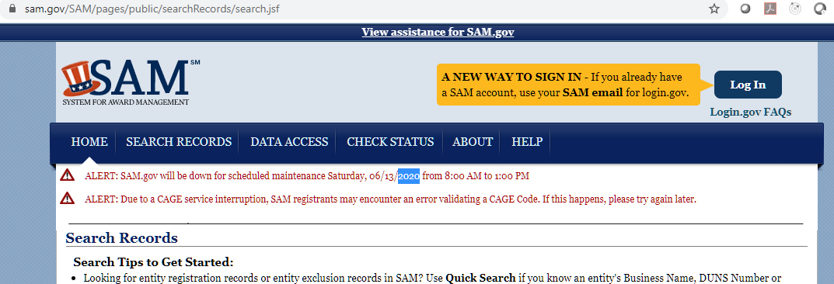

Not applicable, file download

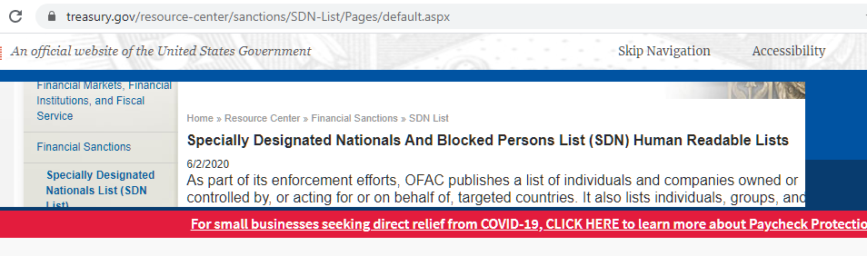

Not applicable, file download