**FDA Websites**

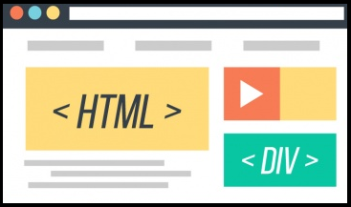

**Investigator Search Engine**

**Database**

**DDAS Application**

**Compliance**

**Forms**



**Resource (User)**

**iSPRINT Application**

**Search using Excel upload**

**iSPRINT Search**

**Manual search**

**Validated Search Results**

**Validation**

**Investigator**

**Search**

**Results**