## Mandatory Sites

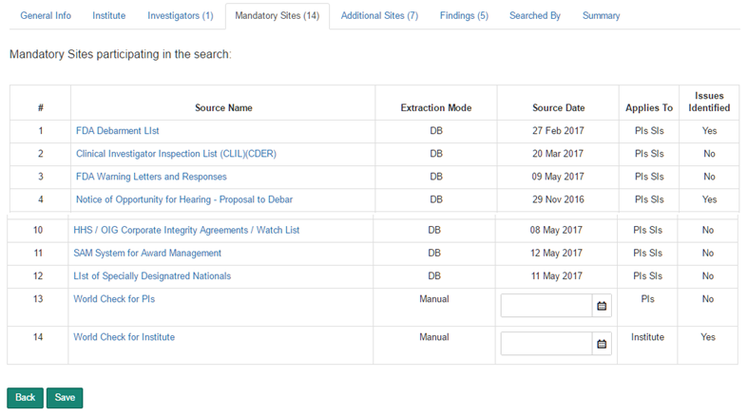

## Additional Sites

Note:

Applies to Mandatory and Additional Site:

Source Date is automatically generated for sites applicable to PIs and Sis and whose extraction mode is ‘DB’ . For other sites, the Source Date is recorded by the user.

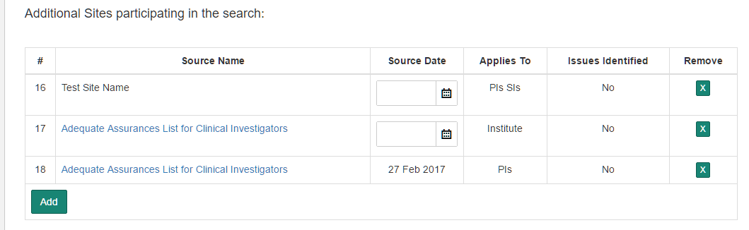

## Findings

The findings are listed in the following order:

1. Institute in ascending order,
2. And then by Source # in ascending order,
3. And Then by Date of Inspection in descending order
4. And then by Investigator in the same order as the record appears on the Compliance Form,
5. And then by Source # in ascending order
6. And then by Date of Inspection in descending order.

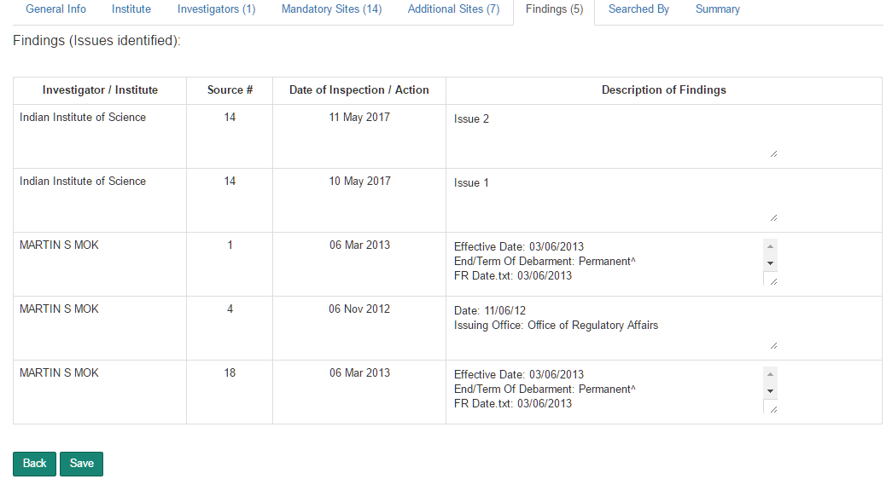

# Configurations

# Site Sources

The Site Sources section displays all the sites available for use with Compliance Forms. The list contains 12 pre-defined Site Sources. The extraction mode for these sites is ‘DB’. These records cannot be removed or modified.

Additional sites can be added to the Site Source list. The extraction mode for additional sites is automatically marked as ‘Manual’

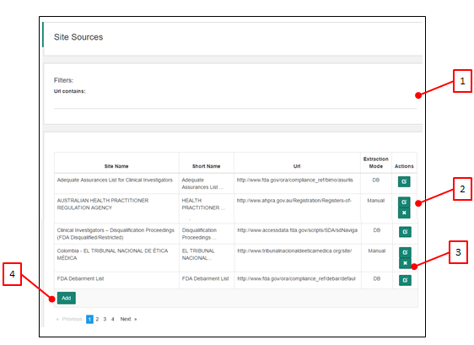

1. Filters: Url contains. Filters records matching the text in the Url contains text box.
2. Edit Record. Applies to Manual sites. DB Sites cannot be edited.
3. Remove Record. Applies to Manual sites. DB Sites cannot be removed.
4. Add a new Site Source with the following values:
   1. Site Name
   2. Short Name
   3. URL
   4. Extraction Mode: Manual

# Default Sites

The application maintains a list Default Sites. The Site Sources listed under this section are added to the compliance form when the form is created.

The fields in the Default Site are:

1. Site Url: Selected from the list of Site Sources. Site Sources are managed in the Site Source section.
2. Order No: Defines the order in which the Site Sources have to appear in the Compliance Form.
3. Name: By default, the Site Name provided by the Site Source is applied. This can be modified.
4. Search Applies To options are:
   1. PI SI
   2. PI
   3. Institute
5. Mandatory, Yes / No. Mandatory Site Sources are listed under the Mandatory section of the Compliance Form. Not Mandatory Site Sources are listed in the ‘Additional Sites to Search’ section of the Compliance form.
6. Extraction Mode: not editable. The Extraction Mode defined in the Site Source section is applied except in the case where the Search Applies To is Insititute. The Default Site Extraction Mode is marked as ‘Manual’ for all records that have ‘Additional Sites To Search’ as Institute.

# Country Specific Site Sources

When a Compliance Form is created, the application will add applicable additional Site Sources as defined in this section.

The application matches the value in the Country field of Compliance Form inputs to the list of corresponding sites in the Country Specific Sites List and adds these sites to the Compliance Form.

Note: This functionality is available only when the Compliance Form is created through the Batch Upload mode.

# Sponsor Specific Site Sources

When a Compliance Form is created, the application will add applicable additional Site Sources related to a Sponsor.

The application matches the first four digits in the Project Number field of Compliance Form inputs to the list of corresponding sites in the Sponsor Specific Site Sources and adds these sites to the Compliance Form.

Note: This functionality is available only when the Compliance Form is created through the Batch Upload mode.